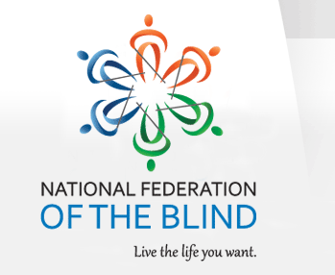
March 23, 2016

National Federation of the Blind
Treasure Coast Chapter

Come join the Treasure Coast Chapter of National Federation of the Blind for its monthly meeting on Tuesday, April 12th, from 11am-2pm at WQCS Radio Station @ IRSC, 3209 Virginia Avenue, Fort Pierce. Our guest speaker this month will be Dr. Timothy Schoen PhD, Foundation fighting Blindness. Dr. Schoen will be discussing on-going research in the field of vision. Our monthly chapter meeting will follow. Please RSVP to Tim Edwards, President of the Treasure Coast Chapter, at 630-432-5090 or you can email Tim at tred34990@gmail.com

Please feel free to share this flyer with other families and professionals, so that they would be able to attend this lecture with our special speaker.

Mark your calendar for upcoming speakers

May 10th Denise Valkema; President for the State of Florida NFB
June 14th Fun day

