The National Federation of the Blind of Florida Newsletter
Issue 1 May/June 2016
President’s note:
Greetings Federation Family,
I hope all is well and that you are enjoying the wonderful spring weather. We are happy to establish a bimonthly newsletter for our state affiliate. With love, hope and determination we can collaborate and make this newsletter informative for all. So we ask you to assist with this process by submitting updates on your chapter or division, and any other information that you would like to see posted in this bimonthly newsletter. This newsletter will bring more communication to every member in the NFBF and help build the federation in Florida.
Sincerely,
Denise Valkema, President
National Federation of the Blind, Florida

Announcements for May and June:
The National convention is fast approaching, and we hope that you are as excited as we are. Below is some important information if you are attending the 2016 National Convention.
• When: Thursday, June 30th through July 5th, 2016
• Where: Rosen Shingle Creek Resort - 9939 Universal Boulevard Orlando, Florida 32819-9357; phone (866) 996-6338
• Deadline for Pre-registration and banquet is May 31st and the cost of pre-registration is $25 and banquet is $60. The cost of both will go up at the door.
• The 2016 room rates are singles and doubles, $83; and triples and quads, $89. In addition to the room rates there will be a tax, which at present is 12.5 percent. No charge will be made for children under seventeen in the room with parents as long as no extra bed is requested. Please note that the hotel is a no-smoking facility.

Birthdays & Celebrations:
The NFBF would like to celebrate:
Birthdays:
May:
Toni King, Tallahassee,
Alicia Kilby, Suncoast
Glenda H., Space Coast
June:
Donald Christie, Tallahassee
Lauren Blum, Suncoast
Scott Wilson, Suncoast
Weddings:
Donald and Jada Christie, Tallahassee, May 29 2016

Legislative Updates:
Space Available: H.R. 2264 and S. 2596 - This legislation will amend Title 10 of the United States Code to permit veterans who have a service-connected, permanent disability rating as "total" to travel on military aircraft in the same manner and to the same extent as retired members of the Armed Forces entitled to such travel. Please follow up with your congressmen and senators and ask them to support H.R. 2264 in the House of Representatives and S. 2596 in the Senate. The Capitol switchboard phone number is (202) 224-3121.

Technology: Tips & Tricks
The KNFB reader is the latest in reading printed material. If you would like a demonstration or instruction contact Jorge Hernandez.

Special announcements:
The NFBF would like to congratulate Dan Hicks on his article, "Driving the Nail” which published in the April issue of the Braille Monitor. You can read it by going to https://nfb.org/images/nfb/publications/bm/bm16/bm1604/bm160411.htm

Chapter, Division, and Committee updates:
Greater Broward Chapter: Tom Ryan, President, Phone: (954)442-1855, Email Ryantom@bellsouth.net

Central Florida Chapter: We meet the third Saturday of each month from 11 A.M. to 1 PM at Lighthouse Central Florida, 215 East New Hampshire Street, Orlando, Florida 32804. For more information, please contact Sherri Brun, chapter president. Please like us on Facebook at: https://www.facebook.com/groups/410985858949160/

Greater Daytona Beach Chapter: Scott Larson, Vice-President, Phone: 386- 235-0565, Email: Blindscotty@samobile.net. We meet the fourth Saturday of the month 11:30am to 1:30pm. at TGI Friday's, 24 Ocean Shore Blvd., Ormond Beach FL 32176. Follow Us on Facebook: www.facebook.com/nfbdaytona

Gainesville Chapter: Judith Hamilton, President, Phone: (352) 373-7806, Email: jrhamilton51@earthlink.net

Greater Jacksonville Chapter: Marita Winston, president, 904-323–8597, Email: marita.winston60@gmail.com. Our chapter hosts a picnic for the blind and their families each year to find people who may need help, and bring the blind community together for a day of fun, food, and fellowship. Some other projects we have initiated are: blind bowlers of Jacksonville, adopt a nursing home, and participation in other charitable organization events.

Greater Miami Dade Chapter: President Fred Haynes, haynes@bellsouth.net
(305) 775-8466. Our meetings are held on the third Thursday of each month.
Location: Denny's Restaurant, 5825 N. W. 36 Street, Miami, FL

Palm Beach Chapter: Tekesha Saffold, President, (561)707-4799, Email: tnsaffold82@gmail.com. We have monthly meetings on the Second Saturday of every month at 4746 North Congress Avenue, Boynton Beach, FL 33425

Pinellas Chapter: Larry Ball; President, 727-614-9134, lball42@tampabay.rr.com Our meetings are held on the third Saturday of the month at Applebee’s, 5110 E Bay Drive in Largo. We meet for lunch at noon and the business meeting starts at 1 pm. We are working hard to change what it means to be blind in Pinellas county.

Polk Chapter: Joe King, President, (863) 293-5648, Email: joenkitty@earthlink.net. Our meetings are held the second Saturday of the month at: Winter Haven Manor, 140 Avenue A S.W., Winter Haven, Florida, at 10:00 a.m.-12:00 p.m.

Space Coast Chapter: Meeting on May 14th from 9:00 am – 12:00 pm. President Joe Naulty is leading the way in transportation for Space Coast Area Transit. A presentation will be given on the ADA paratransit and how to become qualified for this level of transportation service. Alan Kessler and Connie Mounts have developed Technology Tidbits about the evolution of the smart phone. Focusing on the Android and IOS platform. Discussing the so called apps and their functions. The Space Coast chapter has created both a website and a page on Facebook. www.brevard-nfb.org www.facebook.com/nfbmelbourne

FL State Wide Chapter: The State Wide Chapter invites you to join us on our conference call on the third Sunday of every month at 8 PM. This chapter was designed for those who do not have a local chapter or for some reason cannot get to their local chapter for any given reason. Do you love Krispy Kream donuts? The State Wide Chapter is selling buy one dozen get one free donut cards. These cards are only $16 each, and can be yours with just an email or phone call. For more information, please contact Paul Martinez at nfbf.statewide@gmail.com

Suncoast Chapter is having their next meeting on Saturday, June 16 from 12:30 pm – 3 pm at IHOP, 363660 Commercial Way (US 19), Spring Hill, FL 34606. The Chapter just completed our very first pancake breakfast at Beef O’Brady’s in Brooksville. The entire chapter showed up, along with several Kohl’s volunteers. We had had a wonderful time. We are planning a yard sale for later this summer. If you have any questions, please contact President Lauren Blum at (352)584-0795 or email at nfbf.suncoast@gmail.com.

Tallahassee Chapter: Tallahassee held a Mother’s Day Flower Raffle, won by our own Sylvia Young. The prize of a bouquet of flowers was sent to her mother on Mother’s Day. In June the chapter will celebrate fathers with a dinner out at Beef O’Brady’s where we will hear from family member’s extolling the attributes the fathers in our chapter. We meet the 1st Monday of each month and the Lighthouse of the Big Bend, Tallahassee, FL 32303. If you have any questions, please contact President Jada Michael at 850-766-9378 or Pinkpearl.15@comcast.net.

Tampa Chapter: The Tampa Chapter is gearing up to an awesome national convention. At the current time the Tampa Chapter is selling NFB Recyclable grocery bags for $5, and if you missed out on receiving a customize envelope opener you have the opportunity to purchase one for only $2. For more details, contact Miranda Kilby, president at NFBF.Tampa@gmail.com.

Treasure Coast Chapter: Tim Edwards, President, Phone: 630-432-5090, Email: tred34990@gmail.com. We meet the 2nd Tuesday of the month from 11am-1:00pm at WQCS Radio Station @ IRSC, 3209 Virginia Avenue, Fort Pierce. (The chapter does not meet in July or August). We are working to change what it means to be blind in Martin, St Lucie, Indian River & Okeechobee Counties!

Florida Association of Guide Dog Users (FLAGDU): Sherrill O'Brien, Division President, flagdu@nfbflorida.org

Deaf-Blind Division: The FL Deaf-Blind division meets on the first Tuesday of every month at 8 PM. If you are interested in attending this meeting and learning what the division has to offer, please contact the president, Tracie Inman.

Florida Organization of Parents of Blind Children (FOPBC): Parents Division Reorganizing, Holly Idler, (386) 846-3766, Email: hbeanie@gmail.com

Florida Association of Blind Students: The FABS invites any high school or college student to attend our conference calls on the third Sunday of every month at 6 PM. FABS is also proud to announce the kick off of the IPhone S E raffle. The tickets are $5 each and the drawling will be held on July 5th at our national convention. For further questions, contact the president, Paul Martinez at nfbfabs@gmail.com

The National Association of Blind Veterans: PO Box 784957, Winter Garden, Florida 34778, (321) 948-1466, Email: president@nabv.org

Photo Gallery:
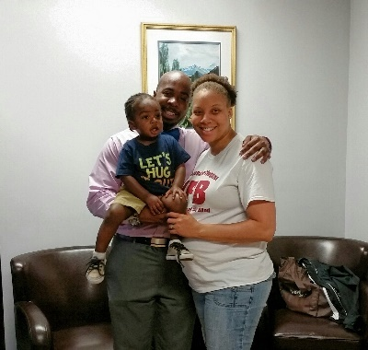
The Tallahassee Chapter wishes the Morgans a bitter-sweet farewell as they move to Atlanta for Rashad’s new position as assistant director at Georgia Tech Disability Services. We will miss them dearly, but know that growth is a part of life. Live the Life you want Morgans!

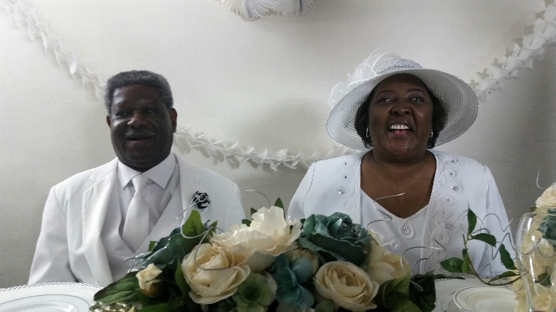
Join the Tallahassee Chapter in congratulating Jada and Donald Christie on their wedding, May 29, 2016. The Federation continues to prove that we Live the Life we want.

Please contact any of the board with questions, comments, concerns or for general information.
NFBF Board of Director’s Information:
Denise Valkema -President
Phone: 305-972-8529
Email: valkemadenise@aol.com

Paul Martinez - 1st Vice President
Phone: 813- 390-5720
Email: paul09ms@gmail.com

Miranda Kilby – 2nd Vice President
Phone: 352- 942-0417
Email: mbkilby@gmail.com

Sylvia Young-Secretary
Phone: 850- 322-5937
Email: slyfox@embarqmail.com

Gloria Mills –Treasurer
Phone: 813-340-9754
Email:glorianfb@irescue-tax.com

Board Members:
Lauren Blum
Phone: 352-584-0795
Email: laurenblum79@gmail.com

Jorge Hernandez
Phone: 305877-2311
Email: jeh1065@comcast.net

Tekesha Saffold
Phone: 561-707-4799
Email: tnsaffold82@gmail.com

Rafael Fernandez
Phone: 305[903-6299
Email: rafael.fernandez0617@gmail.com

Editor: Sylvia Young
To have something posted in the NFBF Newsletter please submit it to the editor, Sylvia young at slyfox@embarqmail.com by the 15th of each odd month.

