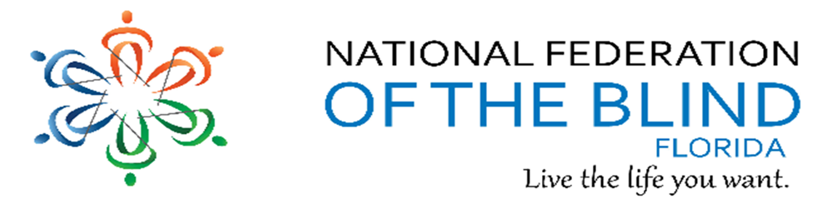BREAKING NEWSLETTER
Issue 12 March/April 2018
President’s note:
Greetings Federation Family,
We are looking forward to our 2018 State Convention and being with family again. Our theme this year is “We are Family” and that’s what the NFB is all about.
Thank you for the love, strength, and hope we share as a family and all you do to welcome others to this circle of family. Best wishes and safe travels during the Easter holiday.
Denise Valkema, President NFB OF Florida
president@nfbflorida.org
Facebook & Twitter @nfbflorida
Find us on twitter and FB @nfbflorida
We are filled with hope, energy and love by participating in the National Federation of the Blind. Every day we work together to help blind people live the lives they want.

Birthdays & Celebrations:
The NFBF would like to celebrate:
Birthdays:
March:
Scott McKinnley - Tampa
Debra Whitt - Gainesville

April:
John Bailey - Tampa
Miranda Kilby – Tampa
Paul Lewis - Tampa

Anniversaries:
Jeffery and Lisa Davis– Tallahassee

Let’s us take a moment to remember our members who left big shoes to fill. In memory of:
Peter Cerullo – Greater Daytona Beach
Tom Ryan - Broward
Charles Stoneback -

Announcements and Comments:

STATE CONVENTION
The hosting chapters are excited that convention will be here soon. We are trying to finalize our activity for Saturday and received many suggestions from our members during our Wednesday, March 28th events committee call. We are still looking for guest speakers, so please contact Lauren Blum or Miranda Kilby with any suggestions. As far as deadlines, please keep in mind, the deadline of May 3rd to book the hotel to get the NFB convention room rate. In addition, the pre-registration deadline is May 8, and if you are one of the first 120 to register you will receive breakfast for all 3 mornings.
The dates for Convention are May 25-28, 2018 at Hilton Tampa Airport Westshore, 2225 North Lois Avenue, Tampa, FL 33607. To make your room reservations, please call the Hilton Tampa Airport Westshore at 813-877-6688. When calling, ask for the National Federation of the Blind of Florida Convention room rate (code NFB) of $104.00 per night. Rooms are reserved on a first-come first-served basis. Your room reservation must be made by May 5, 2018 to guarantee our special hotel rate. It pays to pre-register! Prior to convention the registration fee is $20.00, and the banquet tickets are $40.00 each. The registration and the banquet fee will each increase by $5.00 on Monday, May 7, 2018. So, it is important that we receive your payment by that date to qualify for the special registration and banquet package discount. Don't wait, send your Convention Registration in today! If you have questions, please feel free to contact NFBF Treasurer Gloria Mills-Hicks at: treasurer@nfbflorida.org or by calling 1-866-342-5080 or e-mail President Valkema at president@ nfbflorida.org.
Our National Representative is confirmed; Pam Allen, First Vice President of the NFB, president of the NFB of Louisiana and Director of the Louisiana Center for the Blind.
Call for Resolutions
Please send ideas for a resolution and/or written resolutions to resolutions@nfbflorida.org
Deadline is April 30th. If you have any questions, please call Camille Tate at 321 372 4899 or Merry Schoch at 813 625 1850.

NATIONAL CONVENTION
The National Federation of the Blind will hold its annual National Convention for the final time in Florida, during the week of July 3-8, 2018. The convention will be at the Rosen Shingle Creek Resort in Orlando, FL. The 2018 room rates are singles and doubles, $88; and triples and quads, $93. In addition to the room rates there will be a tax, which at present is 12.5 percent. No charge will be made for children under seventeen in the room with parents if no extra bed is requested. Please note that the hotel is a no-smoking facility.
Call for your reservations at (866) 996-6338 or you may also write directly to the Rosen Shingle Creek, 9939 Universal Boulevard, Orlando, Florida 32819-9357. The hotel will want a deposit of $100 for each room and will want a credit card number or a personal check. If you use a credit card, the deposit will be charged against your card immediately, just as would be the case with a $100 check. If a reservation is cancelled before Friday, June 1, 2018, half of the deposit will be returned. Otherwise refunds will not be made. Preregister for the convention on the NFB website at www.nfb.org as soon as possible.

Kenneth Jernigan Convention Scholarship Fund
Have you always wanted to attend an NFB annual convention but have not done so because of the lack of funds? The Kenneth Jernigan Convention Scholarship Fund invites you to make an application for a scholarship grant. Perhaps this July you too can be in the Rosen Shingle Creek Hotel in Orlando, Florida, enjoying the many pleasures and learning opportunities at the largest and most important yearly convention of blind people in the world.
The three biggest ticket items you need to cover when attending an NFB national convention are the roundtrip transportation, the hotel room for a week, and the food (which tends to be higher priced than at home). We attempt to award additional funds to families, but, whether a family or an individual is granted a scholarship, this fund can only help; it won’t pay all the costs. Last year most of the sixty grants were in the range of $400 to $500 per individual.
We recommend that you find an NFB member as your personal convention mentor, someone who has been to many national conventions and is able to share money-saving tips with you and tips on navigating the extensive agenda in the big hotel. Your mentor will help you get the most out of the amazing experience that is convention week.
Who is eligible? Active NFB members, blind or sighted, who have not yet attended an NFB national convention because of lack of funding are eligible to apply.

NFB BELL Academy
Thanks to NFB Florida, Florida Parents of Blind Children members welcomed Jackie Anderson, TVI, to Orlando, Florida on March 17, 2018 for a Braille Enrichment for Literacy and Learning (BELL) Academy Training session in preparation for the 2018 Orlando BELL Academy. Parents were enchanted by Ms. Anderson’s skills, knowledge, methodology and passion for educating blind kids. Jackie is the model of what a TVI should be and will be sharing her talents with children ages four through twelve from July 9, 2018 to July 20, 2018 from 9:00 a.m. to 3:00 p.m. (week days only) in Orlando, Florida. The 2018 NFB BELL Academy helps blind and low vision children develop the literacy skills that will empower them to achieve their academic goals and live the life they want. With assistance of Wells Fargo, opportunities to develop financial literacy skills will be provided. To learn more about NFB BELL Academy and to apply please visit https://nfb.org/bell-academy and contact Kimberly Banks at 404-259-2654 with any questions.

The National Federation of the Blind Applauds the Introduction of Legislation Implementing the Marrakesh Treaty
Treaty will Expand Availability of Accessible Books for Blind and Print Disabled Americans
Washington, DC (March 15, 2018): Senator Charles E. “Chuck” Grassley (R-IA) and Senators Dianne Feinstein (D-CA), Bob Corker (R-TN), and Bob Menendez (D-NJ) have introduced the Marrakesh Treaty Implementation Act of 2018, S. 2559.
“The National Federation of the Blind was a principal leader in the development and negotiation of the Marrakesh Treaty,” said Mark A. Riccobono, President of the National Federation of the Blind. “By allowing the worldwide production and exchange of accessible books, the treaty will dramatically increase the availability of knowledge to blind people everywhere. We urge both houses of Congress to swiftly pass this legislation, and in doing so, unlock the doors to expanded literacy for millions of blind Americans.”
The legislation will make modifications to United States copyright law to ensure that it fully complies with the terms of the treaty. These modifications are supported by publishing, library, and disability organizations.

Link City: Here are some important links that may be of interest.
NFB: https://nfb.org/
NFBF: http://nfbflorida.org/
March Presidential release: http://bit.ly/2nxgDpv

Legislative Updates from the desk of Camille Tate:
The National Federation of the Blind of Florida Legislative Committee would like to thank all our members who participated in our blitz campaign regarding H.R. 620, the ADA Education and Reform Act of 2017. Your dedication to advancing our legislative priorities is greatly appreciated. Unfortunately, this bill passed the House of Representatives on February 15, 2018. We had our moments of disappointment, hurt and anger, but must push forward to stopping this bill in the Senate. Our fight is not over.
Merry Schoch posted to the Florida list sample letters and talking points for us to use when contacting Senators Nelson and Rubio. We are asking them not to vote for the Senate version of this bill if it comes to the floor. We have also included a letter written by Senator Tammy Duckworth, D-IL, to her Senate colleagues requesting they not sign on to a Senate companion bill. She needs 41 signatures and at the time of this article had 43. But, noticeably absent are Senators Nelson and Rubio. Please visit, write or call our Senators and request they sign the Duckworth letter. Whether they do or not, express your concerns about the ADA bill and how devastating it would be to disabled Americans. According to the debates on the House floor in February, estimates claim that one-fifth of all Americans are disabled. We must do what we can to preserve our rights to equal access and protections written into the Americans with Disabilities Act.
Camille Tate will be leading the push to pass a Blind Parental Rights bill in Florida. As we follow our brethren in other states, it is time we protected the rights of blind parents who encounter discrimination by the court system when trying to retain custody or visitation with their children. Often state agencies, family members or family court intervene to remove children from the custody of their blind parents simply because they are blind. We would like to have our bill introduced on the Florida House floor in March/April 2019. We are looking for stories of blind parents who have struggled to retain their parental rights because of blindness, whether they have won or lost their cases. We are interested in building a presentation that contains facts and figures regarding this same issue, in addition to any statistics pertaining to the safety of children who are in the care of their blind parents. Please contact Camille Tate if you are eager to help us save the parental rights of the blind or have information to share. Camille can be reached at (321) 372-4899 or ctate2076@att.net
The Legislative Committee will meet on Tuesday, April 17, at 8 p.m. The call-in number is (712) 775-7031. The access code is 938047311#.

Technology: Tips & Tricks
Apple Tips and Tricks from the desk of Camille Tate
Our article this month is about gesturing. Some of the most common gestures for use with an IOS device are often learned by accident. We are instructed to use two-finger swipes, three-finger swipes, double tap here and triple tap there. Here are some of the most common ones that we might use on a regular basis. Some can be convenient.

• Three-Finger Swipe Up or Down: If you swipe three fingers up or down, the page you are looking at will scroll in that direction. For example, on the browser (Safari), a three-finger swipe down will scroll to the next page. A three-finger swipe up will scroll to the previous page, if applicable.
• Two-Finger Swipe Down: This gesture is handy to know. If you swipe down with two fingers, it will read a document, web page, email or other item continuously. I know that on the Safari browser and other apps, you can use the reader that is available, but I prefer to use two-finger swipe down. Of course, touching the screen stops the continuous reading.
• Two-Finger Double Tap: This is definitely handy to answer or hang up your iPhone. Just use two fingers and double tap the screen when you receive a call to answer, or to hang up the phone when you are finished. It can be hit or miss when trying to answer the phone, so if you can double tap the center of the screen, that is more accurate.
• Three-Finger Double Tap: For all voiceover users, you must be careful with this gesture. I have accidentally turned off speech using this feature. If you use a three-finger double tap, you can toggle the speech on and off. There are times when the iPhone will turn off speech (I have had this happen just by touching the phone) and most people will restart their phone or tablet. Try using a three-finger double tap and see if speech turns on again. Your voiceover is still on, but the device won’t talk to you.
• Three-Finger Triple Tap: I learned this one purely by accident. I asked someone to look at something on my iPhone screen and they said it was black. A three-finger triple tap toggles the screen curtain feature. If you accidentally turn on the screen curtain, the device will tell you. All you have to do is a three-finger triple tap to turn it off.

These are only some of the gestures that are useful when using an IOS device. There are others, but these are the most common. I often think of them as shortcuts to different commands. When I am somewhere I do not want others to see what is on my screen, or what I’m typing on my phone or tablet, I will use the three-finger triple tap method to basically turn off the screen, so it appears black. I never turn off speech since I would not be able to use my devices, but those who can see their screens might not care. I used the two-finger double tap to answer and hang up calls until I bought a blue tooth headset.

Inspiration Conner:
“If there is one thing I’ve learned in life, it is to fight. Fight for what’s right. Fight for what you believe in and what is important to you. But most importantly, fight for the ones you love and never forget to tell anyone how much they mean to your while they’re still alive.” ― Writer Unknown
Chapter, Division, and Committee updates:
Greater Broward Chapter: Jake McEntyre, President, Email: jmac1920@yahoo.com. Our meetings are held the second Saturday of each month from 10:30 a.m. until 12:30 p.m. at the Westfield Broward Mall, 8000 W. Broward Blvd., Plantation, FL 33312; inside the Plantation Police Outreach Center North side of the Mall. New board elected: Jake McEntyre, President, Debbie Ryan, Vice President, Ralph Smith, Secretary, Lessie Anderson, Treasurer, Lance Louis, Board Member 1, Francis Vitulla, Board Member 2.

Central Florida Chapter: Sherri Brun, President; Please like us on Facebook at: https://www.facebook.com/groups/410985858949160. We meet the third Saturday of each month from 11:00am to 1:00pm at Lighthouse Central Florida, 215 East New Hampshire Street, Orlando, Florida 32804.

Greater Daytona Beach Chapter: Joshua Espinal, President, Phone: 407-534-0160, Email Joshua.espinal@everest.edu. We meet the fourth Saturday of the month 11:30am to 1:30pm at TGI Friday's, 24 Ocean Shore Blvd., Ormond Beach FL 32176. Follow Us on Facebook: www.facebook.com/nfbdaytona.

Gainesville Chapter: Judith Hamilton, President; Phone: 352-373-7806, Email: gainesville_nfb@earthlink.net. The Gainesville Chapter welcomes you to our monthly chapter meetings. Change in meeting venue: In April the Gainesville Chapter will meet at the Alachua County Library, Headquarters, 401 East University Avenue, Gainesville, Florida 32601. We will meet in the Foundation Room Saturday, April 14, 2018 from 2:15 to 4:15PM. Please RSVP by Thursday, April 12, 2018 to Judy Hamilton, Chapter president, 352-373-7806. We will have a guest speaker from United Parcel Service (UPS).

Greater Jacksonville Chapter: Marita Winston, President; Phone: 904-323–8597, Email: marita.winston60@gmail.com. Please join us if you are in the area. The Chapter has two fundraisers in the works; a yard sale and a Flapjack Breakfast at Applebee’s. We are very proud of Russ Davis meeting with the Senator’s representative recently to help oppose HR620.

Greater Miami Dade Chapter Jorge Hernandez – President; Phone: 305-877-2311; Email: jeh1065@comcast.net. Our meetings are held on the third Thursday of each month. Location: Denny's Restaurant, 5825 N. W. 36 Street, Miami, FL. The Miami-Dade Chapter will commence the fundraiser “Worlds Famous Chocolate” to raise funds for State Convention. The new members are eager to participate at their first State Convention.

Melbourne - Space Coast Chapter: Camille Tate, President; Phone: 321 372-4899; Email: ctate20176@att.net Facebook: www.facebook.com/nfbmelbourne. We meet on the second Saturday of each month at The Fountains of Melbourne, 4451 Stack Blvd., Melbourne, FL, 32901. Meetings are from 9:30 a.m. until noon. Contact Camille Tate, President for more information.

Palm Beach Chapter: Tekesha Saffold, President; 561-707-4799; Email: tnsaffold82@gmail.com. We have monthly meetings on the second Saturday of the month. Our next meeting will be April 14th at Duffy’s 11935 Southern Blvd., Royal Palm Beach, FL from 11:00 AM to 1:00 PM. During this meeting, our guest speaker will be Todd J. Bonlarron, Assistant County Administrator.

Polk Chapter: Joe King, President: Phone: 863-293-5648; Email: joenkitty@earthlink.net. Our meetings are held the second Saturday of the month at: Winter Haven Manor, 140 Avenue A S.W., Winter Haven, Florida, at 10:00am-12:00pm.

Florida State-Wide Chapter: Paul Martinez, President; Phone: 813-390-5720; Email: nfbf.statewide@gmail.com. The State-Wide Chapter invites you to join us on our conference call on the third Sunday of every month at 8:00pm. The chapter will be raffling off 6 of the 75th anniversary Lapel Pins that were created a few years ago, as a chapter fundraiser during the state convention. We currently have 8 members that will be attending our state convention. In addition, the chapter is working on finalizing ordering polos for our members.

Suncoast Chapter: Lauren Blum, President; Phone: 352-584-0795; Email: laurenblum79@gmail.com. Meetings are held on the second Saturday of each month from 1:30 pm to 3:30 pm at IHOP,3660 Commercial Way, Spring Hill, FL 34606.

Tallahassee Chapter: Jada Christie, President; Phone: 850-766-9378 Email: emeraldpink15@gmail.com. We meet the 1st Monday of each month and the Lighthouse of the Big Bend, Tallahassee, FL 32303. We have 6 members committed to attend the State Convention and planning a community service activity for a local church next month. We were able to sit down with both Senator Nelson and Rubio’s regional directors to discuss our opposition to the ADA reform bill. They were very receptive.

Tampa Chapter: Miranda Kilby, President; Phone: 352-942-0417; Email: NFBF.Tampa@gmail.com. Join us the fourth Saturday of every month. The chapter attended a vision summit at the beginning of March, Hosted by FFB, where the chapter had a table along with different vendors. We met with Senator Bill Nelson’s regional Director, Digna Alvarez, and we are working on a meeting with Senator Marco Rubio, so the senate office will not drop a bill to reform the ADA. The chapter plans to support the parents division by holding a spirit day/night at Chipotle. All funds raised will go to our NFBF BELL Academy that will be held this summer in Orlando. The chapter is working hard on state convention and looking forward in seeing everyone there.

Treasure Coast Chapter: Tim Edwards, President; Phone: 630-432-5090; Email: tred34990@gmail.com. Come join the Treasure Coast Chapter of National Federation of the Blind for its monthly meeting on Saturday April 14, 2018, from 10 am till noon at WQCS Radio Station @ IRSC, 3209 Virginia Avenue, Fort Pierce. We had chapter elections this month. Our new President is Tamika Butts, our new secretary is Christina Moore, our new treasurer is Carol and Donny Cocher. Our Vice- President will be elected when our chapter meets in May. Board Members are Mary Hanna-Morris, Roberta Cook and Sally Whitehouse. Congratulations to all. We also started a chapter newsletter and the March volume is hot off the presses. Keep your eyes and ears peeled for our next volume. We had a very interesting presentation by Rosemary Mulero. She is from the West Palm Lighthouse for the Blind. She explained the training offered by the lighthouse and the role played by the caretakers. A special guest was Jorge Hernandez. Special thanks to Jorge for joining us. Looking forward to the coming year, as it will be very exciting. Please tell anyone with visual impairments to join us. We will have a lot of fun and learn too.

Florida Association of Guide Dog Users (FLAGDU): Sherrill O'Brien, Division President; flagdu@nfbflorida.org

Deaf-Blind Division: Alicia Betancourt, Interim President; Phone: 386-589-7324; Email: licib85@gmail.com. The FL Deaf-Blind division meets by teleconference call on the second Tuesday of every month at 8:00pm. Call in number is 515-604-9853, Access code: 997037. People with hearing and vision loss represent a unique segment of Florida’s population and we work to promote greater understanding of this dual disability. If you are interested in actively participating and learning more about this division, please contact Alicia Betancourt.

Florida Organization of Parents of Blind Children (FOPBC): The Parents Division is being reorganized by Kimberly Banks, Email: kimberlybanks1984@gmail.com

NFBF Book Club: Our book club meets on the fourth Thursday of each month at 8 p.m. Each month we have a lively discussion about the history and philosophy of our organization. Materials to be discussed are posted to the Florida list prior to the meetings. The call-in number is (712) 775-7031. The access code is 938047311# Come and join us!

Committee to Empower Underserved Populations: Marilyn Baldwin, Chairman, 8427 Lainie Lane, Orlando, Florida 32818, 407-293-0565, CommMDB@aol.com. Everyone is encouraged to attend or have at least one representative from your chapter or division. The Conference call number is (712) 775-7031; Code 938047311

Communication Committee: The committee is thinking of different ways to advertise our upcoming state convention. As of right now we have posted our convention on nfbflorida.org, on our list serves, and we have created an event for our convention on Face Book. We will continue to update all platforms as we finalize items. Our Face Book page has a total of 632 likes, and our Twitter account has 122 follows, we are growing on both platforms, and getting closer to our goals. We have notice that the membership is interacting by sharing and liking our post. We have submitted grants for Publix and Kohls, thanks to Jorge Hernandez and Sylvia Young.

THE Events Committee: Gloria Mills-Hicks, Chairman; Phone: 813-340-9754; Email: glorianfbf@gmail.com. This is the committee that has the responsibility for generating ideas and producing the groundwork for the upcoming NFBF State Convention, which will take place over the Memorial Day Weekend. If you have ideas for this convention, or just want to help make the convention a success, you should call in. The phone number for the call is 712-775-7031; Access Code is 488500#. Stay tuned to the list-sever for the next call.

Fundraising committee: Tickets have been mailed out to all chapters and division for The Amazing Trio Bundle Raffle. The 1st prize winner will win an I Pad Pro or the cash value of $800, the 2nd prize is a $500 Uber or lift gift card or the cash value, and the 3rd prize winner will win a $200 travel voucher or the cash value. Each ticket will be $5, and the drawling will take place at our national convention on Sunday, July 8th. If any chapters or divisions need more tickets please contact the fundraising chair, Paul Martinez at 813-390-5720.

Legislative Committee: The next teleconference meeting will be April 17th @ 8:00 pm. Call: 712 775 7031 access code: 938047311# All are welcome to come

NFB411: Our Special call on NAC was well attended, and Gary Wunder was able to answer questions that many members had. Did you miss the call? Check out the recording by dialing, 712-775-7029. Then use access code 938047311, reference number 34. The next call is in May and is in the planning process. All ideas are welcomed.

Scholarship Committee: The 2018 NFBF Student Scholarship application along with the rules and guidelines has been posted on our nfbflorida.org, our leaders and regular list serves, and announced on both of our social media platforms. Please remember the deadline is April 17th, so share, share, and share.

Senior Concerns Committee: Gloria Mills-Hicks, Chairman; Phone: 813-340-9754; Email: glorianfbf@gmail.com. The phone number for the call is 712-775-7031 The Code is 488500#. We want to continue planning a Senior Retreat, to bring more seniors into the NFBF. There will be other topics of discussion. Remember that you need not be a senior to take part. Stay tuned to the list-sever for the next call.

The National Association of Blind Veterans: Dwight Sayer, President; 321-948-1466; Email: president@nabv.org; PO Box 784957, Winter Garden, Florida 34778.

Photo Gallery:
WE BELIEVE WE CAN FLY
December 30, 2017 two brave National Federation of the Blind Tallahassee Chapter souls decided they could fly. Jada Christie (blind) and myself, Sylvia Young (sighted) have been known for many years as the Eve Sisters because I was born Christmas Eve and Jada New Year’s Eve of the same year. As part of our 60th birthday celebration, Jada and I decided we would literally take the plunge. We went up in an airplane and jumped. Yes, we went skydiving. It was thrilling and awesome and yes, we would do it again. Who says blind people can’t live the life you want? Blindness is not what holds you back. You can do anything you put your mind to. To view our flights, click on these links: Jada - https://youtu.be/z-Bjl-YVr48 Sylvia https://youtu.be/yQkP32BruXE

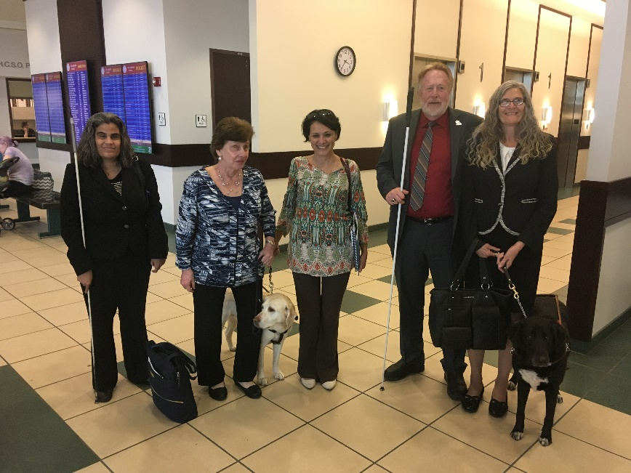
The Tampa Chapter met with Senator Bill Nelson’s regional director, Digna Alvarez, on the march 19th, 2018. Photo below from left to right: Jeanette Torres, Sherrill O’Brien, Digna Alvarez, Marion Gwizdala, and Merry Schoch.

Tampa Bay chapter president, Miranda Kilby prepares for a beef O’Brady's spirit day on March 24, 2018

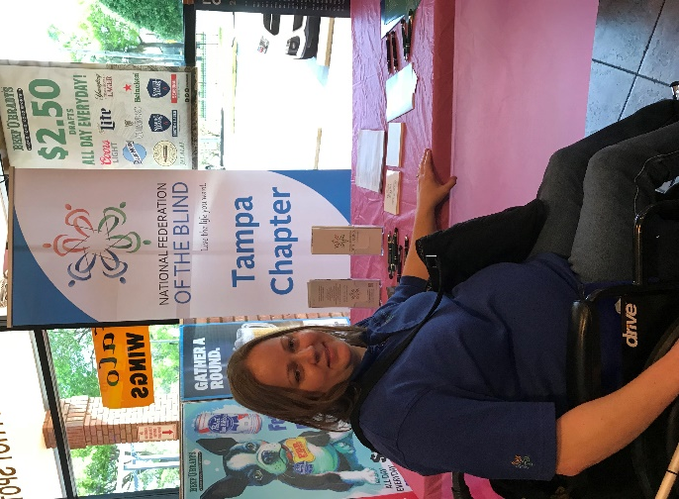

The Tampa Chapter at the FFB vision summit on March 10, 2018.
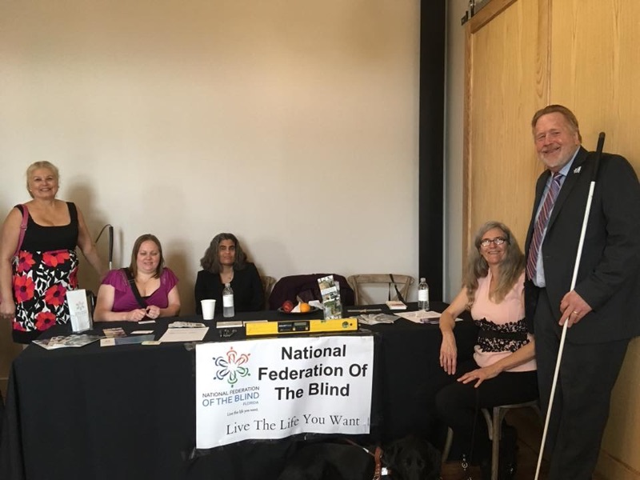

Please contact any of the board with questions, comments, concerns or for general information.
NFBF Board of Director’s Information:
Denise Valkema -President
Phone: 305-972-8529
Email: president@nfbflorida.org

Paul Martinez - 1st Vice President
Phone: 813- 390-5720
Email: paul09ms@gmail.com

Miranda Kilby – 2nd Vice President
Phone: 352- 942-0417
Email: mbkilby@gmail.com

Sylvia Young-Secretary
Phone: 850- 322-5937
Email: secretary@nfbflorida.org

Gloria Mills –Treasurer
Phone: 813-340-9754
Email: glorianfbf@gmail.com

Board Members:
Tekesha Saffold
Phone: 561-707-4799
Email: tnsaffold82@gmail.com

Jorge Hernandez
Phone: 305-877-2311
Email: jeh1065@comcast.net

Camille Tate
Phone: 321-372-4899
Email: ctate20176@att.net

Rafael Fernandez
Phone: 305-903-6299
Email: rafael.fernandez0617@gmail.com
Editor: Sylvia Young
To have something posted in the NFBF Newsletter please submit it to the editor, Sylvia young at secretary@nfbflorida.org by the 15th of each odd month.

