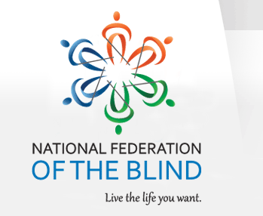

NATIONAL FEDERATION OF THE BLIND OF FLORIDA ANNOUNCEMENT

The National Federation of the Blind of Florida (NFBF) is now accepting student scholarship applications for 2018. Recipients will receive their scholarships at the 2018 NFBF State Convention scheduled for the Memorial Day Weekend, from Friday May 25th thru Monday May 28th in Tampa, Florida.

Qualified high school seniors and college students must complete the NFBF Scholarship Application Form in Microsoft Word format, as well as, submit two letters of recommendation, and transcripts. All documentation must be return to:

Paul Martinez
Scholarship Chair
Email: nfb.fl.scholarship@gmail.com
Cell Phone: (813) 390-5720

The National Federation of the Blind of Florida will be awarding three scholarships, each in the amount of $1,500, at the annual convention banquet scheduled for Sunday evening, May 27, 2018. To qualify students must:
- Be legally blind
- Submit a completed application along with all documentation required
- Attend the entire State Convention with assigned mentors

In addition, all scholarship applicants must provide academic transcripts and complete all components of the scholarship form. Winners will have their ground transportation, convention registration and banquet fees, as well as room and board, covered by the NFBF state affiliate. Completed applications are due to Paul Martinez no later than April 17, 2018.

We have also provided a check list with the documents that are needed for a completed application for your convenience.

