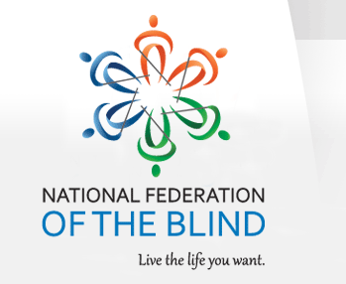 April 30, 2018

National Federation of the Blind
Treasure Coast Chapter

Come join the Treasure Coast Chapter of National Federation of the Blind for its monthly meeting on Saturday May 12th, 2018, from 10 am till noon at WQCS Radio Station @ IRSC, 3209 Virginia Avenue, Fort Pierce. Our speaker this month will be Charmaine Leffler. Charmaine is from the Vision Board. We will be shown how to create a vision board and the means of achieving our dreams. Please RSVP Tamika Buetts, President at 772-708-3749 or Tamika’s email Tamika_butts@aol.com.

Please feel free to share this flyer with other families and professionals, so that they would be able to attend this lecture with our special speaker

Monthly raffle will be held
Please bring your completed membership information form with you

Mark your calendar for the following guest speakers
May 12th Charmaine Leffler from the “Vision Board”
June 9th Gertrude Walker from St Lucie County Supervisor of Elections

