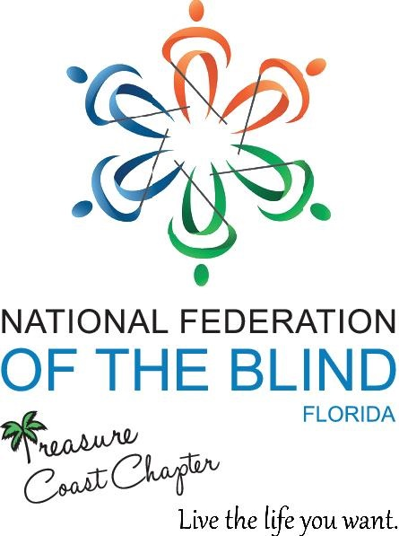

Dear Supporters,

The Treasure Coast Chapter NFB FL meets on the 2nd Saturday of every month from 10am-12noon with guest speakers and discussions related to blindness and low vision education.

We greatly appreciate all donations which are tax deductible. These donations will help us provide scholarships to qualifying members attending the State and National Conventions in 2019. Donations can be gift cards, gift baskets, gift certificates or monetary gifts.

Please contact me directly if you have any questions or concerns at 772-708-3749. You may also email me at Tamika76@gmail.com

Best Regards,
Tamika Butts
President
Treasure Coast Chapter NFB- FL

