Exercise Wrap-Up from Diabetes Meeting

As always, please consult your doctor before starting or changing your exercise routine!

Please wear appropriate clothing (i.e. sneakers or shoes designed for exercise, clothing that allows you to breathe while sweating, etc.).

Please keep yourself hydrated! Water is better because many sports drinks contain too much sugar and salt.

Below are the 10 chair exercises that are low impact and would work well for those who are suffering from other conditions that affect balance or other motor/mobility skils. It will also work well for those who wish to start off very low impact .

Excerpted from “Diabetes Forecast”, March 2017, http://www.diabetesforecast.org/2017/mar-apr/10-exercises-to-get-you-fit.html

1. Seated Knee Extension
Targets: quadriceps
A. Begin in Position No. 1: Sit up straight with your back supported by a chair and feet and knees shoulder-width apart. B. Slowly straighten your right knee, lifting your foot until it is straight out in front of you. Flex your ankle and point your toes toward the ceiling. Lower your right leg. Repeat with the left.
Repetitions: 8 to 12 with each leg, alternating legs
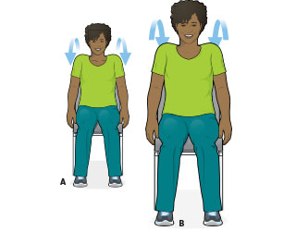

2. Shoulder Shrugs
Targets: upperback and upper neck muscles
A. Begin in Position No. 1 (see Seated Knee Extension above). With your arms at your sides, raise your shoulders toward your ears and slowly roll them forward and down. B. Raise your shoulders toward your ears and slowly roll them backward and down.
Repetitions: 5 to 8 forward, then 5 to 8 backward
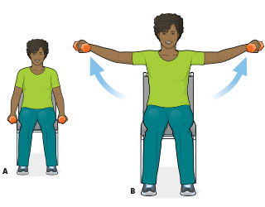

3. Lateral Side Raise
Targets: shoulders
A. Begin in Position No. 1 (see Seated Knee Extension above). Hold a light weight (or bottle of water) in each hand. Keep your arms at your sides with your palms facing in. B. Keeping your elbows slightly bent, slowly raise both arms out to the side until your hands are just above shoulder level. Pause. Slowly lower your arms to the starting position.
Repetitions: 8 to 12
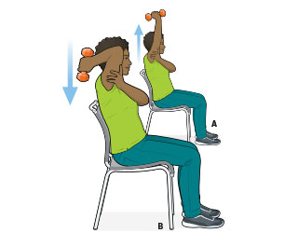

4. Triceps Extension
Targets: triceps
A. Begin in Position No. 1 (see Seated Knee Extension above). Look straight ahead, keeping your chin parallel to the floor. Holding a light weight (or bottle of water) in your right hand, raise your arm above your head. Keep your arm straight, with your elbow facing forward and your upper arm close to your ear. With your left hand, grasp the back of your right upper arm, just below the elbow for support. B. Slowly bend your elbow, and lower the weight toward your right shoulder. Return to the starting position.
Repetitions: 8 to 12 with each arm
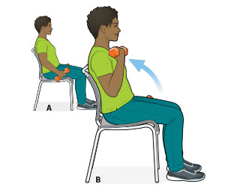

5. Bicep Curl
Targets: biceps
A. Begin in Position No. 1 (see Seated Knee Extension above). Hold a light weight (or bottle of water) in each hand. Keep your arms at your sides, palms facing in. With your upper arms and elbows held close to your sides, bend your elbow to curl the weight in your right hand up to thigh level. B. Rotate your hand to a palm-up position and continue to slowly bend your elbow until the weight reaches shoulder level. Slowly lower the weight, palm up, to thigh level. Rotate your palm so that it faces your thigh, straighten your elbow, and return the weight to the starting position.
Repetitions: 8 to 12 with each arm
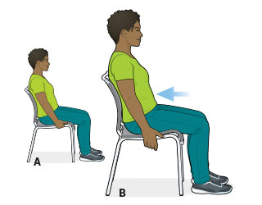

6. Abdominal Brace
Targets: core abdominal muscles
A. Begin in Position No. 1 (see Seated Knee Extension above). Place one hand on either side of the seat, next to your hips. Pull your shoulders back, straightening your posture. Take a breath in and relax your stomach muscles. B. Breathe out, drawing your stomach muscles inward. Hold this position for 5 to 10 seconds. Focus on relaxed breathing. Avoid holding your breath while your muscles are contracting.
Repetitions: 5
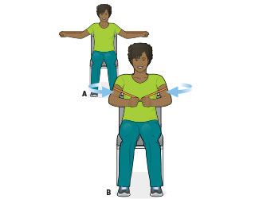

7. Seated Chest Fly
Targets: chest and shoulders
A. Begin in Position No. 1 (see Seated Knee Extension above). Place an exercise band across your back, just below your shoulder blades. Hold one end of the band in each hand. Keeping your elbows slightly bent, straighten your arms out to either side. B. Exhale and slowly bring your arms forward until your hands meet in front of your chest. Inhale and slowly return your arms out to the side.
Repetitions: 8 to 12
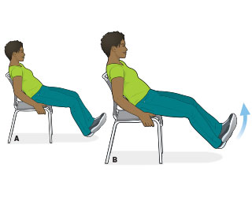

8. Seated Abdominal Curl
Targets: abdominals
A. Sit forward in a chair with your hips toward the front edge of the seat. Lean back so that your upper back is supported by the back of the chair. Gripping the sides of the seat for support, extend your legs out in front of you. Keep your knees slightly bent, heels on the floor, and toes up. Cross your left ankle over your right. B. Tighten your abs, then slowly lift your feet 2 to 3 inches off the floor. The effort to lift should come from your abdominal muscles, not your hips. Pause, and then slowly lower your legs to the starting position.
Repetitions: 8 to 12, then cross your right ankle over your left and repeat.
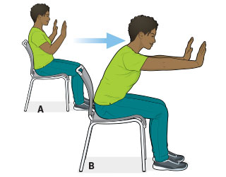

9. Chair Sit-Up
Targets: abdominals
A. Begin in Position No. 1 (see Seated Knee Extension above). Hold your hands in front of your chest, palms facing forward as if you’re going to push something. B. Slowly bend forward at the waist, pulling in your abdominal muscles and keeping your back straight. As you bend forward, extend your elbows and push out with your hands, exhaling as you go. Slowly come up and return to the starting position.
Repetitions: 8 to 12
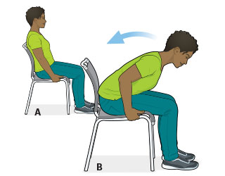

10. Reverse Chair Sit-Up
Targets: lower back
A. Begin in Position No. 1 (see Seated Knee Extension above). Lightly grip the sides of a chair for support. B. While keeping your back straight, bend forward, bringing your chest toward your thighs. Slowly rise to a seated position with your back supported by the chair. Bonus: To increase the resistance, loop an exercise band under the arches of your feet (always wear shoes), and hold one end of the band in each hand. Bend your elbows and anchor your hands against your chest, palms in. Bend forward, then slowly straighten to a seated position with your back supported by the chair.
Repetitions: 8 to 12

