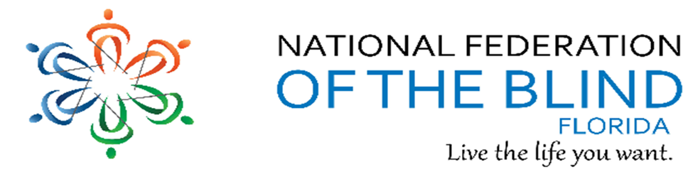BREAKING NEWSLETTER
Issue 22 November/December 2019

President’s note
Greetings Federation Family,
With the holidays upon us, I am thankful to everyone for your leadership and participation throughout the year including all the recent Meet the Blind Month activities. Every member together has made this a great time.
Hope we celebrate with our federation family and prepare in the new year for our 50th anniversary.
Together we are building the federation!
Let’s go build the Federation this fall.
Denise Valkema, President NFB OF Florida
president@nfbflorida.org
Facebook & Twitter @nfbflorida
Find us on twitter and FB @nfbflorida
We are filled with hope, energy and love by participating in the National Federation of the Blind. Every day we work together to help blind people live the lives they want.

How to navigate our newsletter with headings: To enable the quick keys on/off with JAWS use the command “insert + z”. By default, the quick keys are off in Microsoft Word. To browse through the headings of the newsletter. Make sure you have quick keys on and then press the letter “h”. This keyboard command will move from heading to heading on the document. When you find the title of the heading you would like to read, you can use the “insert +down arrow” or the “insert +numbpad2”.

What’s in this Newsletter
Contents
President’s note 1
What’s in this Newsletter 2
Birthdays & Celebrations 2
Calendar of Meetings and Events 3
Article, Announcements and Comments 4
Apple Tips and Tricks 6
Link City 7
Inspiration Corner 7
Legislative Updates from the desk of Camille Tate 7
Photo Gallery 8
Chapters 10
Divisions 13
Groups and Committees: 13
NFBF Board of Director’s Information 16
Editor: Sylvia Young 17

Birthdays & Celebrations
The NFBF would like to celebrate:
Birthdays:
November:
Eleanor Curtis– Treasure Coast
Joe Hannam – Treasure Coast
Andrew Henley – Miami
Dan Hicks – Tampa Bay
Barbra Gaw – Tampa Bay
Patricia Lipovsky – State-Wide
Carol Massey – Gainesville
Joan Miles – Gainesville
Joel Pearl – Treasure Coast
Annely Rose – State-Wide
Benjamin Taylor – Miami
Loquita Walters – Miami
Noe Villeda – Tampa Bay
December:
Carol Adams - Miami
DeVane Bejarano - State-Wide
Alicia Betancourt - State-Wide
Jada Christie – Tallahassee
Roberta Cook – Treasure Coast
Melissa Cummings - Miami
Kathy Davis - Daytona Chapter
Cara Edwards – Treasure Coast
Shelia Hanks – Miami
Pearl Horne - Miami
Lloyd Mathews – Tampa Bay
Gathary McKinley - State-Wide
Connie Scheel - Miami
Merry Schoch – Tampa Bay
Ron VanGelderen - Treasure Coast
Sylvia Young – Tallahassee
Anniversaries:
Mellisa Cummings 1st Anniversary - December

Calendar of Meetings and Events
Groups, Divisions, and Committees for December 2019
December 5rd - Seniors Concerns Committee at 8 pm Phone: 712-7757031 Code: 488550 1 touch mobile: 712-775-7031,488550
December 10th - Deaf Blind Division meeting at 7 pm; Phone: 605-313-5111 Code: 305480, Touch mobile: 605-313-5111,305480
The conference calls below operate on the same number: 712.775.7031, Code 938047311# 1 touch mobile: 712-775-7031,938047311#
December 4th - Diversity and Inclusion meeting at 8:30 pm
Blind Parents are NOT meeting this month
October 14th - Diabetes Awareness at 7 pm
December 17th - Legislative committee at 8pm
December 16th - Communities of Faith at 8:30 pm
NFBF Book Club are NOT meeting this month
December 23rd - Technology Q and A at 8pm
National Important Dates:
February 10, 2020: Washington Seminar and Great Gathering-In, Washington, DC
March 26–27, 2020: Jacobus tenBroek Disability Law Symposium, Baltimore, MD

Article, Announcements and Comments
COMING SOON! New newsletter section
Next year I would like to start a new section in our newsletter to spotlight members across the state. I will be asking you to send me articles of what has inspired you to persevere in your endeavors, to succeed and/or interests, pursuits and talents you would like to share. I think this will allow us to get to know each other better, make some connections and find others with like interests. So, when you get a call or email from me, don’t go silent but embrace the challenge. Don’t worry about how to write it, I will help you edit and modify your article for best presentation. BREAKING NEWSLETTER is all about us and for us! Sylvia Young, Editor

NFB Newsline of Florida subscribers,
I wanted to let you all know about an exciting update to the NFB Newsline Florida Information Channel.
A new article has just been added to the Florida Information Channel, (FIC), and I hope that the information found there will be helpful to you, brand new to the FIC is the NFB of Florida Calendar of Events section which contains the monthly telephone conference calls listing. By accessing this article, you can hear a summary of all of the Affiliate’s open conference calls for the month, for example if you are wondering when the Book Club or the Legislative Committee meet. you can find that info in the article, along with the call-in phone number and the access code.
We hope that by providing this information in a new format, you will find it a little bit easier to keep track of when a call takes place for a division, committee or group, and what the phone numbers and access codes are.
When calling NFB Newsline, just follow the prompts to, "your state’s information channel", then select the "Florida Information Channel". Once there select item #22.
If you are one of our many call hosts, please keep me updated about any changes to your normal call schedule, or if you would like a little extra description added to your calls info.
If anyone reading this email has questions about their NFB Newsline account, or if you would like to sign up for NFB Newsline, we welcome your calls or emails. Your NFB Newsline team can be reached by calling 1-844-827-7371 or by emailing us at newslinesupport@nfbflorida.org
Russel Davis, Chair

Open House Gathering Calls
The National Federation of the Blind invites blind people to learn more about being a member and the benefits. Take advantage of this opportunity to hear from active members and leaders on the myths and uncertainties of the Federation. We will discuss membership, philosophy, and purpose.
Our NEXT one-hour-long open house gathering call is scheduled for December 15, 2019 at 4:00 p.m. EST.
Sign up by emailing membership@nfb.org or calling 410-659-9314, extension 2509.

Mattel Releases a Braille Uno Deck
The makers of Uno just made playing your next game with your friends and family who are blind or visually impaired easier – and more fun! In collaboration with the National Federation for the Blind, Mattel introduced Uno – Braille edition playing cards in October. Each card in the deck has braille on the corner and the company envisions players calling out the card as it is played. In addition, Braille instructions are included with the packaging or the company has given users the option of having Alexa or google Home read the instructions aloud. “We are proud to have UNO Braille on-shelves and to be making UNO more accessible and inclusive to even more families,” Ray Adler, global lead of Mattel games, said in the news release about the new accessible deck.

Apple Tips and Tricks
Apple Tips and Tricks
By Camille Tate
The Vertical Scroll Bar
So, those of us who have downloaded and are navigating the IOS 13 update, may have noticed a scroll bar on the screen. What is this? I realized while in one of the apps I use, that I could scroll through the multiple pages more easily than a three-finger swipe. For example, I use Bite Squad or PostMates to order a meal. The constant three finger swipe up and down often felt like it took forever. Now, with the scroll bar, I can scroll either by 8 or 10%. What that means is I can move through the menu faster, especially since I know it may take six or seven three finger swipes to reach the type of food I’m looking for.
When you open an app, the scroll bar is at 100%, which is usually the first page. As you scroll down, the percentage of all the pages decreases. At 0% you should be at the bottom of all the screens or the last page of the app. Here’s what you do:
• Place your finger (only one) on the scroll bar (on the far left or far right of the screen). You will hear “Vertical scroll bar” and a number (like 100%).
• Swipe up once. This will move the screen down by a percentage (usually 10%). You will then hear what percentage of the app you scrolled down (for example, 90%).
• At this point, you can flick the screen to see where you are in the app or slide your finger down the screen, whichever method you prefer.
• If you are not where you want to be, you can repeat the steps until you find what you are looking for.
While there are issues for many with the IOS 13 update, not all the news is bad. If you have any ideas for Apple Tips and Tricks, please send them to ctate2076@att.net. All contributors will be given attribution for any information they share.

Link City
Here are some important links that may be of interest.
NFB: https://nfb.org/
NFBF: http://nfbflorida.org/
Nation's Blind Podcast – November 27, 2019 – National Guide Dog Month: https://www.nfb.org/sites/www.nfb.org/files/audio/nations-blind-podcast/nations_blind_podcast_november_2019.mp3
Presidential release - #488, November 2019: https://www.nfb.org/images/nfb/audio/podcast/presidential-releases-en/2019_11_english.mp3
Braille Monitor – November: https://www.nfb.org/images/nfb/publications/bm/bm19/bm1910/bm1910tc.htm

Inspiration Corner
“God's dream is that you and I and all of us will realize that we are family, that we are made for togetherness, for goodness, and for compassion.”
-Desmond Tutu

Legislative Updates from the desk of Camille Tate
Legislative Committee
From the desk of Camille Tate
As 2019 comes to a close, we reflect on our pursuits, both nationally and statewide. As we look towards 2020, we await what the future holds. In February 2020, we will make our annual visit as an organization to Washington, D.C., to shake the halls of Congress. When those priorities are released, we will send them out so our collective voices can be heard, all the way from Florida. As we trek with our brothers and sisters in blindness to our nation’s capital, we will request those who could not join us to tie up the switchboard at the Capitol to support us all during Washington Seminar. However, as we move forward, we do not and will not forget those initiatives begun in 2019. We will not stop until our priorities have been successful. Here are the priorities we are and will continue to work on.
National:
• Access Technology Affordability Act (ATAA), H.R.2086, S.815: A refundable tax credit of up to $2000, to be used over a three-year period.
• Transformation to Competitive Employment Act (TCEA), H.R.873, S.260: Phase out of the 14© sub-minimum wage employment practice.
• Greater Accessibility and Independence Through Non-Visual Access Technology (GAIN), H.R.3929: Making home use medical equipment, exercise machines and home appliances accessible to the blind.
State:
• Protecting the Rights of Blind Parents: A long time priority of the National Federation of the Blind is to protect our blind parents and their custodial rights to raise their children.
• Support for the TCEA: As a statewide initiative to end the issuance of 14© certificates in Florida.
• Presumption of Braille into the Florida Statutes: To bring braille back into our Florida Statutes so our blind children will be taught To make Braille the presumed reding material for all blind students. Literacy is key to productivity and employability.
We will continue to work on these priorities and more as they are identified. Legislation may take weeks, months, years or decades to be passed, but we will be there at every step!
The Legislative Committee has formed a State Legislation Sub-committee. It takes the power of our collective voice to effect change. Florida is one of the larger states in terms of the State House and Senate. There are 120 House Districts and 40 Senate Districts. Come and join! Florida also has 27 Federal Districts and 2 Senators. Come and join!
We invite our members to join our legislative calls and participate in our Legislative Committee. The committee meets the third Tuesday of the month at 8 p.m., by calling 712-775-7031, access code: 938047311. Keep a lookout on our list serv as meeting notices will be posted approximately one week prior to each meeting and again within two days before. As you contact your legislators, please keep the co-chairs of our Legislative Committee apprised of your efforts. This helps keep the process efficient and lets us know who we need to follow-up with on each piece of legislation.
Co-Chairs Contact Info:
Merry Schoch. merrys@verizon.net, 813-625-1850
Camille Tate, Ctate2076@att.net, 321-372-4899

Photo Gallery
Jacksonville Chapter Vision Expo
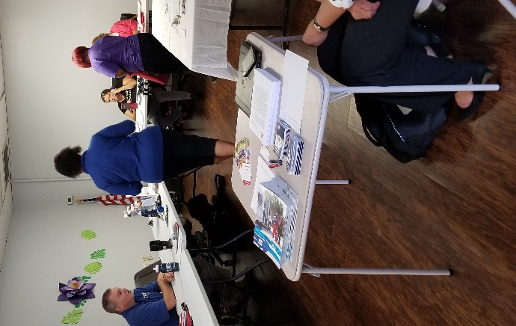
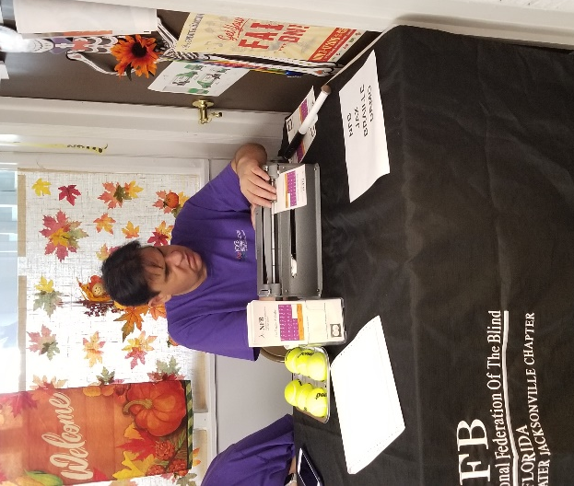

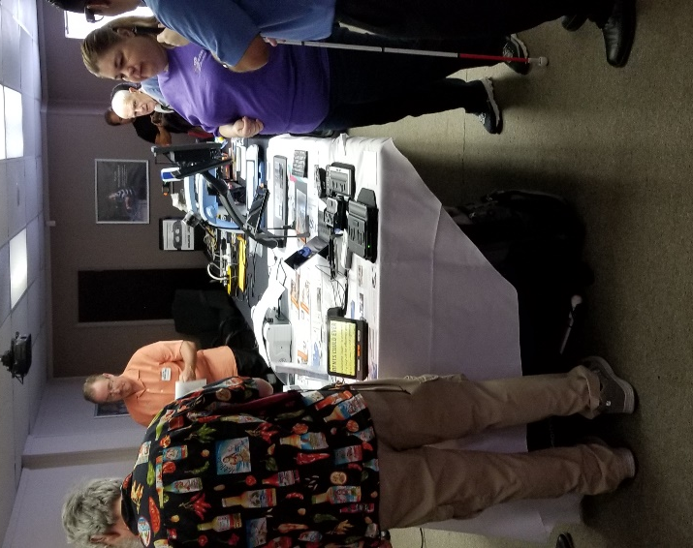
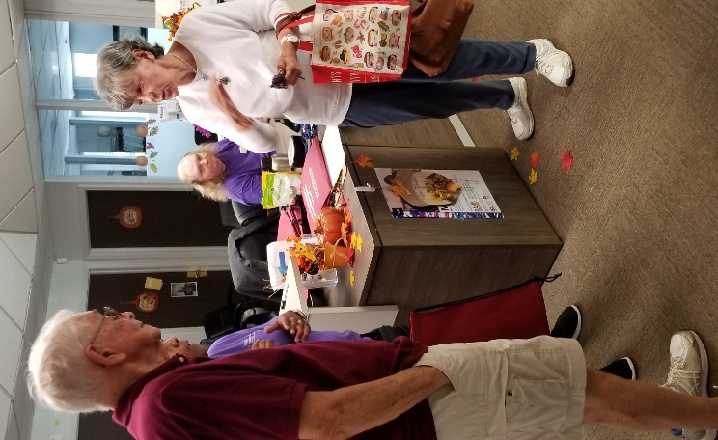

Tallahassee Chapter White Cane Walk, joined by several other local group, over 100 strong participants
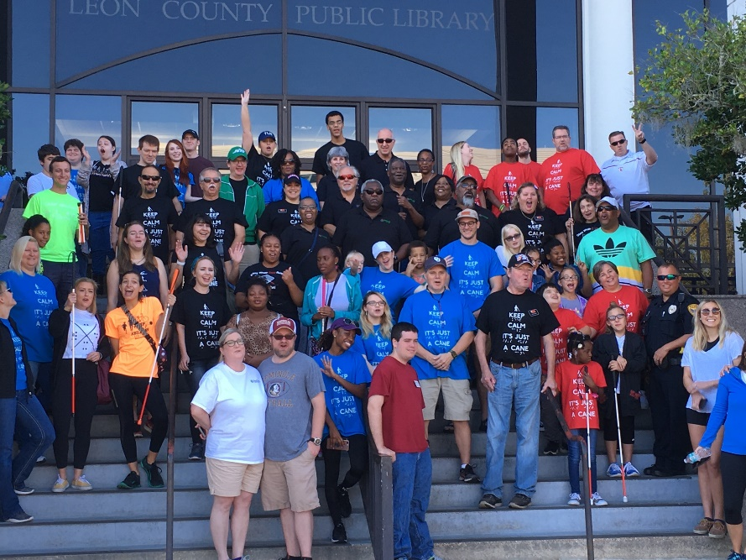
Tallahassee chapter members only
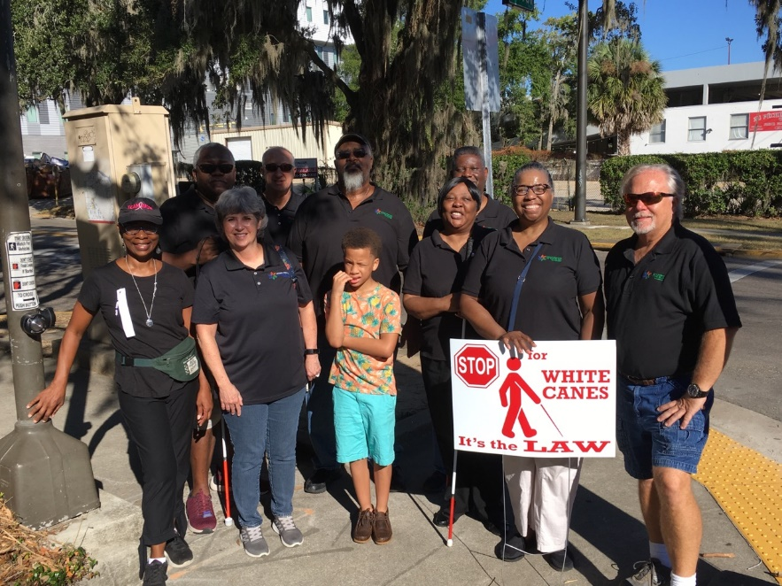

Chapters
Greater Broward Chapter: Jake McEntyre, President, Phone: 954-946-4148, Email: jmac1920@yahoo.com. Meetings are held the 2nd Saturday of each month at the Westfield Broward Mall located at 8000W. Broward Blvd. Plantation, Florida 33312 from 10:30 a.m. until 12:30 p.m. meetings take place inside the Plantation Police Outreach Center, just inside the north entrance to the mall.

Central Florida Chapter: Toni Moore, President, Phone: 850-321-6421. Email: claviet@gmail.com Meetings are held the third Saturday of each month from 11 A.M. to 1 PM at Lighthouse Central Florida, 215 East New Hampshire Street Orlando, Florida 32804. Please like us on Facebook at: https://www.facebook.com/groups/410985858949160.

Greater Daytona Beach Chapter: Brian Norton, President, Phone: 386-871-3359 Email: brian.edward.norton@outlook.com. Meetings are held the fourth Saturday of the month from 1:00 till 3:00pm at Houligans Speedway restaurant, 1725 International Speedway Blvd. Daytona Beach, Florida. Follow Us on Facebook: www.facebook.com/nfbdaytona

Gainesville Chapter: Judith Hamilton, President; Phone: 352-373-7806, Email: gainesville_nfb@earthlink.net. Gainesville Chapter meets monthly with site or conference call to be determined. Please contact chapter president for meeting information. Together we can plan and participate to build the Federation in Gainesville. Judy Hamilton and Kathy Roskos participated in a disability awareness event at Santa Fe College campus October 23, 2019. We would like to thank the Santa Fe Disability Resource Center for letting us share a table and bring awareness of the National Federation of the Blind to campus. Our chapter was represented in the city of Alachua, Florida at a community White Cane Safety Walk October 12, 2019 hosted by the Alachua Lions Club chapter. November 11, 2019 the Gainesville chapter had a social gathering at Applebee's. On a sad note, Kathy and David Roskos said good-bye to Kathy's retired guide dog, Windy who crossed the Rainbow Bridge. Windy lived a long, productive life of service.

Greater Jacksonville Chapter: Andy Rood, President; radiorexandy@gmail.comm, (904) 844-1449. Meetings are held the first Saturday of each month and take place at the Independent Living Resource Center, 2709 Art Museum Drive, Jacksonville, Florida 32207 from 10:00 AM until 12 Noon. Please join us if you are in the area. Welcome aboard New President Rood!

Melbourne - Space Coast Chapter: Camille Tate, President; Phone: 321-372-4899; Email: ctate20176@att.net. Facebook: www.facebook.com/nfbmelbourne. We meet on the second Saturday at The Fountains, 4451 Stack Blvd., Melbourne, FL, 32901. Contact Camille Tate, President, for more information.

Greater Miami Dade Chapter Jorge Hernandez – President; Phone: 305-877-2311; Email: jeh1065@comcast.net. Our meetings are held on the third Thursday of each month at Denny's Restaurant located at 5825 N.W. 36 Street Miami, FL 33166 from 7:00 p.m. until 8:30 p.m.

Palm Beach Chapter: Tekesha Saffold, President; 561-707-4799; Email: tnsaffold82@gmail.com. Meetings are held the Second Saturday of each month at IHOP at 1503 Belvedere Road, West Palm Beach, Florida from 10 am until noon.

Polk Chapter: Joe King, President: Phone: 863-293-5648; Email: joenkitty@earthlink.net. Our meetings are held the second Saturday of the month at Perkins Pancake House and Bakery located at 6005 Cypress Garden Blvd. Winter Haven, FL 33884 from 10:00 AM-12:00 Noon.

Florida State-Wide Chapter: Paul Martinez, President; Phone: 813-390-5720; Email: nfbf.statewide@gmail.com. Meetings are held the Third Sunday of each month at 8 pm (Eastern Time) via conference call using the following number: 605-475-4700 using the access code 800550#.

Tallahassee Chapter: Jada Christie, President; Phone: 850-766-9378 Email: emeraldpink15@gmail.com. The Tallahassee Chapter recognizes it Veterans. We honor Doug Ingram, Lynn Jones, John Matejka, Mary Matejka, and James Young for their proud service to our country. Doug also serves as the First Vice President of the National Association of Blind Veterans. Thank you and happy Veterans’ day!!! In lieu of our November meeting, the Tallahassee chapter dined together at BJ’s Brewery and Restaurant on Saturday, November 9th. The luncheon served as the kickoff to the holiday season. We would like to extend holiday greetings to our NFBF Family. Happy holidays! We meet the first Monday of each month from 6:30-8:00 p.m., at the Lighthouse of the Big Bend located at 3071 Highland Oaks Terrace, Tallahassee, FL 32301.

Tampa Chapter: Miranda Kilby, President; Phone: 352-942-0417; Email: NFBF.Tampa@gmail.com. Join us on the fourth Saturday of each month, from 12 Noon to 2:00 PM at Beef O Brady's located at 8810 North Himes Avenue, Tampa, FL 33614. The chapter is busy planning a BELL (Braille Enrichment for Literacy and Learning) program. We are looking at holding the program June 17th through the 28th.

Treasure Coast Chapter: Tamika Butts, President; 772-708-3749, E-mail: tamika_butts@gmail.com. We will resume our monthly meetings September 14th. Meetings are held on the 2nd Saturday of each month from 10am - 12:00 Noon at WQCS Radio Station located @ IRSC, 3209 Virginia Avenue, Fort Pierce.

Divisions
Deaf-Blind Division: The Division meets on the second Tuesday of the month. Keep an eye on the Florida List and Save the Date calendar for meeting notices and announcements. President: Brian Norton.

Florida Association of Guide Dog Users (FLAGDU): Merry Schoch, President, Phone: 813-625-1850, Email: flagdu@nfbflorida.org

Florida Organization of Parents of Blind Children (FOPBC): Cherice Togun, President; 407-257-7637; chericeflemingtogun@hotmail.com. Contact the President for meeting date and time.

Groups and Committees:
Blind Parents Connect - NFB of Florida: Nicole Fincham-Shehan – Coordinator, Phone: Cell 410-493-4461; Email: ndfinchamshehan@yahoo.com. Meeting Date: 2nd Tuesday of each month at 9pm via conference call using the following telephone number and access code: 712-775-7031,938047311#. If anyone has any questions or concerns, please feel free to contact me on my cell number.

F.A.B.S. - Florida Association of Blind Students: Rafael Fernandez, Phone: 305- 903-6299, Email: rafael.fernandez0617@gmail.com. Call Rafael information and details.

Communication Committee: We have been busy proofing items for members, sending out a calendar outline to help us all stay organize, and growing slowly on our social media platforms. Dan has sent out an email regarding our 50th anniversary project and hopefully submissions will start rolling in. We encourage everyone to submit something towards this project. We are trying to wrap up our PSA project, so if you have not recorded the 1-minute message, please do so soon.

Communities of Faith Group: We meet on the second Monday of each month at 8:00 P.M. Our group is continually growing, and all are welcome. If you are interest in joining us in this uplifting and comforting committee, call 712-775-7031, Code 938047311# or 1 touch mobile: 712-775-7031,938047311# Marilyn Baldwin Chair or Kathy Davis co-chair.

Community Service: Tekesha Saffold – Chair, Phone: (561) 707-4799, Email: tnsaffold82@gmail.com. Meetings are held the first Tuesday of each month at 8 pm via conference call using the following telephone number and access code: 712-775-7031,938047311#.

Diabetics Group: Lauren Blum, Telephone: 352-584-0795, Email: laurenblum79@gmail.com. Meetings are held the second Monday of each month at 7pm via conference call using the following telephone number and access code: 712- 775-7031,938047311#. The Diabetic Awareness Group held their meeting on January14th and had a lively discussion on what constitutes as a carbohydrate.

Diversity and Inclusion: The Committee meets on the first Wednesday of the month, at 8:30 p.m. The committee uses 712-775-7031 and access code 938047311. Keep an eye on the Florida List and Save the Date calendar for meeting notices and announcements. Chair: Marilyn Baldwin.

Fundraising Committee: Paul Martinez – Chair, 11903 Rose Harbor Drive Apt: 113, Tampa, Florida 33625, Phone: 813-390-5720, Email: fundraising@nfbflorida.org

Legislative Committee: The Legislative Committee meets on the third Tuesday of the month, at 8 p.m. The call-in information is: Call in number: 712-775-7031 and access code: 938047311. Keep an eye on the Florida List or Save the Date calendar for meeting notices and announcements. Co-chairs: Camille Tate and Merry Schoch.

NFBF Book Club: The Book Club Discussion Group meets on the fourth Thursday of the month, at 8 p.m. the call information is 712-775-7031 and the access code is 938047311. Coordinator: Camille Tate

NFB411: Our next NFB411 Call To be announced.

Newsline: Russ Davis, Chairperson. 844-827-7371, newslinesupport@nfbflorida.org

President and Vice President Committee: We would like to know what you all would like to discuss next. We are stronger together, when we work together! Call in number: 712-775-7031, access code: 938047311.

Senior Concerns Committee: Gloria Mills-Hicks, Chairman; Phone: 813-340-9754; Email: Glorianfb@irescuetax.com. Meetings are held the First Thursday of each month at 8pm via conference call using the following telephone number and access code: 712-775-7031,938047311#.

Technology Q and A: Rafael Fernandez – Chair; Email: rafael.fernandez0617@gmail.com. Meetings are held monthly on the fourth Monday at 8:00 pm via conference call using the following telephone number and access code: 712-775-7031,938047311#.

The National Association of Blind Veterans: "BLIND VETS SERVING BLIND VETS" Dr. Vernon Humphrey, President; The National Association of Blind Veterans, PO Box 784957, Winter Garden, Florida 34778; Email mr_president@nabv.org, Phone: 706-329-7690

NFBF Board of Director’s Information
Please contact any of the board with questions, comments, concerns or for general information.
Denise Valkema -President
Phone: 305-972-8529
Email: president@nfbflorida.org

Paul Martinez - 1st Vice President
Phone: 813- 390-5720
Email: paul09ms@gmail.com

Miranda Kilby – 2nd Vice President
Phone: 352- 942-0417
Email: mbkilby@gmail.com

Sylvia Young-Secretary
Phone: 850- 322-5937
Email: secretary@nfbflorida.org

Merry Schoch –Treasurer
Phone: 813-523-6573
Email: merrys@verizon.net

Board Members:
Lauren Blum
Phone: 352-584-0795
Email: laurenblum79@gmail.com

Jorge Hernandez
Phone: 305-877-2311
Email: jdh6@bellsouth.net

Camille Tate
Phone: 321-372-4899
Email: ctate2076@att.net

Rafael Fernandez
Phone: 305-903-6299
Email: rafael.fernandez0617@gmail.com

Editor: Sylvia Young
To have something posted in the NFBF Newsletter please submit it to the editor, Sylvia young at secretary@nfbflorida.org by the 15th of each odd month.

