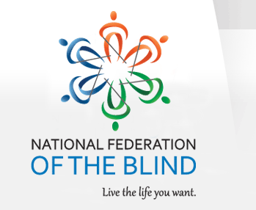

NATIONAL FEDERATION OF THE BLIND OF FLORIDA Scholarship ANNOUNCEMENT

The National Federation of the Blind of Florida (NFBF) is now accepting student scholarship applications for 2020. Recipients will receive their scholarships at the 2020 NFBF state convention scheduled for the Memorial Day Weekend, Friday, May 22nd through Monday, May 25th in Tampa, Florida.
Qualified high school seniors and college students must complete the NFBF scholarship application form in MS word format, write a 500 word essay, provide two letters of recommendation, and submit their academic transcripts. All documentation must be return to:

Merry Schoch, Chair
NFBF Scholarship Committee
Email: scholarships@nfbflorida.org
Cell Phone: (813) 625-1850

The National Federation of the Blind of Florida will be awarding several scholarships, each in the amount of $1,500 at the National Federation of the Blind of florida annual convention banquet on Sunday evening, May 24, 2020.

To qualify students must:

- Be legally blind
- Submit a completed application along with all documentation required
- Attend the entire state convention with assigned mentors

In addition, all scholarship applicants must provide academic transcripts and complete all components of the scholarship form. Scholarship recipients will have their ground transportation, convention registration, banquet fees, and hotel room covered by the NFB of Florida. Completed applications are due no later than April 17, 2020 at 11:59 p.m.
We have also provided a checklist with the documents that are needed for a completed application for your convenience.

