Building the Lives We Want
Building the Lives We Want is an ebook that traces the history of the blindness movement from its dawn in the nineteenth century through the founding of the National Federation of the Blind and beyond.
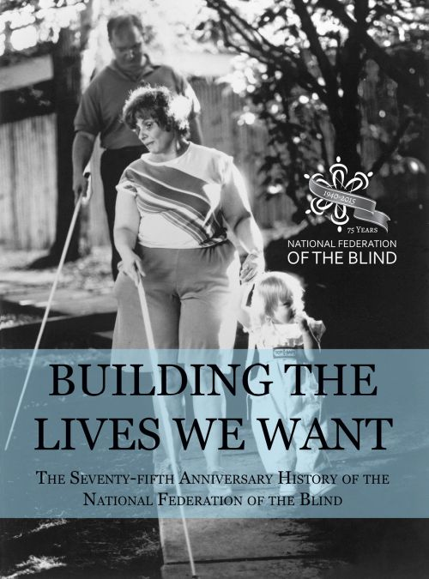It was released in part to commemorate the NFB's seventy-fifth anniversary in 2015.
The story includes the first efforts at grassroots organizing and the emergence of the NFB as an instrument of change. The book also portrays Federationists working tirelessly for access to education, employment, and equal rights, and demonstrates how, through seventy-five years of collective action, blind people are finding the freedom to build the lives we want.

Download the eBook
- Building the Lives We Want (epub format for iBooks, Voice Dream Reader, hardware book readers for the blind, and other epub capable readers)
- Building the Lives We Want (mobi format for Amazon Kindle)
- Building the Lives We Want (zipped HTML format for reading on your computer)
- Quantum Blindness (hear Mrs. Jernigan read her foreword)

How to Read the eBook

iOS Devices
- Open the epub file in the Safari web browser and tap the link for the epub file.
- When the ebook loads, you will see buttons to "Open In" and "Open in iBooks."
- Tap "Open in iBooks" to load the ebook into the preloaded iBooks reader.
- Tap "Open In" to import the ebook into other epub readers such as Voice Dream.

Hardware (Digital Talking Book Players)
- With this page open on your computer, activate the link for the epub file.
- When prompted, save the file somewhere you can find it on your computer (you will need to copy the epub file from where you saved it to the player's memory.
- Save the file in the appropriate folder on your player (depending on your device, there may be a specific folder to save the file in).
- Note that this ebook cannot be played on the players distributed to patrons by the National Library Service for the Blind and Physically Handicapped.

Computers
- You can download a free copy of Adobe Digital Editions, an accessible book reader for Windows and Mac computers which will read epub files through your screen access program's voice. If, when you activate the link for the epub file above, it does not automatically open in Adobe Digital Editions, save the file somewhere you can find it on your computer, then use the "Add to Library" item in Digital Editions' file menu to navigate to the book and add it to the program's library. Once added, use your arrow keys to navigate to the book and press "Enter" to open it.
- You may download the zipped HTML version of the book and save it to your computer. Once downloaded, create a new folder and extract (i.e., copy) the files from the zip file into the new folder. In the new folder, open "building-the-lives-we-want.html." The book will then open in your web browser. Use the Table of Contents or the "Next" and "Previous" page links to move between book sections.

Amazon Kindle App
- Open this page in a web browser on the device with the Kindle Reader.
- Activate the link for the mobi file.
- If prompted, instruct your device to open the file in Kindle.

