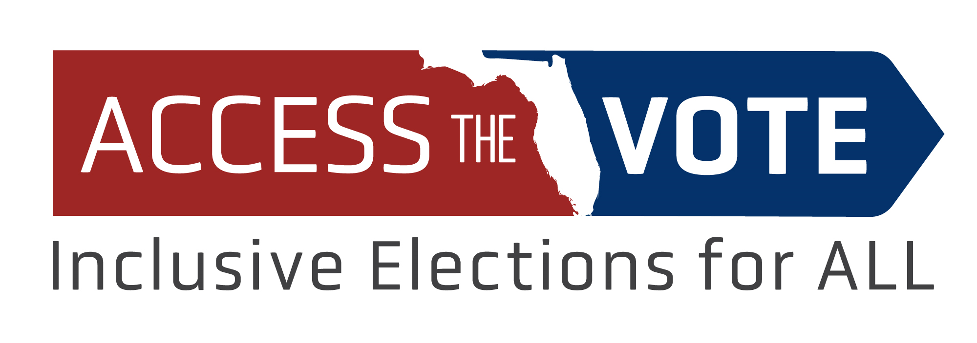
ATVFL holds first Elections Accessibility Summit to challenge accessibility myths and educate

FOR IMMEDIATE RELEASE
Sept. 30, 2020

Contact: Robin Kocher, DRF Director of Communications
Phone: 850.617.9762

Tallahassee, FL – Access the Vote Florida (ATVFL), a state-wide nonpartisan coalition aimed at increasing political participation of disability communities while also engaging candidates and the media on disability issues, will hold its first virtual Elections Accessibility Summit Tues., Oct. 6 from 9am-1pm.

The interactive summit features state and national speakers including the supervisors of elections from Volusia, Orange, Sarasota and Leon counties, as well as representatives from the American Association of People with Disabilities (AAPD), Democracy Live voter information technologies, All Voting is Local, and the National Disability Rights Network.

Panels include state-wide experts presenting best practices in website accessibility, as well as the president of Democracy Live along with the supervisors of elections from Volusia and Orange counties discussing how advance electronic voting works, how other Florida counties can implement it, and how voters can request an accessible ballot. In addition, there will be demonstrations of accessible voting equipment available in Florida by the supervisors of elections in Volusia, Sarasota, and Leon counties, and the final panel will feature a lively examination of the importance of election security versus the need for unassisted and accessible voting for persons with disabilities.

Registration for the 2020 Elections Accessibility Summit is limited to 100 Zoom viewers but will also be simulcast live on Access the Vote Florida’s Facebook page. Or, visit our website for more information.

The 2020 Elections Accessibility Summit schedule:
9-9:30 a.m.: Summit Kickoff – Keri Gray, senior director of stakeholder engagement and strategic communications at AAPD.
9:30-10:15 a.m.: Website Accessibility Panel – Molly Broadway, voting rights specialist, Disability Rights Texas; and Keith Casebonne, technology and communications manager at Disability Rights Florida.
10:15-10:20 a.m.: Vote for Access video
10:20-11:05 a.m.: Democracy Live Panel – Brian Finney, president of Democracy Live; Lisa Lewis, Volusia County Supervisor of Elections; Bill Cowles, Orange County Supervisor of Elections.
11:05-11:10 a.m.: Vote for Access video
11:10-11:55 a.m. Voting Equipment Demonstrations – ExpressVote, Lisa Lewis, Volusia County supervisor of elections; Automark, Marty Gueli and Joanne Gonet, Sarasota County Supervisor of Elections Office; ImageCast (pre-recorded video provided by the Leon County Supervisor of Elections Office), Adam Gaffney from Division of Blind Services will answer questions about ImageCast.
11:55 a.m.-12 p.m.: Vote for Access video
12-1 p.m.: Election Security and Accessibility – Panel Moderator Brad Ashwell, Florida state director, All Voting is Local; Panelists: Michelle Bishop, voter access and engagement manager at National Disability Rights Network; Dan McCrea, Florida director at Verified Voting.

-30 -

Access the Vote Florida (ATVFL) is a state-level nonpartisan coalition affiliated with the national REV UP! Campaign that is coordinated by the American Association of People with Disabilities (AAPD). REV UP! stands for Register, Educate, Vote, Use you Power! The coalition is made up of nine disability-related organizations and its aim is to increase the political participation of disability communities while also engaging candidates and the media on disability issues.

