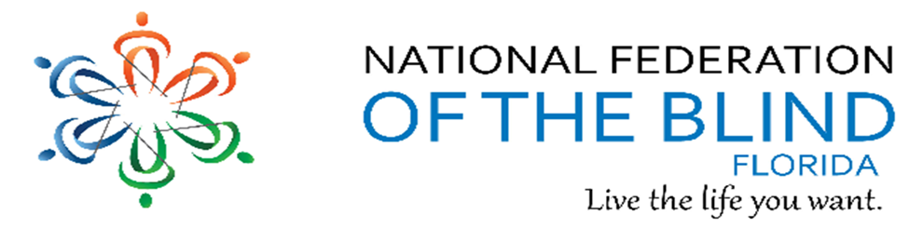BREAKING NEWSLETTER
Issue 30 March/April 2021

President’s note
Greetings Federation Family,
Let’s get registered for our virtual 2021 NFB National Convention, July 6th -11th, by May 31, 2021. More information will be shared during the next few months. We an all attend from anywhere.
Denise Valkema, President NFB OF Florida
president@nfbflorida.org
Facebook & Twitter @nfbflorida
Find us on twitter and FB @nfbflorida
We are filled with hope, energy and love by participating in the National Federation of the Blind. Every day we work together to help blind people live the lives they want.

How to navigate our newsletter with headings:

To enable the quick keys on/off with JAWS use the command “insert + z”. By default, the quick keys are off in Microsoft Word. To browse through the headings of the newsletter. Make sure you have quick keys on and then press the letter “h”. This keyboard command will move from heading to heading on the document. When you find the title of the heading you would like to read, you can use the “insert +down arrow” or the “insert +numbpad2”.

What’s in this Newsletter
Contents
President’s note 1
How to navigate our newsletter with headings: 2
To enable the quick keys on/off with JAWS use the command “insert + z”. By default, the quick keys are off in Microsoft Word. To browse through the headings of the newsletter. Make sure you have quick keys on and then press the letter “h”. This keyboard command will move from heading to heading on the document. When you find the title of the heading you would like to read, you can use the “insert +down arrow” or the “insert +numbpad2”. 2
What’s in this Newsletter 2
Birthdays & Celebrations 3
Important Calendar Events 4
Article, Announcements and Comments 5
Apple Tips and Tricks 6
Laugh it up! 6
Member Spotlight 6
Recipe Conner 7
Health and Wellness 8
Link City 9
Inspiration Corner 9
Legislative Updates from the desk of Camille Tate 9
Photo Gallery 12
Chapters 13
Divisions 14
Groups and Committees: 15
NFBF Board of Director’s Information 17
Editor: Sylvia Young 18

Birthdays & Celebrations
The NFBF would like to celebrate:
Birthdays:
March:
Emily McGowan – Melbourne Space Coast
John Matejka - Tallahassee
Camille Tate - Melbourne Space Coast
Denise Woodard – Melbourne Space Coast
Christina Moore - Treasure Coast
Don Whitehouse - Treasure Coast
Ron Whittum - Treasure Coast

April:
Marie Bochicchio – Melbourne Space Coast
Miranda Kilby – Tampa Bay
Paul Lewis – State-Wide
Angela Pang – Miami

Anniversaries:
John and Mary Matejka - Tallahassee - March
Jeff Davis and Lisa Davis – Tallahassee - April

Important Calendar Events

Our 2021 National Convention will be held virtually again this year, July 6 through July 11, 2021 Everywhere USA.
Our 2021 State convention will be held the 1st weekend in October. If we are able, we will meet in person in Tampa at the Embassy Suites at University of South Florida. If not, we will meet virtually everywhere USA. Make plans to be there.

Monthly Calendar Meetings
1st Wednesday-Diversity & Inclusion
1st Thursday - seniors @ 8pm
2nd & 4th Thursday-Sunrise & Shine with NFB Newsline @ 9am
3rd Sunday FABS @ 6pm
3rd Monday- Communities of Faith @ 8pm
3rd Tuesday- book club @ 8pm
3rd Wednesday - blind parents @ 8:30
4th Thursday - legislation @ 8pm

Article, Announcements and Comments
In Memory of:
Tamika Butts – Treasure Coast Chapter
Bill Langdon – Polk Chapter
Carol Feazell – Jacksonville Chapter
In times of darkness, love sees.
In times of silence, love hears.
In times of doubt, love hopes
Intime of sorrow, love heals.
And in all times, love remembers.

HAPPY NEWS:
Sylvia and James Young greets their welcomed their 14th grandchild on Monday March 29th. Her name is Layla Marie and weighted 5 pounds 7 ounces. See her picture in the photo gallery.

Apple Tips and Tricks
Apple Tips and Tricks
By Camille Tate
COME BACK NEXT ISSUE

Laugh it up!
Laughter is the best medicine. Take as much as you like, several times a day.
Not to brag, but I defeated our local chess champion yesterday in less than 5 moves.
Finally, my high school karate classes came in useful.

Dad can you explain to me what a solar eclipse is
No sun.

My wife beamed at me with pride and said, “Wow! I never thought our son would go that far! “
I said, “This catapult is amazing! Go get our daughter.”

Member Spotlight
Member Spotlight – Broward Chapter
This issue’s spotlight shines on a couple from the Broward Chapter. Bruce and Linda Drinkuth work as a team in their chapter doing whatever is needed and asked of them. They are always willing to do whatever it takes to make things pleasant and welcoming for their members, whether it is getting coffee or waiting with members after meetings for their rides. They also provide rides when needed for appointments.
Bruce is originally from Springfield NJ and loves walking and gardening. Linda is from Indianapolis IN and loves reading and rocking in her rocking chair. They have 2 adult children and 5 grands.
After volunteering their assistance for several years, they were inspired by Debbie and Tom Ryan to become members about 4 or 5 years ago. When asked why they joined, they said they were impressed with the tireless efforts of the Ryans as they assisted blind people in their area “Live the lives they want!”

Recipe Conner
Submitted by Kaye Baker
When I think of Easter, or any holiday, I think of all the great food that is usually enjoyed during that special day. With Easter right around the corner, I look forward to a delicious ham and all the fixins. Here is a recipe that has been a hit at every holiday I have ever cooked for, and what is Easter without dressing?
Grandma’s Cornbread Dressing
1 (16 ounce) package dry corn bread mix
2 tablespoons butter
1/2 cup chopped celery
Celery Hearts
1 small onion
2 eggs, beaten
2 cups chicken stock
2 tablespoons dried sage
salt and pepper to taste
Directions:
Prep - 45 m
Cook - 30 m
Ready In - 1 h 15 m
1 Prepare the dry corn bread mix according to package directions. Cool and crumble.
2 Preheat oven to 350 degrees F (175 degrees C). Grease one 9x13 inch baking dish.
3 In a large skillet over medium heat, melt the butter and saute the celery and onion until soft.
4 In a large bowl, combine the celery, onions, 3 cups crumbled corn bread, eggs, chicken stock, sage and salt and pepper to taste. Mix well.
5 Place into prepared dish and bake at 350 degrees F (175 degrees C) for 30 minutes.

Health and Wellness
Tooth Health
Sweets and treats are tempting but don’t forget about keeping your teeth healthy. Good dental habits will help you keep your teeth longer and stronger. While the easy access to sweet treats can be irresistible, there are ways to keep our teeth and gums healthy.
Some treats are better than others: Sweet treats that are loaded with sugar can create plaque and wear down the protective enamel on your teeth. When it comes to the health of your teeth and gums, learn which treats can be enjoyed in moderation and which treats should be avoided.
The Good
These treats satisfy your sweet tooth while reducing excess sugar and damage to your teeth’s enamel:
Salty treats like pretzels and popcorn that do not leave sugar behind
Sugar-free gum and lollipops
Dark chocolate, which contains less sugar than milk chocolate
Candy bars containing nuts; the nuts help scrape the sugar off your teeth
Chocolate-covered fruit
The Bad
Try to avoid these treats that can play unwelcome tricks on your teeth:
Sticky candies: the stickier the treat (think taffy, caramels, gummies) the longer it sticks around in your teeth, increasing the risk of tooth decay
Hard candy like jawbreakers, which can chip or break your teeth
Sour candies, which contain a high amount of acid that can harm tooth enamel and increase the risk of cavities
Tricks for keeping teeth and gums healthy
Eat candy with meals, since saliva production increases when eating meals, helping to rinse away sticky food particles
Focus on moderation versus deprivation
Brush and floss soon after eating treats
Be sure to visit the dentist twice a year for a routine check-up and cleaning to help keep your teeth and gums in tip-top shape.

Link City
Here are some important links that may be of interest.
NFB: https://nfb.org/
NFBF: http://nfbflorida.org/
Braille Monitor – April 2021 https://nfb.org//images/nfb/publications/bm/bm21/bm2104/bm2104tc.htm
Presidential Release: April 5, 2021 - #504 https://nfb.org/sites/nfb.org/files/2021-04/pr504_short_version_final_0.mp3

Nation's Blind Podcast – March 18, 2021 – A Conversation with the National Federation of the Blind Survivor Task Force
https://nfb.org/sites/nfb.org/files/2021-03/A%20Conversation%20with%20the%20NFB%20Survivor%20Task%20Force.mp3

Inspiration Corner
“Dream as if you'll live forever. Live as if you'll die today.”
By James Dean

Legislative Updates from the desk of Camille Tate
Legislative Committee
From the desk of Camille Tate
Florida is moving full steam ahead following a successful Washington Seminar! As of Thursday, March 25th, Florida can proudly say we have six co-sponsors for the Access Technology Affordability Act (H.R.431/S.212). We have a commitment from the office of a seventh co-sponsor, but it has not officially populated on Congress.gov. Go Team Florida! I can report that we had participation from approximately 60 members of our affiliate. The use of the Zoom virtual platform has allowed us to do what we have never been able to before. We has representation from not only every chapter in the affiliate, but a constituent from all 27 House districts in Florida! We will keep the momentum going with follow-ups throughout the year, to try and get all 27 House members to co-sponsor our bills in Washington, D.C.
As of the writing of this article, our Advocacy and Policy Team in our National Center is working on obtaining a lead sponsor for the remaining issues this year. Those issues are: Medical Devices Non-Visual Accessibility Act; 21st Century Mobile App and Web accessibility Act; and Americans with Disabilities Voting Rights Act. We will update you as additional information becomes available.
State Legislation
We have not forgotten our state legislation. Although none of our priorities were picked up during the 2021 Legislative Session, we will not falter. The current session ends approximately May 2nd. We will re-double our efforts for the 2022 Legislative Session, which will begin in January. We have a legislative alert! The state legislature will be considering a voting bill that would impact our ability to Vote By Mail. HB7041/SB90 will change the Vote By Mail system in Florida. The bill, as currently written, will have a negative impact financially to the state and may suppress our voting rights. Essentially, this legislation will require all voters who register for mail-in ballot to request such ballot each year, instead of keeping the current process. Currently, if a person votes in at least one election per four-year cycle, their voter registration does not change (unless requested by the voter). What that means is, if you are registered to receive a mail-in ballot and voted in the 2020 General Election, your voter status remains active; you will not have to re-register or make requests to vote in 2022 or 2024. As long as you continue to vote at least once every four years, this will remain the same. Under the new legislation, you will have to request mail-in ballot each year, regardless of whether you have voted in the last four years. This would only affect Vote By Mail, which many used to vote in the 2020 election. Considering the inaccessibility of voter registration in Florida, those with a disability that affects their ability to register will be negatively affected. Some of the additional components of this bill are untenable. The legislation goes further by removing many drop boxes around the state, which impedes a person’s ability to drop off their mail-in ballot and criminalizes a person who has a friend or family member drop off their ballots. Unfortunately, voters who are transportation disadvantaged or mobility challenged will have a more difficult, if not impossible, time casting their ballot.
Many Supervisors of Elections offices are opposed to this legislation. The financial burden of administration will fall on each county’s elections office and cost millions of dollars. Under this bill the Supervisor of Elections will be required to maintain in-person surveillance of drop box locations or face fines of $25,000. Religious institutions or other entities that supply buses or other modes of transportation will not be allowed to provide such assistance to voters; this further diminishes the ability of those with transportation, mobility or other factors that keep them from the polls to be able to vote. The end result is that disabled people, groups that are already disenfranchised and the poor (all who have difficulty getting to polling precincts or voting in general) will not have full and equal access to cast their ballots.
What are we going to do as the National Federation of the Blind of Florida? There is an email template that will be circulated, asking our legislators to not support this legislation. This template can be used for a hard copy print to mail or say over the phone to your legislators. If anyone needs help using this document or finding out how to contact their state legislator, please reach out. We will be there to help.
You can go to MyFloridaHouse.gov, click on “Find my Representative” and search by typing in your address. It will pull up both your federal and state legislators, complete with all office information and ways to contact them. You may also go to Congress.gov and perform the same procedure to find those offices.

How to Get Involved
Our legislative committee is open to all. We encourage our members to participate in our legislative process. It is our voice and not just our message that can get results. You do not have to be a college graduate, have any professional certifications, or have any experience in public speaking to lend your voice to our causes.
Our legislative committee meets on the fourth Thursday of each month at 8 p.m. Keep your eyes and ears on our email list for meeting notices and all announcements. We encourage chapter presidents to have at least one chapter member attend the legislative committee meetings to bring information back to the chapter and increase participation. Please feel free to contact the committee co-chairs, whose information is listed below.
Russ Davis, 904-993-8433, russell@radiorusty.com; Merry Schoch, 813-625-1850, merrys@verizon.net; Camille Tate, 321-372-4899, Ctate2076@att.net

Photo Gallery
Layla Marie Phillips – granddaughter of James and Sylvia Young
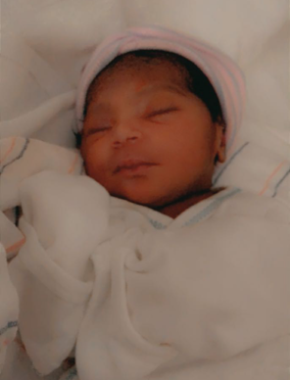

Easter picture of Paul, Miranda, and Isabella
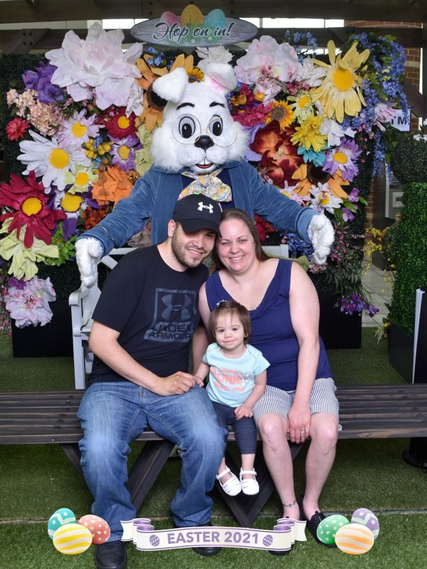

Chapters
Greater Broward Chapter: Jake McEntyre, President, Phone: 954-946-4148, Email: jmac1920@yahoo.com. Meetings are held the 2nd Saturday of each month at the Westfield Broward Mall located at 8000W. Broward Blvd. Plantation, Florida 33312 from 10:30 a.m. until 12:30 p.m. meetings take place inside the Plantation Police Outreach Center, just inside the north entrance to the mall.

Central Florida Chapter: Marilyn Baldwin, President, 407-293-0565 Home and 407-810-0554 Cell. Meetings are held the third Saturday of each month from 11 A.M. to 1 PM at Lighthouse Central Florida, 215 East New Hampshire Street Orlando, Florida 32804. Please like us on Facebook at: https://www.facebook.com/groups/410985858949160.

Greater Daytona Beach Chapter: Brian Norton, President, Phone: 386-871-3359 Email: brian.edward.norton@outlook.com. Meetings are held the fourth Saturday of the month from 1:00 till 3:00pm at Houligans Speedway restaurant, 1725 International Speedway Blvd. Daytona Beach, Florida. Follow Us on Facebook: www.facebook.com/nfbdaytona

Gainesville Chapter: Judith Hamilton, President, Phone: 352-373-7806, Email: gainesville_nfb@earthlink.net. The Gainesville Chapter has been meeting monthly by Free Conference Call due to COVID 19. We are looking forward to making more connections and serving in our community when it is safe to do so. We invite and welcome members and those interested in learning about the National Federation of the Blind. Let’s move forward to build the Federation together!

Greater Jacksonville Chapter: Kaye Baker, President, phone: (904) 580-6819, Email: nfbjax@gmail.com. Meetings are held the first Saturday of each month and normally take place at the Independent Living Resource Center, 2709 Art Museum Drive, Jacksonville, Florida 32207 from 10:00 AM until 12 Noon. Until further notice, we will be meeting on Zoom. Please email if you would like to attend our meeting.

Melbourne Space Coast Chapter: Camille Tate, President, Phone: 321-372-4899, Email: ctate20176@att.net. Facebook: www.facebook.com/nfbmelbourne. We meet on the second Saturday of each month, currently via Zoom. Please contact Camille Tate, President for ways you can join us.

Greater Miami Dade Chapter: Jorge Hernandez, President, Phone: 305-877-2311, Email: jeh6@bellsouth.net. Miami-Dade Chapter Newsletter. The chapter continues to meet virtually, and members are encouraged to participate. We are gathering the membership to practice with Zoom so we can have an exciting state convention and all of our members can participate. Our meetings are held on the third Thursday of each from 7:00 p.m. until 8:30 p.m.

Polk Chapter: Joe King President, Phone: 863-293-5648, Email: joenkitty@earthlink.net. Our meetings are held the second Saturday of the month at Perkins Pancake House and Bakery located at 6005 Cypress Garden Blvd. Winter Haven, FL 33884 from 10:00 AM-12:00 Noon.

Florida State-Wide Chapter: Paul Martinez, President; Phone: 813-390-5720; Email: nfbf.statewide@gmail.com. The Statewide Chapter meets via conference call every third Sunday of the month at 8:00 pm. The call-in phone number: 605-475-4700, Code: 800550#; 1 touch mobile: 605-475-4700, 800550# Everyone is welcome to attend. We held elections in February, here are the results: Vice President Brittany Fraer, Secretary Jerilyn Higgins, Board seat two Jannik Pesch, Board seat one Scott Wilson. Our treasurer Debbie Malone is now president of NFB Florida’s Dog Guide Division. Congratulations to all. The Statewide chapter is growing with 5 new members this month. We are working on fund raising to accomplish our goals to achieve equality, opportunity, and security for the lives of the blind of Florida. Please join us to bring this to fruition.

Tallahassee Chapter: Jada Christie, President; Phone: 850-766-9378 Email: emeraldpink15@gmail.com. We meet the first Monday of each month from 6:30-8:00 p.m., normally at the Lighthouse of the Big Bend located at 3071 Highland Oaks Terrace, Tallahassee, FL 32301. However, we are currently meeting via telephone conference until further notice due to the COVID-19 restrictions at 605-313-4802 access code 790189

Tampa Chapter: Miranda Kilby, President; Phone: 352-942-0417; Email: NFBF.Tampa@gmail.com. Join us on the fourth Saturday of each month at our Zoom Meeting https://zoom.us/j/98776627448 Meeting ID: 987 7662 7448Tampa Bay Chapter.

Treasure Coast Chapter: Ron VanGelderen, Acting President; 352-272-9577, E-mail: treasurecoastnfb@gmail.com. The Chapter will have conference call meetings until further notice. Our calls are held the 2nd Saturday of each month at 10am.

Divisions
Deaf-Blind Division: The Division meets on the second Tuesday of the month. Keep an eye on the Florida List and Save the Date calendar for meeting notices and announcements. President: Brian Norton, president. Phone: 386-871-3359 Email: brian.edward.norton@outlook.com.

Florida Association of Guide Dog Users (FLAGDU): Sherrill O’Brien, President; Phone: 813-935-0474, Email: flagdu@nfbflorida.org

Florida Organization of Parents of Blind Children (FOPBC): Cherice Togun, President; 407-257-7637; chericeflemingtogun@hotmail.com. Contact the President for meeting date and time.

Groups and Committees:
Blind Parents Connect - NFB of Florida: Miranda Kilby – coordinator. Phone: 352- 942-0417; Email: mbkilby@gmail.com. If anyone has any questions or concerns, please feel free to contact me.

F.A.B.S. - Florida Association of Blind Students: Jorge Hernandez – Chair. Phone: 305-877-2311; Email: jdh6@bellsouth.net. Call Jorge for information and details.

Communication Committee: Chair - Douglas Ingram contact information: Phone: 850-567-8123; Email: dingram59@comcast.net

Communities of Faith Group: We meet on the second Monday of each month at 8:00 P.M. Our group is continually growing, and all are welcome. If you are interest in joining us in this uplifting and comforting committee, call 712-775-7031, Code 938047311# or 1 touch mobile: 712-775-7031,938047311# Marilyn Baldwin Chair or Kathy Davis co-chair.

Diversity and Inclusion: The committee meets on the first Wednesday of each month at 8 p.m. The call-in number is 712-775-7031, access code 938047311. Keep an eye on the list for any notices from the committee. Chair: Marilyn Baldwin.

Fundraising Committee: Douglas Ingram contact information: Phone: 850-567-8123; Email: dingram59@comcast.net or fundraising@nfbflorida.org

Legislative Committee: The Legislative Committee meets on the third Tuesday of the month. Keep an eye on the Florida List for meeting notices. Co-Chairs: Merry Schoch and Camille Tate.

NFBF Book Club: The book club meets the fourth Thursday of each month at 8 p.m. The call-in number is 712-775-7031, access code 938047311. Keep an eye on the Florida List for meeting notices and the selection for the month. Coordinator: Camille Tate.

NFB411: Our next NFB411 Call To be announced.

Newsline: Russ Davis, Chairperson. 844-827-7371, newslinesupport@nfbflorida.org

Presidents and Vice Presidents Committee: We would like to know what you all would like to discuss next. We are stronger together, when we work together! Call in number: 712-775-7031, access code: 938047311.

Senior Concerns Committee: Gloria Mills-Hicks, Chairman; Phone: 813-340-9754; Email: Glorianfb@irescuetax.com. Meetings are held the First Thursday of each month at 8pm via conference call using the following telephone number and access code: 712-775-7031,938047311#.

Technology Q and A: Jorge Hernandez – Chair. Phone: 305-877-2311; Email: jdh6@bellsouth.net. Meetings are held monthly on the fourth Monday at 8:00 pm via conference call using the following telephone number and access code: 712-775-7031,938047311#.

The National Association of Blind Veterans: "BLIND VETS SERVING BLIND VETS" Dr. Vernon Humphrey, President; The National Association of Blind Veterans, PO Box 784957, Winter Garden, Florida 34778; Email mr_president@nabv.org, Phone: 706-329-7690

NFBF Board of Director’s Information
Please contact any of the board with questions, comments, concerns or for general information.
Denise Valkema -President
Phone: 305-972-8529
Email: president@nfbflorida.org

Miranda Kilby - 1st Vice President
Phone: 352- 942-0417
Email: mbkilby@gmail.com

Jorge Hernandez – 2nd Vice President
Phone: 305-877-2311
Email: jdh6@bellsouth.net

Sylvia Young-Secretary
Phone: 850- 322-5937
Email: secretary@nfbflorida.org

Merry Schoch –Treasurer
Phone: 813-523-6573
Email: merrys@verizon.net

Board Members:
Russell Davis
Phone: 904-993-8433
Email: russell@radiorusty.com
Camille Tate
Phone: 321-372-4899
Email: ctate2076@att.net
Douglas Ingram
Phone: 850-567-8123
Email: dingram59@comcast.net

Editor: Sylvia Young
To have something posted in the NFBF Newsletter please submit it to the editor, Sylvia young at secretary@nfbflorida.org by the 15th of each odd month.

