MAC1105
College Algebra Final Exam Review

Click on solutions to view the tutorial for the problem. This will open a video tutorial on Youtube.com, courtesy of the Math Resource Center (MRC)/ Title III “Math Success” grant.
Feel free to visit the MRC throughout the semester for group sessions*

*Note that the MRC is available to all HCC students to use as a study room and tutoring sessions are available to the cohort in the current semester.
The MRC is also open to all current HCC students for advising purposes. Click the following hyperlink to open up the internet with and set an appointment or walk-in with your student ID.

Question | Directions | Problem | Explanation
1 | Solve the absolute value equation or indicate that the equation has no solution. | |4𝑋 − 7| + 7 = −2 | Problem 1
2 | Solve the absolute value inequality. Use internal notation to express the solution set and graph the  solution set on a number line. | |3(𝑋 + 1) + 9| ≤ 12 | Problem 2
3 | Solve the absolute value inequality. Other than no solution, use internal notation to express the solution set and graph the solution set on a number line. | 8 + |1 − 𝑋| ≥ 10  2 | Problem 3
4 | Use the graph to determine the function’s domain and range. | 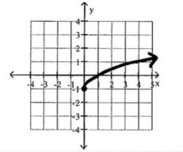 | Problem 4
5 | Identify the intervals where the function is changing as requested.  Increasing? | 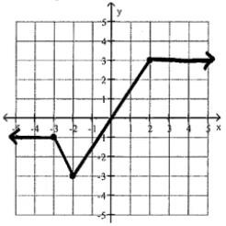 | Problem 5

6 | Identify the intervals where the function is changing as requested.  Decreasing? | 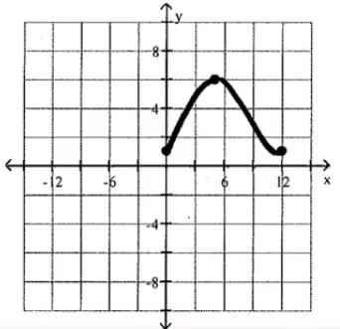 | Problem 6
7 | Determine where the function is even, odd, or neither. | 𝐹(𝑋) = 5𝑋² + 𝑋⁴ | Problem 7
8 | Use possible symmetry to determine whether the graph is the graph of an even function, an odd function, or a function that is neither even nor odd. | 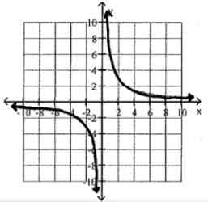 | Problem 8
9 | Evaluate the piecewise function at the given value of the independent variable. | 𝑓(𝑥) = 𝑥 − 3 𝐼𝑓 𝑥 > −5  { −(𝑥 − 3) 𝐼𝑓 𝑥 ≤ −5  𝐹𝑖𝑛𝑑 𝑓(−8) | Problem 9
10 | Evaluate the piecewise function at the given value of the independent variable. | 𝑥² + 5  𝑓(𝑥) = { 𝑥 + 3 𝐼𝑓 𝑥 ≠ −3  𝑥 − 7 𝐼𝑓 𝑥 = −3  𝐹𝑖𝑛𝑑 𝑓(−8) | Problem 10
11 | Graph the line whose equation is given. | 𝑌 = 3 𝑋 − 3  4 | Problem 11
12 | Graph the line whose equation is given. | −9𝑋 + 𝑌 = 5 | Problem 12

13 | Find the slope of the line that goes through the given points. | (3, −5), (−9, −8) | Problem 13
14 | Use the given conditions to write an equation for the line in slope-intercept form. | 𝑆𝑙𝑜𝑝𝑒 = −3 ,  𝑝𝑎𝑠𝑠𝑖𝑛𝑔 𝑡ℎ𝑟𝑜𝑢𝑔ℎ (−5,3) | Problem 14
15 | Solve the word problem. | Along with incomes, people's charitable contributions have steadily increased over the years. The table below shows the average deduction for charitable contributions reported on individual income tax returns for the period from 1993 to 1998.  Express the average rate of change in in charitable contributions  between 1995 and 1997 in words. | Problem 15
16 | Find and simplify the difference quotient for the given function.  𝑓(𝑥 + ℎ) − 𝑓(𝑥) , ℎ ≠ 0  ℎ | 𝑓(𝑥) = 6𝑥 − 2 | Problem 16
17 | Find and simplify the difference quotient for the given function.  𝑓(𝑥 + ℎ) − 𝑓(𝑥) , ℎ ≠ 0  ℎ |  | Problem 17
18 | Identify the transformations in the order they are performed on the function  𝑓(𝑥) = 𝑥² to obtain the function g(x). | 𝑔(𝑥) = (𝑥 − 7)² − 5 | Problem 18

19 | Begin by graphing the standard square root function  𝑓(𝑥) = √𝑥 . Then use transformations of this graph to graph the given function  𝑔(𝑥) = √(𝑥 + 2) −1. | 𝑔(𝑥) = −√𝑥 + 2 − 1 | Problem 19
20 | For the given functions f and g, find the indicated composition. | 𝑓(𝑥) = 𝑥² + 2𝑥 + 2  𝑔(𝑥) = 𝑥² − 2𝑥 − 3  𝐹𝑖𝑛𝑑 (𝑓 ° 𝑔)(−3) | Problem 20
21 | Find the given functions and g, find the indicated composition. | f(x) = 3x + 9 and g(x) = 5x - 1 Find (f∘g)(x) | Problem 21
22 | Find the inverse of the one-to- one function. | 𝑓(𝑥) = 6𝑥 − 7  5 | Problem 22
23 | Graph f as a solid line and  𝑓⁻¹ as a dashed line in the same rectangular space.  Use interval notation to give the domain and range of f  and 𝑓⁻¹. | f(x) = 2x - 3 | Problem 23
24 | Find the coordinates of the vertex for the parabola defined by the given quadratic function. | 𝑓(𝑥) = −7𝑥² + 14𝑥 − 4 | Problem 24
25 | Find the x-intercepts (if any) for the graph of the quadratic function. |  | Problem 25
26 | Solve the problem. | The cost in millions of dollars for a company to manufacture x thousand automobiles is given by the function 𝐶(𝑥) = 3𝑥² − 18𝑥 + 63. Find the number of automobiles that must be produced to minimize  the cost. | Problem 26

27 | Solve the problem. | April shoots an arrow upward into the air at a speed of 64 feet per second from a platform that is 12 feet high.  The height of the arrow is given by the function h(t) = -16t² + 64t +12, where t is the time in seconds.  What is the maximum height of the arrow? | Problem 27
28 | Use the leading coefficient test to determine the end behavior of the polynomial  function. | 𝑓(𝑥) = 𝑥 + 4𝑥² − 3𝑥³ | Problem 28
29 | Use the leading coefficient test to determine the end behavior of the polynomial  function. | 𝑓(𝑥) = −3𝑥⁴ + 4𝑥³ − 5𝑥² − 4𝑥 − 1 | Problem 29
30 | Use the leading coefficient test to determine the end behavior of the polynomial function. | 𝑃(𝑥) = 6𝑥³ + 3𝑥² − 3𝑥 + 8 | Problem 30
31 | Find the zeros for the polynomial function and give the multiplicity for each zero. State whether the graph crosses the x-axis or touches the x-axis and turns around,  at each zero. | 𝑓(𝑥) = 4(𝑥 − 2)(𝑥 + 1)⁴ | Problem 31
32 | Find the zeros for the polynomial function and give the multiplicity for each zero. State whether the graph crosses the x-axis or touches the x-axis and turns around,  at each zero. | 𝑓(𝑥) = 𝑥³ + 𝑥² − 6𝑥 | Problem 32
33 | Find the domain of the function. | 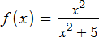 | Problem 33

34 | Find the domain of the function. | 𝑔(𝑥) = 2𝑥  𝑥2 − 36 | Problem 34
35 | Find the horizontal asymptote, if any, of the given rational function. | 20𝑥³  ℎ(𝑥) = 5𝑥2 + 1 | Problem 35
36 | Find the horizontal asymptote, if any, of the given rational function. | 𝑔(𝑥) = −5𝑥 − 3  4𝑥 − 6 | Problem 36
37 | Find the horizontal asymptote, if any, of the given rational function. | 𝑓(𝑥) = −10𝑥  2𝑥3 + 𝑥2 + 1 | Problem 37
38 | Find the vertical asymptotes, if any, of the graph of the rational function. | ℎ(𝑥) = 𝑥  𝑥 + 3 | Problem 38
39 | Graph the rational function. | 𝑓(𝑥) = 2𝑥  𝑥 − 4 | Problem 39
40 | Graph the rational function. | 𝑓(𝑥) = − 2  𝑥2 − 9 | Problem 40
41 | Evaluate the expression without using a calculator. |  | Problem 41
42 | Write the equation in its equivalent logarithmic form. | 7² = 49 | Problem 42
43 | The graph of an exponential function is given. Select the function for the graph from the functions listed. | 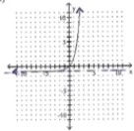 | Problem 43

44 | The graph of a logarithmic function is given. Select the function for the graph from the options. | 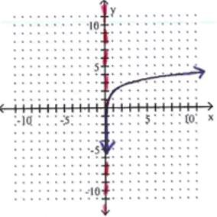 | Problem 44
45 | Find the domain of the logarithmic function. |  | Problem 45
46 | Find the domain of the logarithmic function. | 𝑓(𝑥) = log₅(𝑥 + 7) | Problem 46
47 | Use properties of logarithms to expand the logarithmic expression as much as possible. When possible, evaluate the logarithmic expressions without using a calculator. | 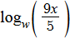 | Problem 47
48 | Use properties of logarithms to expand the logarithmic expression as much as possible. When possible, evaluate the logarithmic expressions without using a  calculator. | 𝑥𝑦²  log_{𝑏}( 𝑧5 ) | Problem 48
49 | Use properties of logarithms to expand the logarithmic expression as much as possible. When possible, evaluate the logarithmic expressions without using a  calculator. |  | Problem 49

50 | Use properties of logarithms to condense the logarithmic expression. Write the expression as a single logarithm whose coefficient is  1. Where possible, evaluate logarithmic expressions. | 5 ln(𝑥 − 8) − 4ln(𝑥) | Problem 50
51 | Use properties of logarithms to condense the logarithmic expression. Write the expression as a single logarithm whose coefficient is  1. When possible, evaluate the logarithmic expressions  without using a calculator. | 1 log 𝑥 + log 𝑦 2 9 9 | Problem 51
52 | Use properties of logarithms to condense the logarithmic expression. Write the expression as a single logarithm whose coefficient is  1. When possible, evaluate the logarithmic expressions  without using a calculator. | 4 log (4) + 1 log (𝑟 − 8) − 1 log (𝑟)  6 7 6 2 6 | Problem 52
53 | Solve the equation by expressing each side as a power of the same base and then equating exponents. | 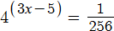 | Problem 53
54 | Solve the exponential equation. Express the solution set in terms of natural logarithms. | 2𝑥+7 = 3 | Problem 54
55 | Solve the logarithmic equation. Be sure to reject any value that is not in the domain of the original logarithmic expressions. Give  the exact answer. | log₄(𝑥 − 1) + log₄(𝑥 − 7) − 2 | Problem 55

56 | Solve the logarithmic equation. Be sure to reject any value that is not in the domain of the original logarithmic expressions. Give the exact answer |  | Problem 56
57 | Find out how long it takes a  $3100 investment to double if it is invested at 8% compounded semiannually. Round to the nearest tenth of a year. Use given formula. | 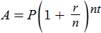 | Problem 57
58 | If Emery has $1300 to invest at 9% per year compounded monthly, how long will it be before he has $2600? If the compounding is continuous, how long will it be? Round your answers to three decimal places and use the  given formula. | 𝐴 = 𝑃𝑒^{𝑟𝑡} | Problem 58
59 | Solve the system of equations. | x + 4y + 2z = -2 4y + 5z = -3  z = 1 | Problem 59
60 | Solve the problem. | A vendor sells hot dogs, bags of potato chips, and soft drinks. A customer buys 2 hot dogs, 3 bags of potato chips, and 3 soft drinks for  $10.50. The price of a hot dog is  $1.50 more than the price of a bag of potato chips. The cost of a soft drink is $3.25 less than the price of two hot dogs. Find the cost of each item. | Problem 60

61 | Graph the solution set of the system of inequalities or indicate that the system has no solution. |  | Problem 61
62 | Graph the system of inequalities. | 𝑦 ≥ 𝑥²  𝑥 + 𝑦 > 2 | Problem 62

