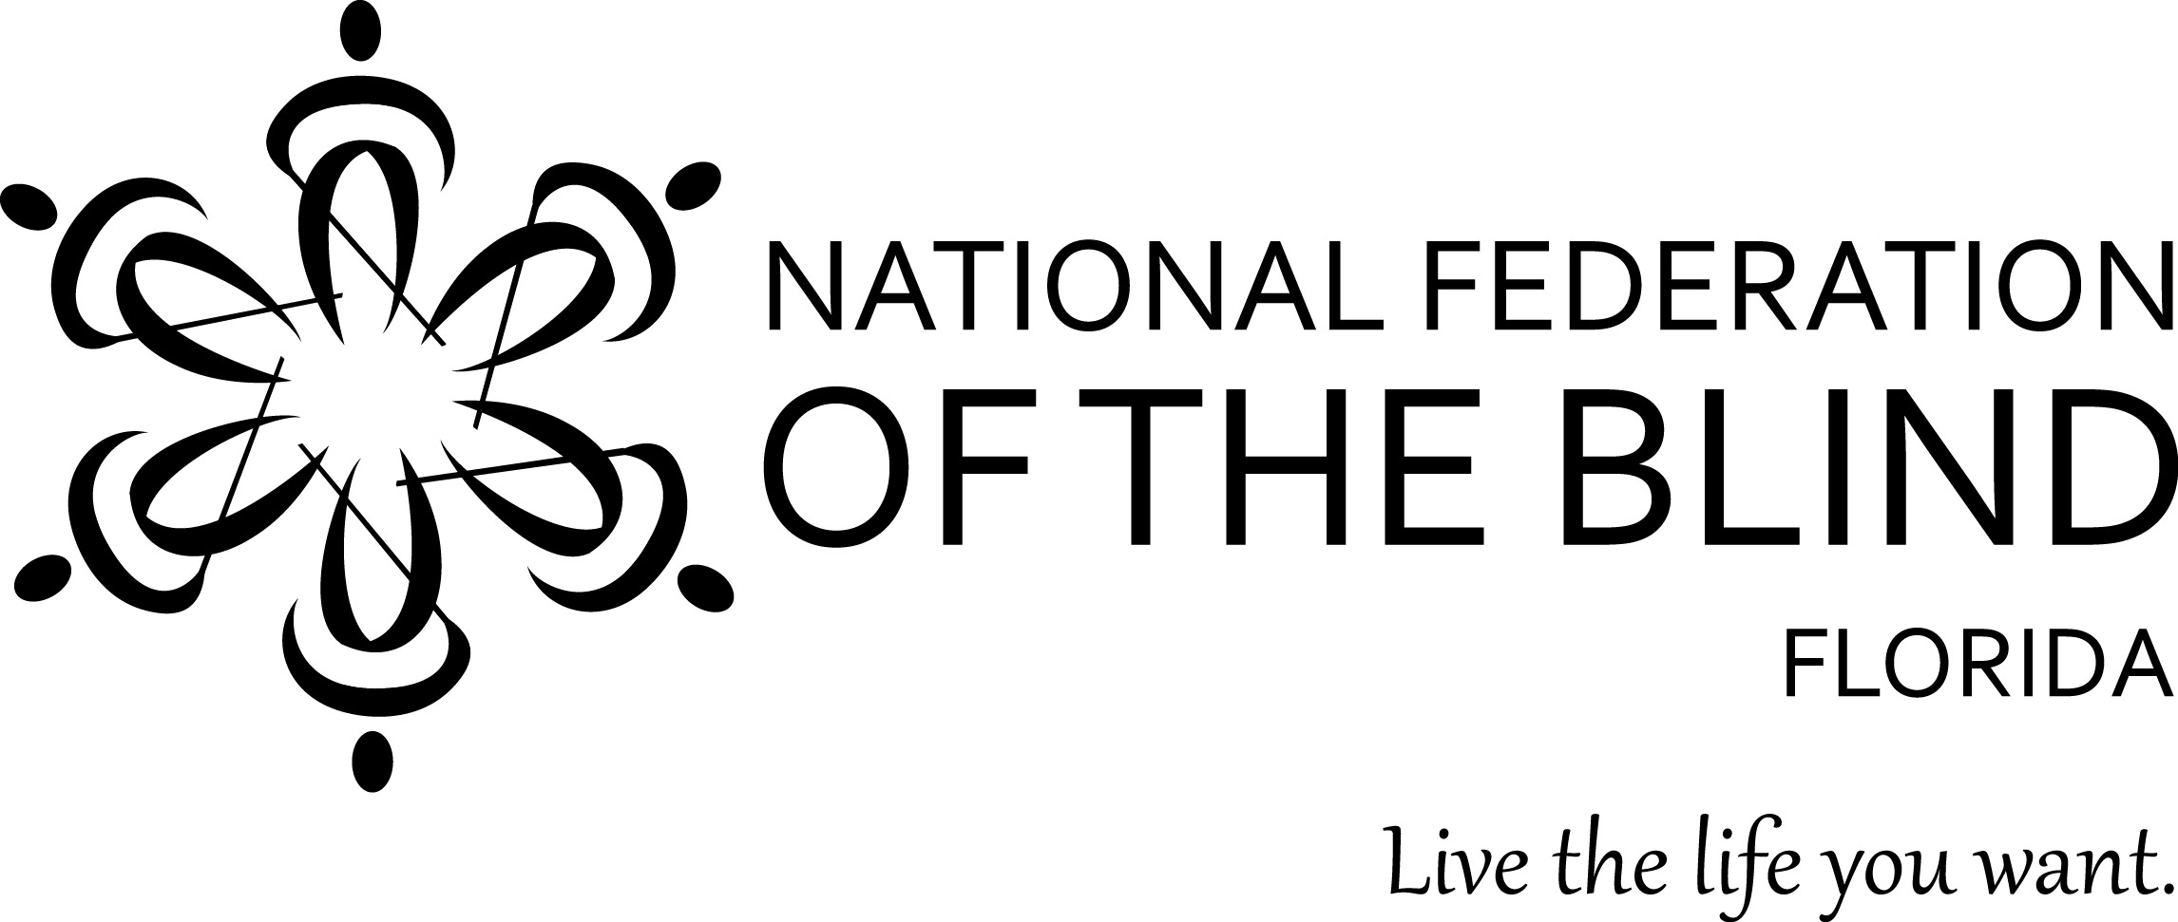

**NATIONAL FEDERATION OF THE BLIND OF FLORIDA**

**Financial Assistance Application Form**

**Applicant Information:**

Name:

Best Contact Phone:

Address:

City, State, ZIP:

E-mail:

Chapter/Division:

Chapter President Name:

Chapter President Phone Number:

Member Since:

I am seeking assistance to attend:

( ) National Convention

( ) State Convention

( ) Other NFBF Seminar/Event (Please specify event name):

Indicate any other sources for funding you have applied to, including Chapters of NFBF:

Indicate Federation activities in which you have been involved in the last two years, including but not limited to National Convention, State Convention, and Washington Seminar.

Indicate positions of leadership you have held:

Why do you want to attend a National Convention?

What would you gain from attending a National Convention?

How do you plan to give back or contribute to our Organization and/or Our

Movement?

NFBF reserves the right to require repayment of any award if recipient fails to attend convention or complete assigned tasks.  If unable to attend, recipient must inform committee immediately.  By signing below, I acknowledge and understand that as a condition of receiving funding, I:

1. Must abide by the NFB Code of Conduct and all affiliate policies;

2. Must attend all activities associated with the event for which I am receiving funding;

3. Must work any assigned jobs, shifts, or tasks at the event that are assigned to me by the NFBF;

4. Must notify NFBF immediately if my plans change and I am either unable to attend the event or must shorten the duration of my participation in the event;

5. Must return any awarded funds if I do not attend the event and/or return the portion determined to be appropriate by NFBF if I shorten the duration of my attendance at the event;

6. Am responsible for finding my own roommate to share in the lodging costs

7. Should I violate any of the above requirements, NFBF will summarily rescind any financial assistance it has committed, I am responsible for my own costs and repaying any costs NFBF has already paid on my behalf, and I am not eligible for financial assistance from NFBF in the future.

Signature of Applicant:

Date: