

Pancake Breakfast

In honor of the American’s Disability Act (ADA)

# Hosted by the Tampa Bay Chapter of the National Federation of the Blind

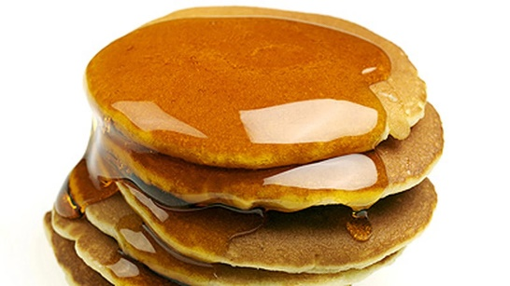

* **What: 2 pancakes or 3 French toast sticks, bacon or sausage, and your choice of coffee, tea, or juice, and opportunities to enter into some amazing raffles – all for only $8.00 donation.**
* **When: Saturday, July 23rd from 9:00 AM until 10:30 AM**
* **Where: Beef o Brady’s 8810 North Himes Avenue, Tampa, Florida 33614**

**Purchase tickets in advance or make reservations. If you do not have a ticket, please RSVP before 07/20/2022 by calling Miranda Kilby at 352-942-0417 or by e-mail at nfbf.tampa@gmail.com.**