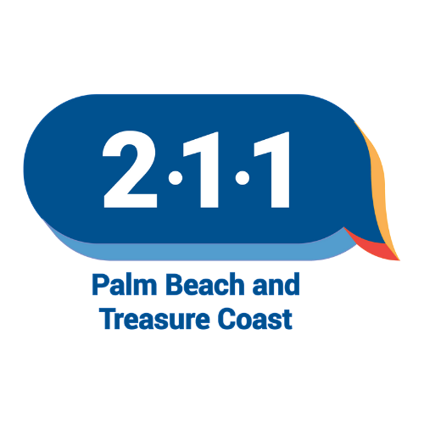

**FREE ZOOM WORKSHOP**

**Thurs November 21, 2024**

**2PM to 330PM (EST)**

**Join FOCB and guest speaker, Wendy Savona from 211 Palm Beach, the incredible HELP HOTLINE!**

**211 is a confidential, community helpline and crisis hotline service** providing guidance and support 24/7 for individuals and families who find themselves without answers to problems they may face on a daily basis.

***211 provides an array of support and assistance***, including information; assessment; advocacy; referral; and linkage to appropriate community agencies, as well as telephone counseling, crisis intervention, and suicide prevention is provided. As the central gateway to health and human services, 211 collects, maintains, and makes available up-to-date resource information via phone, text, email, website, printed guides and directories.

***CALL 211 for help or visit their website:*** <https://211palmbeach.org/>

JOIN US ON ZOOM FOR THE WORKSHOP:

Meeting ID: 835 8160 5488

Passcode: 182630

**BY PHONE:**

1-312-626-6799

**BY COMPUTER**

[https://us02web.zoom.us/j/83581605488?pwd=UWYvTVZ2Q2RRejhJamVJREF4Rlltdz09 [us02web.zoom.us]](https://urldefense.com/v3/__https:/us02web.zoom.us/j/83581605488?pwd=UWYvTVZ2Q2RRejhJamVJREF4Rlltdz09__;!!COIdcu9TKnUF_QTdrw!JiD21OsK47Ux7j7fntI2JUtAq-NYi2H9HiqiQv9iEfA1OtAOBNs6ZkofuAkmfOwTETQ$)

FOR INFO on the workshop, and FOCB’s FREE CLASSES, TRAINING & MORE, contact us: 561-642-0005, [Info_FOCB@bellsouth.net](mailto:Info_FOCB@bellsouth.net)

The Florida Outreach Center for the Blind is a nonprofit organization/training facility that is nationally accredited by the Association for Education & Rehabilitation of the Blind & Visually Impaired (AER). Classes/training are available in English, Spanish, Creole and French.

Address: 2315 South Congress Avenue, Palm Springs, FL 33406.

Website: <http://blindfocb.org>

Like us on Facebook! <https://www.facebook.com/FOCBInc>

Watch us on Youtube! <https://www.youtube.com/watch?v=GPBDXBkfxEQ>