February 10, 2025

Dear Florida State Legislature Member:

The National Federation of the Blind is the nation’s oldest and largest organization of the blind,
consisting of affiliates in all 50 states, the District of Columbia and Puerto Rico. The National Federation of the Blind of Florida is a proud affiliate member, representing the blind community in the State of Florida. Each year, we bring legislative priorities both on a state and national level to our legislators that increase productivity and well-being to the blind.

One of our priorities for 2025 is the Blind Students’ Right to Independence, Training and Education Act (BRITE). Literacy, orientation and mobility skills (travel with a white cane) and learning Braille are key components to education and employability for blind people. The employment rate for blind Americans hovers around the 30% mark, meaning approximately 70% of blind people of working age are unemployed or underemployed. Blind students must often struggle to obtain instruction in those skills that will advance their ability to become adequately educated and employed as they grow into adulthood.

We are seeking support to ensure blind students will have the proper education and mobility skills to grow into productive, educated and employable adults. Enclosed with this letter is bill language that will be the first step into a bright future for Florida’s blind students.

We look forward to discussing this vital piece of legislation. I may be reached at (321) 372-4899 or President@NFBFlorida.org, to answer any questions you may have.

Sincerely,

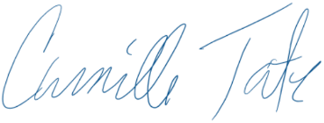
Camille Tate, President
National Federation of the Blind of Florida
Legislative Co-Chair

