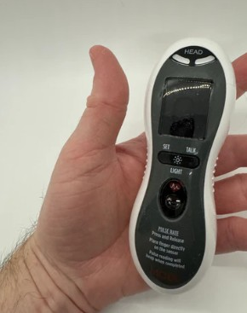FREE ZOOM WORKSHOP
ON ASSISTIVE TECHNOLOGY!

Thursday, March 19, 2026
TIME: 2-330PM

The workshop will be led by Brent Harbolt, owner & creator of the Harbolt Company.

The Harbolt Company was started in July of 2014 by Brent Harbolt, out of a love for finding unique and interesting technology items. Whether it be high tech, low tech, or no tech, all items that Harbolt sells are guaranteed to be accessible to those who are visually impaired.

Brent will discuss their ever-changing inventory and their variety of interesting and unique products to make your life a little easier. They ship everywhere in the United States, and to most countries worldwide. They encourage everyone to sign up for their newsletter so you can receive new product announcements, daily deals, and info on their contests, promotions, and special events. https://harboltcompany.com/

ZOOM Meeting ID: 835 8160 5488
Passcode: 182630
BY PHONE:
1-312-626-6799
BY COMPUTER
https://us02web.zoom.us/j/83581605488?pwd=UWYvTVZ2Q2RRejhJamVJREF4Rlltdz09 [us02web.zoom.us]

The Florida Outreach Center for the Blind is a nonprofit organization/training facility that is nationally accredited by the Association for Education & Rehabilitation of the Blind & Visually Impaired (AER). Classes/training are available in English, Spanish, Creole and French. FOR INFO on this and other workshops, FOCB’s FREE CLASSES, TRAINING & MORE, contact us:

2315 South Congress Avenue, Palm Springs, FL 33406
561-642-0005
email: Info_FOCB@bellsouth.net
Website: http://blindfocb.org
Like us on Facebook! https://www.facebook.com/FOCBInc/
Follow us on Twitter: https://twitter.com/FlaOutreachCtr
Watch us on Youtube! https://www.youtube.com/watch?v=GPBDXBkfxEQ

