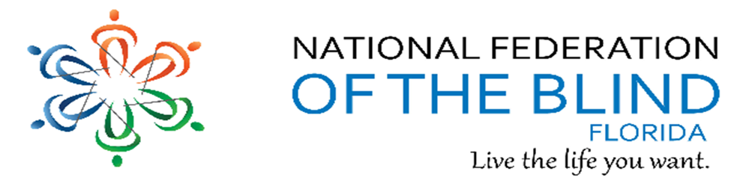BREAKING NEWSLETTER
Issue 19 May/June 2019

President’s note
Greetings Federation Family,
Thanks to all for an exciting 49th State Convention. Each and everyone of us had fun and had fun while working together. Thank you for your continued support of the NFBF board of directors and together we are one organization local, state and national. Let’s go build the Federation together with love, hope and determination transforming dreams into reality.
See some of you in Vegas.
Denise Valkema, President NFB OF Florida
president@nfbflorida.org
Facebook & Twitter @nfbflorida
Find us on twitter and FB @nfbflorida
We are filled with hope, energy and love by participating in the National Federation of the Blind. Every day we work together to help blind people live the lives they want.

How to navigate our newsletter with headings: To enable the quick keys on/off with JAWS use the command “insert + z”. By default, the quick keys are off in Microsoft Word. To browse through the headings of the newsletter. Make sure you have quick keys on and then press the letter “h”. This keyboard command will move from heading to heading on the document. When you find the title of the heading you would like to read, you can use the “insert +down arrow” or the “insert +numbpad2”.

What’s in this Newsletter
Contents
President’s note 1
How to navigate our newsletter with headings: . 2
What’s in this Newsletter 2
Birthdays & Celebrations 2
Calendar of Meetings and Events 3
Article, Announcements and Comments 5
Apple Tips and Tricks 8
Link City 9
Inspiration Corner 9
Legislative Updates from the desk of Camille Tate 9
Photo Gallery 11
Chapters 14
Divisions 16
Groups and Committees: 16
NFBF Board of Director’s Information 19
Editor: Sylvia Young 20

Birthdays & Celebrations
The NFBF would like to celebrate:
Birthdays:
May:
Tom Bellone – Daytona Beach
Janet Beyer – State-Wide
Jean Cerullo – Daytona Beach
Max Daugherty – Gainesville
Sue Ann Goldman – Treasure Coast
Alicia Kilby – State-Wide
Chet Rot – Treasure Coast
June:
Lauren Blum – State-Wide
Donald Christie – Tallahassee
Donnie Coker - Treasure Coast
Tinetta Cooper - State-Wide
Fran Cupeta - State-Wide
Max Daugherty - Gainesville
Mary Hannah-Morris – Treasure Coast
Leslie McKinnley – State-Wide
David Hoss – Tallahassee
Jeannette Torres - Tampa Bay
Scott Wilson – State-Wide
Anniversaries:
Jada and Donald Christie – May
Doug and Melissa Ingram - May
David and Kathy Roskos – May

Calendar of Meetings and Events
Groups, Divisions, and Committees for June 2019
June 6th Seniors Concerns Committee at 8 pm
Phone: 712-7757031
Code: 488550
1 touch mobile: 712-775-7031,488550
June 11th Deaf Blind Division at 7 pm
Phone: 515-604-9853
Code: 997037
1 touch mobile: 515-604-9853,997037
The conference calls below operate on the same number:
712-775-7031, Code 938047311#
1 touch mobile: 712-775-7031,938047311
June 4th Community Service at 8 pm
June 10th Diabetes Awareness at 7 pm
June 11th Blind Parents Initiative at 9 pm
June 13th Diversity and Inclusion at 8 pm
June 17th Communities of Faith at 8 pm
June 18th Legislation Committee at 8 pm
June 24th Technology Q and A at 8 pm
June 27th NFBF Book Club at 8 pm

Article, Announcements and Comments
Newley elected 2019 State Affiliate Board:
Our State Board remained the same this year with Miranda Kilby, Sylvia Young, Jorge Hernandez and Camille Tate re-elected at convention.
Full board listed below:
President Denise Valkema
1st Vice President Paul Martinez
2nd Vice President Miranda Kilby,
Secretary Sylvia Young
Treasurer Merry Schoch
1st Board position Lauren Blum
2nd Board position Jorge Hernandez
3rd Board position Camille Tate
4th Board Position Rafael Fernandez

COMING SOON NATIONAL CONVENTION:
Sunday, July 7 to Friday, July 12, 2019. Get registered today!
It's hard to believe, but the annual National Convention of the National Federation of the Blind is only a month away. We look forward to seeing everyone at the beautiful Mandalay Bay Resort and Casino in Las Vegas from July 7 to July 12, 2019!
Preregistration for the convention is closed, so now you will need to register on site at the convention.
BE AWARE AT THE CONVENTION HOTEL:
The Mandalay Bay rooms have a minibar on top of the dresser which contains candy, nuts and snacks which have sensors for each item and if accidentally bumped, the guest room will be automatically charged. The same charges apply for items in the refrigerator. Guests can opt to have the Minibar removed, as well as the refrigerator locked or removed from the room for $50. It is recommended to call the desk if items sensors are tipped, to avoid charges. The minibar owners take inventory prior to your arrival and after you leave, so whatever is missing is what you will charged. After the final minibar inventory, any items that may have been shifted or lifted off the sensors accidentally for which you have been charged, will t but are still there, will then be removed from your bill.

Brian Norton receives honors
Thursday, April 11,2019, Brian Norton received two awards: Dayton State College Student Engagement Award and their Hall of Fame Award for Academic Excellence, school and community leadership and citizenship values in action. This Daytona State College Awards ceremony is accessible and can be viewed on YouTUBE, and after about 45 minutes shows Earline and Brian walking up on stage to accept the awards from the college president.
Brian is grateful to DBS for financial support of his education to regain competency for employment again in the legal field. It is his hope to take the Florida Bar exam this year to regain his law license. Join us in congratulating him for his awesome accomplishments.

Want to Help Transform Dreams into Reality?
The NFB Braille Enrichment for Literacy and Learning (BELL) Academy prepares blind and low-vision children ages four through twelve to grow into confident and independent blind people who live the lives they want.
The program provides Braille and nonvisual skills instruction through fun, hands-on learning in a two-week day program.
Our NFBF BELL Academy will begin June 17th through June 28th, Monday through Friday, from 9 AM to 3 PM at the Boys’ & Girls’ Club of Tampa Bay in Tampa, Florida.
How would you like to be a sponsor for a student to live the life they want? Please see the break down below.
• Donating $25 will cover the cost of supplies for 1 child for the 2
week program.
• Donating $50 will cover the cost for the supplies and all the food
for 1 child for 2 weeks.
• Donating $75 will cover the supplies, all the food for 1 child for 2
weeks, and a custom BELL Academy shirt.
• Donating $100 will cover the cost for supplies, all the food for 1
child for 2 weeks, a custom BELL Academy shirt, and assist with the
cost of activities.
Any chapter, division, company, or individual donating $100 will have their name recognized on the back of the student’s shirt as a sponsor. Want to be a sponsor? Mail a check or money order payable to the NFBF to:
Merry Schoch, NFBF Treasurer, 710 Oak Field Dr. Suite 210, Brandon, FL 33511
Or by using PayPal at the below link. Please identify in the memo that the funds is for the BELL Academy. So, your donation can be appropriately assigned easily.
https://www.paypal.me/nfbf
All Sponsorships must be in by June 9th, so shirts can be ordered.
We thank you in advance for all your support in helping us transform our student’s dreams into reality.

Apple Tips and Tricks
Apple Tips and Tricks
By Camille Tate
COMING SOON AGAIN NEXT MONTH

Link City
Here are some important links that may be of interest.
NFB: https://nfb.org/
NFBF: http://nfbflorida.org/
Nation's Blind Podcast – Not available this month
Presidential release - May: https://www.nfb.org/images/nfb/audio/podcast/presidential-releases-en/2019_05_english.mp3
Braille Monitor - June: https://www.nfb.org/images/nfb/publications/bm/bm19/bm1906/bm1906tc.htm

Inspiration Corner
“One of the main tasks of theology is to find words that do not devide but unit, that do not create conflict but unity, that do not hurt but heal.”
- Henri Nouwen

Legislative Updates from the desk of Camille Tate
Legislative Committee
By Camille Tate
Now that we all are recovered from our incredible 2019 State Convention, it is time to go back to work! The National Federation of the Blind of Florida is gearing up for a campaign to introduce and pass our legislative priorities nationally and statewide. At our Legislative Committee meeting at convention, we discussed some guidelines for everyone to follow when working on state and national legislation. We ask that communications, via email, phone call or office visit, be transmitted to the Legislative Committee Co-Chairs, Camille Tate and Merry Schoch. This is to keep us looking as professional as we are and will work to eliminate duplication and increase effectiveness.
State: The 2020 Legislative Session begins on January 14, 2020. We currently have two items to get onto the agenda with our Representatives and Senators. Stay tuned for a possible third item.
Our first state priority is the Blind Parents Initiative. Inside the packets handed out, on the right side of the folder, are some documents. At the very back is our “Parenting Without Sight” brochure, the model parental rights bill, the resolution that passed the National Convention in 2016 and a letter signed by President Denise Valkema. Chapter Presidents or whomever chairs the chapter’s legislative committee should make copies to hand out to members who will be visiting their Representative or Senator. These documents were also posted to the Florida List on Tuesday, May 28.
Our second priority for 2020 is the ending of the Federally Sheltered Workspace, more commonly known as 14(C) programs. On the right side of the packet, the first two documents are a letter signed by President Denise Valkema and the resolution which passed the National Federation of the Blind of Florida convention just a few days ago.
National: On the national agenda we have legislative priorities to work on. In the left side pocket of the Legislative folder are the fact sheets for the priorities advocated for at Washington Seminar 2019. Chapter Presidents or whomever chairs the chapter’s legislative committee should make copies for all members who will be visiting their federal Representative and Senator.
Access Technology Affordability Act (ATAA) has been revamped for 2019. It provides a tax credit of up to $2,000 to be used over a three-year period.
Greater Accessibility and Independence Through Non-Visual Access Technology Act (GAIN) will make home use medical equipment, home appliances and fitness equipment accessible since these devices are increasingly using digital interfaces to operate. This makes them inaccessible to the blind because there is no voice interaction with the flat panel displays.
Disabled Employment Act (DEA) seeks to end sub-minimum wages. It will revamp the programs under AbilityOne and open more supervisory and managerial positions to the disabled. Further, it will create a commission populated by representatives from disability organizations (such as the blind and developmentally disabled) to oversee the trust created through the government procurement process. It also will prevent entities tasked with training disabled people for jobs to also receive monies as an employer of the disabled.
As evidenced above, we have lots of work to do! Keep an eye on our list for updates to our legislative priorities, legislative alerts or other pertinent information. All chapters should have their legislative packets. If not, please do not hesitate to contact either Camille Tate or Merry Schoch, whose information will be listed at the end of this article. All packet information will be posted to the list for everyone to read.
Together we are stronger. We grow together. It is through our collective voice, making a joyful noise, that we can accomplish! Join our Legislative Committee, which meets on the third Tuesday of each month at 8 p.m. Prior to each meeting a notice will be posted to the Florida list with the date, time and conference call number.
Our next legislative meeting will be Tuesday, June 18, at 8 p.m. The conference call information is: 712-775-7031, access code: 938047311.
Mobile users: 7127757031,,,938047311#
Contact Info:
Merry Schoch. merrys@verizon.net, 813-625-1850
Camille Tate, Ctate2076@att.net, 321-372-4899

Photo Gallery
2019 State Convention
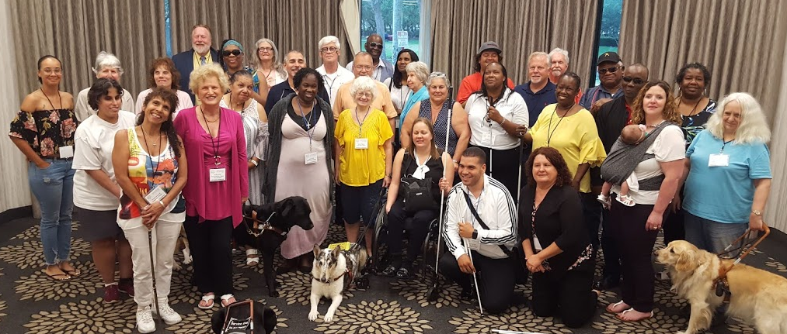
Chapter representatives and state board of directors at Leadership Seminar

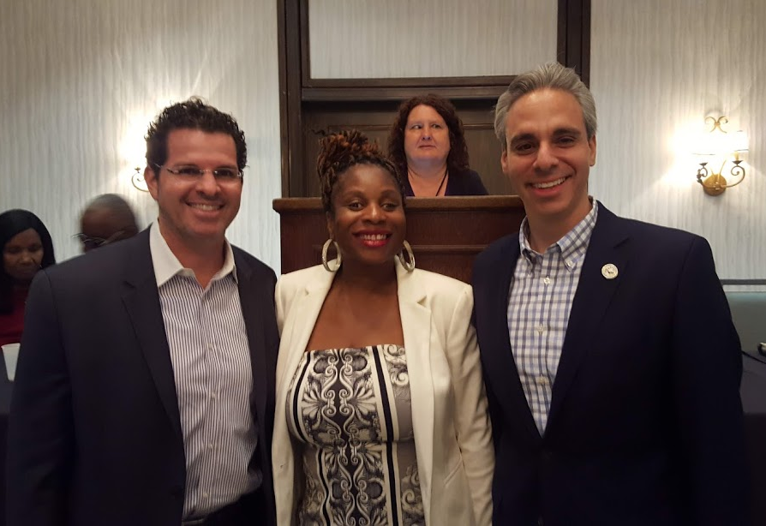
Opening ceremonies with Todd J. Bonlarron, Assistant County Administrator, Tekesha Saffold, Denise Valkema and Mayor Scott Singer of Boca Raton

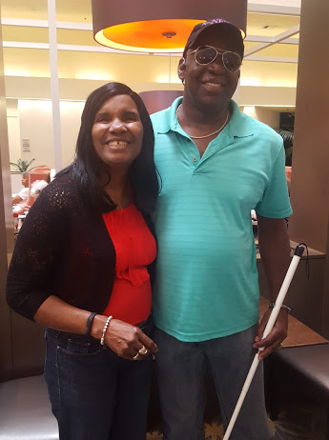
National Rep Ron Brown and wife Jean Brown
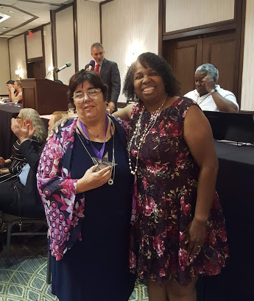
Legacy Award winner Gloria Mills-Hicks and Leadership Award Winner Tamika Butts with Sylvia Young

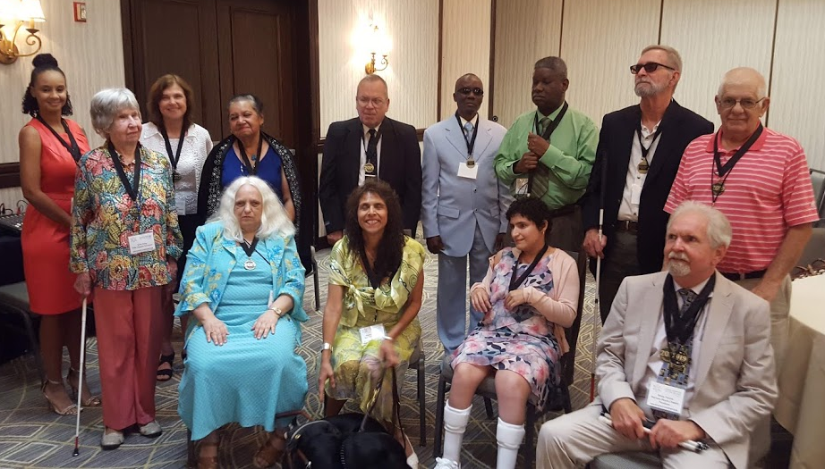
Chapter Outstanding member recognition: Tanya Dawson, Kitty King, Nancy Epps, Andy Rood, Maria Rigoglios, Andy Rood, John Johnson, Yvonne Rosanelli, Donald Christie, Ronald VanGelderen, Cecelia Rodriguez, Tom Bellone, and Brian Norton, Aileen Jasper, and Geraldine Jones
Scholarship winners Brian Norton and Mikayla Maiorano with Merry Schoch

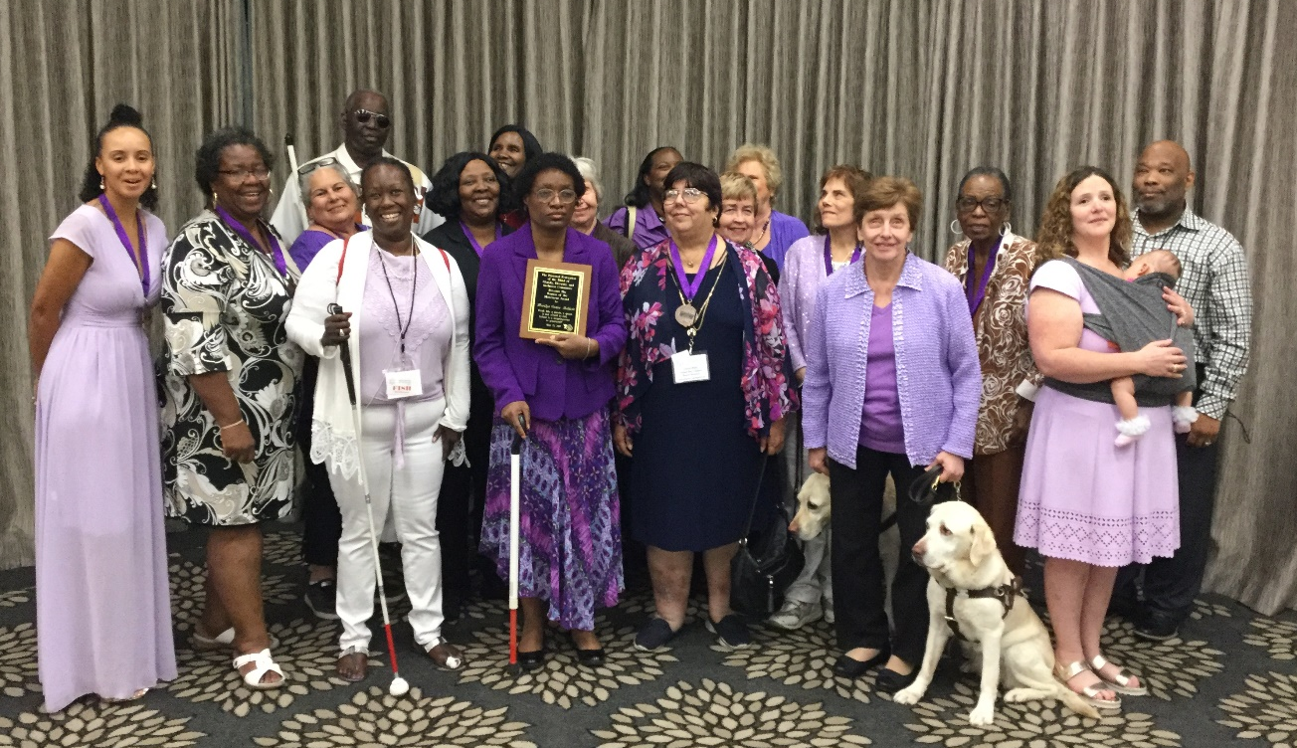
Womens Luncheon: Honorees, guest speakers and committee members

Chapters
Greater Broward Chapter: Jake McEntyre, President, Phone: (954) 946-4148, Email: jmac1920@yahoo.com. Meetings are held the 2nd Saturday of each month at the Westfield Broward Mall located at 8000W. Broward Blvd. Plantation, Florida 33312 from 10:30 a.m. until 12:30 p.m. meetings take place inside the Plantation Police Outreach Center, just inside the north entrance to the mall.

Central Florida Chapter: Toni Moore, President, Phone: (850) 321-6421. Email: claviet@gmail.com Meetings are held the third Saturday of each month from 11 A.M. to 1 PM at Lighthouse Central Florida, 215 East New Hampshire Street Orlando, Florida 32804. Please like us on Facebook at: https://www.facebook.com/groups/410985858949160.

Greater Daytona Beach Chapter: Brian Norton, President, Phone: 386-871-3359 Email: brian.edward.norton@outlook.com. Meetings are held the fourth Saturday of the month from 1:00 till 3:00pm at Houligans Speedway restaurant, 1725 International Speedway Blvd. Daytona Beach, Florida. Follow Us on Facebook: www.facebook.com/nfbdaytona

Gainesville Chapter: Judith Hamilton, President; Phone: 352-373-7806, Email: gainesville_nfb@earthlink.net. Gainesville Chapter meeting to be announced. Together we can plan and participate to build the Federation in Gainesville.

Greater Jacksonville Chapter: Marita Winston, President; Phone: (904) 580-6819, Email: nfbjax@gmail.com. Meetings are held the first Saturday of each month and take place at the Independent Living Resource Center, 2709 Art Museum Drive, Jacksonville, Florida 32207 from 10:00 AM until 12 Noon. Please join us if you are in the area.

Melbourne - Space Coast Chapter: Camille Tate, President; Phone: 321-372-4899; Email: ctate20176@att.net. Facebook: www.facebook.com/nfbmelbourne. Meetings are held the 2nd Saturday of each month, from 9:30 a.m. until noon at The Fountains of Melbourne located at 4451 Stack Boulevard, Melbourne, Florida, 32901. Call Camille Tate, President, with questions. Contact Camille Tate, President for more information.

Greater Miami Dade Chapter Jorge Hernandez – President; Phone: 305-877-2311; Email: jeh1065@comcast.net. Our meetings are held on the third Thursday of each month at Denny's Restaurant located at 5825 N.W. 36 Street Miami, FL 33166 from 7:00 p.m. until 8:30 p.m.

Palm Beach Chapter: Tekesha Saffold, President; 561-707-4799; Email: tnsaffold82@gmail.com. Meetings are held the Second Saturday of each month at IHOP at 1503 Belvedere Road, West Palm Beach, Florida from 10 am until noon.

Polk Chapter: Joe King, President: Phone: 863-293-5648; Email: joenkitty@earthlink.net. Our meetings are held the second Saturday of the month at Perkins Pancake House and Bakery located at 6005 Cypress Garden Blvd. Winter Haven, FL 33884 from 10:00 AM-12:00 Noon.

Florida State-Wide Chapter: Paul Martinez, President; Phone: 813-390-5720; Email: nfbf.statewide@gmail.com. Meetings are held the Third Sunday of each month at 8 pm (Eastern Time) via conference call using the following number: (605) 475-4700 using the access code 800550#.

Tallahassee Chapter: Jada Christie, President; Phone: 850-766-9378 Email: emeraldpink15@gmail.com. We meet the first Monday of each month from 6:30-8:00 p.m., at the Lighthouse of the Big Bend located at 3071 Highland Oaks Terrace, Tallahassee, FL 32301. We are excited to attend the State Convention and receive 3rd place for Fundraising this year. We have worked hard in Tallahassee to build our membership and the Federation. We plan to have 5 members attend the National Convention in Las Vegas.

Tampa Chapter: Miranda Kilby, President; Phone: 352-942-0417; Email: NFBF.Tampa@gmail.com. Join us on the fourth Saturday of each month, from 12 Noon to 2:00 PM at Beef O Brady's located at 8810 North Himes Avenue, Tampa, FL 33614. The chapter is busy planning a BELL (Braille Enrichment for Literacy and Learning) program. We are looking at holding the program June 17th through the 28th.

Treasure Coast Chapter: Tamika Butts, President; (772) 708-3749, E-mail: tamika_butts@gmail.com. Meetings are held on the 2nd Saturday of each month from 10am - 12:00 Noon at WQCS Radio Station located @ IRSC, 3209 Virginia Avenue, Fort Pierce.

Divisions
Deaf-Blind Division: Alicia Betancourt, President, Phone: (386) 589-7324, E-mail: Licib85@gmail.com. Meetings are held every second Tuesday of the month at 8:00pm by conference call. calling information:(515) 604-9853 and using the access code 997037#.

Florida Association of Guide Dog Users (FLAGDU): Merry Schoch, President, Phone: 813-625-1850, Email: flagdu@nfbflorida.org

Florida Organization of Parents of Blind Children (FOPBC): Cherice Togun, President; (407) 257-7637; chericeflemingtogun@hotmail.com. Contact the President for meeting date and time.

Groups and Committees:
Blind Parents Connect - NFB of Florida: Nicole Fincham-Shehan – Coordinator, Phone: (410) 493-4461, Email: nicoledfincham@yahoo.com. Meetings are held the Second Tuesday of each month, at 9pm via conference call using the following telephone number and access code: (712) 775-7031,938047311#.

F.A.B.S. - Florida Association of Blind Students: Rafael Fernandez, Phone: (305) 903-6299, Email: rafael.fernandez0617@gmail.com. Call Rafael information and details.

Communication Committee: We have been busy proofing items for members, sending out a calendar outline to help us all stay organize, and growing slowly on our social media platforms. Dan has sent out an email regarding our 50th anniversary project and hopefully submissions will start rolling in. We encourage everyone to submit something towards this project. We are trying to wrap up our PSA project, so if you have not recorded the 1-minute message, please do so soon.

Community Service: Tekesha Saffold – Chair, Phone: (561) 707-4799, Email: tnsaffold82@gmail.com. Meetings are held the first Tuesday of each month at 8 pm via conference call using the following telephone number and access code: (712) 775-7031,938047311#.

Diabetics Group: Lauren Blum, Telephone: (352) 584-0795, Email: laurenblum79@gmail.com. Meetings are held the second Monday of each month at 7pm via conference call using the following telephone number and access code: (712) 775-7031,938047311#. The Diabetic Awareness Group held their meeting on January14th and had a lively discussion on what constitutes as a carbohydrate.

Diversity and Inclusion: : We are scheduled to meet on Thursday, June 13, at 8:30 p.m. Call-in number: (712) 775-7031, Access Code: 938047311#. Chair: Marilyn Baldwin, Phone: (407) 293-0565, Email: commMDB@aol.com. Stay informed through our Florida list. Chair: Marilyn Baldwin.

Fundraising Committee: Paul Martinez – Chair, 11903 Rose Harbor Drive Apt: 113, Tampa, Florida 33625, Phone: (813)390-5720, Email: fundraising@nfbflorida.org Tickets for the High Roller raffle were ordered and sent on Monday March 18th to every chapter president. Each ticket will be sold for $5, and the drawling will be on July 12th. Prizes are below:
• 1st prize: $1000
• 2nd Prize: $500
• 3rd Prize: $250
The best part about this fundraiser is the more you sell for your chapter the more the chapter will receive. So, put on your thinking caps and happy selling!

Legislative Committee: We meet on the third Tuesday of the month at 8 p.m. Come and hear about state and national legislation. The call-in information is: 712 775 7031, access code 938047311. Contact co-chairs Merry Schoch, 813 625 1850 or Camille Tate, 321 372 4899 for more information.

NFBF Book Club: We meet on the fourth Thursday of the month. June’s selection is a re-visit of “Blindness: The Other Half of Inertia” by request for those who missed it at state convention. Our meeting is June 27, at 8 p.m. The call-in information is: 712-775-7031, access code: 938047311. Coordinator: Camille

NFB411: Our next NFB411 Call To be announced.

Newsline: Russ Davis, Chairperson. (844) 827-7371, newslinesupport@nfbflorida.org

President and Vice President Committee: We would like to know what you all would like to discuss next. We are stronger together, when we work together! Call in number: 712 775 7031, access code: 938047311.

Senior Concerns Committee: Gloria Mills-Hicks, Chairman; Phone: 813-340-9754; Email: Glorianfb@irescuetax.com. Meetings are held the First Thursday of each month at 8pm via conference call using the following telephone number and access code: (712) 775-7031,938047311#.

Technology Q and A: Rafael Fernandez – Chair; Email: rafael.fernandez0617@gmail.com. Meetings are held monthly on the fourth Monday at 8:00 pm via conference call using the following telephone number and access code: (712) 775-7031,938047311#.

The National Association of Blind Veterans: Dwight Sayer, President; 321-948-1466; Email: president@nabv.org; PO Box 784957, Winter Garden, Florida 34778.

NFBF Board of Director’s Information
Please contact any of the board with questions, comments, concerns or for general information.
Denise Valkema -President
Phone: 305-972-8529
Email: president@nfbflorida.org

Paul Martinez - 1st Vice President
Phone: 813- 390-5720
Email: paul09ms@gmail.com

Miranda Kilby – 2nd Vice President
Phone: 352- 942-0417
Email: mbkilby@gmail.com

Sylvia Young-Secretary
Phone: 850- 322-5937
Email: secretary@nfbflorida.org

Merry Schoch –Treasurer
Phone: 813-523-6573
Email: merrys@verizon.net

Board Members:
Lauren Blum
Phone: 352-584-0795
Email: laurenblum79@gmail.com

Jorge Hernandez
Phone: 305-877-2311
Email: jdh6@bellsouth.net

Camille Tate
Phone: 321-372-4899
Email: ctate2076@att.net

Rafael Fernandez
Phone: 305-903-6299
Email: rafael.fernandez0617@gmail.com

Editor: Sylvia Young
To have something posted in the NFBF Newsletter please submit it to the editor, Sylvia young at secretary@nfbflorida.org by the 15th of each odd month.

