WE MAKE A DIFFERENCE;

YOU CAN TOO!
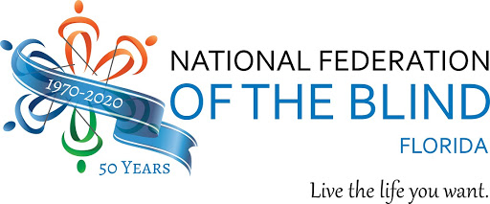
  - Celebrate Meet the Blind Month and White Cane Awareness Day!
Join the Greater Jacksonville Chapter of the National Federation of the Blind in celebrating Meet the Blind Month and White Cane Awareness Day. This virtual event features a panel of both blind and sighted individuals from multiple organizations that will enlighten and inspire all of us with stories of how they positively impact the lives of family, friends and communities that surround them. The event will be held via Zoom, an accessible platform that offers several ways to join the celebration.
Wednesday, October 21, 2020 at 6:30 pm
Registration is requested. Contact Russ via email at nfbjax@gmail.com or by phone at 1-844-827-7371, ext. 1to reserve your spot.

