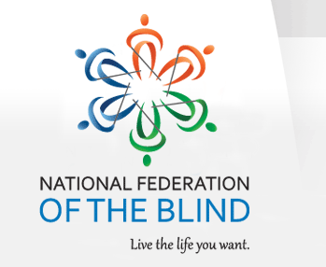

October 12, 2019 MINUTES
National Federation of the Blind
Treasure Coast Chapter

Host Ron VanGelderen Vice President
Pledge of Allegiance Donnie Coker
NFB Pledge Carol Coker
Prayer Mary Hannah-Morris
Treasurers report Donnie Coker
Meeting started 10:08 am adjourned 11:55 am
Beginning balance $ 1,244.41 ending balance $1234.41
-$10.00 sent to National for PAC
Ron VanGelderen agreed to be added to TCC bank account
Members in attendance 10 Guest in attendance 3
Discussions:
1. The value of using Seeing AI, Be my eyes, Aira, Script Talk and devices to help you to see
2. January 11th meeting, Horst Mueller, proprietor of, “Even eyes can see” will be the host. Members and several children will be making personalized pieces of art.
3. Doreen Franklin moved that the Chapter pay the fee for each paid member to Horst for the pieces of art. Second ed by Christina Moore. Quorum of Board members approved this motion
4. Doreen Franklin moved that the Chapter pay the fees for Joe and William Lenartiene for Even eyes can see art pieces. Seconded by Christina Moore. Quorum of Board members approved the motion.
5. Hair Cuttery and Chilies fundraisers were discussed
6. Carol Coker needs to have ALL State raffle tickets and money in by Oct. 18th.
Old news Elections were updated and sent in to the NFB

Secretary
Mary Hannah-Morris
215-680-8385

