Exposing the Exploitation of Disabled Workers

$ Nearly 250,000 disabled workers in the U.S. are paid less than the minimum wage
$ 78 employers in the State of Florida pay less than the minimum wage
$ 6,502 disabled workers in Florida earn less than the minimum wage
$ 10 companies in Tampa Bay pay disabled workers less than the minimum wage
$ 793 disabled workers in Tampa Bay earn less than the minimum wage

“The National Federation of the Blind has advocated for the elimination of the subminimum wage since our founding in 1940 and this documentary powerfully sets forth the case against the unfair and separate wage system for people with disabilities.”
Mark A. Riccobono, President – National Federation of the Blind

Bottom Dollars exposes the exploitation of nearly 250,000 people with disabilities in the U.S. who are legally being paid less than the minimum wage, on average, earning less than $2.00 per hour. This documentary calls for the phase out of the unfair practice of subminimum wages and sheltered workshops, offering solutions for fair wages and inclusive employment. Following the screening, disability advocates from the National Federation of the Blind will conduct a Q&A to discuss the issues and explore alternatives to segregated employment and unfair wages.

WHEN: Saturday, January 21
TIME: 1:00-3:00 p.m.
WHERE: John F. Germany Public Library Auditorium
900 North Ashley Street, Tampa
Light refreshments will be served.

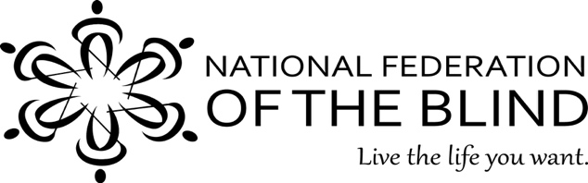
Merry Schoch, LCSW
813-625-1850
merrys@verizon.net

