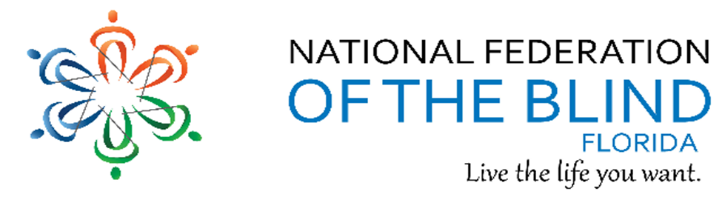BREAKING NEWS
Newsletter
Issue 7 May/June 2017
President’s note:
Greetings Federation Family,
Anticipating having a great time at our state and national conventions with our federation family uniting, learning, sharing, laughing, eating, working, and enjoying one another. We will experience the hope, energy, and love of our family. Can't wait to see everyone soon!
Sincerely, Denise Valkema, President NFBF
Remember we want your tips, stories, recipes, chapter activities, here in the Newsletter.
Find us on twitter and FB @nfbflorida.
Denise Valkema, President NFB OF Florida
president@nfbflorida.org
Facebook & Twitter @nfbflorida
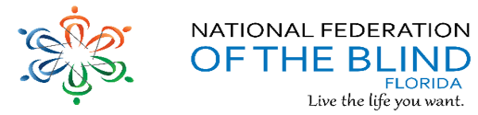
We are filled with hope, energy and love by participating in the National Federation of the Blind. Every day we work together to help blind people live the lives they want.

Announcements and Comments:
Newley elected 2017 State Affiliate Board:
President Denise Valkema
1st Vice President Paul Martinez
2nd Vice President Miranda Kilby,
Secretary Sylvia Young
Treasurer Gloria Mills-Hicks
1st Board position Tekesha Saffold
2nd Board position Jorge Hernandez
3rd Board position Camille Tate
4th Board Position Rafael Fernandez

New Chapter Officers
Reminder to send list of new officer’s names to the president and secretary so we can update our website and records. Thank you for your cooperation.

Lapel Pins on Sale
A “must have” for our collection of federation collectables. Wear it with pride, wear it with joy, wear it; it is a fashion statement. The cost of this beautiful souvenir is only $8.00. You can purchase this unique item during our state convention. All you need to do is ask anyone to assist you locating Jorge Hernandez, Fundraiser Chair. Listen to the fundraising announcements before and after general session, before and after any breakout session in the hallway, and at any time during the state convention when time permits.

COMING SOON NATIONAL CONVENTION:
Monday, July 10th – Friday through July 15th. Get registered today!

UBER
The National Federation of the Blind (NFB) has entered into a settlement agreement with Uber related to guide dogs/service animals. Beginning May 8th, we will kick off a nationwide monitoring project to measure Uber's compliance with the settlement. Each state has a coordinator who will collect and submit the data to our NFB national office monthly. I, Merry C. Schoch will be the coordinator for Florida. My responsibility will be to collect and submit the data from individuals who are willing to participate in the project. If you are interested in being a part of this please let me know by sending an email to merrys@verizon.net You do not have to be a member of the NFB to participate.

FLAGDU ANNOUNCEMENT
Yellow Cab of Tampa, one of Florida's largest taxicab companies, has partnered with the National Association of Guide Dog Users to raise awareness of the rights and responsibilities of disabled individuals who use service animals. They have begun installing NAGDU's "Service Animals Welcome" decals on their fleet of 180 vehicles. These 4 X 5 decals feature the logo of the National Federation of the Blind along with the website of the National Association of Guide Dog Users and the toll-free number to the NAGDU Information & Advocacy Hotline. NAGDU's decals are provided to companies free of charge; however, there is a small postage fee collected upon ordering. If you know of a company wishing to display these decals, prior order authorization is required. To receive your authorization, please send an email message with the number of decals desired and the shipping address to Info@nagdu.org. If you have any questions, please do not hesitate to write, as well. We look forward to partnering with more companies to raise awareness and expectations of the blind!

VOLUNTEER IN THE INDEPENDENCE MARKET & SHARE CONVENTION INFO
Register for the convention and invite others. Share: nfb.org/convention. Volunteer in our Independence Market. Contact: Patricia Maurer at (410) 659-9314, extension 2272 or pmaurer@nfb.org

NFB-NEWSLINE Announces Four New Publications
The NFB-NEWSLINE Team is pleased to share some new publications with you.
First is New York Times Online, International Business Times, McClatchy DC. and Rome News-Tribune.

Talking Book Announcements:
Bard Express is a new Windows-based application for those who download from BARD through a computer. BARD Express simplifies the process of downloading and transferring audio materials to a cartridge or USB flash drive by unzipping and transferring the files for you with the simple click of a button. It is designed for use on personal computers running Windows XP, Vista, 7, 8, 8.1, and 10. It is not for use on mobile devices, nor will it run on Macintosh computers.
NLS has developed a high-volume version of the digital talking book machine for use by patrons who are hearing impaired. The high-volume player is available in either standard or advanced models that have been programmed to have an amplified volume up to 120 decibels. It can be issued only by NLS and will bear a warning label. The high-volume feature only works with the set of stereo headphones that NLS provides with the player and it replaces the old amplifier/headset accessory. An application for the high-volume player can be downloaded from the NLS web site at www.loc.gov/nls/pdf/hvp.pdf.

SHOP SMILE.AMAZON.COM
Start with a smile and shop smile.amazon.com and select NFBF as charity of choice. NFBF will benefit at no additional cost to you. Nothing changes, just use your regular sign on and password and shop as usual. NFBF will reap the rewards by you doing the what you usually do. Happy shopping! Amazon Smile: You shop. Amazon gives.

Please Remember the National Federation of the Blind of Florida in Your Will
If you or a friend would like to remember the National Federation of the Blind of Florida in your Will, you can do so by employing the following language:
“I give, devise, and bequeath unto: National Federation of the Blind of Florida, 3708 West Bay to Bay Blvd, Tampa, FL 33629 a Florida nonprofit corporation, the sum of $____ [or “___ per cent of my estate” or “the following stocks and bonds: ___”] to be used for its worthy purposes on behalf of blind persons.”
All donations to the NFB of Florida are tax-deductible.
How You Can Donate to the National Federation of the Blind of Florida
Please remember that the National Federation of the Blind of Florida gladly accepts contributions to help us carry on the work of Changing What it Means to be Blind. We are a 501(C)(3) charitable organization. Your gift is Tax-Deductible.
If you wish to help us in our campaign to attain and protect Security, Equality, and Opportunity for all blind persons in Florida, the United States, and the world, please send your contribution to: Gloria Mills Hicks, Treasurer, National Federation of the Blind of Florida, 3708 West Bay to Bay Blvd., Tampa, FL 33629
Please make checks payable to "National Federation of the Blind of Florida" or "NFBF".
You can also donate using your credit card, debit card, or bank account, via PayPal. Click on donate button on www.nfbflorida.org

Birthdays & Celebrations:
The NFBF would like to celebrate:
Birthdays:
May:
Alicia Kilby – Suncoast
June:
Lauren Blum – Suncoast
Gordon Bowman - Tallahassee
Donald Christie – Tallahassee
Max Daugherty - Gainesville
Mary Hannah-Morris – Treasure Coast
David Hoss – Tallahassee
Scott Wilson – Suncoast
Anniversaries:
Jada and Donald Christie – May
Doug and Melissa Ingram - May
David and Kathy Roskos – May

Congratulations to Florida’s NLS Certificate Recipients
Under a contract with the National Library Service for the Blind and Physically Handicapped, Library of Congress (NLS), the National Federation of the Blind administers the courses leading to NLS certification of Braille transcribers and proofreaders.
Debra Stratton Fogarty, Jacksonville
Pamela Lynn Wiker, Jacksonville

NFBF Calendar: You can also find important dates on our Webpage
Empowerment committee meeting: TBA, call 712-775-7031 Code: 488500#
411 Interest Topic Call: at 8pm Topic: NFB Philosophy; 712-775-7031 Code: 938047311# Next meeting will be held in May; watch for announcement for date and topic.
Newsline Committee meeting: TBA
Presidents & Vice Presidents Committee meeting: TBA, call 712-775-7031 Code: 488500#
Senior Committee meeting: TBA, call 712-775-7031 code: 488500#
State Board Meeting: Open board meeting at the convention May 26, 2017
2017 National convention July 10-15, 2017. Call Rosen Shingle Creek at (866) 996-6338or (407) 996-9939 to reserve your room.

Legislative Updates:
Here’s a great and simple way to all you legislators contact information so you will be ready when a call for action is sent out. Text your zip code to 520-200-2223 and you will get a message with the phone numbers for all your legislators from your senator on down to your state representative. You will get the information in minutes.
Shared by Sherri Brun

The National Federation of the Blind opposes H.R. 620, the ADA Education and Reform Act. Read President Riccobono’s letter to learn more.

The National Federation of the Blind opposes H.R. 1990, legislation to privatize interstate rest stops. Read President Riccobono’s letter opposing H.R. 1990.

Accessible Instructional Material in Higher Education Act, H.R. 1772 (AIM HIGH)
This bill will promote instructional technology and content that are accessible to students who are blind or print disabled. Read the AIM HIGH fact sheet to learn more.
The Access Technology Affordability Act of 2017, H.R. 1734 and S. 732 (ATAA)
These bills will facilitate the purchase of access technology for blind people by creating a refundable, per person tax credit. Read the Access Technology Affordability Act of 2017 fact sheet to learn more. With respect to NLS funding for refreshable Braille displays, it appears that this is more likely to occur in fiscal year 2019. As a result, we are pivoting our NLS funding efforts to focus on the preservation of the funding that occurs via the Library Services Technology Act (LSTA). These funds are distributed by the Institute of Museum and Library Services (IMLS). Please check with your state library for the blind and ask them if they receive LSTA funding.
Marrakesh Treaty to Facilitate Access to Published Works for Persons who are Blind, Visually-Impaired, or otherwise Print Disabled.
All of the key stakeholders have agreed on proposed language for the Marrakesh Implementation Act. Now that all of the key Senate confirmations are complete, we expect the Senate to begin work on this treaty. We will keep you informed on next steps.
Transitioning to Integrated and Meaningful Employment Act of 2017, H.R. 1377 (TIME)
This bill will increase employment opportunities for people with disabilities by removing stigmas and low expectations propagated by section 14(c) of the Fair Labor Standards Act. Note that the bill now phases out subminimum wages over a six-year period corresponding to the recommendation of the National Council on Disability.
Please contact your representative and ask them to cosponsor H.R. 1772, H.R. 1734, and H.R. 1377. Please also call your two senators and ask them to cosponsor S. 732. The best way to contact your member of Congress is to call the Capitol Switchboard at (202) 224-3121 and ask for the office in question. Emailing your member of Congress is also a good idea. If you do so, please copy JPare@nfb.org. You may also want to request a meeting with your member of Congress while they are back in the district during the week of Memorial Day.
Current Cosponsors in Florida:
Rep. Murphy, Stephanie N. [D-FL-7] – AIM HIGH
Rep. Bilirakis, Gus M. [R-FL-12] – ATAA

Technology: Tips & Tricks
Accessibility Phone Support from Microsoft and Apple
Microsoft has a Disability Answer Desk (DAD) featuring staff who specialize in assisting customers with disability as well as proving support using accessibility settings in Microsoft products. Help is available for screen magnifiers, speech recognition software, Microsoft-compatible devices and accessibility features. DAD, which can be contacted a 1-800-963-5900, is available Monday – Friday from 6 am- 10 pm and weekends from 7 am – 6 pm. For more information, including a 24/7 chat link, visit Microsoft.com/enable.
Apple also offers a telephone support desk specifically for customer who have visual, hearing, motor or learning impairments. Apple accessibility support is available 24/7 and can be reached at 877-204-3930. For more information, visit apple.com/support/accessibility.

KNFB Reader wants you to make the print yours and expand your horizons. KNFB Reader is a mobile app that reads print aloud. To buy KNFB Reader visit www.knfbreader.com or visit the App Store or the Google Play Store. If you would like a demonstration or instruction contact Jorge Hernandez at Phone: 305-877-2311 or Email: jeh1065@comcast.net.

Inspiration Conner:
Knowing is not enough; we must apply. Wishing is not enough; we must do. - Johann Von Goethe

Chapter, Division, and Committee updates:
Greater Broward Chapter: Tom Ryan, President; Phone: 954-442-1855, Email Ryantom@bellsouth.net.

Central Florida Chapter: Sherri Brun, President; Please like us on Facebook at: https://www.facebook.com/groups/410985858949160. We meet the third Saturday of each month from 11:00am to 1:00pm at Lighthouse Central Florida, 215 East New Hampshire Street, Orlando, Florida 32804.

Greater Daytona Beach Chapter: Joshua Espinal, President. We meet the fourth Saturday of the month 11:30am to 1:30pm at TGI Friday's, 24 Ocean Shore Blvd., Ormond Beach FL 32176. Follow Us on Facebook: www.facebook.com/nfbdaytona.

Gainesville Chapter: Judith Hamilton, President; Phone: 352-373-7806, Email: gainesville_nfb@earthlink.net. The Gainesville Chapter welcomes you to our monthly chapter meetings. Meetings are held the second Saturday of each month from 2:00PM to 4:00PM, with meet and greet at 1:00PM. For additional meeting information/updates, please contact Judy Hamilton, Chapter President at the above contact information. Looking forward to seeing our Federation family at state convention May 26 – 29. Stop by our table in the exhibit hall.

Greater Jacksonville Chapter: Marita Winston, President; Phone: 904-323–8597, Email: marita.winston60@gmail.com. We are planning a pancake breakfast at Applebee’s May 6, 2017. Please join us if you are in the area. Drop by our table at the State Convention, or look for members of the Greater Jacksonville chapter at the National Convention to purchase your raffle tickets to win an iPad! That's right, if you've always wanted one, and wondered what all the talk was about, now is your chance. Tickets are $5 for 1 and $12 for 3. The winner will be drawn at the National Convention on July 14th. You do not need to be present to win.

Greater Miami Dade Chapter Jorge Hernandez – President; Phone: 305-877-2311; Email: jeh1065@comcast.net. Our meetings are held on the third Thursday of each month. Location: Denny's Restaurant, 5825 N. W. 36 Street, Miami, FL. New board member was elected during our April meeting. We welcome Alicia Smith to the board of the Miami-Dade Chapter. Come join the Miami-Dade Chapter on June 10th, for the walk in the Park fundraising event. Tickets are $10 and will include food and beverages. The event will be at the following address: Greynolds Park, 17530 W Dixie Hwy, North Miami Beach, FL 33160. For further information, please call Jorge Hernandez at the above contact information.

Melbourne - Space Coast Chapter: Joe Naulty, President; Facebook: www.brevard-nfb.org www.facebook.com/nfbmelbourne. Our next meeting will be on Saturday, June 10, 2017. We meet at The Fountains, 4451 Stack Blvd, Melbourne, FL 32901. The meeting is from 9:30 a.m.-12:00 p.m. Anyone needing transportation, please call Joe Naulty, (321) 768-9500.

Palm Beach Chapter: Tekesha Saffold, President; 561-707-4799; Email: tnsaffold82@gmail.com. We have monthly meetings on the Second Saturday of every month at 4746 North Congress Avenue, Boynton Beach, FL 33425.

Pinellas Chapter: Janice Snow, President; Phone: 727-303-4307; email; mojokitty50@gmail.com. Our meetings are held on the third Saturday of the month at Applebee’s, 5110 E Bay Drive in Largo. We meet for lunch at noon and the business meeting starts at 1:00pm. We are working hard to change what it means to be blind in Pinellas county.

Polk Chapter: Joe King, President: Phone: 863-293-5648; Email: joenkitty@earthlink.net. Our meetings are held the second Saturday of the month at: Winter Haven Manor, 140 Avenue A S.W., Winter Haven, Florida, at 10:00am-12:00pm.

FL State Wide Chapter: Paul Martinez, President; Phone: 813-390-5720; Email: nfbf.statewide@gmail.com. The State-Wide Chapter invites you to join us on our conference call on the third Sunday of every month at 8:00pm. This chapter was designed for those who do not have a local chapter or for some reason cannot get to their local chapter for any given reason.

Suncoast Chapter: Lauren Blum, President; Phone: 352-584-0795; Email: laurenblum79@gmail.com. Meetings are held on the third Sunday of each month from 1:30 pm to 3:30 pm at IHOP,3660 Commercial Way, Spring Hill, FL 34606.The Suncoast Chapter just had a successful Pancake Breakfast in April, and is holding a raffle in June for over $500 worth of gift cards. We are working hard to be involved in the community and Living the life we want.

Tallahassee Chapter: Jada Christie, President; Phone: 850-766-9378 Email: emeraldpink15@gmail.com. We meet the 1st Monday of each month and the Lighthouse of the Big Bend, Tallahassee, FL 32303. We honored the ladies of our chapter for Mother’s Day with dinner at Seineyard Seafood Restaurant May 2nd. We will also honor our men for Father’s Day June 12th. As part of our community service, we donated 400 pounds of food to Second Harvest of Big Bend.

Tampa Chapter: Miranda Kilby, President; Phone: 352-942-0417; Email: NFBF.Tampa@gmail.com. Join us the fourth Saturday of every month. We are growing one member at a time.

Treasure Coast Chapter: Tim Edwards, President; Phone: 630-432-5090; Email: tred34990@gmail.com. Come join the Treasure Coast Chapter of National Federation of the Blind for its monthly meeting on Saturday June 10th, from 10am till noon at WQCS Radio Station @ IRSC, 3209 Virginia Avenue, Fort Pierce. Treasure Coast Chapter had an inside picnic during our May 13th meeting. Our picnic consisted of pizza, salad, cookies, drinks, 2 raffles, fundraising and lots of fun and laughter.

Florida Association of Guide Dog Users (FLAGDU): Sherrill O'Brien, Division President; flagdu@nfbflorida.org

Deaf-Blind Division: Darlene Laibl-Crowe, President; Email: Nfb.florida.deafblind@gmail.com. The FL Deaf-Blind division meets on the first Tuesday of every month at 8:00pm. If you are interested in attending this meeting and learning what the division has; please contact the president.

Florida Organization of Parents of Blind Children (FOPBC): The Parents Division is being reorganized by Kimberly Banks, Email: kimberlybanks1984@gmail.com

Florida Association of Blind Students: The FABS invites any high school or college student to attend our conference calls on the third Sunday of every month at 6:00pm. For further information, contact the president, Paul Martinez at nfbfabs@gmail.com To call into our meetings use conference number 641-715-324 and access code 401665. New President elected during state convention Joseph Chica.

The National Association of Blind Veterans: Dwight Sayer, President; 321-948-1466; Email: president@nabv.org; PO Box 784957, Winter Garden, Florida 34778.

Photo Gallery:
Treasure Coast indoor picnic meeting in May. Members pictured enjoying all the good food.
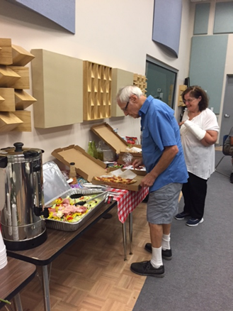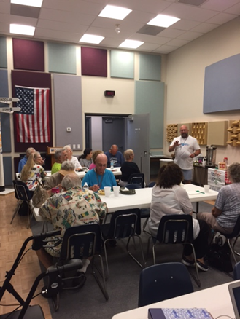
1 Gorgenina in dress after FABS met the challenge of pledging $1000 at the 2017 State convention banquet. 2 National Rep Adelmo Vigil giving his address Saturday, May 28th.
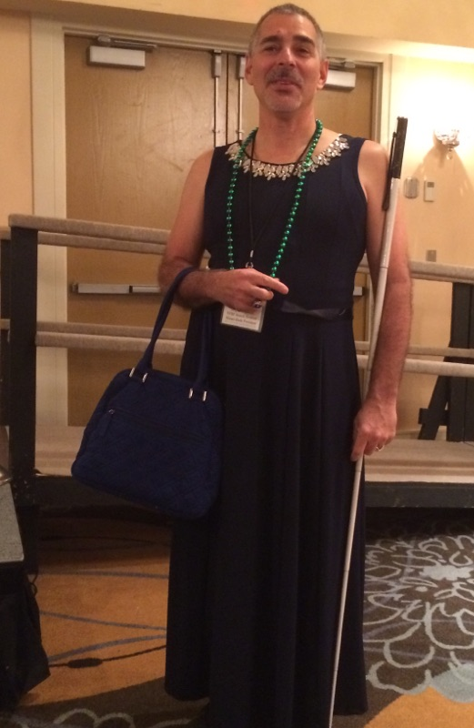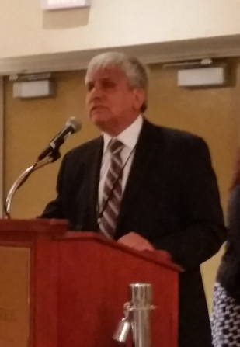
Newly Elected State Board
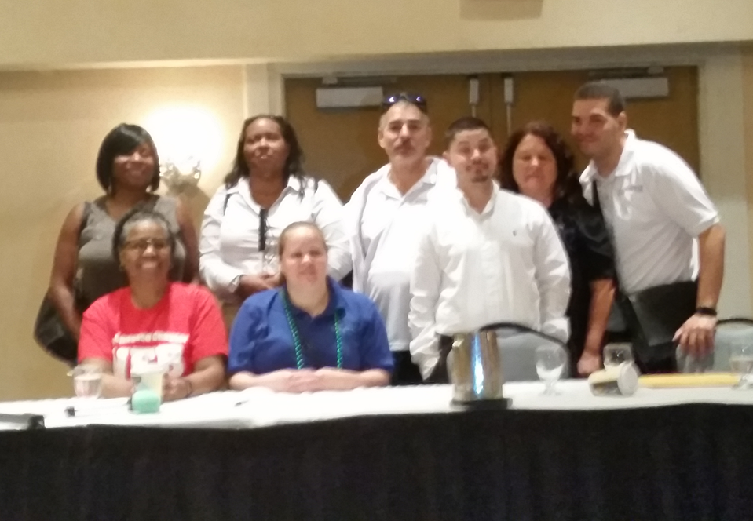
Newley elected State Board and the Central Florida chapter holding the City and County proclamations.
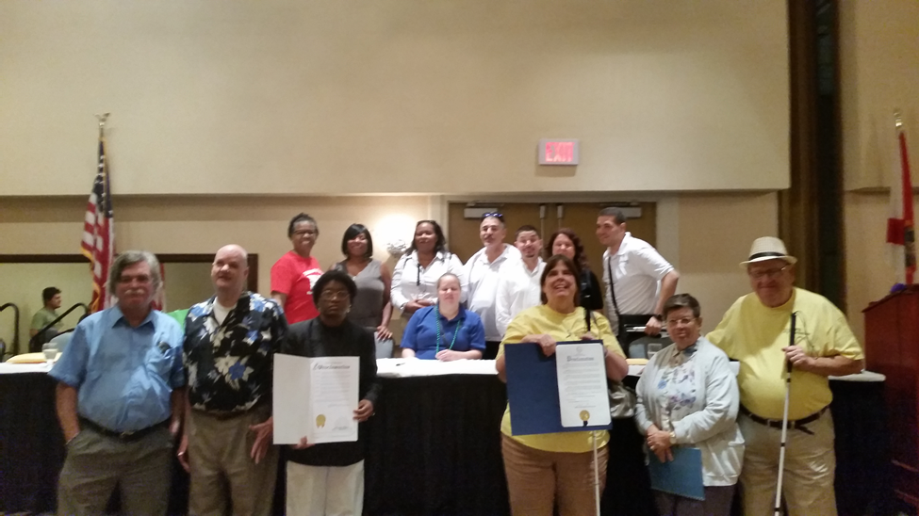

1 Judith Hamilton and Denise Valkema, after Judith received the Leadership Award at the banquet. 2 Joe King and Denise Valkema, after Judith received the Leadership Award at the banquet.
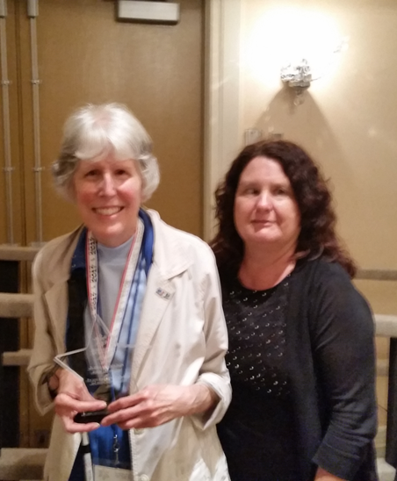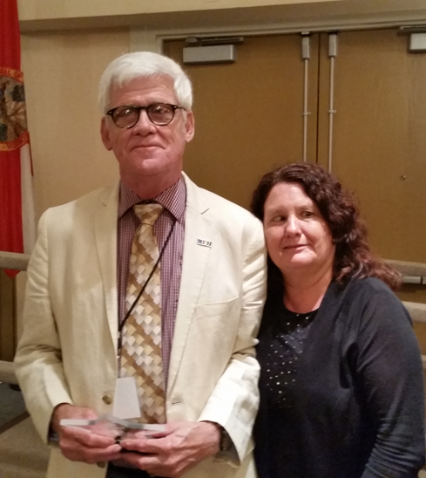
Joan Wade, Daniella Salinas, Joseph Chica, the 3 scholarship winners pictured with Paul Martinez.
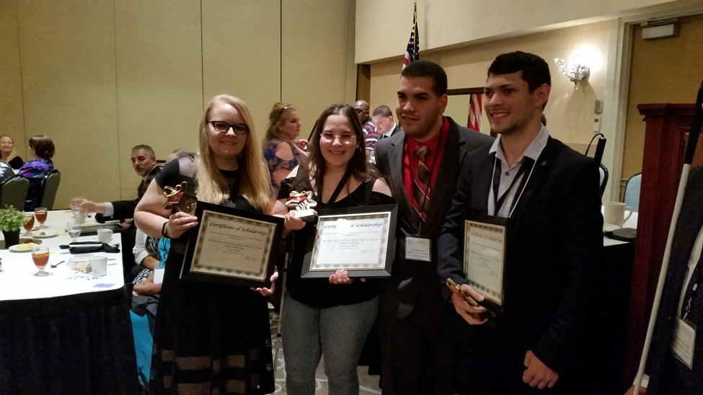
Joseph Chica and Bertha Alexander after Joseph received 2017 Student Scholarship sponsored partially by her husband Dr. Henry Alexander.
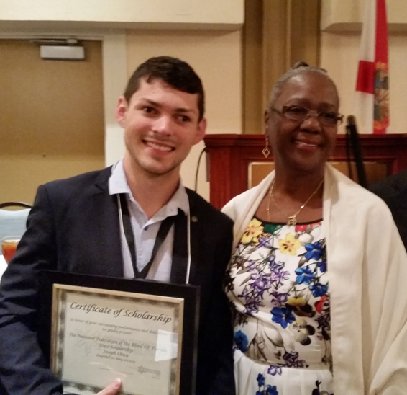

Please contact any of the board with questions, comments, concerns or for general information.
NFBF Board of Director’s Information:
Denise Valkema -President
Phone: 305-972-8529
Email: president@nfbflorida.org

Paul Martinez - 1st Vice President
Phone: 813- 390-5720
Email: paul09ms@gmail.com

Miranda Kilby – 2nd Vice President
Phone: 352- 942-0417
Email: mbkilby@gmail.com

Sylvia Young-Secretary
Phone: 850- 322-5937
Email: secretary@nfbflorida.org@nfbflorida.orgtary@nfbflorida.org

Gloria Mills –Treasurer
Phone: 813-340-9754
Email: glorianfbf@gmail.comglorianfbf@gmail.comlorianfbf@gmail.com

Board Members:
Tekesha Saffold
Phone: 561-707-4799
Email: tnsaffold82@gmail.com

Jorge Hernandez
Phone: 305-877-2311
Email: jeh1065@comcast.net

Camille Tate
Email: Yankiecat1999@cfl.rr.com

Rafael Fernandez
Phone: 305-903-6299
Email: rafael.fernandez0617@gmail.com
Editor: Sylvia Young
To have something posted in the NFBF Newsletter please submit it to the editor, Sylvia young at secretary@nfbflorida.org by the 15th of each odd month.

