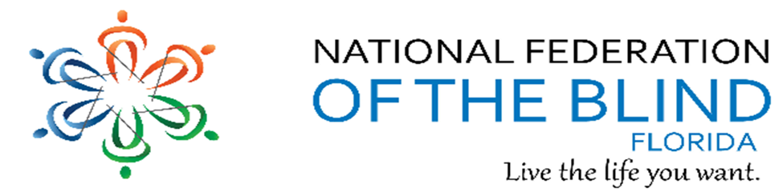BREAKING NEWSLETTER
Issue 13 May/June 2018
President’s note:
Greetings Federation Family,
Thanks to our federation family that participated and contributed to the success of our 2018 state convention. We shared fun, laughs, and information creating lasting memories, friendships, and learned to help us grow as federationists. Thanks for the service of our former board members and congratulations to all elected to the NFBF board making this a great board working together sharing hope, love, and determination as we help lead the federation in Florida! See some of you soon at our national convention!
Denise Valkema, President NFB OF Florida
president@nfbflorida.org
Facebook & Twitter @nfbflorida
Find us on twitter and FB @nfbflorida
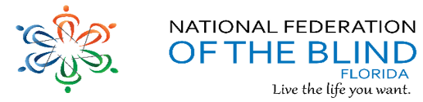
We are filled with hope, energy and love by participating in the National Federation of the Blind. Every day we work together to help blind people live the lives they want.

Birthdays & Celebrations:
The NFBF would like to celebrate:
Birthdays:
May:
Tom Bellone – Daytona Beach
Janet Beyer – State-Wide
Jean Cerullo – Daytona Beach
Max Daugherty – Gainesville
Sue Ann Goldman – Treasure Coast
Chet Rot – Treasure Coast
June:
Donald Christie - Tallahassee
Donnie Coker - Treasure Coast
Tinetta Cooper - State-Wide
Fran Cupeta - State-Wide
Leslie McKinnley – State-Wide
Mary Hannah-Morris - Treasure Coast
Jeannette Torres - Tampa Bay
Anniversaries:
Jada and Donald Christie – Tallahassee - May
Doug and Melissa Ingram – Tallahassee- May
David and Kathy Roskos – Gainesville - May

Announcements and Comments:
2018 STATE CONVENTION
If you missed the state convention this year, you missed a lot of fun and excitement. We had a wonderful turn out and a special visit from Congressman Gus Bilirakis. The auction baskets were fantastic and over $3000 were raised for our BELL Program. We elected new officers to our state board and are looking forward to great thing on the horizons. Please see the photos of all the fun we had in the photo gallery below. The recipient for the Leadership Award was Dan Hicks and the Legacy Award was given to Tom Ryan posthumously. We also honored members from our chapters and divisions listed below. Please take a moment to say “well done” to each of them:
Greater Broward Chapter – Linda Drinkuth
Central Florida Chapter – James Evans
Greater Daytona Beach - Kathy Davis
Gainesville Chapter – Marion Debusk
Greater Jacksonville Chapter - Russell Davis
Melbourne-Space Coast Chapter - Arlene Naulty
Miami-Dade Chapter - John Williams
Palm Beach Chapter - Brook Evans
Polk Chapter – Judy Black
Florida Statewide Chapter - Fran Cupeta
Sun Coast Chapter- Scott Wilson
Tallahassee Chapter – Doug Ingram
Tampa Chapter - Merry Schoch
Treasure Coast Chapter – Roberta Cook
Deaf /Blind Division - Joe Naulty
Florida Association of Guide Dog Users - Sherrill O’Brien

Attention all Diabetics: Whether you are a Type 1, Type 2, Borderline, or gestational Diabetic; This is the group for you. We will be meeting the second Monday of each month starting with June 11th at 7pm. These will be conference calls. We will be discussing anything from different insulins and blood glucose monitors to the complications with diabetes. Please be on time and prepared to share your ideas. The conference call number is: 712-775-7031; Access code: 938047311#; We can’t wait to get started!

NATIONAL CONVENTION
The National Federation of the Blind will hold its annual National Convention for the final time in Florida, during the week of July 3-8, 2018. The convention will be at the Rosen Shingle Creek Resort in Orlando, FL. Please note that the hotel is a no-smoking facility.
Call for your reservations at (866) 996-6338 or you may also write directly to the Rosen Shingle Creek, 9939 Universal Boulevard, Orlando, Florida 32819-9357. Preregister for the convention on the NFB website at www.nfb.org as soon as possible.
National Federation of the Blind 2018 Convention Host Committee and Aira announce a special performance: Allan Pineda Lindo, best known as apl.de.ap from The Black-Eyed Peas, will perform live at the convention July 6, 2018. apl.de.ap will headline a concert set for 7:00 p.m. on July 6, 2018 the Rosen Shingle Creek Resort in Orlando. Legally blind in both eyes from nystagmus, apl.de.ap has always lived the life he wants. On November 18, 2008, apl.de.ap launched the apl.de.ap Foundation, a charity dedicated to helping various communities and children in the Philippines and throughout Asia. As a brand ambassador for Aira, he is excited and honored to perform for everyone attending this year’s National Federation of the Blind Convention.

National Federation of the Blind Announces 2018 Scholarship Program Finalists
The National Federation of the Blind announced the finalists for its 2018 Scholarship Program, which awards thirty scholarships each year to recognize achievement by blind scholars. Our own Amanda Lannan of Florida who is majoring in Education was one of the esteemed scholars. Amanda was also one of our scholarship winners recognized at our State Convention.

AIRPORTS, BLINDSQUARE ENABLED
About BlindSquare Enabled Airports
MIPsoft, makers of BlindSquare, the most used waypoint navigation solution for persons who are blind or partially sighted, has created a special version of BlindSquare, made available for use when entering or exiting BlindSquare Enabled Airports.
Access is enabled through the BlindSquare Event app, available for free on the iTunes store.
Travelers arriving at BlindSquare Enabled Airports, whether by ground or air, will be able to activate BlindSquare Airport Event automatically be provided with free use, regardless of location and continue with the support of BlindSquare EVENT for the next 7 days.
When arriving by ground (for departure), or by air (on arrival), BlindSquare Airport EVENT is ready for use at ANY destination airport on the globe. This, to assist in completing the journey to connect to ground transportation on arrival, hotels, meetings, places to eat and places of fun, supported with all the tools of BlindSquare and 105,000,000+ points of interest globally. When returning to any sponsored airport, the 7-day counter is renewed, for another 7 days.
Interactive maps:
US airports in Florida include:
• Miami International Airport - Miami
• Orlando International Airport - Orlando
• Tallahassee Regional Airport - Tallahassee
• Tampa International Airport – Tampa

Articles by Florida Members
Attending my First Braille Conference
by Roanna Bacchus
Braille is essential to the personal and academic success of all blind students. Parents of blind children have had to fight for their children to receive braille instruction in the classroom. As a recent college graduate and a blind student who went through the public-school system, I am passionate about ensuring that all blind and visually impaired students receive their materials in an accessible format. My braille reading and writing skills have allowed me to excel academically and personally and to find employment as a braille transcriber in the future.
Recently, I had the opportunity to attend the "Working with The Experts- Braille! A Passport to The Future for Students with Visual Impairments" conference in Tampa, Florida. This event was hosted by the Visual Aid Volunteers of Florida (VAVF) and the Florida Instructional Materials Center for The Visually Impaired (FIMCVI). FIMCVI is the agency that provides accessible materials in braille, large print, and digitally to blind students throughout Florida. The VAVF was founded by a small group of members from Central Florida who were passionate about ensuring that visually impaired students receive their materials in an accessible format. They work closely with the FIMCVI staff and other personnel from school districts and agencies around the state to get assignments that need to be brailled for students. Their membership includes certified braille transcribers and Teachers of the Visually Impaired (TVI) from across the country. The conference was held from Wednesday, April 4th through Friday, April 6th at the FIMCVI office in Tampa.
Food and prizes for the event were purchased with donations from companies that make assistive technology devices and personal funds from the FIMCVI and VAVF staffs. During the conference, I had the opportunity to meet some fellow braille transcribers from the Braille Association of Mid Florida, a nonprofit organization that brailles books for students throughout Florida. On the last morning of the conference, I attended a workshop about braille transcription. The presenter discussed the basic formatting principles for transcribing and producing high-quality braille for visually impaired students. Friday afternoon, I attended a workshop about tools that are used to produce tactile graphics. In high school my TVI taught me to use Wikki stix to produce my own graphs for homework.
This Summer I will be working with an instructor from the Braille Association of Mid Florida to complete the certification course to become a braille transcriber. I enjoyed my experience at this conference.

Link City: Here are some important links that may be of interest.
NFB: https://nfb.org/
NFBF: http://nfbflorida.org/
May Presidential release: https://nfb.org/images/nfb/audio/podcast/presidential-releases-en/pr472.mp3

Legislative Updates from the desk of Camille Tate:
The Legislative Concerns Committee invites you to join our movement to equalize, enhance and move blind people into first-class citizenship. Our committee works on the legislative priorities of our National Office and to move the dial within Florida. Each year, the National Federation of the Blind of Florida sends delegates to Washington, D.C. to participate in Washington Seminar, where we descend upon our elected officials to pass legislation that will affect the blind on a nationwide scale.
We bring to the committee and our state leaders the issues our members feel are important. The Legislative Concerns Committee will discuss these issues, consult with our Governmental Affairs Team in Baltimore and create a plan of attack to accomplish our goals.
One of the priorities we are moving forward with is blind parental rights. Across our organization, several affiliates have worked successfully on establishing the rights of blind parents to retain custody of their children and not have their abilities dismissed by social service agencies, family courts and/or family members simply because they are blind. If you have experienced interference by such entities, whether or not you have been successful, please share them with us. If you know of someone who has been through this process, refer them to us. The Legislative Concerns Committee will begin working diligently on Florida’s blind parents’ rights in the upcoming months. We would like to have our bill introduced in the 2019 Legislative Session in the Florida Congress. Camille Tate is spearheading this effort and can be contacted at (321) 372-4899 or ctate2076@att.net.
The Legislative Concerns Committee meets on the third Tuesday of each month at 8 p.m. If you want to join us in bringing Florida residents into first-class status or are interested in our national agenda, come to one of our meetings. All meetings are announced on the Florida list. The call-in number is (712) 775-7031; and the access code is 938047311#.
The committee is co-chaired by Merry Schoch and Camille Tate. Our contact information:
Merry Schoch
(813) 625 1850
merrys@verizon.net
Camille Tate
(321) 372-4899
Ctate2076@att.net

Inspiration Conner:
“Karma. What goes around comes around. Keep your circle positive. Speak good words. Think good thoughts. Do good deeds.” ― Writer Unknown
Chapter, Division, and Committee updates:
Greater Broward Chapter: Jake McEntyre, President, Email: jmac1920@yahoo.com. Our meetings are held the second Saturday of each month from 10:30 a.m. until 12:30 p.m. at the Westfield Broward Mall, 8000 W. Broward Blvd., Plantation, FL 33312; inside the Plantation Police Outreach Center North side of the Mall.

Central Florida Chapter: Sherri Brun, President; Please like us on Facebook at: https://www.facebook.com/groups/410985858949160. We meet the third Saturday of each month from 11:00am to 1:00pm at Lighthouse Central Florida, 215 East New Hampshire Street, Orlando, Florida 32804.

Greater Daytona Beach Chapter: Joshua Espinal, President, Phone: 407-534-0160, Email Joshua.espinal@everest.edu. We meet the fourth Saturday of the month from 1-3 p. m. unless moved for State Convention or Thanksgiving, when it is the third Saturday at Houligan’s Restaurant, 1725 W. International Speedway Blvd., Daytona Beach, FL 32114. Follow Us on Facebook: www.facebook.com/nfbdaytona.

Gainesville Chapter: Judith Hamilton, President; Phone: 352-373-7806, Email: gainesville_nfb@earthlink.net. The Gainesville Chapter welcomes you to our monthly chapter meetings. The Gainesville Chapter meeting will be June 9, 2018 at the Alachua County Headquarters Library, Foundation Room, 401 East University Avenue from 2:00PM to 4:00PM. There will be an Access Art Event at the Harn Museum, June 16, 2018 from 11:00AM to 2:00PM. Our members plan to be at this public event.

Greater Jacksonville Chapter: Marita Winston, President; Phone: 904-323–8597, Email: marita.winston60@gmail.com. Please join us if you are in the area.

Greater Miami Dade Chapter Jorge Hernandez – President; Phone: 305-877-2311; Email: jeh1065@comcast.net. Our meetings are held on the third Thursday of each month. Location: Denny's Restaurant, 5825 N. W. 36 Street, Miami, FL. The Miami-Dade Chapter sent 15 members of the chapter to the State Convention in Tampa, Florida. Our Basket for the auction is full of great items and will be one of the best baskets from the affiliate. We are finalizing plans for our second annual “Walk in the Park” event once our members return from the convention. The City of North Miami Beach will be providing a proclamation making the date “June 9th” NFBF Miami-Dade Chapter a day where the Walk in the Park is to educate, advocate, and demonstrate that we are living the life’s we want as blind individuals. In June, we have the President and CEO of the Miami Lighthouse for the Blind be our guest speaker and provide information on the services the Lighthouse is offering. Also, we are planning to have a representative from Emergency Management to speak and educate the members in the upcoming hurricane season. Fundraising events are in the planning stages for the remaining month of the year.

Melbourne - Space Coast Chapter: Camille Tate, President; Phone: 321 372-4899; Email: ctate20176@att.net Facebook: www.facebook.com/nfbmelbourne. We meet the second Saturday of each month at The Fountains of Melbourne, 4451 Stack Blvd., Melbourne, FL, 32901. We meet from 9:30 a.m.-noon. Please contact President Camille Tate with questions at the number above.

Palm Beach Chapter: Tekesha Saffold, President; 561-707-4799; Email: tnsaffold82@gmail.com. We have monthly meetings on the second Saturday of the month.

Polk Chapter: Joe King, President: Phone: 863-293-5648; Email: joenkitty@earthlink.net. Our meetings are held the second Saturday of the month at: Winter Haven Manor, 140 Avenue A S.W., Winter Haven, Florida, at 10:00am-12:00pm.

Florida State-Wide Chapter: Paul Martinez, President; Phone: 813-390-5720; Email: nfbf.statewide@gmail.com. The State-Wide Chapter invites you to join us on our conference call on the third Sunday of every month at 8:00pm. The State-Wide members had a great time at convention. Some enjoyed seeing old college friends, and many helped by being ambassadors, aiding with registration, being runners during general session, and assisted with the fundraiser for next year’s convention hotel stay raffle. The chapter is thrilled that we took the Orange trophy away from the Tampa Bay Chapter, and we know it is here to stay. The chapter will regroup after state convention to organize goals and celebrate our achievements.

Suncoast Chapter: Lauren Blum, President; Phone: 352-584-0795; Email: laurenblum79@gmail.com. The Suncoast Chapter (Hernando County) will meet on Saturday, June 16 at 1 pm at Perkin’s Restaurant and Bakery located at 4685 Commercial Way, Spring Hill, FL 3460. We will be discussing the state convention and the direction for our chapter.

Tallahassee Chapter: Jada Christie, President; Phone: 850-766-9378 Email: emeraldpink15@gmail.com. We meet the 1st Monday of each month at the Lighthouse of the Big Bend, Tallahassee, FL 32303. The Chapter was excited to bring 6 members to the convention, one of which was a first timer and had multiple door prize winners during the sessions. We look forward to seeing everyone again at the National Convention.

Tampa Chapter: Miranda Kilby, President; Phone: 352-942-0417; Email: NFBF.Tampa@gmail.com. Join us the fourth Saturday of every month. The Tampa Bay chapter along with the Suncoast Chapter hosted a fabulous convention. We loved being with all our NFB family during the Memorial Day weekend. We definitely are thankful to everyone who help make this the best convention ever!!! The Chapter thanks the State-Wide chapter for the friendly competition, but would like to let the chapter know, we will take back our trophy soon. So, don’t get used to it. In all honesty, congratulations!!! The chapter will now start the planning process for attending our National convention.

Treasure Coast Chapter: Tamika Butts, President; (772) 708-3749, tamika_butts@aol.com. Come join the Treasure Coast Chapter of National Federation of the Blind for its monthly meetings are held on the 2nd Saturday of each month, from 10 am till noon at WQCS Radio Station @ IRSC, 3209 Virginia Avenue, Fort Pierce. We had a guest speaker, Bobby Davis from the Division of Blind Services at our April meeting. She explained the services provided and how to contact her if any assistance is needed. Chapter T-shirts were ordered by our members and we gained four new members. Our chapter is growing!

Florida Association of Guide Dog Users (FLAGDU): Sherrill O'Brien, Division President; sherrill.obrien@verizon.net; flagdu@nfbflorida.org

Deaf-Blind Division: Alicia Betancourt, Interim President; Phone: 386-589-7324; Email: licib85@gmail.com. The FL Deaf-Blind division meets by teleconference call on the second Tuesday of every month at 8:00pm. Call in number is 515-604-9853, Access code: 997037. People with hearing and vision loss represent a unique segment of Florida’s population and we work to promote greater understanding of this dual disability. If you are interested in actively participating and learning more about this division, please contact Alicia Betancourt.

Florida Organization of Parents of Blind Children (FOPBC): Cherice Togun, President; (407) 257-7637; chericeflemingtogun@hotmail.com

NFB of Florida - Blind Parents Initiative
We meet on the 2nd Tuesday of the month via conference call at 8:30pm. The phone number is 712-775-7031, and the code is 938047311. The Blind Parents want to serve as a resource and outlet for Blind parents to express concerns, questions or just have a positive dialect with one another. Learn how we parent as a blind parent and what techniques we use that may be different from our sighted peers. If anyone has any questions or would like to speak to me, please contact Nicole Fincham-Shehan, Vice-President, Coordinator of Blind Parents Initiative.

NFBF Book Club: You are invited to join the NFBF Book Club and Discussion Group. We meet on the fourth Thursday of each month at 8 p.m. The call-in number is (712) 775-7031 and the access code is 938047311#. Check the Florida List for the topic of the month. Come and join the lively discussion!

Committee to Empower Underserved Populations: Marilyn Baldwin, Chairman, 8427 Lainie Lane, Orlando, Florida 32818, 407-293-0565, CommMDB@aol.com. Everyone is encouraged to attend or have at least one representative from your chapter or division. The Conference call number is (712) 775-7031; Code 938047311

Communication Committee: The committee diligently advertised the state convention on all our platforms. We encourage all members to Like us on Face Book and follow us on Twitter. In addition, signing up to our list serve is a great way to stay connected throughout the year, and allows you to share information as well. The committee needs your help by sending content for our NFBF Newsletter and for Newsline. Need help, contact Miranda Kilby, Communications Chair.

Fundraising committee: The fundraiser committee thanks everyone who participated and contributed in all our fundraising efforts over the year, and at this year’s state convention. Our 2018 auction was extremely lively, and all funds will go towards our 2018 BELL Academy. The battle was won by President Valkema and our 1st Vice President Paul Martinez was pied in the face. A huge thanks to Merry Schoch who paid $100 to pie Paul’s handsome face. Once again, thank you, thank you, and thank you for everyone’s contribution during our 2018 state convention!!! In addition, if you were unable to purchase our latest raffle for a 3-night stay at next year’s state convention, you still have an opportunity to enter. Paul Martinez, fundraising chair will be accepting mail in orders, PayPal, or you can see him before the Florida coccus at national convention. Please contact the fundraising chair, Paul Martinez at 813-390-5720 for more information.

Legislative Committee: Keep an ear out for the announcement of the next teleconference meeting. Call: 712 775 7031 access code: 938047311# All are welcome to come

NFB411: The next call is in July and is in the planning process. We will be holding a NFB411 call this month on communication throughout our organization. Updates will be posted throughout our list serv.

Scholarship Committee: The students had a great time, and some have joined chapters and divisions. Comments from the scholarship winners are as follows: Michelle says, “Thank you so much for everything. I truly appreciate receiving the scholarship, and I had a fantastic time at the National Federation of the Blind state convention.” Shaquice says, “I had an amazing time. Thank you so much for the opportunity, and the hard work and time that went into making sure the weekend ran smoothly. Everything was great, the people, food, workshops, and all. I really enjoyed and learned a lot.” Amanda says, “That she will be sending a thank you card to the board. She appreciated the opportunity and was excited to network with everyone.”

Senior Concerns Committee: Gloria Mills-Hicks, Chairman; Phone: 813-340-9754; Email: glorianfbf@gmail.com. The phone number for the call is 712-775-7031 The Code is 488500#. Stay tuned to the list-sever for the next call.

Sponsorship Committee: We ask that you join us at our Florida caucus at our national convention, to welcome our 2018 sponsorship winners.

The National Association of Blind Veterans: Dwight Sayer, President; 321-948-1466; Email: president@nabv.org; PO Box 784957, Winter Garden, Florida 34778.

Photo Gallery:
2018 National Rep – Pam and husband Roland Allen
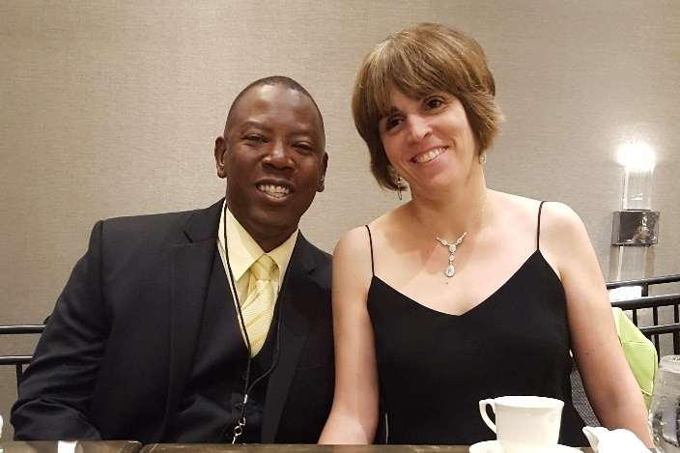

Paul Martinez pied for fundraising
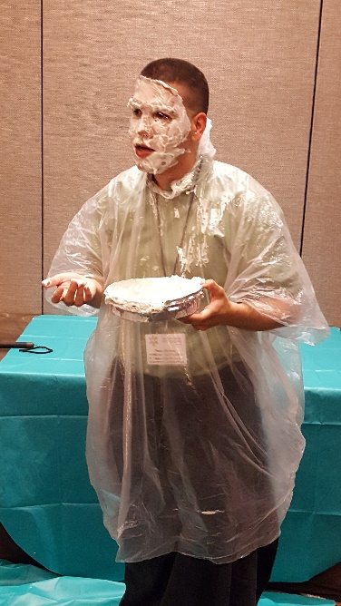
2018 Scholarship Winners – Lannan Amanda, Michelle Yongue, and Shaquice Floyd,
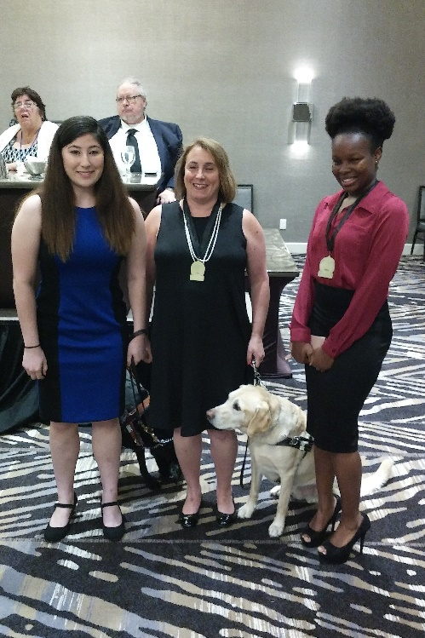

Leadership Award winner – Dan Hicks / Legacy Award Winner – Tom Ryan, accepted by Debbie Ryan
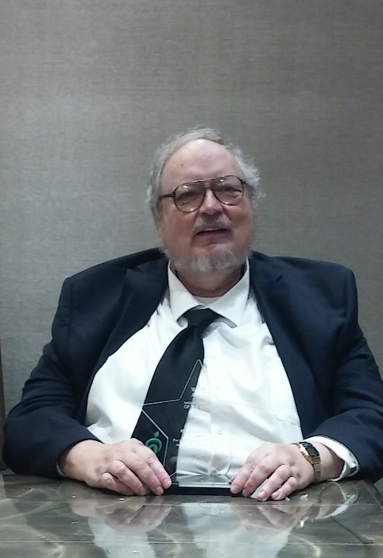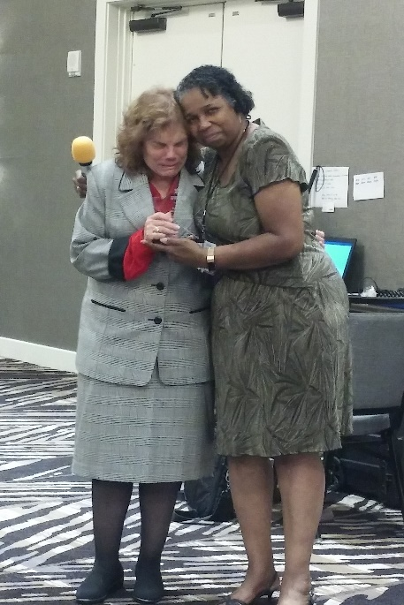

Outstanding Chapter Members – Listed above in announcement section.
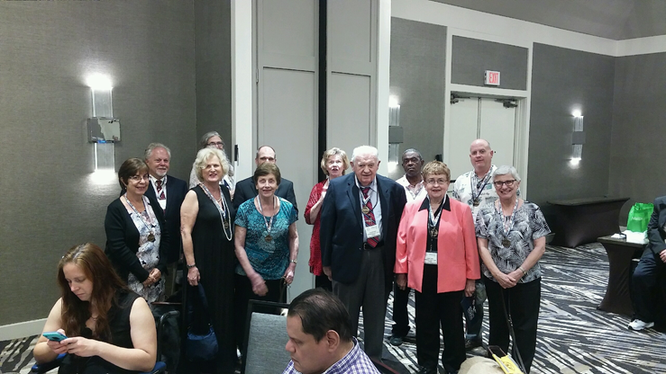
Honorable Luis Viera, Chair, Pro-Tem, Tampa City Council, National Rep Pam Allen, Congressman Gus Bilirakis, Scholarship winners - Michelle Yongue, and Shaquice Floyd, Paul Martinez and Merry Schoch
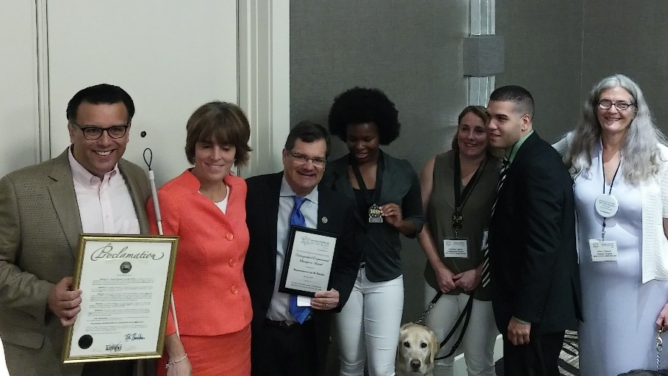
2018 NFBF State Board
Young, Martinez, Hernandez, Schoch, Fernandez (back row)
Valkema, Kilby, Blum and Tate (Front row)

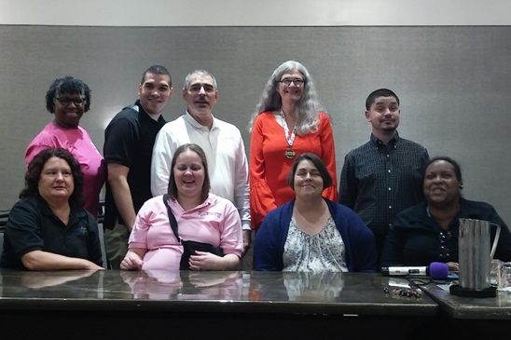

Please contact any of the board with questions, comments, concerns or for general information.
NFBF Board of Director’s Information:
Denise Valkema -President
Phone: 305-972-8529
Email: president@nfbflorida.org

Paul Martinez - 1st Vice President
Phone: 813- 390-5720
Email: paul09ms@gmail.com

Miranda Kilby – 2nd Vice President
Phone: 352- 942-0417
Email: mbkilby@gmail.com

Sylvia Young-Secretary
Phone: 850- 322-5937
Email: secretary@nfbflorida.org

Merry Schoch –Treasurer
Phone: 813-523-6573
Email: merrys@verizon.net

Board Members:
Lauren Blum
Phone: 352-584-0795
Email: laurenblum79@gmail.com

Jorge Hernandez
Phone: 305-877-2311
Email: jdh6@bellsouth.net

Camille Tate
Phone: 321-372-4899
Email: ctate2076@att.net

Rafael Fernandez
Phone: 305-903-6299
Email: rafael.fernandez0617@gmail.com
Editor: Sylvia Young
To have something posted in the NFBF Newsletter please submit it to the editor, Sylvia young at secretary@nfbflorida.org by the 15th of each odd month.

