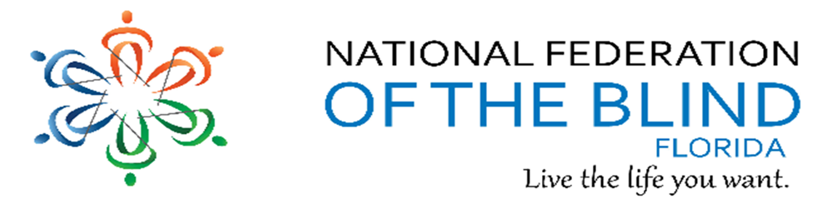BREAKING NEWSLETTER
Issue 14 September/October 2018
President’s note:
Greetings Federation Family,
October is meet the Blind month and many of our chapters are holding events in the community. We have many conference calls on different topics meeting the same day and time monthly or bimonthly. These calls are listed in the newsletter and posted on our lists. Come join us. Thank you to all who are participating actively in the federation.
Denise Valkema, President NFB OF Florida
president@nfbflorida.org
Facebook & Twitter @nfbflorida
Find us on twitter and FB @nfbflorida
We are filled with hope, energy and love by participating in the National Federation of the Blind. Every day we work together to help blind people live the lives they want.
What’s in this Newsletter:
Birthdays & Celebrations – Page 2
Announcements and Comments – Page 3
Apple Tips and Tricks – Page 6
Link City – Page 7
Inspiration Conner – Page 7
Legislative Updates – Page 7
Chapter, Division, and Committee updates – Page 9
Photo Gallery – Page 14
NFBF Board of Director’s Information – Page 15

Birthdays & Celebrations:
The NFBF would like to celebrate:
Birthdays:
September:
Blanche Butts – Treasure Coast
Carol Coker – Treasure Coast
Marion Debusk – Gainesville
Judy Hamilton – Gainesville
Gloria Mills Hicks – Tampa Bay
Christine Van Gelderen – Treasure Coast
October:
Monique Bowden – Tallahassee
David Roskos – Gainesville
Fran Roth – Treasure Coast

Anniversaries:
James E and Sylvia Young – Tallahassee - October

ANNOUNCEMENTS AND COMMENTS
The Independence Market website will be down until January. However, their staff is available to assist you by phone or email; Monday through Friday from 9:00 a.m. to 4:00 p.m. ET.
Phone: 410-659-9314, extension 2216
Fax: 410-685-2340
Email: independencemarket@nfb.org

Microsoft Disability Answer Desk
We hope you’ve had the opportunity to use our Specialized Help feature and call the Microsoft Disability Answer Desk. It is important to us at Be My Eyes that the feature continues to be a helpful and efficient solution to any technical issues.
Microsoft has been pleased to offer you this extended customer support - so much that they are now expanding their opening hours. You may now call the Microsoft Disability Answer Desk through Be My Eyes Specialized Help 24/7! This means whenever you need technical assistance with your Microsoft product or service, a Microsoft agent will be ready to help you out.
“We are honored to join the thousands of volunteers in Be My Eyes’ global community that help empower people who are blind or have low vision lead more independent lives. That is why we are thrilled to expand this support offering from Microsoft’s Disability Answer Desk to 24 hours, 7 days a week, for their users. Specialized Help is a great example of bringing new services to people that can make the world more accessible and inclusive.”
– Neil Barnett, Director of Inclusive Hiring and Accessibility, Microsoft
We are thrilled to team up with Microsoft to offer you the best possible customer support with increased reliability and receptivity. We sincerely hope that this expansion continues to serve you well.
Alexander Hauerslev Jensen,
Community Director at Be My Eyes
Keep in touch, find us on: <https://www.facebook.com/bemyeyesapp> <https://twitter.com/bemyeyes> <https://www.youtube.com/bemyeyes> <https://www.instagram.com/bemyeyesapp/>

The Importance and Value of Voting by Camille Tate
On November 6th, the nation will cast their votes and choose their leaders in the mid-term elections. Voting is an essential and integral right of each and every American citizen. All of us remember from Social Studies/Civics/American History class the famous words, “no taxation without representation”. This was the founding principle of the United States of America. We have fought bloody battles to gain voting rights for African-Americans and women. Voting is a quintessential right that all Americans share.
As blind Americans, we are familiar with the difficulty in exercising our right to vote independently and secretly. For years, we needed a sighted person, whether a family member, friend or poll worker, to assist us in casting our ballot. Those days are long behind us. The Help America vote Act (HAVA) of 2001 mandated that all polling stations have at least one working accessible voting machine. There should also be a poll worker who is able to show the uninitiated how to operate the machine and be available to fix a non-working machine. If your polling station does not have an accessible voting machine or the one available does not work, contact your local Supervisor of Elections. Stand up for your right to vote secretly and independently.
We urge you to cast your ballot, no matter your political affiliation or feelings about American politics. One vote can make a difference, even more so during a mid-term election. Statistically, less people vote than in a Presidential election, so your one vote may tip the scales in the direction you want. Whether you are a Democrat, Republican or Independent, do not let this opportunity to participate in the election process pass by.
If you are not registered to vote in Florida, contact your local Supervisor of Elections. Bring your photo identification and voter's registration card to the polling station. Due to a lengthier early voting period, there are many opportunities to vote. Do not be afraid to request an accessible voting machine and assistance to use it if you are unfamiliar with the technology. Some Supervisor of Elections offices may allow the disabled public to “practice” with the machine prior to an election; please call them and find out if this service is available and when you can take advantage of it. In the 21st century, we the blind, have more opportunities to direct who sits in what office in government.
Tech it Out
Announcing a new Hadley discussion group, Tech it Out. These regularly scheduled discussions will offer a chance to learn a few tips from a technology expert, ask your questions, and share your experiences.
Our first session on 9/25/18 will cover technology and food delivery services, hosted by Ricky Enger, a Hadley Learning Expert.
“Food may not magically appear on our tables,” Ricky explains, “but we can tap into the power of technology to get pretty close.”
Tune in to ask your questions and share your experiences with various restaurant and grocery delivery services.
Join this discussion from your computer, an app on your phone, or simply by calling in.
Date: Tuesday, September 25, 2018; Time: 8:00 PM Central Time; Call: 1 (646) 876-9923; then enter the meeting ID: 652 959 377#
You can also join from your PC, Mac, Linux, iOS or Android using this link: <http://click.icptrack.com/icp/relay.php?r=17848682&msgid=830963&act=Y8O6&c=225701&destination=https%3A%2F%2Fzoom.us%2Fj%2F652959377> https://zoom.us/j/652959377
Or iPhone one-tap: US: +16468769923,,652959377#
Ricky Enger, Hadley Learning Expert

The Florida Rehabilitation Council for the Blind and the Division of Blind Services announces a public meeting to which all persons are invited.
DATE AND TIME: October 18, 2018, 5:00 p.m. - 6:00 p.m.
PLACE: Hilton Miami Airport Blue Lagoon, 5101 Blue Lagoon Drive, Miami, FL 33126, Phone: 1(888) 670-3525, Passcode: 1242528392#
GENERAL SUBJECT MATTER TO BE CONSIDERED: For consumer input on the effectiveness of services provided by the Florida Division of Blind Services in assisting individuals with visual impairments achieve employment and independence under Title I of the Rehab Act.
A copy of the agenda may be obtained by contacting: Open meeting with no agenda
Pursuant to the provisions of the Americans with Disabilities Act, any person requiring special accommodations to participate in this workshop/meeting is asked to advise the agency at least 10 days before the workshop/meeting by contacting:
Selena Sickler, The Division of Blind Services, 325 W. Gaines Street, Room 1114, Tallahassee, FL 32399, (850) 245-0329 or e-mail: Selena.Sickler@dbs.fldoe.org.
If you are hearing or speech impaired, please contact the agency using the Florida Relay Service, 1(800)955-8771 (TDD) or 1(800)955-8770 (Voice).

Advertising is the key to success, and we can help!
I hope you all are well, and that you all are gearing up for a fantastic Meet the Blind Month. I would like to remind all of you to utilize our different platforms to share your activities. For example:
Each chapter and Division has their own channel on Newsline and Russ Davis is ready for your submissions. You can contact him by emailing, newslinesupport@nfbflorida.org.
Also, we would love to advertise your events on our Face Book and Twitter accounts. So, let us know prior to the event, and we can share your event to all of our followers. However, let us know your successes too. Send us pictures, videos, and share the energy with your family. Send your social media information with Miranda Kilby at mbkilby@gmail.com or with President Valkema at Valkemadenise@aol.com, and we will get your information posted. Please don’t forget to send any descriptions of any pictures or videos.
If you have any questions, comments, or concerns, please feel free to reach out to me at your convenience.

APPLE TIPS AND TRICKS
By Camille Tate
Using the Rotor
One of the disadvantages of voice over when writing using an iPhone or iPad is correcting misspellings, punctuation and grammar. Using voice over, spell check does not work. Normally, with a spelling error, a drop-down menu becomes available with a list of the correct spellings. However, this menu does not appear when using assistive technology, like voice over. Also, while voice dictate is convenient when sending texts and emails, editing is often necessary. Here is when the rotor comes in handy.
Some of the functions the rotor is helpful to use is editing characters, words, lines and rows. It allows a user to move the cursor either by character, word, line or row. Some of the selections include misspellings and punctuation. The usefulness of this tool makes it easier to edit entire documents without having to start at the beginning of text and swiping up or down to find the error. Here is a basic set of instructions for accessing the rotor:
• Double tap on the line you wish to edit. You will hear that you are in character mode, either at the start of the line or the end.
• Using your thumb and forefinger, place the two fingers on the surface of the device and pretend you are turning a knob, either to the left or the right. You will hear the first selection. Keep turning until you hear the function you want to use, i.e. “characters, words”, etc.
• Once you hear the function you want, swipe up or down, depending on the direction you intend to move.
• You will be able to edit, either by deleting or adding letter, numbers, symbols, emojis etc.
These are simple instructions on the rotor and it will take some practice. There are times you will have to start over or have missed the function you are looking for. Remember, you can turn the rotor dial left or right, depending on what you want to do. Practice, practice, practice.
On the iPad, the rotor allows you to move from the app you are working in or the “doc”. This function works by utilizing the “containers” feature in the rotor. Once again, practice!

Link City: Here are some important links that may be of interest.
NFB: https://nfb.org/
NFBF: http://nfbflorida.org/
Nation's Blind Podcast - September: https://t.co/RX2uUdGMA5
Presidential release - September: https://nfb.org/images/nfb/audio/podcast/presidential-releases-en/pr473.mp3
Braille Monitor - October: https://nfb.org/images/nfb/publications/bm/bm18/bm1809/bm1809tc.htm
2018

Inspiration Conner:
“Beauty to me is being comfortable in your own skin.” - Gwyneth Paltrow

Legislative Updates from the desk of Camille Tate:
The National Federation of the Blind of Florida would like to thank all of our members who have participated in our legislative priorities from the 2018 Washington Seminar. Our affiliate members, along with Federation members across the nation, have worked diligently to get the Marrakesh Treaty Implementation Act discharged and up for a vote in the House of Representatives. We have called Representative Goodlatte, Chairman of the House Judiciary, to move this long-awaited legislation forward. At the time of the writing of this article, the Implementation Act is up for a vote to the full House! Keep an eye and ear out for the latest news regarding this vote on our list. Hopefully the next post will share the good news that it has passed. Our collective voice can make a difference.
We will not let up the pressure on Senators Nelson and Rubio and the Access Technology Affordability Act. Please continue to contact their offices, requesting they sign on as co-sponsors to the Senate Companion to this bill. Additionally, we still have Florida Representatives who have yet to sign on as co-sponsors to ATAA (H.R. 1734) and Accessible Instructional Materials in Higher Education (AIM HI), (H.R. 1772). If your Representative is not yet signed on to either of these bills, please encourage them to do so. As more and more of us seek meaningful, better wage-earning jobs or higher education, the importance of these bills cannot be stressed. Education and access are key to our success to living as first-class citizens. Make a phone call, write a letter or email or visit their district office. If you send an email, please copy Merry Schoch, merrys@verizon.net and John Pare, jpare@nfb.org.
The Blind Parents Initiative is kicking into high gear. The National Federation of the Blind of Florida is working to join our Federation brethren in getting a bill into the Legislative Session in March/April 2019. We believe that blindness should not be an obstacle to a parent’s right to raise their children. Contact Camille Tate, ctate2076@att.net, about our Blind Parent’s Initiative.
We are pleased to announce that the Space Available Act was finally passed in Congress. Thank you to each and every member who participated in this long-anticipated victory! It may take years for our efforts to come to fruition, but we never give up.
The Legislative Committee will meet on Tuesday, October 16th at 8 p.m. The call-in information is below:
Call-in number: 712 775 7031 Access Code: 938047311#
The committee is co-chaired by:
Camille Tate - Ctate2076@att.net - 321 372 4899
Merry Schoch - merrys@verizon.net - 813 625 1850

US House of Representatives Passes Marrakesh Treaty Implementation Act Treaty Now Awaits Presidential Action (Released 9/25/18)
Washington, DC (September 25, 2018): The United States House of Representatives has passed the Marrakesh Treaty Implementation Act (S. 2559), which makes modest changes to copyright law that will bring the United States into compliance with the terms of the Marrakesh Treaty. The Senate gave its advice and consent to ratification of the treaty and passed the implementing legislation on June 28.
"For almost a decade now, the National Federation of the Blind, our partners, and other advocates have worked to bring the Marrakesh Treaty into being and into force," said Mark A. Riccobono, President of the National Federation of the Blind. "Today we applaud the United States House of Representatives for its passage of the Marrakesh Treaty Implementation Act. We now urge President Trump to sign this implementing legislation, and to order the State Department to deposit the instrument of ratification with the World Intellectual Property Organization as soon as practicable. We are closer than ever to the day when blind Americans will have greater access to the world's nowledge, in many of its original languages, than we have ever had in human history."

Legislation signed into Law
August 13, 2018 at 3:15 PM Eastern, President Donald Trump signed into law the National Defense Authorization Act which included the Space A Bill we have worked so hard to get passed into law. This signing was done at the home of The Army's 10th Mountain Division at Fort Drum NY. Thank you, Mr. President for taking such good care of our Men and Women of the Armed Forces and our Veteran Population all across this great nation. God Bless the United States of America. Dwight Sayer, President NABV

Chapter, Division, and Committee updates:
Greater Broward Chapter: Jake McEntyre, President, Email: jmac1920@yahoo.com. Our meetings are held the second Saturday of each month from 10:30 a.m. until 12:30 p.m. at the Westfield Broward Mall, 8000 W. Broward Blvd., Plantation, FL 33312; inside the Plantation Police Outreach Center North side of the Mall.

Central Florida Chapter: Sherri Brun, President; Please like us on Facebook at: https://www.facebook.com/groups/410985858949160. We meet the third Saturday of each month from 11:00am to 1:00pm at Lighthouse Central Florida, 215 East New Hampshire Street, Orlando, Florida 32804. Several of our chapter members attended all or part of the National Convention in Orlando. Tanya Dawson was appointed chapter treasurer and Josh Snowden as a board member. James Evans, our previous treasurer received the outstanding chapter member award at our State Convention. White Cane and Guide Dog event which will also serve as our Meet-The-Blind event will be held on White Cane Day, October 15th from 11 a.m. to 2 p.m. at Princeton Elementary School. Sheila Young has served as committee chair. We have recruited many venders including Florida Reading and Vision, Magnifying America and Polara, the makers of audible pedestrian devices. We will have demonstrations of devices and alternative techniques as well as activities for children. We will also have a school board member among other politicians to present both county and city proclamations. We are also going to do street crossings.

Greater Daytona Beach Chapter: Brian Norton, President, Phone: 386-871-3359; Email benorton@samobile.net. We meet the fourth Saturday of the month from 1-3 p. m. unless moved for State Convention or Thanksgiving, when it is the third Saturday at Houligan’s Restaurant, 1725 W. International Speedway Blvd., Daytona Beach, FL 32114. Follow Us on Facebook: www.facebook.com/nfbdaytona.

Gainesville Chapter: Judith Hamilton, President; Phone: 352-373-7806, Email: gainesville_nfb@earthlink.net. The Chapter meeting is second Saturday of the month at 2:00PM. Location to be announced. Contact Judy Hamilton, Chapter President.

Greater Jacksonville Chapter: Marita Winston, President; Phone: 904-323–8597, Email: marita.winston60@gmail.com. Please join us if you are in the area.

Greater Miami Dade Chapter Jorge Hernandez – President; Phone: 305-877-2311; Email: jeh1065@comcast.net. Our meetings are held on the third Thursday of each month. Location: Denny's Restaurant, 5825 N. W. 36 Street, Miami, FL.

Melbourne - Space Coast Chapter: Camille Tate, President; Phone: 321 372-4899; Email: ctate20176@att.net Facebook: www.facebook.com/nfbmelbourne. second Saturday of each month from 9:30 a.m.-noon. We meet at The Fountains of Melbourne, 4451 Stack Blvd., Melbourne, FL, 32901. Please contact President Camille Tate if you have any questions.

Palm Beach Chapter: Tekesha Saffold, President; 561-707-4799; Email: tnsaffold82@gmail.com. We have monthly meetings on the second Saturday of the month. We will be having a social engagement activity for Meet the Blind Month at Applebee’s, located at 1975 N. Military Trail, West Palm Beach. It will take place on Saturday October 27, 2018 at 5pm. This is an opportunity for us as a chapter to get together and relax and have great food and fellowship with one another. In addition, we want to show the public that we as Blind or Visually Impaired individuals get out to interact and do the same things as our sighted peers. All are welcome to join us. If you are planning to attend, please contact Nicole, Vice President of NFB of Palm Beach Chapter at 561-328-8191 or for any questions. Hope to see you all there!!!

Polk Chapter: Joe King, President: Phone: 863-293-5648; Email: joenkitty@earthlink.net. Our meetings are held the second Saturday of the month at: Winter Haven Manor, 140 Avenue A S.W., Winter Haven, Florida, at 10:00am-12:00pm.

Florida State-Wide Chapter: Paul Martinez, President; Phone: 813-390-5720; Email: nfbf.statewide@gmail.com. The State-Wide Chapter invites you to join us on our conference call on the third Sunday of every month at 8:00pm.

Suncoast Chapter: Lauren Blum, President; Phone: 352-584-0795; Email: laurenblum79@gmail.com. We meet at IHOP 4736 US 19, New Port Richey, FL 34652.

Tallahassee Chapter: Jada Christie, President; Phone: 850-766-9378 Email: emeraldpink15@gmail.com. We meet the 1st Monday of each month at the Lighthouse of the Big Bend, Tallahassee, FL 32303. We have a White Cane Walk scheduled for October 13th downtown Tallahassee and to be presented with Meet the Blind Day proclamations by the Mayor at the city commissioner’s meeting, October 24th at City Hall. We will also be making a presentation about NFB at our local Senior Center October 9th.

Tampa Chapter: Miranda Kilby, President; Phone: 352-942-0417; Email: NFBF.Tampa@gmail.com. Join us the fourth Saturday of every month. The Chapter was excited to have 9 members at our national convention, and we brought the NFB fever home with us. In September the chapter held their first social event in the community. We had a great time bowling and hanging out together. In our September meeting we hosted two guest speakers from the League of Women Voters to review the amendments on this year’s ballot. Also, we are diligently working on finalizing our White Cane Safety walk, which will be held on October 13th from 10am until 12pm, on the corner of North Dale Mabry Highway and Spruce Street. We will also be holding a Meet the Blind Month activity, our Vision Fair November 10th. This event will have vendors, activities, light refreshments, free eye pressure screenings, and the viewing of the movie, “Do You Dream in Color”.

Treasure Coast Chapter: Tamika Butts, President; (772) 708-3749, tamika_butts@aol.com. Come join the Treasure Coast Chapter of National Federation of the Blind for our monthly meetings. Our next meeting is October 13, 2018. It will be held on the campus of IRSC., Building R- room 132. 3209 Virginia Ave. Fort Pierce, Florida; from 10am to noon.

Florida Association of Guide Dog Users (FLAGDU): Sherrill O'Brien, Division President; sherrill.obrien@verizon.net; flagdu@nfbflorida.org

Deaf-Blind Division: Alicia Betancourt, Interim President; Phone: 386-589-7324; Email: licib85@gmail.com. The FL Deaf-Blind division meets by teleconference call on the second Tuesday of every month at 8:00pm. Call in number is 515-604-9853, Access code: 997037. People with hearing and vision loss represent a unique segment of Florida’s population and we work to promote greater understanding of this dual disability. If you are interested in actively participating and learning more about this division, please contact Alicia Betancourt.

Florida Organization of Parents of Blind Children (FOPBC): Cherice Togun, President; (407) 257-7637; chericeflemingtogun@hotmail.com

Blind Parents Connect - NFB of Florida: We will have a conference call on the 2nd Tuesday of October. We will meet on October 9, 2018 at 8:30pm. The call-in information is: phone number, 712-775-7031 and access code is 938047311. If anyone has any questions or needs further information, please feel free to contact Nicole Fincham-Shehan, Vice-President, Coordinator of Blind Parents Connect, NFB of Florida, 561-328-8191; email is NicoleDfincham@yahoo.com.

NFBF Book Club: The Book Club Discussion Group meets on the fourth Thursday of each month. Meeting reminders, along with the item for discussion, will be posted to the Florida list. Come and learn our history and philosophy! The call-in number is (712) 775-7031 and the access code is 938047311#. Check the Florida List for the topic of the month.

Committee to Empower Underserved Populations: Marilyn Baldwin, Chairman, 8427 Lainie Lane, Orlando, Florida 32818, 407-293-0565, CommMDB@aol.com. Everyone is encouraged to attend or have at least one representative from your chapter or division. Next meeting TBA. The call-in number is (712) 775-7031 and the access code is 938047311#.

Communication Committee: We are excelling in the communication department across Florida with several different platforms. We are up to 169 followers on Twitter, and we are at 688 likes on Face Book. Also, we have been working on PSA’s to be used across Florida to promote the white cane law and to share who we are with our 1-minute message; however, Marion is in the experiment process with the 1-minute message and needs your help. We are asking that you record yourself stating the 1-minute message and send in your submissions and help with this project. As a friendly reminder please don’t forget to utilize Newsline by sending Russ Davis updates regarding your chapter or division. If you are holding a White Cane Safety Day or a Meet the Blind Month activity please share details regarding the event prior and after to President Valkema or Miranda Kilby, so the information can be added to our social media platforms. Remember, we are stronger together, when we work together. Need help, contact Miranda Kilby, Communications Chair.

Diabetics Group: The Diabetic awareness Group meeting TBA. This group is open to everyone from Diabetics to everyone that wants to learn. Please come join us for our conference call Please call into 712-775-7031, 938047311# to join us!!

Legislative Committee: Our next meeting TBA. The call-in number is (712) 775-7031 and the access code is 938047311#.

NFB411: Our last NFB411 call discussed the Braille Monitor with Gary Wundor. To hear what was discussed, check out the recording by dialing, 712-775-7029. Then use access code 938047311, reference number 40#. Our next call will be November 11th and the topic is on the Nation’s Blind Podcast with Melissa Riccobono, so mark your calendar to attend.

President and Vice President Committee: The next call TBA.

Senior Concerns Committee: Gloria Mills-Hicks, Chairman; Phone: 813-340-9754; Email: glorianfbf@gmail.com. The next meeting TBA. The phone number for the call will be 712-775-7031 The Code is 488500#. (If dialing in from a smartphone, use this shortcut: 712-775-7031,488500# Remember that you need not be a senior to take part. All are welcome! Bring your ideas and your open mind.

The National Association of Blind Veterans: Dwight Sayer, President; 321-948-1466; Email: president@nabv.org; PO Box 784957, Winter Garden, Florida 34778.

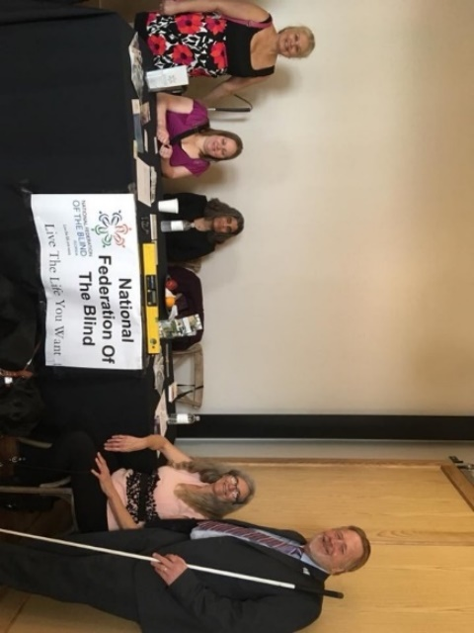
Photo Gallery:
Tampa Bay Chapter social outing: Bowling
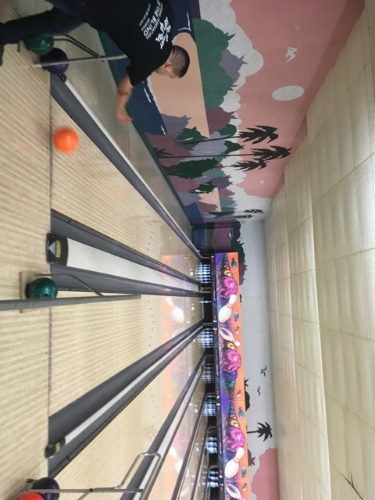
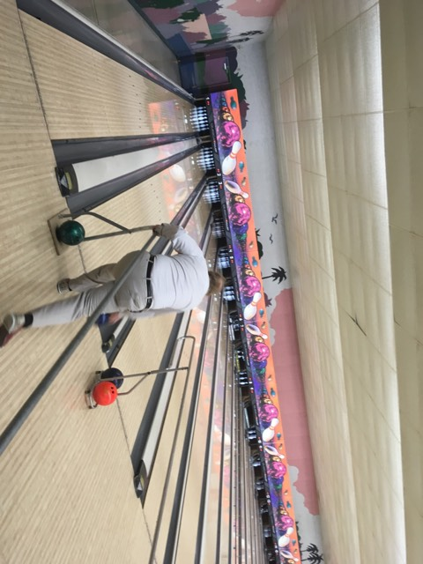
Members sitting at registration table Marion bowling
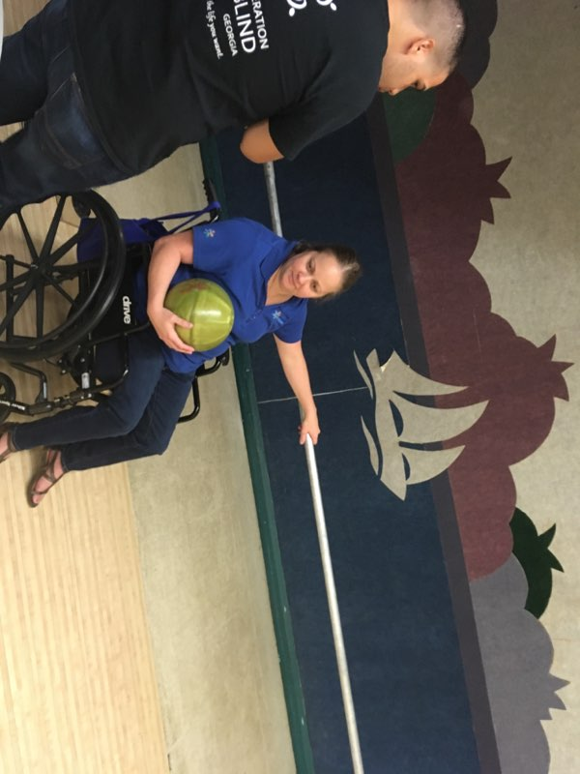
Paul bowling Paul and Miranda preparing to bowl
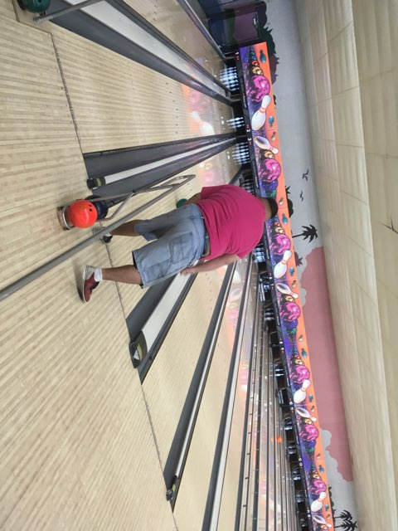
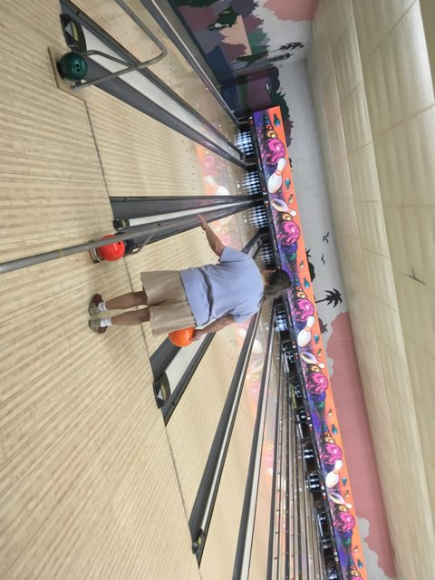
Member bowling Member bowling

Please contact any of the board with questions, comments, concerns or for general information.
NFBF Board of Director’s Information:
Denise Valkema -President
Phone: 305-972-8529
Email: president@nfbflorida.org

Paul Martinez - 1st Vice President
Phone: 813- 390-5720
Email: paul09ms@gmail.com

Miranda Kilby – 2nd Vice President
Phone: 352- 942-0417
Email: mbkilby@gmail.com

Sylvia Young-Secretary
Phone: 850- 322-5937
Email: secretary@nfbflorida.org

Merry Schoch –Treasurer
Phone: 813-523-6573
Email: merrys@verizon.net

Board Members:
Lauren Blum
Phone: 352-584-0795
Email: laurenblum79@gmail.com

Jorge Hernandez
Phone: 305-877-2311
Email: jdh6@bellsouth.net

Camille Tate
Phone: 321-372-4899
Email: ctate2076@att.net

Rafael Fernandez
Phone: 305-903-6299
Email: rafael.fernandez0617@gmail.com
Editor: Sylvia Young
To have something posted in the NFBF Newsletter please submit it to the editor, Sylvia young at secretary@nfbflorida.org by the 15th of each odd month.

