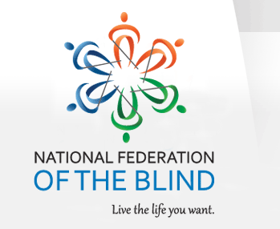

NATIONAL FEDERATION OF THE BLIND OF FLORIDA ANNOUNCEMENT

The National Federation of the Blind of Florida (NFBF) is now accepting student scholarship applications for 2019. Recipients will receive their scholarships at the 2019 NFBF State Convention scheduled for the Memorial Day Weekend, from Friday, May 24th thru Monday, May 27th in Boca Raton, Florida.
Qualified high school seniors and college students must complete the NFBF scholarship application form in MS word format, submit two letters of recommendation, and transcripts. All documentation must be return to:
Merry Schoch
Scholarship Chair
Email: scholarships@nfbflorida.org
Cell Phone: (813) 625-1850

The National Federation of the Blind of Florida will be awarding two scholarships, each in the amount of $1,500 at the annual convention banquet scheduled for Sunday evening, May 26, 2019.
To qualify students must:
- Be legally blind
- Submit a completed application along with all documentation required
- Attend the entire State Convention with assigned mentors
In addition, all scholarship applicants must provide academic transcripts and complete all components of the scholarship form. Winners will have their ground transportation, convention registration, banquet fees, and hotel room covered by the NFBF state affiliate. Completed applications are due to Merry Schoch no later than April 17, 2019.
We have also provided a checklist with the documents that are needed for a completed application for your convenience.

