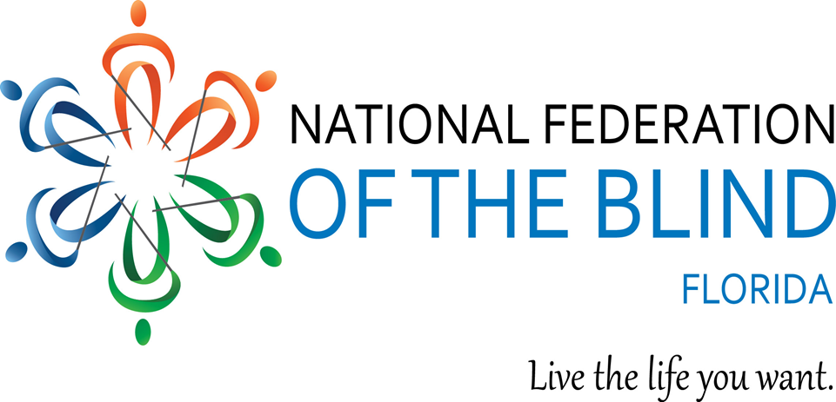

2022 STATE CONVENTION

Friday through Sunday,
October 7 - 9, 2022

The Southbank Hotel and Conference Center,
(a Marriott Bonvoy property)
1515 Prudential Drive,
Jacksonville, FL 32207
Phone: 904-396-5100

Please Note: This agenda is subject to change at any time without notice.

NFB PLEDGE

I pledge to participate actively

In the efforts of the National Federation of

the Blind

To achieve Equality, Opportunity,

And Security for the blind;

To support the policies and programs of the

Federation;

And to abide by its constitution.

Important Convention Information

You must be registered for the Convention to WIN door prizes and to qualify for the hotel’s special convention rates!
Door prizes will be awarded at general sessions and at the banquet. You must be PRESENT in the session or on approved National Federation of the Blind of Florida business to receive a door prize.
Please turn in auction baskets and door prizes at the NFB of Florida Registration Desk in the Pre-Convention Area Friday, October 7th from 4:30 - 7:30 pm.

COVID POLICY
Masks are optional at our convention. If any attendees wish to wear a mask, they may feel free to do so. The National Federation of the Blind of Florida will follow the hotel’s policies. We will additionally follow any guidelines mandated by the Centers for Disease Control (CDC) and local, state or federal entities that may be enacted up until the close of our convention.
Note: This policy is subject to change based on hotel policy, local, state, or federal regulations that may be placed in effect at the time of our convention.

INCLUSIVITY, DIVERSITY, AND CODE OF CONDUCT
We are committed to providing a welcoming, safe, and healthy environment for everyone. Thank you for cultivating an atmosphere of mutual respect in which participants from diverse backgrounds can learn, network, and share with each other. We are committed to diversity, equity, and the free expression of ideas. These principles have been outlined in our Code of Conduct found at https://nfb.org/codeofconduct.
We recognize a shared responsibility to create and uphold that atmosphere for the benefit of all. Prohibited behaviors include harassment and sexual misconduct. Prohibited behavior will not be tolerated and may result in removal from the convention and/or other consequences. For assistance or to report an incident at the convention, please call 410-659-9314, extension 2475, or email code@nfb.org. Formal reports can be submitted at https://www.nfb.org/about-us/history-and-governance/code-conduct/code-conduct-complaint-report-form. All formal reports will be fully investigated according to the steps in our Code of Conduct. For support or guidance, connect with our survivor-led task force at survivors@nfb.org or extension 2238. Thank you for your commitment to the safety and support of the blind community.

CLUSIV

Building Unseen Talent

Hey NFB Florida!

Clusiv is the world's first accessible e-learning platform built for & by people who are blind.

Clusiv training teaches you the necessary skills needed to access remote job opportunities in today’s modern workforce.

Learn confidence-building techniques for virtual interviews, save files on the cloud, master email platforms, and become a vital part of any remote team with Clusiv’s training.

Clusiv is remote and self-paced so you can learn from the comfort of home. Ask your vocational rehab counselor about Clusiv today!!!

Visit Clusiv.io to find out more.

Vanda Pharmaceuticals

Vanda pharmaceuticals is dedicated to raising the awareness of Non-24-Hour Sleep-Wake Disorder (Non-24) and supporting the blindness community.

Non-24 is a rare circadian rhythm disorder affecting up to 30% of totally blind individuals. People living with Non-24 experience excessive daytime sleepiness, nighttime sleeplessness which leads to impaired social and occupational function due to misalignment of the internal master body clock to the 24-hour day, disrupting the sleep-wake cycle.

Come visit us at our booth to learn more about Non-24

and sign up for additional information

Non-24

A circadian rhythm disorder

Visit us online at www.non-24.com

Call a health educator toll free at 1-855-856-2424, 24 hours a day

Property Search by Voice with Finding Homes
Stellar MLS is proud to collaborate with Lundy, Inc. to bring search by voice and enhanced data accessibility to our customers, their prospects, and homebuyers and sellers who are searching for homes in Florida and Puerto Rico. Now, with Lundy's comprehensive voice-activated property search engine via Amazon's Alexa app, blind and visually impaired individuals can be immersed in the home buying experience.

Scan the QR code here to listen to our Finding Homes video for more information!

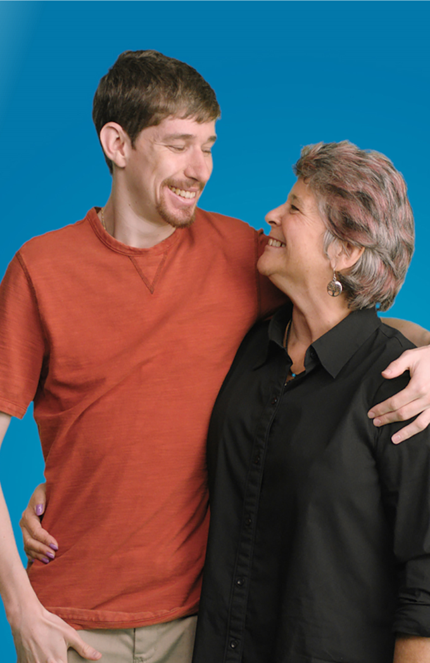
Florida’s Disability
Savings Program
ABLE United has provided thousands of Floridians
with disabilities a new way
to save tax-free without
impacting government
benefits. Open an account
today — it’s more than
just saving, it’s investing
in a brighter future.
thousands of Floridians
- Save with the potential for tax-free growth
- Save with the help of family and friends
- Save without impacting Medicaid or SSI
- Use for housing, assistive technology and more
ENROLL BY NOVEMBER 11 AND RECEIVE A $50 ACCOUNT CONTRIBUTION
ableunited.com

UZURV
IS PROUD TO SPONSOR THIS YEAR’S NFB OF FLORIDA CONVENTION. WE WORK WITH TRANSIT AGENCIES TO PROVIDE PRIVATE, ON-DEMAND TRANSPORTATION THAT IS SAFE, COURTEOUS AND ACCESSIBLE FOR PEOPLE WITH DISABILITIES AND THE TRANSPORTATION DISADVANTAGED. DRIVERS ARE FULLY CREDENTIALED, AND EVERY TRIP IS MONITORED IN REAL-TIME. WE’RE CURRENTLY IN JACKSONVILLE, ORLANDO, AND THE TAMPA BAY REGION. LEARN MORE AT UZURV.COM/RIDE.

Democracy Live – Accessible Voting Technologies

Anytime. Anywhere. In too many states, voters with disabilities don’t have equal access to voting independently and privately from home. Fortunately, there are new accessible at-home voting technologies now available. The Democracy Live OmniBallot accessible at-home voting system is a fully ADA Section 508, WCAG 2.1 compliant remote ballot marking solution. The system has been tested to meet the accessibility requirements of over 90 combinations of browsers, operating systems, screen readers and devices. OmniBallot has been deployed as an accessible absentee tool since 2008, in over 4,000 elections, serving more than 2,500 jurisdictions, in 28 states and 96 countries around the world. OmniBallot has been tested and reviewed by members of most every leading disability organization in the nation. For further information, please contact

Democracy Live: 855-655-VOTE (8683) Toll Free Email: info@democracylive.com

www.democracylive.com

Presidential Suite - Room 401
By appointment – Please make appointments by contacting President Martinez at 813-390-5720 or President@NFBFlorida.org.

Hospitality Suite – Room 133

Friday, October 7th
3:00pm – 7:00pm

Saturday, October 8th
7:30am – 8:45am, 12:00pm – 6:00pm

Sunday, October 9th
7:30am – 8:45am, 12:00pm– 5:00pm

Exhibit Hall – Starboard Ballroom

Russ Davis, Exhibit Hall Coordinator

Friday, October 7th, 3:00pm – 7:00pm

Saturday, October 8th, 12:00pm – 6:00pm

Sunday, October 9th, 12:00pm – 5:00pm

The Big Red Bus will be on site at the hotel, (in the rear parking lot near the Exhibit Hall), Saturday, October 8th, 11:00am – 7:00pm. Donors will receive a $20 eGift Card and a Halloween T-shirt. Also doing wellness checkups. Appointments are encouraged, visit oneblood.org/donate and use sponsor code #68952. ID REQUIRED.

The Jacksonville Speech and Hearing Center will be on site with its Communications Station – located in the rear parking lot near the Exhibit Hall for free hearing evaluations, Saturday, October 8th, 12:00pm – 6:00pm.

Schedule of Convention Events

Friday, October 7, 2022

3:00pm - 7:00pm EXHIBIT HALL- Starboard Ballroom

Russ Davis, Coordinator

National Federation of the Blind of

Florida

3:00pm - 6:00pm Tactile Art Display and Sale

by Local Artists (Fundraiser Event) Public Invited

Atrium Foyer

Vicky Lennon, Curator

Greater Jacksonville Chapter

4:00pm - 7:30pm Convention Registration

Atrium Foyer

Sylvia Young, Treasurer, National Federation of the Blind of Florida

4:00pm - 4:45pm Ambassadors Meeting

Hotel Lobby

Doug Ingram, Chair, Ambassadors Committee National Federation of the Blind of Florida

5:00pm Guided Hotel Tour

Led by Ambassadors

Hotel Lobby

6:00pm Rookie Round-up

Port Ballroom

Paul Martinez, President, National

Federation of the Blind of Florida

7:00pm - 7:45pm Resolutions Committee

Port Ballroom

Camille Tate, Chair, Resolutions Committee, National Federation of the Blind of Florida

8:00pm - 9:00pm Open Board Meeting

Port Ballroom

Paul Martinez, President, National Federation of the Blind of Florida

9:00pm - 10:00pm Happy 52nd Birthday Party, National Federation of the Blind of Florida

Winward Ballroom

Peggy Fleischer, Convention

Planning Chair, National Federation

of the Blind of Florida

10:00pm - 11:00pm Students Social

Hospitality Suite, Room 133

Z’Leah Liburd, Vice President, Florida Association of Blind Students

Saturday, October 8, 2022

7:15am - 8:45am President’s/Vice President’s

Breakfast

Admiralty Room

Paul Martinez, President, National Federation of the Blind of Florida

7:30am - 8:45am Devotions

Tug Room

Communities of Faith

8:15am - 8:45am Convention Registration

Atrium Foyer

Sylvia Young, Treasurer, National Federation of the Blind of Florida

General Session

9:00am to 12:00 Noon
Port Ballroom

9:00am Call to Order

Paul Martinez, President, National Federation of the Blind of Florida

9:03am Invocation

Dr. Winson Butler, Dinsmore Baptist Church, Jacksonville, FL

9:08am Pledge of Allegiance and Veterans

Salute

Doug Ingram, United States Navy

Board Member, National Federation of the Blind of Florida

9:20am National Anthem

Z’Leah Liburd, Vice President

Florida Association of Blind Students

9:25am National Federation of the Blind

Pledge

Scott Larson

Greater Daytona Beach Chapter

9:27am National Federation of the Blind

One Minute Message

Russ Davis, Treasurer, Greater Jacksonville Chapter

9:30am Welcome

Kaye Baker, President, Greater Jacksonville Chapter

Brian Norton, President, Greater Daytona Beach Chapter

Peggy Fleischer, Convention Planning Chair

Greater Daytona Beach Chapter

9:45am Welcome from the City of

Jacksonville

Kara Tucker, Chief Disabled Service Division

10:00am National Report

John Pare’, Executive Director of Advocacy and Policy, National Representative

10:25am Title Sponsor - Clusiv

Luke Simianer, CEO Clusiv

10:35am Report from the Division of Blind

Services

Robert Doyle, Director

Division of Blind Services

10:55am Report from our Florida School for

the Deaf and the Blind, President,

Carol Bogue, Principal

Department of the Blind

11:05am Navigating Healthcare When All

They Can See is That You Can’t
Debra Kendrick, Author, National
Federation of the Blind

11:15am Braille Panel

Kaye Baker, Secretary, National Federation of the Blind of Florida

11:30am Why I Am a Federationist

Doug Ingram, Board Member

National Federation of the Blind of Florida

11:35am Senator Audrey Gibson

Florida State Legislature, Senate District 06

11:50am Title Sponsor: Able United

John Finch, CEO

12:00pm Announcements & Adjournment

12:00pm - 1:00pm Lunch Break

12:00pm - 12:45pm Treasurers Lunch
Navigator Room

Sylvia Young, Treasurer

National Federation of the Blind of Florida

12:00pm - 6:00pm Exhibit Hall - Starboard Ballroom

12:00pm - 6:00pm Hospitality Suite 133

Saturday Special Interest Meetings and Workshops
1:00pm to 5:00pm

1:00pm - 1:45pm How to Protect Your Assets
Sail Room
Edward Kimmel, RFC, LUTCF
Kimmel Insurance & Investments LLC

Would you like to keep more of your earnings and prevent your assets from shrinking? Several strategies will be explored, which will include controlling spending, eliminating debt, maximizing savings, providing for your children and grandchildren’s education, and using cash flow insurance to reduce taxes and create opportunities to earn more than inflation.

1:00pm - 2:45pm Deaf-Blind Division Annual Meeting

Port Ballroom

Brian Norton, President

Deaf-Blind Division of Florida

Come learn about services available for Deaf-Blind children and adults with guest speakers Carol Bogue Principal, Department for the Blind, Florida School for the Deaf and Blind and Nancy Epps, Conklin Davis Center.

1:00pm - 2:45pm Florida Association of Guide Dog

Users

Anchor Room

Brittany Fraer, President, Florida,

Guide Dog Users
Come and participate in a discussion with a veterinarian and have your questions answered.

1:00pm - 2:45pm Tactile Art Workshop

Tug Room

Vicky Lennon, Curator

Greater Jacksonville Chapter

Have you been checking out all the tactile art pieces displayed? Come and learn how to express yourself by making your own tactile art masterpiece.

2:00pm - 3:45pm Florida Association of Blind

Students Annual Meeting

Sail Room

Z’Leah Liburd, Vice President

Florida Association of Blind Students

There’s a lot going on with our students. Come find out about all the happenings.

2:00pm - 3:45pm Employment Seminar

Commerce Room

Kaye Baker, Secretary, National Federation of the Blind of Florida

Are you interested in the wide variety of jobs blind individuals can hold? Come to our employment seminar and find out what we do, and how we do it. Listen to our panel as we discuss what jobs we hold, how we got them, and what technology we use to get our work done every day. We’ll discuss challenges, successes and much more. We’ll even have time for your questions. We look forward to seeing you there.

3:00pm - 4:45pm Seniors Concerns Committee

Anchor Room

Gloria Mills-Hicks, Vice President

Tampa Bay Chapter

This year the Senior Concerns Committee will focus on transportation throughout Florida. Did you know that grants are being awarded throughout the state to make future travel easier and more affordable for the transportation disadvantaged? This and other topics we will discuss should be of interest to all seniors and those who plan to be seniors – in short, everyone!

4:00pm - 5:00pm Dress for Success

Commerce Room

Camille Tate, 2nd Vice President

Jorge Hernandez, 1st Vice

President, National Federation of the Blind of Florida
Living in a sighted world, we are often judged by our appearance. What do I wear for a job interview? How do I dress for a cocktail party? How important is it to wear make-up and when do I wear it? All these questions and more can be answered at Dress for Success. We will talk about professional, business casual and casual modes of dress for any occasion. Come and ask your questions and win a prize!

4:00pm - 5:00pm Florida Statewide Chapter

Presidential Suite, Room 401

Paul Martinez, President

Florida Statewide Chapter

5:00pm - 6:30pm Dinner - on your own

6:30pm - 7:30pm Live Entertainment

Windward Ballroom

The Timeless Elegance of Miranda Madison, The Siren of Swing

7:30pm -10:30pm Annual Fundraising Auction

Windward Ballroom

Paul Martinez, Auctioneer

10:30pm - 11:00pm Live Entertainment

Windward Ballroom

Miranda Madison

www.mirandamadison.com

Sunday, October 9, 2022

7:30am - 8:00am Devotions

Tug Room

Communities of Faith

7:45am - 8:45am Nominating Committee

Delegates only

Sail Room

Camille Tate, Committee Chair, 2nd Vice President, National Federation of the Blind of Florida

8:15am - 8:45am Convention Registration

Final Opportunity!!

Atrium Foyer

Sylvia Young, Treasurer, National Federation of the Blind of Florida

General Business Session

9:00am - 12:00pm
Port Ballroom

9:00am Call to Order

Paul Martinez, President, National Federation of the Blind of Florida

9:03am Invocation

Dr. Joyce Taylor, Vice President Melbourne Space Coast Chapter

9:08am National Federation of the Blind

Pledge and One Minute Message

Andrew Rood

Greater Jacksonville Chapter

9:10am God Bless America

Sherry Adams

Greater Daytona Beach Chapter

9:12am President’s Report

Paul Martinez, President, National Federation of the Blind of Florida

9:30am Treasurer’s Report

Sylvia Young, Treasurer, National Federation of the Blind of Florida

9:35am Resolutions Committee Report

Camille Tate, Chair, Resolutions Committee

9:50am From the Classroom to the

Courtroom

Owen McCaul

Florida School for the Blind

10:10am Title Sponsor: Vanda

Pharmaceuticals

Vicki Preddy

10:20am Title Sponsor: Stellar

10:30am Nominating Committee Report

Camille Tate, Chair, Nominating Committee

10:35am Elections

12:00pm Announcements & Adjournment

12:00pm - 1:00pm Lunch - On your own

12:00pm - 12:45pm Secretaries Lunch
Navigator Room
Kaye Baker, Secretary, National Federation of the Blind of Florida

12:00pm - 5:00pm Exhibit Hall - Starboard Ballroom

12:00pm - 5:00pm Hospitality Suite 133

Sunday General Interest Meetings and Workshops
1:00pm to 5:00pm

1:00pm - 1:45pm Florida Blind Parents

Tug Room

Miranda Kilby, President, Tampa Bay Chapter

﻿Home remedy tricks and tips Join the Blind parents group and learn a few different home remedies that work! Come share your home remedy with others. all are welcome to attend.

1:00pm - 2:45pm Clusive Workshop

Sail Room

1:00pm - 1:45pm Federation Foundations

Anchor Room

Camille Tate, 2nd Vice President National Federation of the Blind of Florida
Our Book Club, now re-named Federation Foundations, invites you to a discussion on “Leadership and the Matrix”, a speech given by Dr. Marc Mauer in July 2002, at the Louisville, Kentucky convention. You may read or listen to the speech by visiting nfb.org/banquet-speeches. This will be an interactive discussion!

2:00pm - 2:45pm Sports and Recreation

Commerce Room

Denise Valkema, Board Member

National Federation of the Blind of Florida

Come to an easy to do strength and balance class designed to strengthen key muscles to improve and maintain balance. You will be able to continue taking classes at home. Lisa Fisher, Wellness Coordinator New Vision for Independence

2:00pm - 3:45pm Legislation and Self-Advocacy

Anchor Room

Russ Davis, Legislative Director

Camille Tate, Legislative Director

Kaye Baker, Secretary, National Federation of the Blind of Florida

Come and join us as we discuss our state and national legislative priorities! We will also have a self-advocacy discussion led by Kaye Baker, Secretary of the National Federation of the Blind of Florida, and President of the Greater Jacksonville Chapter!

3:00pm - 4:45pm Diversity and Inclusion: STEM and

Transportation

Sail Room

Marilyn Baldwin, Chair and Tashara Cooper, Central Florida Chapter

S.T.E.M. Thinking Beyond & The Value of the Blind

This audience interactive presentation will focus on describing various STEM and STEM related/complementary fields within government, industry, and academia. More specifically, how persons who are blind can leverage the skills and tools they utilize in their everyday lives to market themselves within this competitive job market. Topics such as human factors, instructional design, user interface design, user experience and more will be discussed. They will be discussed from the "value of blindness" perspective along with real-world examples.

3:00pm - 4:00pm Communications Workshop

Tug Room

Doug Ingram, Communications Director, National Federation of the Blind of Florida

3:00pm - 4:45pm Technology: 3D from VERC

Commerce Room

Vision Education and Rehabilitation Center, Florida State College at Jacksonville

Come and find out how 3-D printing can work in the blind community! The Vision Education and Rehabilitation Center in Jacksonville, Florida, will demonstrate the 3-D printing process and answer your questions.

4:00pm - 4:45pm Sighted Supporters Meeting

Navigator Room

Sylvia Young, Treasurer, National Federation of the Blind of Florida

This is an open discussion among sighted Federationists who want to support their fellow Federation friends and family to live the life they want.

Convention Banquet

Sunday, October 9, 2022
7:00pm - 10:00pm
Russ Davis and Camille Tate, Masters of Ceremonies
Port and Windward Ballrooms

7:00pm Call to Order

Paul Martinez, President, National Federation of the Blind of Florida

7:03pm Welcome and Introductions

Russ Davis and Camille Tate, Masters of Ceremonies, National Federation of the Blind of Florida

7:10pm Invocation

Paul Martinez, President, National Federation of the Blind of Florida

7:45pm Keynote Address

John Pare’, Executive Director Advocacy and Policy National Federation of the Blind Representative

8:45pm Presentation of Scholarship

Winners

Jorge Hernandez, 1st Vice President, National Federation of the Blind of Florida

9:25pm Awards Presentation

Doug Ingram, Chair, Board Member, National Federation of the Blind of Florida

9:50pm Raffles and Drawings

10:00pm Adjournment

Convention Sponsors and Exhibitors

Title Sponsors
ABLE United
Clusiv
Stellar MLS
Vanda Pharmaceuticals

Independent Sponsors
ORCAM

Equality Sponsors
Democracy Live Inc
Friends of Library Access Inc
UZURV

Security Sponsor
Blind Girl Designs
Emerald Coast Vision Aids
Enhanced Vision
Family First Life Insurance
Florida Reading & Vision Technology
Florida School of the Deaf & The Blind
GuideLights and Gadgets Inc
Lighthouse Works Central Florida
Patriot Vision Industries

Non-Profit Exhibitors
Advocates for Service Animal Partners
Center for Independent Living of Jacksonville
Division of Blind Services
Florida Association of Blind Students
Florida Association of Guide Dog Users
Florida School of the Deaf & Blind
Guide Dogs for the Blind
IRIS Lending Library for the Blind Inc
Greater Jacksonville Chapter
Melbourne Space Coast Chapter
New Vision for Independence
The Seeing Eye
Florida Statewide Chapter
Southeastern Guide Dogs

Southbank Hotel by Marriott-Description
2022 National Federation of the Blind of Florida
State Convention

The Greater Jacksonville and Greater Daytona Chapters of the National Federation of the Blind of Florida are ready to welcome you to our 2022 State convention at the Southbank Hotel.
Built in 1981, the Southbank Hotel is nestled on the south bank of the St Johns River and boasts convenience to both the San Marco and Riverside neighborhoods. The hotel has many amenities including an outdoor pool, fitness center and on-site bar and restaurant. The hotel has been recently renovated and draws inspiration from the many ports and bridges around Jacksonville.
As we enter the hotel’s entrance, we find ourselves in a spacious lobby. The lobby area is shaped like a rectangle, with the entrance and elevators on the short sides of the rectangle, and the check-in area and bar along the long sides. If we were to walk straight upon entering the lobby we would come to a seating area with several couches and tables. This area can be best identified by the carpeting on the floor. The carpet is a great landmark to help us find the check-in desk, so after entering the main entrance, we will walk straight until we encounter the carpet, then make a right. Follow the carpet until it ends, then continue walking straight, and the check-in counter will be right in front of us. Immediately to the right of the counter is an ATM machine.

If we place the counter on our right and continue walking straight, the next area we come to will be a vending area. Here, items such as snacks, Starbucks coffee, sodas and other sundries can be purchased. Note, the machine used to purchase the items is currently not accessible, so a member of the hotel staff, friend or volunteer will be happy to assist.
Making a right immediately after the check-in counter ends will lead down a long hallway which has the fitness center on the left, and a vending machine containing medical supplies such as pain relievers and masks.
Continuing past the vending area will bring us to a water station on the right. The water station is a table with a water cooler and cups sitting on it. There is also a trash can directly to the left of the water station so that any used cups can be discarded.
Once we come to the end of the water station, there will be a column on the left. This column is a good indicator that the hallway that leads to the elevators is coming up soon. Turning right at the next hall, will lead into the hallway that holds both the elevators, and Convention center. The elevators are to the left, and convention center to the right.
For now, lets return to the main entrance, and explore the other side of the lobby. This time, from the entrance, we will again go straight until we get to the carpet, but instead of a right, we will turn left. Walk until the carpet ends on the right and turn right again. Johnny’s bar will be immediately on the left.

If we continue past Johnny’s and walk until the wall on our left side ends, the hotel restaurant will be straight ahead. The restaurant currently is open for breakfast only.
If we pass Johnny’s and make a left when the wall ends, we will enter an area that has a pool table and a foosball table. Going straight will take us to an exit door. This door can be used to get to one of the dog relief areas.
For this exit door, a room key is not needed. Once we have exited the hotel, we will continue to walk straight until we reach a sidewalk. Make a right on the sidewalk and keep walking straight. One great landmark is the sound of the air conditioning units. Once we hear the AC units we know the dog relief area is on the right. A trash can with baggies is also being provided. To find this continue down the sidewalk until it veers to the left. Once the sidewalk turns, start checking on the right for the trash can and bag stand.
Now that we are back in the hotel, lets check out the convention center area. Remember that if we enter the hallway just after the water station, the elevators will be on the left, and the convention center on the right. The convention center is shaped like a crescent, with 3 entrances. When we first enter the convention center, we will find ourselves in the pre-function registration area. This is where we will hold convention registration. Making a right here will take us down a long hall with meeting rooms on the right, and seating on the left. The first meeting room we come to is Anchor, followed by Rope. After Rope is an open area with hallways that lead to the hospitality suite, the pool, and the second dog relief area. If we turn right here, we will come to some restrooms, and an exit that leads out to the pool. If we make a left instead of a right, we will come to a hall with some suites, including our hospitality suite and an exit. Using this exit to get to the second dog relief area will require a room key.
However, if we continue going straight through the open area and down the hallway, we will come to a dead end. If we make a left here, there will be windows on the right, and Port Ballroom on the left. Port is where our General Session will be held. The next room is Winward which is where the auction will be held. Starboard is next which is where our exhibit hall will be.
Remember that when we were in the pre-function area, we made a right to get to the meeting rooms. Now let’s go back to the pre-function area and make a left. Doing this will bring us to a hallway with meeting rooms on either side. The first room on the right is Tug, on the left are Rigging and Sail. There are two final rooms that should be mentioned. They are just outside of the pre-function area. If we are coming from the elevators and walking straight, they will be on the right. Those rooms are called Commerce and Dockside.
Now that we have finished our tour of this great hotel, it is time to get ready for an awesome state convention. Remember that if you get a little lost listen for the talking signs. We will have talking signs and ambassadors throughout the hotel to assist whenever needed.
Also, don’t hesitate to reach out to either of the host chapters or the state board with any questions or concerns.

Nearby Pharmacies:
Publix Pharmacy
Publix – Shops at East San Marco
2039 Hendricks Ave.
Jacksonville, FL. 32207
Distance from hotel = 1.5 miles
(904) 523-7317

Nearby Veterinary Hospitals:
San Marco Animal Hospital
1546 San Marco Blvd.
Jacksonville, FL. 32207
Distance from hotel = 0.9 miles
ph. 904-516-9767
open 7 days per week

After hours Emergency Veterinarian
Blue Pearl Animal Hospital
3444 Southside Blvd. Unit #103
Jacksonville, FL. 32216
Distance from hotel = 7.4 miles
ph. 904-642-5911

National Federation of the Blind of Florida

Officers and Board of Directors
Paul Martinez, President
Jorge Hernandez, First Vice President
Camille Tate, Second Vice President
Kaye Baker, Secretary
Sylvia Young, Treasurer
Board of Directors:
Russ Davis
Denise Valkema
Peggy Fleischer
Douglas Ingram

The National Federation of the Blind of Florida thanks the Jacksonville and Daytona Beach Chapters, the Convention Planning Committee, and everyone else for their dedication and hard work organizing the 2022 state convention. We thank everyone for joining and supporting us here in Jacksonville. We acknowledge all our sponsors for their generous donations which made the convention a great success, as well as everyone who contributed to the development process. We look forward to continuing to work with all of you in 2023.
Let’s Go build the Federation!
Sincerely,
Paul Martinez, President
National Federation of the Blind of Florida

Chapters, Divisions, Committees, and Groups

President:
State Affiliate - Paul Martinez, (813)390-5720, president@nfbflorida.org

Chapters:
Greater Broward - Jake McEntyre, (954) 946-4148, jmac1920@yahoo.com
Central Florida - Marilyn Baldwin, 407-293-0565, commmdb@aol.com
Greater Daytona Beach - Brian Norton, (386) 871-3359, brian.edward.norton@outlook.com
Gainesville - Judy Hamilton, (352) 373-7806, hamilton.j.r.2309@gmail.com
Greater Jacksonville - Kaye Baker, 904-580-6819, nfbjax@gmail.com
Melbourne-Space Coast - Camille Tate, (321) 372-4899, Ctate2076@att.net
Greater Miami-Dade - Jorge Hernandez, (305) 877-2311, jeh6@bellsouth.net
Polk - Joe King, (863) 293-5648, joenkitty@earthlink.net
State-Wide - Paul Martinez, (813) 390-5720, nfbf.statewide@gmail.com
Tallahassee - Donald Christie, (850) 727-6794, doctime59@comcast.net
Tampa Bay - Miranda Kilby, (352) 942-0417, tampabay@nfbflorida.org
Treasure Coast - Rosemary Brunson (772) 519-0679 Rosemarybrunson1@gmail.com

Divisions:

Deaf Blind - Brian Norton, (386) 871-3359,
brian.edward.norton@outlook.com
Florida Association of Guide Dog Users - Brittany Fraer, (804)274-8908, bcwilson4418@gmail.com
Florida Association of Blind Students – Jannik Pesch (941) 264-6305, jannikpesch85@gmail.com

Committees/Groups:
Blind Parents - Miranda Kilby, (352) 942-0417, tampabay@nfbflorida.org
Communities of Faith - Marilyn Baldwin, (407) 293-0565, commmdb@aol.com
Diversity and Inclusion - Marilyn Baldwin, (407) 293-0565, commmdb@aol.com
Federation Foundations - Camille Tate, (321) 372-4899, Ctate2076@att.net
Legislation - Camille Tate, (321) 372-4899, Ctate2076@att.net and Russ Davis, (904) 469-8433; Russell@radiorusty.com
Newsline® - Russ Davis, (844) 827-7371, newslinesupport@nfbflorida.org
Senior Concerns – Gloria Mills Hicks, (813) 340-9754, Gloriannfbf@gmail.com

