*TAMPA BAY SPIRIT NIGHT!*

On Sunday, October 17, cheer on the

Tampa Bay Bucs

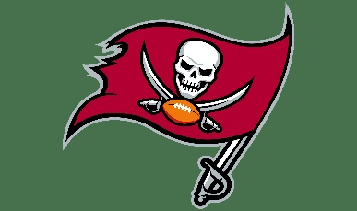

and support the Tampa Bay Chapter of the

National Federation of the Blind of Florida! 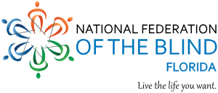

Here is how…

On Game Day (October 17) head to Beef O’Brady’s

8810 North Himes Ave.



**Present this Flyer!** Eat and drink the best game food and libations in town and ENJOY THE GAME! **Beef O’Brady’s will automatically donate 15% of your check to the Tampa Bay Chapter of the NFB!**

We plan on holding prize drawings and an Auction for special Buccaneers memorabilia during HALFTIME! (How about footballs

signed by Bucs players Mike Evans and Joe Tryon-Shoyinka!)