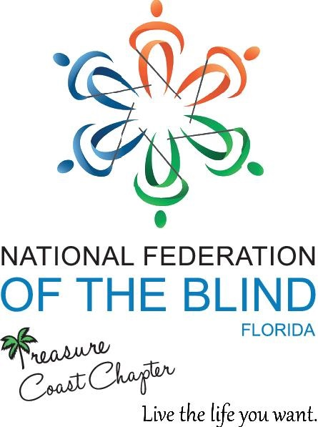  The Treasure Coast Chapter NFB FL greatly appreciates any donations given which are tax deductible.  All donations will help us provide chapter scholarships for qualifying members attending the State and / or National Conventions in 2022. Checks may be made payable to NFB Treasure Coast.  Thank you for your support! |  | Serving the Treasure Coast: St. Lucie, Martin, Indian River & Okeechobee Counties  St  We meet the 2nd Saturday of every month from  10am-12 noon  WQCS Radio Station at IRSC in Ft. Pierce, Florida  Guest Speakers & discussion related to Blindness & Low Vision Education  Contact Information  NFB Treasure Coast  c/o Joe Chite, Treasurer  360 NE Solida Drive  Port St. Lucie, FL 34983  772-521-5563  nfbtc.bank@gmail.com  Treasure Coast Chapter NFB and like our page!

