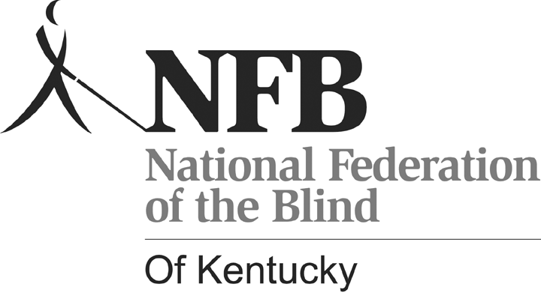Please type or neatly print this application form. The attached letter should be typed.
NATIONAL FEDERATION OF THE BLIND OF KENTUCKY SCHOLARSHIP
2010

Name:________________________________________________________________

Date of Birth: __________________________________________________________

Address: _____________________________________________________________

City: _____________________________ State: ____________ Zip: ___________

Phone: ___________________________ E-mail: ____________________________

School Attended During the 2009-2010 School Year: ______________________________________________________________________

School You Will Attend During the 2010-2011 School Year:

Major: ________________________________________________________________

Minor: _______________________________________________________________

(Continued on back.)

Attach a copy of your most recent transcript to the completed application. Include two (2) letters of recommendation with your application.

Write a letter, of no more than two typed pages, stating how a National Federation of the Blind of Kentucky Scholarship will help you achieve your career goals. Explain how you are involved in your community, organizations that you are involved in, and activities that you participate in. Describe any honors, awards, or special recognition that you have received. Explain how you would like to be involved in the National Federation of the Blind of Kentucky. Tell us anything you would like us to know that will help us choose scholarship recipients.

Return the Completed Application and Attachments to:

Lora J. Felty, Chairperson
National Federation of the Blind of Kentucky Scholarship Committee
1127 Sharon Court
Ashland, KY 41101
Phone: (606) 324-3394
E-mail: lorafelty@windstream.net

Scholarship recipients must be legally blind or visually impaired and eligible for services from the Kentucky Office for the Blind. Also, winners must reside in Kentucky and/or attend a college or university in Kentucky. Scholarship applicants must be enrolled in a post-secondary program, or be accepted into a program. (Please include a copy of the letter of acceptance into a post-secondary program if not already enrolled.) Applications Should Be Postmarked No Later Than July 15, 2010.

Scholarship finalists are required to attend and participate in the 2010 Convention of the National Federation of the Blind of Kentucky. Travel, hotel accommodations, registration fee, and banquet ticket are provided to the scholarship finalist. Scholarship winners will be chosen during the 2010 state convention which will be held at the Holiday Inn Hurstbourn, Louisville, Kentucky during the weekend of September 24-26, 2010. Scholarships will be awarded at the banquet on Saturday night, September 25, 2010.

