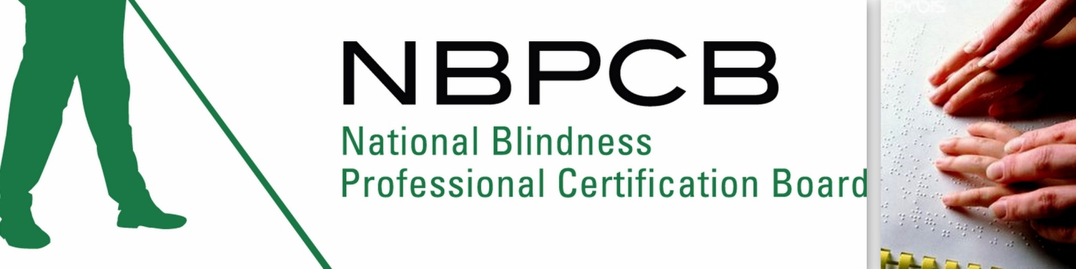The National Certification in Literary Braille (NCLB)
Fact Sheet

What is the National Certification in Literary Braille (NCLB)?

The NCLB is a nationally recognized certification in literary braille geared specifically toward teachers. The NCLB is a five-year renewable certification awarded to those who successfully pass all four sections of the National Literary Braille Competency Test. The NCLB Test is administered solely under the direction of the National Blindness Professional Certification Board (NBPCB).

Who can take the NCLB?

The target population includes pre and in-service teachers who teach or will teach braille reading and writing to children and adults. Other individuals interested in demonstrating their knowledge/proficiency in reading and writing the literary braille code are also welcome. There are no prerequisites, although a good working knowledge of the literary braille code is assumed.

What is the format of the NCLB test?

The NCLB is a written examination that tests an applicant’s ability to read, write, and understand literary braille. The examination consists of four sections; including:

1. Braille Writing - using a braillewriter
2. Braille Writing - using a slate and stylus
3. Proofreading - identifying braille errors
4. Multiple Choice - correct braille usage and rules

Where is the NCLB offered?

As interest in the NCLB grows, so does the number of locations the test is offered. Current listings can be found at www.nbpcb.org/nclb.

Why should I, or an employee of mine, take the NCLB?

The NCLB is an added credential to any teacher of the blind or visually impaired that demonstrates knowledge and proficiency in the Literary Braille code. Holders of the NCLB demonstrate to their profession that they hold the nation's highest credential for knowledge of literary braille. As certification continues to be sought and even required by employers, holding the NCLB credential will make the candidate for employment highly valuable to prospective employers, while helping employers to demonstrate that they have a highly qualified workforce.

How much does it cost to take the NCLB?

All fees can be paid online at www.nbpcb.org/nclb by credit card or Pay Pal account. Fees may alternatively be paid by personal check, bank draft, or money order.

Application Fee: $250.00
Re-Test Fee: $250.00
Single Section: $75.00

Where can I register to take the NCLB?

Registration for the NCLB must be done online at www.nbpcb.org/nclb. The online application is simple and easy to follow. You may also pay for the test at this time using a credit card or Pay Pal account.

How do I prepare to take the NCLB?

There is an entire section on our website, www.nbpcb.org/nclb dedicated to preparing you for the test; there are sample tests, practice passages, proofreading exercises and other study materials available to you. The official reference for the exam is the 1994 edition of EBAE as revised in 2002, available for purchase from the American Printing House for the Blind (APH).

Who should I contact for more information if I’m interested in hosting an NCLB test?

You may contact Deja Powell by phone at (318) 257-2029 Monday-Fridays; or by email at dpowell@latech.edu. Many more details about the test can also be found on our Website at www.nbpcb.org.

