FOR IMMEDIATE RELEASE
CONTACT
Voleine Amilcar, ITVS 415-356-8383 x 244 voleine_amilcar@itvs.org
Mary Lugo 770-623-8190 lugo@negia.net
Cara White 843-881-1480 cara.white@mac.com

For downloadable images, visit http://pressroom.pbs.org

LIVES WORTH LIVING Premieres on the PBS Series INDEPENDENT LENS
Thursday, October 27 at 10 PM During
National Disability Employment Awareness Month

Powerful Documentary Chronicles the History of America’s Disability Rights Movement

While there are over 54 million Americans living with disabilities, Lives Worth Living is the first television history of their decades-long struggle for equal rights. Produced and directed by Eric Neudel, Lives Worth Living is a window into a world inhabited by people with an unwavering determination to live their lives like everyone else, and a look back into a past when millions of Americans lived without access to schools, employment, apartment buildings, and public transportation – a way of life unimaginable today. Lives Worth Living premieres on the Emmy® Award-winning PBS series Independent Lens, on Thursday, October 27, 2011 at 10 PM (check local listings) to coincide with National Disability Employment Awareness Month.

Lives Worth Living traces the development of the disability rights movement from its beginning following World War II, when thousands of disabled veterans returned home, through its burgeoning in the 1960s and 1970s, when it began to adopt the tactics of other social movements. Told through interviews with the movement’s pioneers, legislators, and others, Lives Worth Living explores how Americans with a wide variety of disabilities — including blind, deaf, physical, intellectual and psychiatric — banded together to change public perception and policy. Through demonstrations and legislative battles, the disability rights community finally secured equal civil rights with the 1990 passage and signing into law of the Americans with Disabilities Act, one of the most transformative pieces of civil rights legislation in American history.

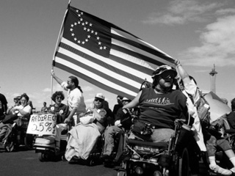
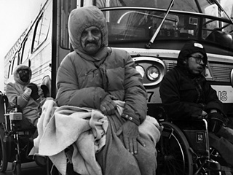
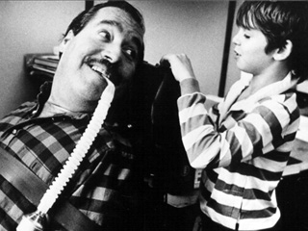
To learn more about the film, and the issues involved, visit the film’s companion website at www.pbs.org/independentlens/. Get detailed information on the film, watch preview clips, read an interview with the filmmaker, and explore the subject in depth with links and resources. The site also features a Talkback section, where viewers can share their ideas and opinions.

--More--
About the Participants, in Order of Appearance
Fred Fay, early leader in the disability rights movement (1944 – 2011)
Ann Ford, director of the Illinois National Council on Independent Living
Judy Heumann, leading disability rights activist, Co-Founder of World Institute on Disability
Judi Chamberlin, Mental Patients Liberation Front, a movement for the rights and dignity of people with mental illness (1944-2010)
Dr. William Bronston, former staff physician at the notorious Willowbrook State School who was dismissed after agitating for change
Bob Kafka, established ADAPT of Texas, a disability rights advocacy organization
Zona Roberts, counselor, UC Berkeley's Physically Disabled Students’ Program and Center for Independent Living, Berkeley; mother of disability rights pioneer Ed Roberts
Pat Wright, Former Disability Rights Education and Defense Fund
John Wodatch, Former Chief, Disability Rights Section, Civil Rights Division, U. S. Department of Justice
Jack Duncan, Former Counsel, U.S. House of Representatives
Mary Jane Owen, disability rights activist, philosopher, policy expert, and writer
Marca Bristo, CEO, Access Living of Metropolitan Chicago, former chair of the National Council on Disability, and leader in the disability rights movement
Michael Winter, Former director, Berkeley Center for Independent Living
Lex Frieden, Former director, National Council on the Handicapped (now National Council on Disability)
Dr. I. King Jordan, President Emeritus, Gallaudet University
Jeff Rosen, alumni leader, Gallaudet University
Senator Tom Harkin, (D-Iowa), co-author of the ADA
Bobby Silverstein, Former Chief Counsel, Senate Subcommittee on Disability Policy
Richard Thornburgh, U.S. Attorney General, 1988-1991
Tony Coelho, Former Congressman (D-California), House Majority Whip, 1986-1989, author of the ADA
Justin Dart, leader in the disability rights movement (1930 – 2002)

About the Filmmaker
Eric Neudel (Producer/Director) has produced, directed, and edited numerous award-winning films for public television. His many credits include Eyes on the Prize, AIDS: Chapter One, LBJ Goes to War, Tet 1968, Steps, After the Crash, The Philippines and The US: In Our Image, Body and Soul, and more. He was a visiting senior critic and lecturer in film at Yale University and served as producer, director, and editor for Harvard University’s Derek Bok Center for Teaching and Learning, and Spectrum Media’s program series on the art and craft of teaching. Neudel was also a photographer and video production consultant, teaching video production to a team working for the Compass Project in Malawi. Photographs from his two years in Malawi were exhibited in the Sandra and Phillip Gordon Gallery at The Boston Arts Academy in October 2007.

He also served as story consultant for Row Hard No Excuses, an award-winning documentary about two middle aged American men who set out to cross the Atlantic in a rowboat. Most recently he served as a photographer in Rwanda for The Boston Globe, where he directed, produced, and edited a companion documentary about the Maranyundo Middle School, which was built on the site of one of the worst concentration camps and killing fields in Rwanda.

About Independent Lens
Independent Lens is an Emmy® Award-winning weekly series airing Thursday nights at 10 PM on PBS. The acclaimed anthology series features documentaries and a limited number of fiction films united by the creative freedom, artistic achievement, and unflinching visions of their independent producers. Independent Lens features unforgettable stories about a unique individual, community or moment in history. Presented by the Independent Television Service (ITVS), the series is supported by interactive companion websites and national publicity and community engagement campaigns. Further information about the series is available at www.pbs.org/independentlens. Independent Lens is jointly curated by ITVS and PBS; it is funded by the Corporation for Public Broadcasting (CPB), a private corporation funded by the American people, with additional funding provided by PBS and the National Endowment for the Arts. The series producer is Lois Vossen.

###

