I love KSB Shirts
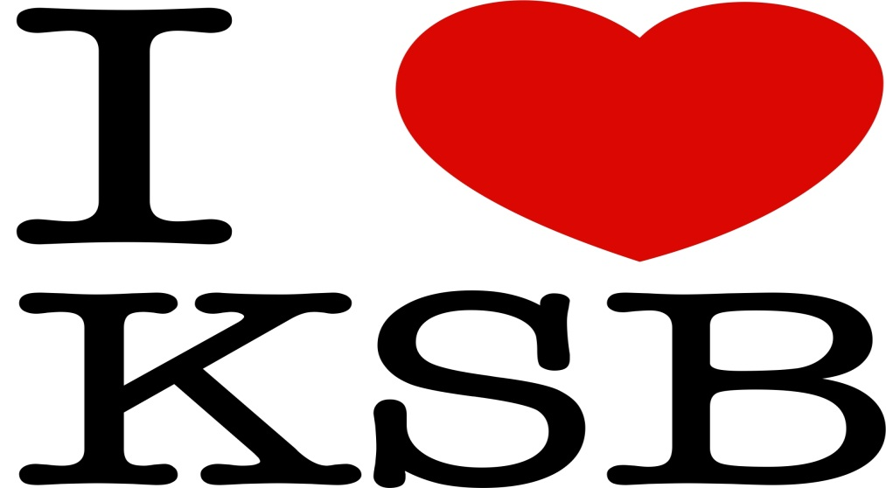

T shirt= $10.00, Long Sleeve t= $12.00, Sweat Shirts=15.00 and Hoodies=$20.00 and comes in sizes S,M,L,XL,XXL,XXXL. Shirt orders are due by May 7, 2012. Please make any checks payable to KSB. Shirts will also have I (heart) KSB in Braille on the back
Name | Shirt Size | Amount

