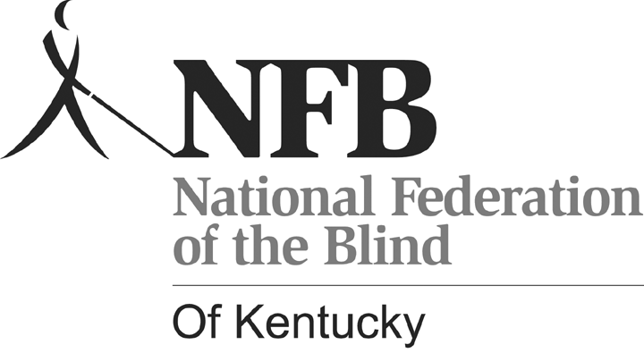

National Federation of the Blind
Of Kentucky Scholarship
Program
2013

General Requirements

- Applicants must be either legally blind and/or eligible to receive services from the Kentucky Office for the Blind.
- Applicants must live in Kentucky and/or attend a post-secondary school in Kentucky.
- Scholarship finalists must attend and participate in all activities at the annual state convention of the National Federation of the Blind of Kentucky. Convention expenses are covered as a part of the scholarship program.

Applications must include the following:

- Personal letter of Introduction Addressed to the Scholarship committee
- Most Recent school Transcript
- Three (3) letters of recommendation, one of which must be from a member of the NFB of Kentucky. If you do not personally know an NFBK member, please contact the scholarship committee member from your region of the state. Committee members are listed below.
- Proof of legal blindness, I.e., a statement from a physician, and/or a statement from the Kentucky Office for the Blind stating that you are a current consumer.
- Proof of enrollment in a post-secondary educational institution.

NFB of Kentucky Scholarship Committee

Lora Felty, Chairperson
(606) 324-3394 Eastern Kentucky

Todd Stephens
(859) 433-5023 Lexington and Northern Kentucky

Betty Allen
(502) 875-1413 Frankfort and Central Kentucky

Katie Adkins
(502) 533-5933 Greater Louisville

Jennifer Hall
(270) 988-2816 Western Kentucky

Scholarship Awards

On an annual basis, the National Federation of the Blind of Kentucky will award any or all of the scholarships listed below.

Betty J. Niceley Memorial Scholarship

This scholarship in the amount of $1,000 is awarded by the NFB of Kentucky in memory of Betty J. Niceley, long time president of the NFB of Kentucky. Betty worked for many years at the Kentucky Department for the Blind. She served as president of NAPUB (National Association to Promote the Use of Braille) and served on the BANA (Braille Authority of North America) board. Braille was near and dear to Betty’s heart. Throughout her life, she was a tremendous advocate for Braille. This scholarship will be awarded to an individual who reads Braille and finds it an essential part of his/her daily life.

Emerson Foulke Memorial Scholarship

This scholarship in the amount of $1,000 is presented by the NFB of Kentucky in honor of Emerson Foulke. Emerson was a long time Federationist. In his career he worked as a professor of psychology at the University of Louisville, where he served as director of the Perceptual alternatives lab. He conducted countless research projects dealing with all aspects of perception. This scholarship will be presented to an individual studying for a degree in psychology, science, research, technology or general education.

Charles and Betty Allen Scholarship

This scholarship in the amount of $1,000 is endowed by Charles and Betty Allen, long time members of the Frankfort Chapter of the NFB of Kentucky. Requirements for this scholarship are as follows:

Priority shall be given to totally blind applicants.
It shall not be necessary to award the scholarship annually.

The applicant shall:

1. Be a Federationist!
2. Be recommended by a longtime Federationist.
3. Be a Kentucky resident.
4. Show a grade point average of 3.0 or better.
5. Provide proof of enrollment as a full-time student in a college or university.

NFB of Kentucky Scholarships

NFB of Kentucky scholarships in the amount of $1,000 and/or $500 may also be awarded to deserving candidates. These scholarships may be awarded to either full time or part time students who meet the criteria set forth above.

The scholarship committee reserves the right to present these scholarships on an annual basis; however, if the committee feels that they have not found worthy candidates, it may choose not to award some scholarships.

NOTE: Scholarship Applications MUST include all required documentation. Incomplete applications will not be considered for a scholarship award.

SCHOLARSHIP DEADLINE:

June 1, 2013

All scholarship applications must be received no later than June 1, 2013.

Scholarship applications will be accepted electronically via email or in hard copy via standard mail. Please email applications to lorafelty@windstream.net. Please send hard copy applications to:

Lora Felty, Chairperson
National Federation of the Blind of Kentucky Scholarship Committee
1127 Sharon Court
Ashland, KY 41101

If you have any questions regarding the scholarship process, please feel free to contact NFBK Scholarship Committee Chairperson, Lora Felty, via email or phone.

NATIONAL FEDERATION OF THE BLIND OF KENTUCKY SCHOLARSHIP
2013

Please type or neatly print this application form. The attached letter should be typed.

Name: _____________________________________________________________

Date of Birth: _______________________________________________________

Address: ___________________________________________________________

City: _____________________________ State: ____________ Zip: ___________

Phone: ___________________________ E-mail: ___________________________

School Attended During the 2012-2013 School Year: ____________________________________________________________________

School You Will Attend During the 2013-2014 School Year:

Major: ______________________________________________________________

Minor: ______________________________________________________________

Do you read Braille? ____ Yes ____ No

If yes, please explain how you use Braille in your every day life

____________________________________________________________________
____________________________________________________________________
____________________________________________________________________

Do you use a cane or Dog Guide? Explain: _______________________________

____________________________________________________________________

____________________________________________________________________

Attach a copy of your most recent transcript to the completed application. Include three letters of recommendation with your application, one of which must be from a member of the National Federation of the Blind of Kentucky. (See instructions above).

Write a letter, of no more than two typed pages, stating how a National Federation of the Blind of Kentucky Scholarship will help you achieve your career goals. Explain how you are involved in your community, organizations that you are involved in, and activities that you participate in. Describe any honors, awards, or special recognition that you have received. Explain how you would like to be involved in the National Federation of the Blind of Kentucky. Tell us anything you would like us to know that will help us choose scholarship finalists.

Return the Completed Application and Attachments via email or hard copy to:

Lora J. Felty, Chairperson
National Federation of the Blind of Kentucky Scholarship Committee
1127 Sharon Court
Ashland, KY 41101

Phone: (606) 324-3394
E-mail: lorafelty@windstream.net

Scholarship recipients must be legally blind or visually impaired and eligible for services from the Kentucky Office for the Blind. Also, winners must reside in Kentucky and/or attend a college or university in Kentucky. Scholarship applicants must be enrolled in a post-secondary program, or be accepted into a program. (Please include a copy of the letter of acceptance into a post-secondary program if not already enrolled.) Applications Should Be received No Later Than June 1, 2013.

Scholarship finalists are required to attend and participate in all activities at the 2013 Convention of the National Federation of the Blind of Kentucky. Scholarship winners will be chosen during the 2013 state convention of the National Federation of the Blind of Kentucky that will be held in Louisville during the first weekend of October.

NOTE: Scholarship finalists who are invited to attend the 2013 NFB of Kentucky state convention are not guaranteed a scholarship. The scholarship committee will make final decisions regarding scholarship awards during the convention.

