NFBKTAD
FUNDRAISER
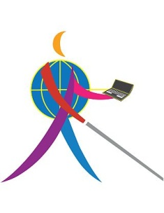 The Technology Assistance Division (TAD), is hosting a Raffle for a 32GB iPad Mini. Tickets are $5 each. You can purchase them from TAD Board Members(Todd Stephens, Melanie Peskoe, Sandra Williams, Jennifer Hall, Michael Freholm, Scott Spaulding, & John Glisson). Proceeds will go to increase TAD’s ability to have webinars/workshops that promote blindness skills and awareness. We appreciate your support & will draw for the iPad mini after banquet festivities!

