Katie Adkins, President
NFB of Greater Louisville
2025 Brownsboro Rd.
Apt. 411
Louisville, KY 40206
502-262-1403

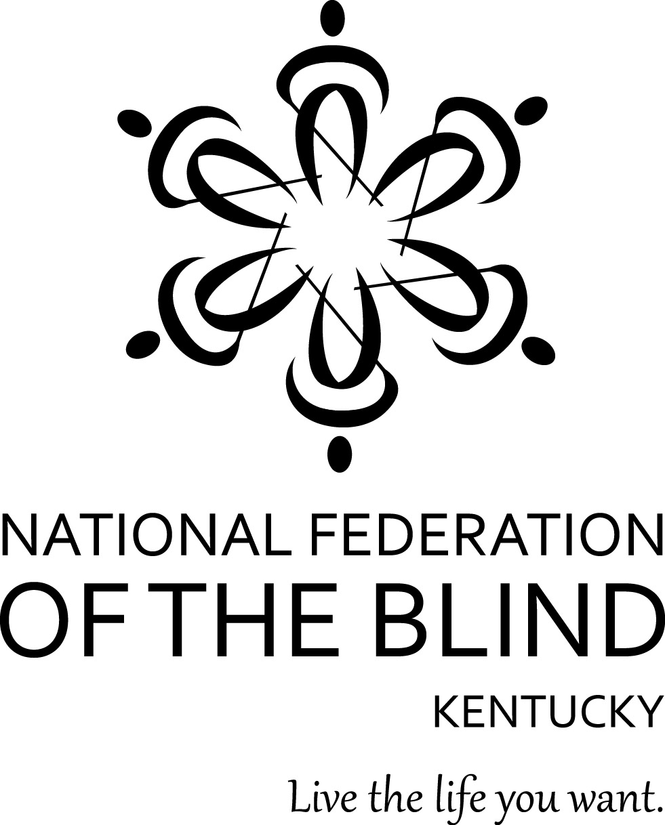

For Immediate Release:

National Federation of the Blind of Greater Louisville

2015 Annual Chili Supper and Fundraising Auction

The mission of the National Federation of the Blind is to achieve widespread emotional acceptance and intellectual understanding that the real problem of blindness is not the loss of eyesight but the misconceptions and lack of information which exists.

The National Federation of the Blind of Greater Louisville hosts an annual chili supper and auction to raise much needed funds to support our mission and programs to enhance the lives of blind people. 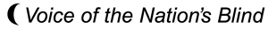This event will take place on February 7, 2015 at Christ Church Cathedral, 421 S. Second St. Louisville, KY 40202. We would be honored to have you join us!

To help make this worthwhile event a fundraising success we kindly request the donation of items for the auction. These items may be tangible or monetary and are 100% tax deductible.

If you would like to support the efforts of the National Federation of the Blind, please give the item to the person who gave you this letter or send auction items to:

National Federation of the Blind of Greater Louisville

2025 Brownsboro Rd. Apt. 411

Louisville, KY 40206

Thank you very much for your donation. Through your generosity we are able to provide programs to foster independence and leadership training for many blind individuals.

Your contributions are 100% tax deductible.

The NFB of Greater Louisville is raising money on behalf of the National Federation of the Blind of Kentucky, a 501-c-3 organization, upon request a letter of exemption will be provided.

If you have further questions, please call:

Katie Adkins, President at (502) 533-5933 or Kcpenn01@louisville.edu

