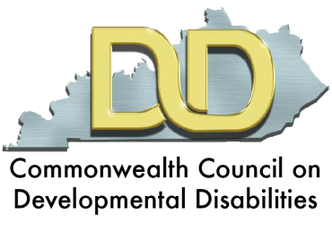
Kentucky ABLE Act
Promoting Independence, Work & Savings for
Kentuckians with Disabilities

Starting July 15, 2016, eligible Kentuckians can open ABLE accounts
without jeopardizing Medicaid eligibility or means-tested benefits such as SSI.

FACTS ABOUT THE KY ABLE ACT
- The Kentucky ABLE Act (SB 179) allows Kentuckians to benefit from the federal Achieving a Better Life Experience (ABLE) Act, which allows people with disabilities to establish tax-deferred savings accounts under §529A of the US Tax Code. The new law will be effective on July 15, 2016.
- The new law DOES NOT create a state program.
- The new law DOES allow Kentuckians to establish accounts (operated under other states programs) without jeopardizing means test benefits or Medicaid.
- The new law directs the State Treasurer to work with several other government and advocacy stakeholders to determine the best plan of action related to ABLE accounts for Kentuckians.
HOW CAN KENTUCKIANS OPEN ACCOUNTS?
- As of June 2, 2016, Ohio is the only state that has a program offering ABLE Accounts.
The Ohio program is open to people from other states, including Kentucky.
More information is available at http://www.stableaccount.com/ .
- Several other states plan to begin offering accounts soon, including: Tennessee, Nebraska, Virginia and Colorado.
KEY CHARACTERISTICS OF ABLE ACCOUNTS
- To quality, an individual must become disabled before age 26. In addition, an individual either must be entitled to Supplemental Security Income or Social Security Disability Income benefits, or file a disability certification with the IRS.
- ABLE Accounts are similar to college-savings plans governed by §529 of the US Tax Code. However, spending is allowed for “qualified disability expenses” (not just on education-related expenses).
- Qualified disability expenses are any expenses made for the benefit of the designated beneficiary related to his/her disability, including: education, housing, transportation, employment training and support, assistive technology and personal support services, health, prevention and wellness, financial management and administrative services, legal fees, expenses for oversight and monitoring, funeral and burial expenses.
- Any person, such as a family member, friend, or the person with a disability, may contribute to an ABLE account for an eligible beneficiary
- The legislation includes a Medicaid pay-back provision, which could allow recoupment for Medicaid payments from money left in the account after the beneficiary’s death.

For more information, visit http://www.ablenrc.org/.

