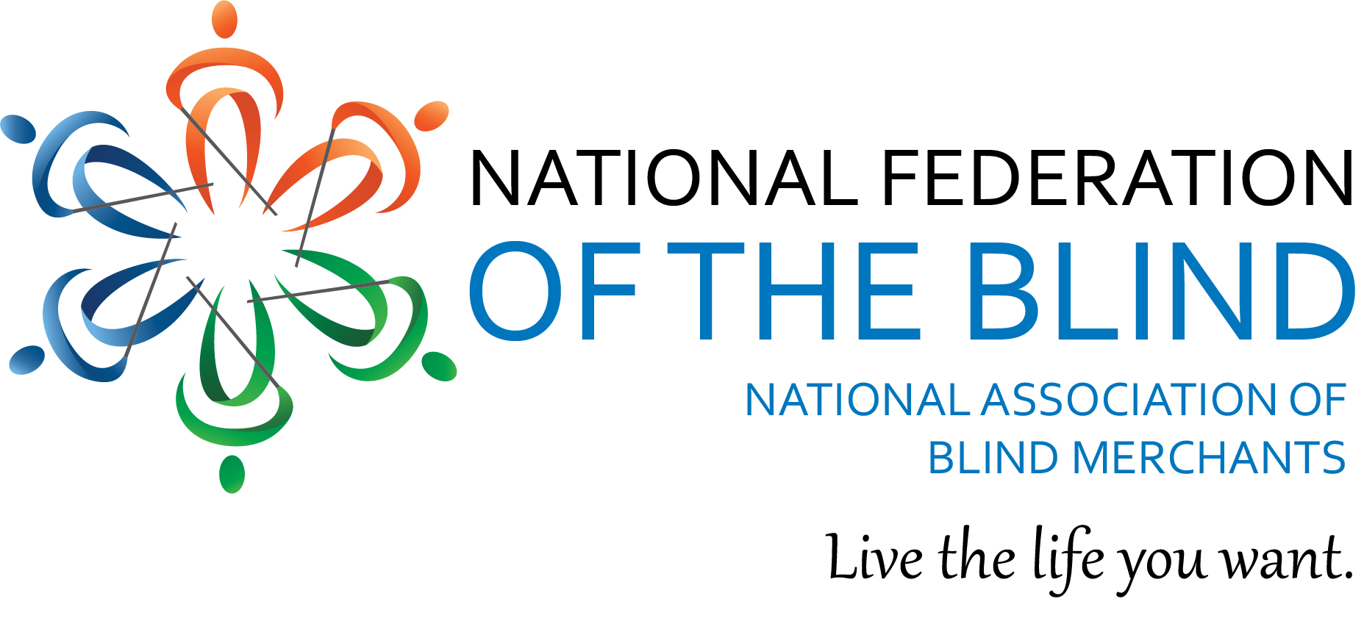
Dear Blind Entrepreneur:
The National Association of Blind Merchants is trying to increase our membership along with building up our data base. We have found in the past that blind entrepreneurs are not always receiving the information that is put out by NABM. By building up our data base, we can ensure that each individual member will receive all correspondence that NABM distributes.
Your membership in NABM also helps us with all of the advocacy work that we do on behalf of all vendors across the country. The larger the number the better when we talk with members of Congress.
We also plan to do members only Zoom calls where we can discuss issues that affect all of us. You need to join to be on those calls.
The fee for membership is only $10 a year, and if you join now , your membership is good until December 31st, 2022. You will also receive an email reminder every year that your membership is due for renewal.
To join, go to our website at www.blindmerchants.org/membership. It won’ take you more than 5 minutes and you will be helping the cause.
We appreciate your consideration in helping NABM build our membership.

Sincerely,
Nicky Gacos, President
President@merchants-nfb.org

