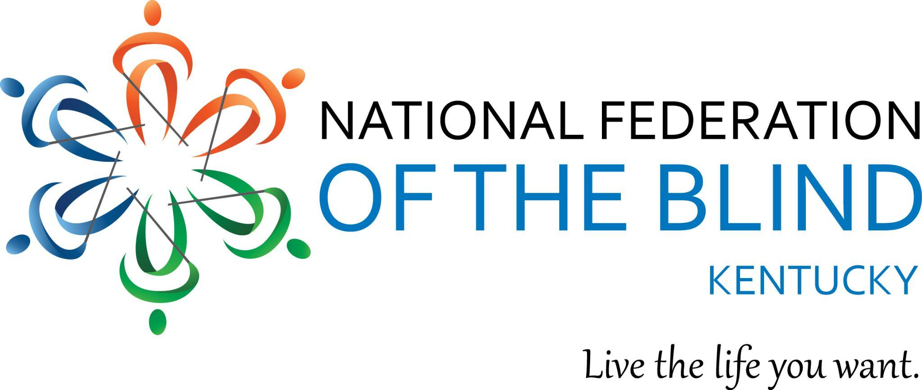 National Federation of the Blind of Kentucky

77th Annual State Convention

Hilton Garden Inn NE Louisville Kentucky

Thursday, October 31 to Sunday, November 3, 2024

The Board of Directors of the National Federation of the Blind of Kentucky Welcomes you to our 77th annual state convention. We are pleased that you have joined us as we Go for the Gold. Our goal is to help you build your tool kit to enable you to Live the Life You Want.

NFB of Kentucky Board of Directors:

**Executive Board**

Angela Henderson, Interim President, Ashland

Karen Mayne, Interim 1st Vice-President, Frankfort

Todd Stephens, Treasurer, Lexington

Lora Stephens, Secretary, Lexington

**Board Members**

Danielle Burton, Louisville

Jacob Hack, Louisville

Ashley Swafford, Louisville

Sandra Williams, Louisville

We want to welcome our National Representative, Marilyn Green. Marilyn serves as secretary of the National Federation of the Blind and as the President of the NFB of Illinois Affiliate.

**Convention Sponsors**

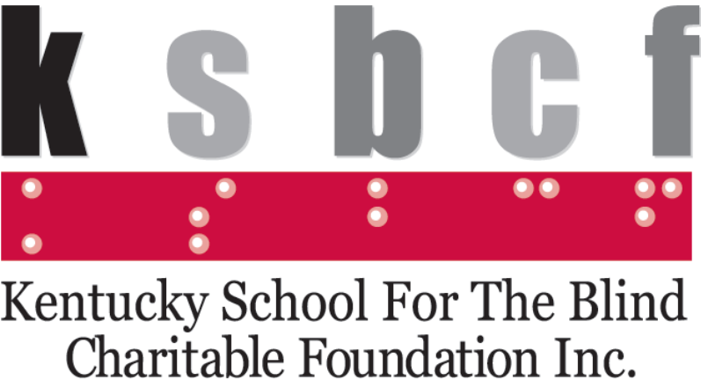

Kentucky School for the Blind Charitable Foundation

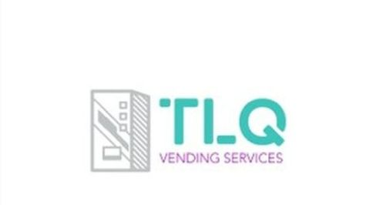

TLQ Vending Services

**Membership Sponsors**

Platinum:

Melissa Caldwell

Cathy Jackson

Gold:

Angela and Ben Henderson

Silver:

Alan Shrebtienko

Bronze:

Michelle Haycraft

JP Pullens

Lonnie and Ashley Swafford

Jenny Tyree

Sandra Williams

Thursday, October 31, 2024

1st Annual Senior Summit

(Sponsored by the NFB of Kentucky Technology Assistance Division (TAD)

You must be 55 and older to participate in this session.

**1:00-2:00 Arrival/Registration**

**2:00-2:10 Welcome/Housekeeping**

Mistress of Ceremonies: Melanie Peskoe

**2:10-2:30 NFB, Who We Are and What We Do**

Angela Henderson, NFB of Kentucky Interim President and Cathy Jackson, NFB of Kentucky President Emeritus

**2:30-3:00 Coming to Terms with Blindness**

Todd Stephens, Sharri Anderson, and Sandra Williams

**3:00-3:30 APH Connect Center**

Resources for Vision Loss: Olaya Landa-Vialard

**3:30-3:40 Apps & Devices for Everyday Use Seeing AI/Be My AI & the A-Lady**

Angela Henderson

**3:40-4:10 Low Vision Solutions**

Melanie Peskoe and Heather Marshall

**4:10-4:30 Simple Solutions for Everyday Life**

Lora Stephens, and Sandra Williams

**4:30-4:45 Accessible Reading Solutions: NFB-NEWSLINE®, BARD/Bookshare, Victor Stream, Sense Player**

**4:45-5:00 Accessible Cell Phones; iPhone, Android, Blind Shell, Habel**

**5:00-5:45 Questions and Answers Round Table Discussion Everything You Wanted to Know About Blindness, But Were Afraid to Ask**

Facilitator, Angela Henderson

**6:00-7:00 Dinner**

Invocation: Todd Stephens

**7:00-8:00 Exhibits, Hands-On Experiences, Mix & Mingle, Audience Evaluation and Survey**

Friday November 1, 2024

**8:30-9:00 Registration/packet pick-up**

**12th Annual Technology Assistance Division (TAD) Symposium**

**9:00-9:10 Welcome and Introductions**

Mistress of Ceremonies: Sandra Williams

**9:10-9:40 Dennis McKinney - Advanced Low Vision Technology**

Dennis will be presenting on Envision AI. Envision glasses are the Smart glasses for the blind and low vision developed on the Google platform. Read more about Envision AI at <https://www.letsenvision.com/glasses/home>

**9:45-10:15 Ryan Jones- Vispero/Freedom Scientific.**

Ryan will be presenting on the latest development in blind and low vision technology. Read more at <https://www.freedomscientific.com/>

**10:20-11:20 Low Vision Gaming**

Joseph Hodge, Quality Assurance Manager with APH and NFB Kentucky TAD Program manager. Joe and TAD Board Members will be presenting on blind and low vision gaming technology. All you gamers out there; you do not want to miss this!

**11:25-11:50 Tactile Sports Broadcasting**

Bree Fraser and Jerred Mace with One Court. The first tactile sports broadcast! Transforming gameplay into trackable vibrations, so blind and low vision fans can watch the game with their fingertips. Read more at <https://www.onecourt.io/>

**11:50 - 12:00 NFB-NEWSLINE®**

Lora and Todd Stephens

NFB-NEWSLINE®, the audio reading service for the print impaired. This is a free audio reading service developed and implemented by the blind but is not exclusive to the blind. Todd and Lora will be available to speak with you and get you signed up on-site. Read more about NFB-NEWSLINE Kentucky at <https://nfbnewsline-ky.org>

**The NFB Kentucky TAD Business Meeting will follow the symposium. To read more about the NFB Kentucky Technology Assistance Division (TAD and the work that we do), please visit us at** [**https://nfbkentuckytad.org**](https://nfbkentuckytad.org)

**12:00-12:30 TAD Annual Business Meeting**

Technology enthusiasts, come one and all! Join our Technology Assistance Division as we discuss what TAD has been doing this past year and make plans for the year ahead! Todd Stephens, president

**12:30-2:00 Lunch Break**

(For those who purchased a boxed lunch, a meal ticket is included in your registration packet. Please remit the ticket when you pick up your boxed lunch.)

**2:00-4:00 Sports & Rec Group**

Join our sports and rec group for some hands-on exploration of adapted sports equipment, play a lively game of corn hole, explore other adapted sports activities, and find your inner peace with a nice relaxing yoga session! Comfortable clothing is recommended!

Danielle Burton and Jacob Hack: Co chairs.

Yoga instructor: Marilyn Green

**5:00-7:00 Parents Group**

This event is for the whole family. Join the Blind Parents & Parents of Blind Children group for a fun filled pizza and Pool Party: Ashley Swafford, chair.

**7:00-8:00 Resolutions Committee**

Lonnie Swafford, Chair

Please join the Resolutions Committee as it meets to finalize the resolutions that will be brought before the general assembly during the annual business meeting on Sunday morning for vote. This is one of the most important aspects of our convention as Our Resolutions are how we develop policy for our organization.

**8:00-11:00 Monster Mash Party and Social**

Sandra Williams, Chair.

This event will be fun for all ages! We are extending Halloween by one day this year! Come dressed in your Halloween costume and enjoy some Halloween/fall themed fun festivities! Costume contests for all ages including best decorated cane and guide dogs are sure to impress.

Saturday November 2nd, 2024

**7:00-8:00 Scholarship Breakfast**

Lora Stephens, Chair

(This is a closed meeting for scholarship recipients, committee members, and invited guests.)

**8:30-9:00 Registration/Packet Pick-Up**

**General Session:**

**9:00- 9:20 Call to order**

Angela Henderson, Interim President

Invocation, Lonnie Swafford, Secretary NFB of Greater Louisville

National Anthem, Sandra Williams, NFB of Kentucky Board Member

Pledge of Allegiance, MaKenna Harrod and Emma Swafford

NFB Belief Statement, Karen Mayne, Interim 1st Vice-President

NFB Pledge, Danielle Burton, NFB of Kentucky Board Member

**9:20-9:30 Greetings from our National Office**

Marillyn Green, Secretary, National Federation of the Blind, President NFB of Illinois

**9:30-10:00 Going for the Gold; Building your toolkit to live the life you want**

Dave Wilkinson: My life as an athlete

**10:00-10:30 Going for the Gold; Building your toolkit to live the life you want**

Samantha Sinclair: My life as an Author

**10:30-10:40 FIT BREAK**

**10:45-11:00 Panel Discussion from our NFB BELL Academy Students, Parents, and Volunteers**.

Facilitated by Lora Stephens, NFB BELL Academy Instructor

**11:00-11:30 All about NFB-NEWSLINE®**

Todd and Lora Stephens, NFB-NEWSLINE® Kentucky

**11:30-12:00 The state of transportation in Louisville: TARC Update**

Shawn Riley, TARC Marketing Coordinator

**12:30-2:00 Lunch Break**

(For those who purchased a boxed lunch, a meal ticket is included in your registration packet. Please remit the ticket when you pick up your boxed lunch.)

**General Session:**

**2:00 Call to Order**

Angela Henderson, Interim President

**2:00-2:30 Report from the National office**

Marilyn Green, National Representative.

**2:30-2:50 Kentucky Talking Book Library Updates**

Evan Hatter, KTBL Information Officer

**2:50-3:10 American Printing House for the Blind**

Anne Lancaster, Vice-President of Innovation and Strategy

**3:10-3:25 Congressman John Morgan McGarvey, Representing Kentucky’s 3rd District**

**3:25-3:35 Get on the PAC Plan!**

Sandra Williams, PAC Chair

**3:30-3:50 CloverNook Center for the Blind and Visually Impaired, Cincinnati, Ohio**

Stephanie Jones, Technology and Accessibility Coordinator

**3:50-4:10 Legislative Collaboration**

Justin Jeter, Commonwealth Council on Developmental Disabilities

**4:10-4:30 Accessible Voting: Get out and vote!**

Karen Mayne, Interim 1st Vice-President

**4:30-4:50 Reading of the proposed Constitutional Amendments**

Lonnie Swafford. Chair

**5:00 Adjourn**

**7:00 Annual Banquet**

Mistress of ceremonies: Sandra Williams, NFB of Kentucky Board Member

Invocation: Ashley Swafford, NFB of Kentucky Board Member

Recognition of the Head Table: Sandra Williams, Mistress of Ceremonies

Banquet Keynote Address: Marilyn Green, Secretary, National Federation of the Blind, President, NFB of Illinois

Presentation of NFB of Kentucky Scholarships: Lora Stephens, chair

Presentation of Greater Louisville Chapter Scholarships: Lonnie Swafford Chair

Presentation of Awards: Cathy Jackson, Chair

Conclusion: Drawings and Door prizes!

Sunday November 3 2024

General Session/Annual Business Meeting

**9:00 Call to Order**

**9:00-9:30 Presidential Report**

Angela Henderson, Interim President NFB of Kentucky

**9:30-9:45 Treasurer's Report**

Todd Stephens, Treasurer, NFB of Kentucky

**9:45-10:00 Report from the Resolution’s Committee**

Lonnie Swafford, Chair

**10:00-10:15 Report from the NFB of Kentucky Constitution Committee**

Lonnie Swafford, Chair

**10:15-10:30 Report from the Nominating Committee**

Karen Mayne Chair

Election of Officers

**10:30-10:45 Old Business**

**10:45-11:00 New Business**

**11:00 Adjournment**

**NFB Belief Statement:**

The National Federation of the Blind advances the lives of its members and all blind people in the United States. We know that blindness is not the characteristic that defines you or your future. Every day, we raise the expectations of blind people because low expectations create obstacles between blind people and our dreams. Our collective power, determination, and diversity achieve the aspirations of all blind people.

**NFB Pledge:**

I pledge to participate actively in the effort of the National Federation of the Blind to achieve equality, opportunity, and security for the blind; to support the policies and programs of the Federation; and to abide by its constitution.