

FINANCIAL PATHWAYS TO INDEPENDENCE

**ASSISTIVE TECHNOLOGY AND APPALACHIAN ASSISTIVE TECHNOLOGY LOAN FUND**

**FEBRUARY 19, 2025 - 2:00 PM - 3:00 PM**

Join us for an informative webinar on achieving independence through assistive technology (AT).

Discover what assistive technology is and how it enhances independence for individuals with disabilities and older adults. Learn about Appalachian Assistive Technology Loan Fund (AATLF) and its Mini-Loan program, designed to make obtaining AT more affordable for Kentuckians.

We’ll discuss the benefits of AATLF Mini-Loans and how they can improve personal freedom, opportunities, and credit scores. Whether you are seeking AT for yourself, helping a loved one, or working in the field, this webinar is your gateway to funding resources.

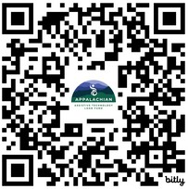

PRE-REGISTRATION IS REQUIRED:

[Click Here to Register](http://bit.ly/Financial_Pathways_to_Independence)

or

Scan the QR Code

**To use the QR code:**

Open your smart phone’s camera. Focus it on the QR code. Tap the yellow pop-up that appears

to go to registration.

Appalachian Assisitve Technology Fund logo.
KATS Network: Disability Solutions Through Technology logo.ASL, CART, and Spanish language interpretation will be provided. Please let us know by February 12, 2025, if you require additional accommodations. If you have any questions or need help registering, contact: [khassett@patf.us](mailto:khassett@patf.us).