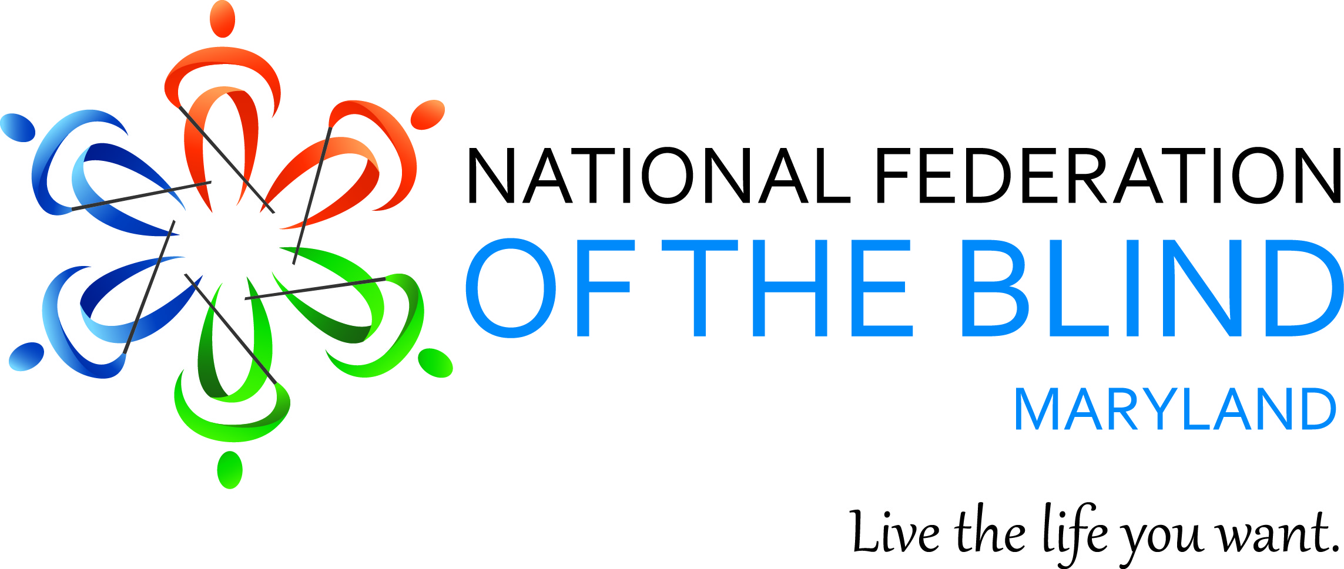
www.nfbmd.org
ANNUAL CRAB FEAST
To benefit the John T. McCraw Scholarship Fund
Friday, August 7, 2015 - 7:00 p.m. to 12:00 a.m.
Columbus Gardens - 4301 Klosterman Ave. - Baltimore, MD 21236
(off 8400 block of Belair Road)
50/50 &
Money Wheel!
Steamed Crabs, Pit Beef, & Ham – All You Can Eat!
Plus a Buffet of Entrees & Sides`
Yuengling, Bud, and Coors Light on Tap
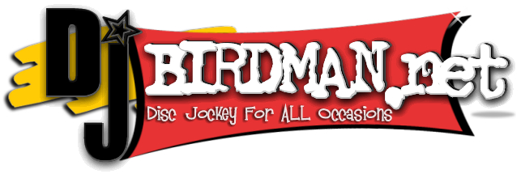
Carbonated Beverages and Coffee
DJ Music, Dancing, Door Prizes

Tickets: $55.00 per person if purchased on or before 7/31/15 OR $60.00 per person
if purchased after 7/31/15. Children 6 and under are FREE.
Purchaser’s Name: ____________________________________________________

Address: ____________________________________________________________

City: ___________________________ State: ____________ Zip: _____________

Phone: ( ) ________________ Email: ________________________________

Number of Tickets Needed: _______ @ $55.00 each OR ______ @ $60.00 each

Amount Due: $_________________ Tickets Sold By: ______________________

Buy or Sell 25 or more tickets and your ticket is FREE!
Pay online at: www.nfbmd.org
Make checks payable to: NFBMD
Mail to: Crab Feast, 1631 Shadyside Road, Baltimore, MD 21218
For additional information: (443) 570-5285 or email Steve@SteveBrand.net

