An Evening At the Movies
Enjoy a new, critically acclaimed documentary based on the stories of four inspiring young people.

Date: Thursday, January 4, 2018
Time: 6:30pm - 8:30pm
Movie and Discussion
Place: Howard County Central Library, 10375 Little Patuxent Parkway, Columbia, MD 21044

Please register at: http://host.evanced.info/hclibrary/lib/eventsignup.asp?ID=97388&ret=http://host.evanced.info/hclibrary/lib/eventcalendar.asp?ln=ALL

The documentary “Do You Dream in Color?” is the coming-of-age story of four courageous blind high school students as they strive to prove that their disability will not hold them back from achieving their dreams. This movie will appeal to people of varying backgrounds. It demonstrates adapting to, and overcoming, challenges – something that everyone encounters throughout life.
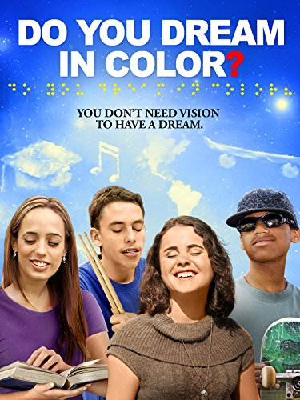
Sponsored by the Central Maryland Chapter of the National Federation of the Blind and the Howard County Library.

