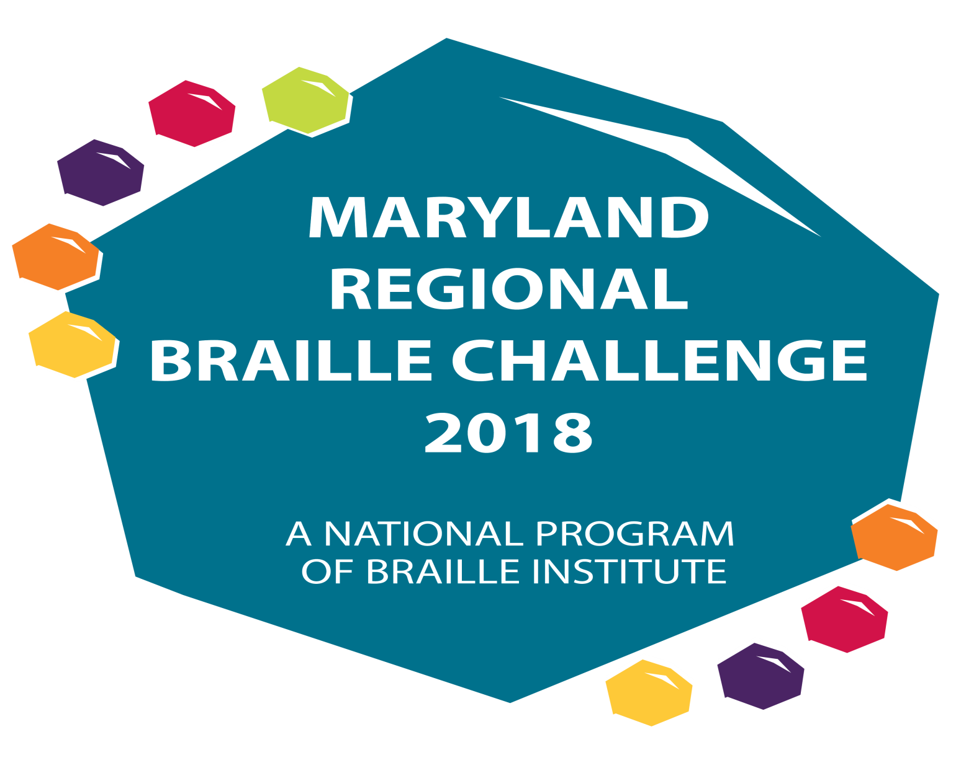

THE MARYLAND REGIONAL BRAILLE CHALLENGE
February 3, 2018
(Snow Date – February 10, 2018)
Location: Maryland School for the Blind
Follow us on Twitter @mdbrlchallenge #mdbc18

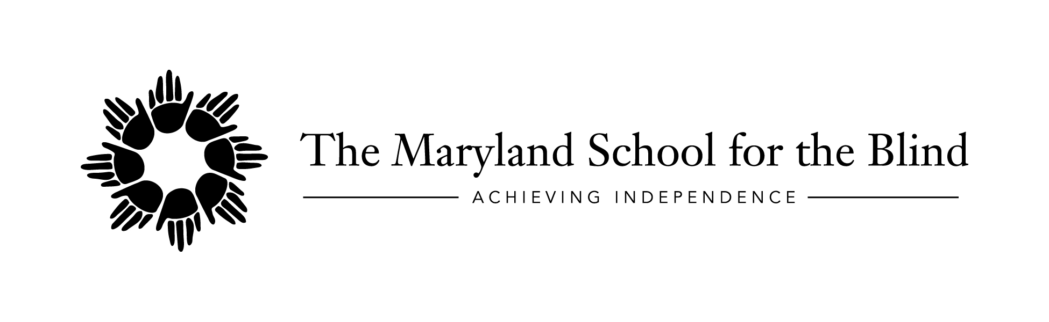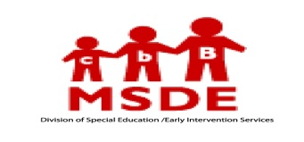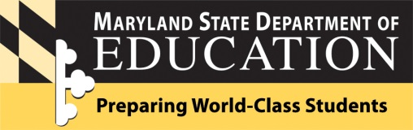

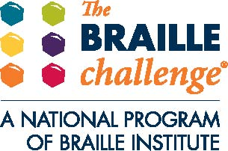

The Maryland State Department of Education and The Maryland School for the Blind will be hosting the Maryland 2018 Regional Braille Challenge.
The weather may be cold outside but we have plans to make you feel warm! For the first time, this year we will be having a theme: Hawaiian Luau! So please wear clothing with a tropical flair! Aloha Braille!

Braille is an important key to literacy! It allows for the enjoyment of reading, leads to school success, and opens the doors to future employment. Come celebrate braille literacy with a day filled with fun, competition, learning, and prizes! In addition, bring in Braille books you no longer read for our Braille Book Exchange!

The non-competitive program for Braille Enrichment for Literacy and Learning (BELL) will return again this year. Students will participate with peers and blind adult role models in various fun activities which integrate Braille. This is for elementary aged students and the group size is limited to 10. This program is designed for beginning braille readers who are learning the alphabet and some contractions.

Students who read braille in grades Prekindergarten through Grade 12 are invited to participate in the Maryland Regional Braille Challenge reading and writing contests. Parents are invited to participate in workshops while students are taking the tests. Teachers and school staff are invited to assist with test proctoring, scoring, and facilitating activities throughout the day. Presentations include workshops to address independent and adaptive living skills, and JAWS screen reading software. The JAWS screen reading software presentation is limited to the first 10 individuals that sign up, so make sure you get your name on the list. Our keynote speaker is Kristen Smedley, author of Thriving Blind. We hope you will join us for the exciting day!

For the 2018 Braille Challenge all contests for all grade levels will be in UEB. There will be no EBAE option for 2018.
To learn more about the Braille Challenge visit brailleinstitute.org and to find practice materials go to Braille Institute's Braille Challenge Information and select the “Sample Contests” link.
WHEN: Saturday, February 3, 2018 (Snow Date: February 10, 2018)
COST: FREE
TIME: 8:00 AM to 4:00 PM (Lunch will be provided)
WHERE:
The Maryland School for the Blind
3501 Taylor Avenue
Baltimore, Maryland 21236

Maryland 2018 Regional Braille Challenge Tentative Agenda
Parent/Guardian Tentative Agenda

8:00-8:45 Registration (Knefley Gym)

9:00-9:30 Opening Ceremony (Knefley Gym)
- Welcome and Introductions
- Event Schedule
- Housekeeping Items
9:45-10:30 Session 1 (Knefley Gym)
    - Keynote Speaker: Kristen Smedley, Author and Motivational Speaker
10:40-12:40 Session 2 (Knefley Gym)
    - Presentation: Integrating Braille into Independent Living Skills and Adaptive Living Skills. Presented by Daniel Norris, Program Coordinator, University of Massachusetts Boston and Sara Borlie, Educational Consultant, Maryland School for the Blind
    - Presentation: Hands on Experience with JAWS for Parents.
Presented by Cody Laplante, B.S.Ed, TVI, Technology Instructor, Maryland School for the Blind
12:45 – 1:15 Lunch
1:15-2:00 Session 3 (Same Locations)
    - Continuation of Presentation
2:00-3:15 Session 4 (Knefley Gym)
    - Reuniting of Families as Testing is Completed
- Vendor Fair and Activities
3:15-4:00 Awards (Knefley Gym)

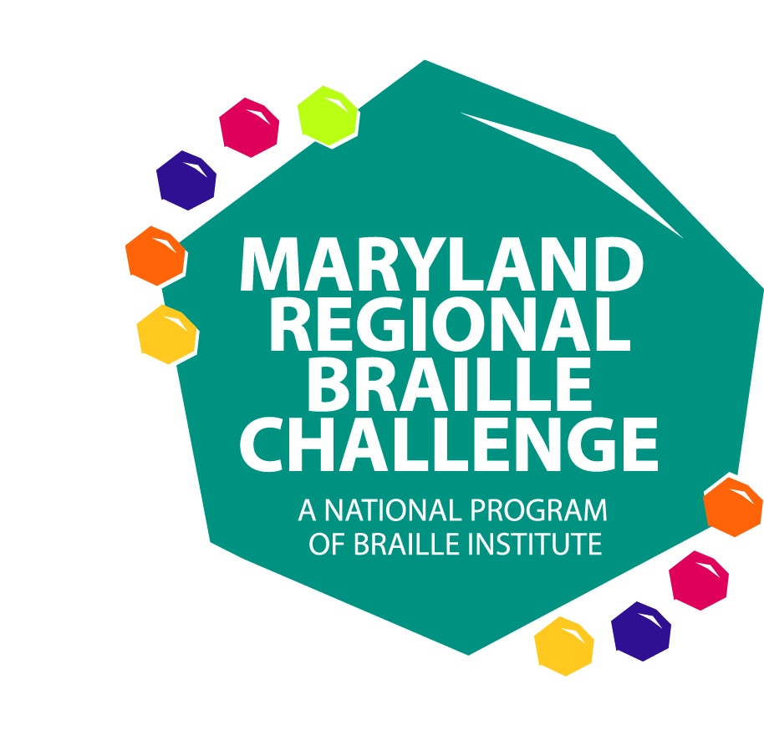
Student Tentative Agenda

8:00-8:45 Registration (Knefley Gym)
9:00-9:30 Opening Ceremony (Knefley Gym)
- Welcome and Introductions
- Event Schedule
- Housekeeping Items
9:45-10:45 Session 1
    - Students in PreK-12 Testing and/or Mini-BELL
11:00-11:45 Session 2
    - Students in PreK-12 Testing and/or Mini-BELL
11:45 – 12:30 Lunch
12:30--2:00 Session 3
    - Students in PreK-12 Testing and/or Mini-BELL
2:00-3:15 Session 4
- Continuation of Testing as Needed
- Vendor Fair and Activities with Family Members (Knefley)
3:15-4:00 Awards (Knefley Gym)

MARYLAND REGIONAL BRAILLE CHALLENGE
Baltimore – February 3, 2018 Snow Date: February 10
PARENT REGISTRATION

Participant’s Name: _________________________________________
Lunch Option (circle one): Wraps – Chicken, Turkey, Roast Beef, Vegetarian

Please select: ( ) Braille Challenge or ( ) BELL Participant

Name of Parents/Guardians Attending:
__________________________________________________________
Lunch Option (circle one): Wraps – Chicken, Turkey, Roast Beef, Vegetarian

__________________________________________________________
Lunch Option (circle one): Wraps – Chicken, Turkey, Roast Beef, Vegetarian

I’d like to participate in the JAWS Workshop (Limited to first 10 registrants) ( )

Accommodations (to be provided upon request) for Parents/Guardians.
Please specify. ( ) Large Print ( ) Braille ( ) Electronic
For Students in Grade 5-12 Only: Students may bring their own or school system Victor Reader Stream and headphones to use for the “Speed and Accuracy” contest. If they cannot bring one, a Bookport Plus will be provided for use. Please check one box. Students should able to use one or both devices independently. Please contact Jackie Otwell at jacquelineo@mdschblind.org if this is a concern.
( ) I will need a BookPort Plus OR ( ) I will bring a Victor Stream
( ) Yes, I would like to bring books to exchange at the Braille book exchange. I will bring approximately ____ books (count each volume as a separate book please, this is to help with planning).
*Is your child a member of the Maryland State Library for the Blind and Physically Handicapped? If not, visit Maryland Library for the Blind and Physically Handicapped to download an application.*
Workshops will be provided throughout the day for parents.
NOTE: At least one parent must attend and remain on site throughout the day while their child is present and competing. Parents are not allowed in the testing rooms with their child. You are encouraged to participate in the workshops provided. Your children will be escorted and supervised by teachers and staff from the Local School Systems and The Maryland School for the Blind.

Parent Signature: _______________________________________
THIS FORM MUST BE SIGNED and SENT TO KERRY MICHAEL BY JANUARY 12, 2018
FAX 410-319-5708 or Email @ kerrym@mdschblind.org
THANK YOU FOR THE SUPPORT FROM OUR NATIONAL SPONSORS

