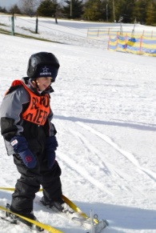Picture of Student Snow Skiing
Skiing at
Deep Creek Lake, MD
Feb 11-13, 2019
6 students
Only IF we fill up first week 6 spots we may have also open 6 more spots
Feb 18-20, 2019
6 students
Age 8 and Up
Deep Creek Lions is sponsoring 2 days of all expense paid
Snow Skiing,
Possible Tubbing, snow mobiling
At Wisp, etc.
Come join us
Let us know ASAP. We only have 12 spots for student plus a parent to chaperone we do have a couple parent willing to chaperone a couple students without a parent Chaperone if the student is self-independent
TLpickrel@hotmail.com
Trudy Pickrel 301-501-1818
Need Forms returned by Jan 15th!!!

