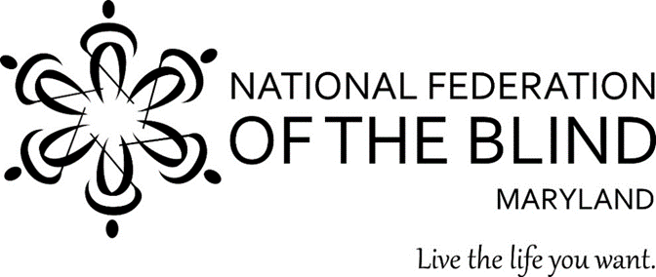 NFBMD Logo

B & B Bingo Returns!

Featuring BASKETS AND BAGS from:
Longaberger, Kate Spade, Coach, Dooney & Bourke and more!

benefitting

The National Federation of the
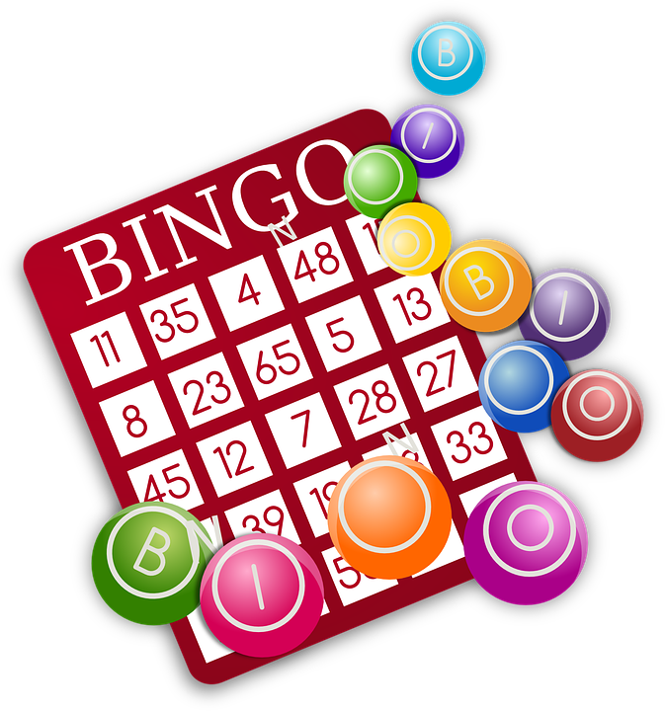
Blind of Maryland

Friday, September 10, 2021
7:00 p.m. (Doors open at 6:00 p.m.) bingo player
bingo card
The Lodge
2832 Nine Mile Circle
Catonsville, MD 21228

$25 per ticket before September 10*
$30.00 per ticket on September 10 (if available)
(pay by cash, check made out to NFBMD, or PayPal through www.nfbmd.org)

Mail checks and orders to: 9013 Nelson Way Columbia, MD 21045

Over $4,000 in prizes!!! All baskets and bags filled!!!

Back by Popular Demand…Our Fabulous Pick-Your-Prize Raffle!

*All ticket sales are final. *Seats must be claimed by 6:45 p.m. *For more information call 410-715-9596

