National Federation of the Blind of Maryland

2022 Annual Convention

AGENDA

Reconnect, Reimagine, Reignite!

Friday, November 11 to Sunday, November 13

Image description: An up-close, head-on photo of a lit match with a tall orange flame.

The Members of the Board of Directors and the
Host Committee welcome you to the 56th Annual Convention of the National Federation of the Blind of Maryland

Ronza Othman, President
National Federation of the Blind of Maryland

Meleah Jensen and Justin Young, Co-Chairpersons
Convention Organization and Activities

Meleah Jensen, President
TLC Chapter

Christopher Danielsen, President
Greater Baltimore Chapter

Qualik Ford, President
Maryland Association of Blind Students

Garret Mooney, President
Maryland Parents of Blind Children

Sheraton Baltimore North Hotel
903 Dulaney Valley Road, Towson, MD 21201
410-321-7400

Welcome
Welcome to the 56th annual convention of the National Federation of the Blind of Maryland being held in Towson at the Sheraton Baltimore North Hotel. A detailed description of the layout of the hotel can be found later in this agenda. When you check into the hotel, you will be asked to confirm your departure date. If you decide to leave earlier than the departure date you confirm when you check in, there may be a change fee.

Special Information for First-Time Attendees
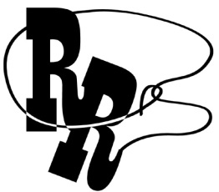
All first-time convention attendees are cordially invited to attend a First-Timers Orientation from 8 to 9:30 p.m., on Thursday, November 3. The Ambassadors Committee will walk you through the events that will take place throughout the weekend, explain processes such as door prizes and voting, as well as make sure every first-time convention attendee is matched with a mentor.
Zoom Meeting ID: 624 813 8327
One-Number Conference Call: 339-209-4083

Diversity, Equity, Inclusion, and Social Conduct
We are committed to providing a safe and harassment-free environment for everyone. Thank you for cultivating an atmosphere in which participants from diverse backgrounds can learn, network, and share with each other in an environment of mutual respect. We are committed to diversity, equity, inclusion, and the free expression of ideas. These principles have been outlined in our code of conduct, which can be found at NFB.org/Code-Conduct.

We recognize a shared responsibility to create and uphold that atmosphere for the benefit of all. Prohibited behaviors include harassment, unwelcome sexual attention, and inappropriate use of the NFBMD convention space and platforms. Prohibited behavior or misuse of our space and platforms will not be tolerated and may result in removal from the convention and/or other consequences.
For assistance or to report an incident at the convention,
please call 504-621-4162 or email Convention@nfbmd.org for immediate attention.
Formal reports can be submitted to the NFB national office at:
NFB.org/About-Us/History-and-Governance/Code-Conduct/Grievance-Report-Form.
All formal reports will be fully investigated according to the code of conduct. Thank you for contributing to our community and the high expectations we strive to maintain.

Policy on In-Person Events
Note: The NFBMD Board of Directors may update this policy based on public health guidance. The most up-to-date version of this policy is available at NFBMD.org/EventPolicy.
This policy is applicable to all chapters, divisions, and the affiliate, as well as any activities, meetings, fundraisers, or in-person gatherings of an official nature.
- This policy augments any local public health requirements, including those established by the State of Maryland and the County where the event takes place. This policy is the minimum required for in-person events and activities and may be more restrictive than local guidance. However, if local public health guidance imposes additional or more restrictive requirements, the more restrictive requirements govern.
- The following individuals should stay home:
  - Individuals who feel sick, including experiencing any of the following symptoms: fever, sore throat, runny nose, loss of smell or taste, or those ordinarily associated with COVID-19;
  - Unvaccinated individuals who have tested positive for COVID-19 in the past 14 days or vaccinated individuals who have tested positive for COVID-19 in the last 10 days;
  - Individuals who have a pending COVID-19 test;
  - Individuals who have been exposed to an individual who is known or suspected of having COVID-19, for the period of time indicated by the Centers for Disease Control and Prevention (CDC);
- Individuals who purchase tickets for an event and either experience symptoms or later determine they do not feel comfortable attending a large gathering due to the pandemic may choose between requesting and receiving a full refund or donating all or part of the purchase price to the organization;
- The event host must have masks on hand for individuals who do not bring their own or whose masks are damaged or soiled;
- If an individual observes that another event participant is not adhering to this policy, such as not wearing a mask, that individual is encouraged to either remind the other participant about the requirement or notify an event organizer/leader so they can do so;
In-door gatherings:
- COVID-19 screening will be conducted using an affiliate designated/approved screening for any event with more than 50 participants. The event organizer will implement a screening process of its choosing, as long as that process is consistent with CDC recommended screenings for COVID-19 for events with 50 or fewer participants. Those reporting symptoms and/or recent exposure to COVID-19 will be denied admission;
- Individuals must wear masks that fully cover their mouths and noses at all times unless actively eating and drinking, and unless they have been granted a reasonable accommodation based on disability or religion by the affiliate President or Vice Presidents;
- Physical distancing is required at all events, e.g. 6 feet apart unless from the same household;
- Events are limited to 75% venue capacity, but where it would be difficult to ensure physical distancing as required by #8 above, capacity may be limited to 50%;
- Those working the event, including guides, ticket takers, servers, food preparers, etc. must wear masks at all times and must wash hands frequently consistent with CDC guidance;
- The event host must provide hand sanitizer and/or easy, convenient, and accessible means for event attendees to wash their hands consistent with CDC guidance;
- Individuals may only eat and drink while stationary;
- When the COVID-19 transmission rate is moderate (yellow) or high (red), food served at any event must be prepared by a commercial kitchen that adheres to COVID-19 food preparation requirements;
- Individuals preparing and serving food must wear gloves;
- To the maximum extent practicable, event organizers must gather the names and contact information for all event attendees for contract tracing purposes;
Out-door gatherings:
- Individuals must follow the county’s requirements concerning wearing masks;
- Physical distancing may be required at all events for individuals not from the same household, e.g. 6 feet apart.
- Those working the event, including guides, ticket takers, servers, food preparers, etc. must wear masks and frequently wash hands consistent with CDC guidance;
- The event host must provide hand sanitizer and/or easy, convenient, and accessible means for event attendees to wash their hands consistent with CDC guidance;
- Individuals may only eat and drink while stationary;
- Food served at any events is recommended to be prepared by a commercial kitchen that adheres to COVID-19 food preparation requirements;
- Individuals preparing and serving food must wear gloves;
- COVID-19 screening will be conducted using an affiliate designated/approved screening for any event with more than 50 participants. The event organizer will implement a screening process of its choosing, as long as that process is consistent with CDC recommended screenings for COVID-19 for events with 50 or fewer participants. Those reporting symptoms and/or recent exposure to COVID-19 will be denied admission;
- To the maximum extent practicable, event organizers must gather the names and contact information for all event attendees for contract tracing purposes.

Adopted: August 16, 2021
Last Updated: August 27, 2022

Pre-Registration and On-Site Registration
Registration activities take place in the Fitzgerald North Foyer, which is outside of the F. Scott Fitzgerald Ballroom (Fitzgerald Ballroom), located on the Plaza Level (first floor), between 2 and 6 p.m., on Friday; 8 and 8:25 a.m., and 12 and 12:15 p.m., Saturday; and 8:30 and 8:50 a.m., Sunday. All convention attendees (both local and from out of town) are asked to register.

- Those who pre-registered for convention may pick up their registration packets in the area designated pre-registration.

- Those who did not pre-register may go to the area designated registration. Please have your check, credit card, or cash ready to pay the registration fee of $25 per person.

Convention registration is a requirement for voting, door prize eligibility, and a number of other convention activities. We condition rates for hotel rooms on proof of registration. All registrants will receive wrist bands, which will indicate voting eligibility.

Fun with Friends Convention Child Care Activities
All child care (for children ages 6 weeks to 9 years) will take place in the Duncan Room on the second level. Hours are: Friday 8:30 a.m. to 6:00 p.m.; and Saturday 8:15 a.m. to 5:15 p.m., and 6:30 to 10 p.m., or at conclusion of the banquet, whichever is earlier (lunch and dinner will be provided). Parents, contact Garret Mooney for details.

Exhibit Hall
The exhibit hall is located in the Fitzgerald West Foyer and in Fitz A on the plaza level. The exhibit hall will operate on Friday from 11 a.m. to 6 p.m.

Special Attention Items
- We will host a COVID-19 vaccine booster clinic on Saturday, November 12. Priority will be given to convention registrants. Individuals should bring their proof of previous vaccination and insurance if they have coverage. More information on how to sign up for a vaccine will be posted on the website and listserves. Advanced sign-ups are required, as we do not know if there will be enough doses for walk-ins; should there be additional availability for walk-ins, we will make an announcement at the convention.
- Banquet tickets may be purchased for $55 by cash or check at the on-site registration area. We will accept cash, credit cards, and checks. No tickets will be available after 12 p.m., on Saturday. At the banquet ticket exchange table, you may make arrangements to reserve a specific seat for yourself or for a group of up to 10 people. On the evening of the banquet, tickets will be required to enter the ballroom and will be collected at the tables. Tickets may be exchanged for vegetarian or meat meals at the banquet ticket exchange table if done so by 2 p.m., on Saturday.
- Individuals with dietary restrictions must submit those requests in advance, as such meals must often be ordered and/or prepared off-site. Such requests should be sent to President Othman by October 31, 2022.
- Requests for reasonable accommodations, other than Braille and large print agendas which will be available for all, must be submitted in advance, as such arrangements often require advanced arrangements. Such requests should be sent to President Othman by October 31, 2022.
- Banquet ticket exchange will be located in the Fitzgerald North Foyer, on the plaza level, outside the Fitzgerald Ballroom on Saturday between 1:20 and
2 p.m.
- General Sessions will be held in the Fitzgerald Ballroom on the plaza level.
- Boxed lunches will be resold if not picked up by 12:30 p.m., on Friday. Those interested in boxed lunches on Friday should visit the Fitzgerald North Foyer. Those failing to pick up their boxed lunches by 12:30 p.m., on Friday will forfeit them and will not receive a refund.
- Tickets for other meals may be purchased on a first-come, first-served basis from the registration Table and cost as follows:
  - Dinner and a Play: $20
  - Senior Issues Luncheon: $30
  - Parents Luncheon: $30
  - Students Luncheon: $30
  - Banquet: $55
- Qualik Ford and Juhi Narula are the co-chairs of the Door Prize Committee. Please turn in your door prizes to Qualik and/or Juhi as soon as possible. You must be registered for the convention and be present when your name is called in order to win a door prize. Door prizes will be awarded during the general sessions on Saturday and Sunday and during the convention banquet.
- Mike Bullis is the chairman of the National Funding Support Committee, which manages our Bake and Experience Auction. Please consider bringing baked goods and donating experiences such as dinners, cooking lessons, etc., for this auction. The Student Division will be hosting a Fire Sale for individually wrapped baked items, e.g. single cupcakes, brownies.
- We will have a cane walk with individualized cane travel instruction by an NOMC on Friday at 4 p.m. To reserve a slot for your child or for yourself, please contact Garret Mooney.
- On Sunday, you must check out of your room before 11 a.m.
- If you are leaving the Sheraton Baltimore North Hotel by an NFB of Maryland bus, please bring your luggage to the Warfield Ballroom on the plaza level between 7:30 and 9 a.m., Sunday, where it will be tagged and held for storage until noon when buses will be loaded. Please be sure your luggage is clearly labeled with your name, address, and telephone number.
- The two Guide Dog Relief Areas are located in the courtyard adjacent to the hotel registration/check-in desk and just outside the Fitzgerald North Foyer. Please be mindful that both areas are down a short flight of stairs, and you will need to prop the door for the Fitzgerald North Foyer in order to be able to get back into the hotel from that entrance.
Organization Information

National Federation of the Blind of Maryland
1800 Johnson Street, Suite N1, Baltimore, MD 21230
443-426-4110; President@nfbmd.org

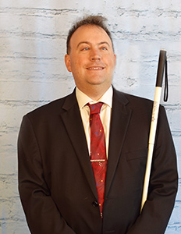 | 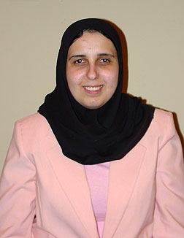
Image: Mark Riccobono  President  National Federation of the Blind | Image: Ronza Othman  President  National Federation of the Blind of Maryland
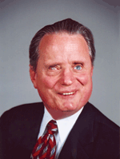 | 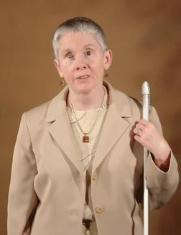
Image: Marc Maurer  Immediate Past President  National Federation of the Blind | Image: Sharon Maneki  Immediate Past President  National Federation of the Blind of Maryland
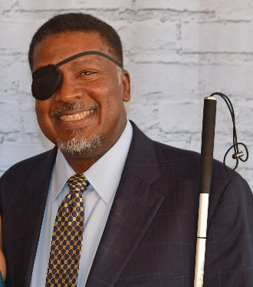
Image: Donald Porterfield
National Representative & President
National Federation of the Blind of Arizona

Officers:
Ronza Othman, President, Baltimore
Deborah Brown, First Vice President, Rockville
Dezman Jackson, Second Vice President, Baltimore
Judy Rasmussen, Secretary, Kensington
Jenivieve White, Treasurer, Owings Mills

Board of Directors:
Qualik Ford, Baltimore
Sharon Maneki, Columbia
Garret Mooney, Baltimore
Mildred Rivera, Halethorpe
Melissa Riccobono, Baltimore
Marguerite Woods, Baltimore

Our Credo
The National Federation of the Blind knows that blindness is not the characteristic that defines you or your future. Every day we raise the expectations of blind people, because low expectations create obstacles between blind people and our dreams. You can live the life you want; blindness is not what holds you back!

The National Federation of the Blind Pledge
I pledge to participate actively in the efforts of the National Federation of the Blind to achieve equality, opportunity, and security for the blind; to support the policies and programs of the federation; and to abide by its constitution.

About the National Federation of the Blind of Maryland

The National Federation of the Blind of Maryland (NFBMD), an affiliate of the National Federation of the Blind (NFB), is an organization of blind people and their family and friends. We believe in the full capacity of blind people; we have the power, influence, diversity and determination to help transform our dreams into reality. Our members work together for a brighter tomorrow by raising the expectations for blind people everywhere so that blind persons can live the lives they want.

Who We Are
The National Federation of the Blind of Maryland is a 501c(3) nonprofit comprised of blind people of all ages, their families and friends. Our strong local chapters and divisions, and well-trained leaders help newly blind people adjust to vision loss and promote the full participation and integration of blind people in our communities. We bring our collective experiences together to effect change at the state and national level.

What We Do
- Assist blind persons to acquire the skills of independence
- Help blind persons to develop confidence in themselves through our many service activities
- Teach blind persons the skills of leadership through active participation in conventions, chapter meetings, and civic activities
- Encourage blind seniors to continue their active and meaningful lifestyles
- Prepare blind students for productive tax-paying careers through academic and training scholarships
- Inform people with diabetes about their options for coping with vision loss
- Support parents and friends of blind children with information about the capabilities of the blind
- Protect and promote the civil rights of blind persons through public education and legislative action
- Advocate for policies that eliminate discrimination and guarantee equal access to educational programs and high-quality rehabilitation
- Educate the public through seminars, community activities and our publications

LIVE THE LIFE YOU WANT
Lyrics copied from October 2015 Presidential Release

Chorus: Live the life you want. Nobody can stop you.
Shoot for the sun and break on through.
So you're blind. You'll be fine. We've got good news!
You can live the life you want. Yes, we know the truth.
Grab a cane, get trained, gotta get movin’.
Make a change in the wage, that's what we're doin’.
Come with me, yeah
Chorus
You and me, NFB, let’s dream together.
NFB, you and me, lives on forever.
You will see yeah
Chorus
You can live the life you want. You’ll know the truth.

Thank You, Convention Sponsors

We extend profuse thanks to the following convention sponsors.
Vanda Pharmaceuticals, Title Level Sponsor
AdNet/AccountNet, Inc., Independence Level Sponsor
Brown, Goldstein and Levy LLP, Equality Level Sponsor
Friends of the Maryland State Library for the Blind and Print Disabled, Opportunity Level Sponsor
Maryland Accessible Telecommunications Program, Opportunity Level Sponsor

Navigating the Sheraton Baltimore North
The Sheraton Baltimore North Hotel is located at 903 Dulaney Valley Road, across the street from the Towson Town Center. Meeting rooms and common areas are located on the first and second floors. Sleeping rooms are on the third floor and above. The gym and pool are also on the third floor.

Plaza Level (first floor):
As you come into the tiled lobby of the hotel through the main entrance, directly in front of you is a large carpeted square seating area with chairs. To the right of the central carpeted area is the front desk.

On the far side of the carpeted area, directly opposite the main door, is another entry/exit to: a smoking area; a flight of stairs with trash cans on either side at the top of the steps; and at the bottom of the stairs, a grassy area appropriate for dog relief. (Please don’t forget to use a baggie!) This exit is also the closest one to Towson Town Center.

To the left of the central carpeted area (opposite the front desk) is a divided hallway which leads to the rest of the hotel facilities on this level. If you make a left into the section of this hallway farthest away from the main entrance, straight ahead you will find the Coffee Corner, where every day from 6:30 a.m. to 2 p.m., you can get Starbucks, pastries, salads, sandwiches, yogurt, and assorted fresh fruit and snacks. If you are facing the Coffee Corner, the elevator lobby is immediately to your right. Turning right into the elevator lobby, there are two elevators on the left and one on the right. All three elevators may be used to go to the sleeping rooms, the meeting rooms on the second floor, and the fitness area including the pool on the third floor.

With the Coffee Corner on your right, go straight ahead until you can turn right into the central (carpeted) hallway. Immediately on your right is the first set of stairs which lead to the second floor. You can also enter this central hallway directly from the main part of the lobby. With the lobby directly behind you, continue down this hallway. First on your left is the Business Center (for guest use), with two tables, each with a computer, and a printer between them. Next on the left of the hallway you will find some big comfy chairs facing a flat screen TV. Opposite this seating area, on the right side of the main hallway are the afore-mentioned stairs (which are around the corner from the Coffee Corner).

Further down the hall on the left is a high-top table surrounded by six chairs with plug-ins for eight devices. Directly opposite this table, on the right side of the hallway, is the beginning of Warfield’s Ballroom. Warfield’s Ballroom extends down the right side of the hallway. One entrance to Warfield’s Ballroom has a few steps in front. Further down the hallway on the left are several groupings of round high-top tables and chairs.

Past Warfield’s you will be heading straight to the host stand for the Rain 903 Restaurant and Lounge, where you wait to be seated. At this point the main part of the hallway (which is no longer carpeted) opens up and turns off to the left. Once you have turned left, you will pass the restaurant and then the steps that lead up to the bar on your right. Past the bar on the right side of the hallway are the restrooms. There is a wall with a flat screen display blocking direct access to the restrooms. Go around the wall on either side to find the restroom alcove with the ladies’ room on the left and the men’s on the right. There are two water fountains between the restrooms. On the left side of the hallway opposite the wall shielding the restroom alcove are more high-top tables with chairs.

Continue past the restrooms just a short distance and find another large carpeted open area. This is the Fitzgerald West Foyer. With your back to the central hallway, there’s another entry/exit door going to/from the parking area, on your left. To your right, across the foyer is the very large F. Scott Fitzgerald Ballroom. There are many entry/exit doors to this area, which we will use for exhibits and other meetings on Friday, general sessions on Saturday and Sunday, and the banquet on Saturday evening.

Along the far left side of the Fitzgerald Ballrooms, you will find another long hallway, called the Fitzgerald North Foyer. This is where convention registration, packet pickup, and banquet ticket exchange will be located. You must walk through the Fitzgerald West Foyer to get to the Fitzgerald North Foyer. At the end of the Fitzgerald North Foyer is a short set of stairs that lead outside to a second guide dog relief area.

At the end of the hallway that leads from the main lobby, past the Fitzgerald West Foyer, is the second set of stairs, which lead to the second floor. One can walk directly under the stairs, so be careful not to bump your head.

Second Floor:
Directly across from the top of the stairs that are in the Fitzgerald Foyer area is one of the two entrances to the Duncan Room. You can only turn right at the top of the stairs. On your left you will first pass the Duncan Room, followed by the Amphitheater. After the first entrance to the Amphitheater, the hallway opens up to something like a T-intersection. If you follow the wall on the left, past the second Amphitheater entrance, you will be able to make a right into another hallway. On the left side of this hallway, you will first encounter a set of restrooms (ladies on the left and men’s on the right). Further down the hall on the left you will find Lindsay A, B, and C. There is nothing else in this hallway.

Back at the 3-way intersection with the stairs behind you, the Grason Room is straight ahead of you. Turn right here an on your left you will pass the Burke Room, the MacIntosh Room and the Cole Room, beyond that is the Sales and Catering Office. Along the right side of the hallway is an opening which allows you to look down on the Plaza Level. As you approach the end of this hallway, there is another large open space. If you follow the wall to your left, you will find the stairs which take you downstairs near the lobby around the corner from the Coffee Corner. Pass the stairs on your left and turn left into the elevator lobby, where you will find two elevators on the left and one on the right.

Third Floor:
As you leave the elevator lobby, straight ahead is the fitness center, including the pool. You will need your room key to enter this area. The hallway off to the right leads to guest rooms.

Chapters and Divisions of
the National Federation of the Blind of Maryland

At Large Chapter
Marguerite Woods, president, 443-271-1668, mwoods719@gmail.com
Monthly meetings, third Tuesday at 7:30 p.m., via phone: 339-209-4083

Central Maryland Chapter
Matt Yannuzzi, president, 443-851-1944, Matthew.Yannuzzi@gmail.com
Monthly meetings, first Tuesday in Columbia

Eastern Shore Chapter
Heather Guy, president, 410-430-8954, hguy403@comcast.net
Monthly meetings, second Saturday in Salisbury

Greater Baltimore Chapter
Chris Danielsen, president, 410-262-1281, Cdanielsen@nfb.org
Monthly meetings, third Saturday in Baltimore

Greater Carroll County Chapter
Brian Keseling, president, 410-855-5605, bkmaverick@gmail.com
Monthly meetings, second Saturday in Westminster

Maryland Association of Blind Students
Qualik Ford, president, 301-312-9813, qsford@outlook.com
Periodic meetings throughout the year

Maryland Association of Blind Merchants
Melba Taylor, president, 240-381-1637, m.taylor@encoreassoc.com
Periodic meetings throughout the year

Maryland Parents of Blind Children
Garret Mooney, president, 480-433-8003, james.garret.mooney@gmail.com
Periodic meetings throughout the year

National Harbor Chapter
Amber Woods, president, 301-978-6686, woodsamber83@gmail.com
Monthly meetings, fourth Saturday in Suitland

Senior Issues Division
Marguerite Woods, president, 443-271-1668, mwoods719@gmail.com
Periodic meetings throughout the year

Sligo Creek Chapter
Debbie Brown, president, 301-881-1892, Deborahb14@verizon.net
Monthly meetings, second Saturday primarily in Silver Spring

TLC Chapter
Meleah Jensen, president, 504-621-4162, MeleahHeather@gmail.com
Monthly meetings, third Monday in Towson

Western Maryland Chapter
Wendy Ruth, president, 301-991-8312, Wendyruth996@gmail.com
Monthly meetings First Saturday in Cumberland

Image description: Half-page ad for AdNet/AccountNet, inc. with company logo and 30-year anniversary seal celebrating advocates for workplace excellence and equality. Serving the blind, deaf and mobility impaired community in their workplace by providing Reasonable Accommodations Support Services to government and corporate entities. Contact Betsy Cerulo, CEO at bcerulo@adnetp3.com or 410-715-4035. Ad ends with a group photo of smiling people in professional attire, and seals identifying recognition by NGLCC, the National LGBT Chamber of Commerce; WBENC certified as a Women’s Business Enterprise; and SBA 8(a) certification.

Stay Connected and Informed:
Follow the National Federation of the Blind of Maryland on Twitter:
twitter.com/NFBMD

Friend the National Federation of the Blind of Maryland on Facebook: facebook.com/NationalFederationOfTheBlindOfMaryland

Stay connected with your fellow Maryland Federationists by joining our state email listserv. This list allows you to receive affiliate and national announcements, and also to start and participate in discussions regarding blindness and blindness issues. To sign up visit nfbnet.org, click on “join or drop NFB mailing lists,” and activate “NFBMD” link, and follow the instructions. Many of our local chapters now also have a listserv. Talk to your chapter president to learn how to sign up so you don’t miss important information about chapter news and events.

Visit our website at nfbmd.org. Check out our blog for the President’s Messages. Be sure to check out the Blindness Resources link, and the Know Your Rights link to keep up to date on important information. Be sure to download and print “About NFBMD,” in the “About Us” tab on nfbmd.org, for use at chapter outreach events.

Braille Spectator
The Braille Spectator is published for members of the National Federation of the Blind of Maryland and others who share an interest in the work of this organization. The Braille Spectator can be read on the web at nfbmd.org/newsletter or can be listened to on the local channel of NFB-Newsline.

Maryland NFB BELL Academy
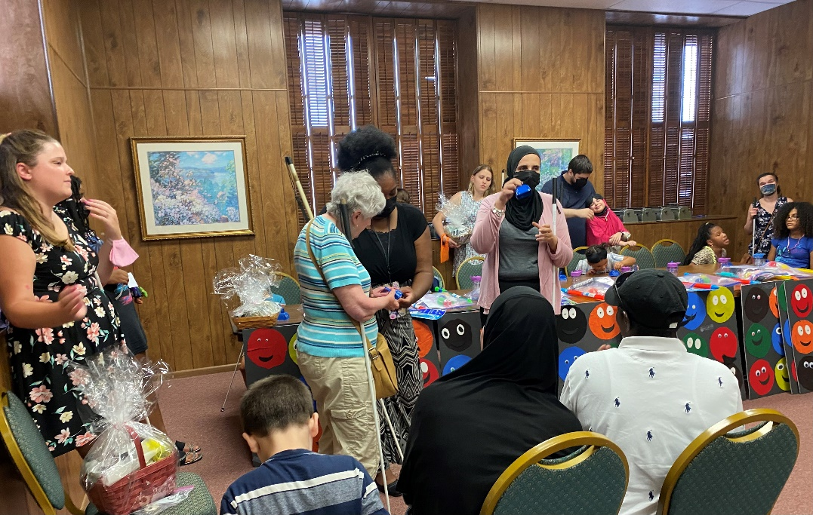
Image: NFBMD President Ronza Othman holds up a BELL during the 2022 Maryland NFB BELL Academy graduation as teacher Jackie Anderson hands a BELL to Sharon Maneki surrounded by the children and families

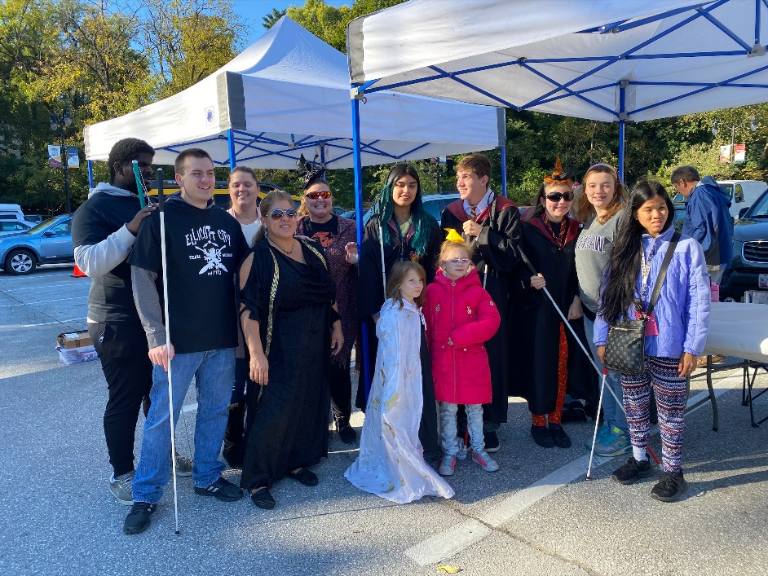
Wizarding Weekend on Magical Main
Blind Equality Achievement Month Event
Image: Group photo of the Wizarding Weekend volunteers — some are wearing wizard outfits and some are holding long white canes

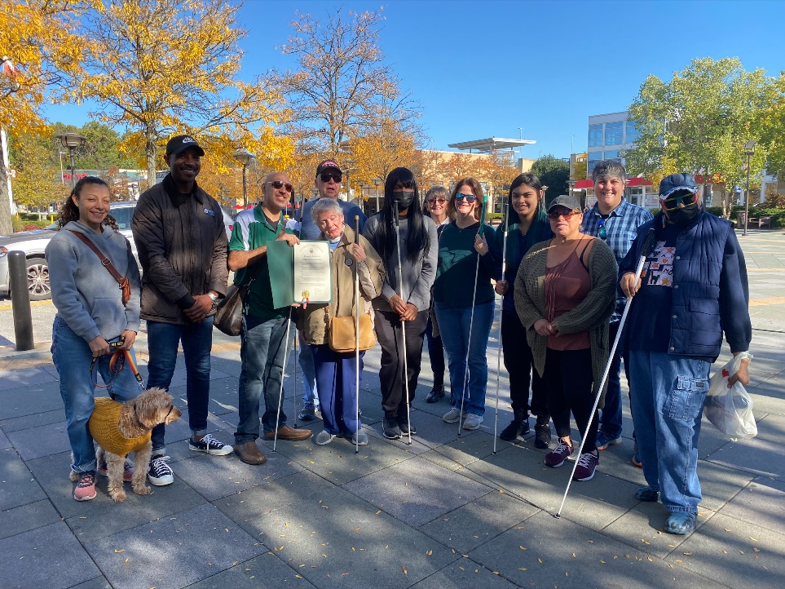
Central Maryland Chapter
White Cane Awareness Day Mall Walk
Image: Blind members and family with Representative Mike Harris with White Cane Day proclamation

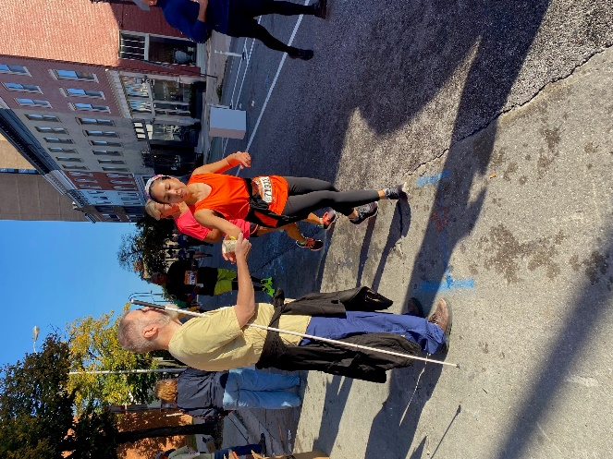
Greater Baltimore Chapter
White Cane Awareness Day Baltimore Running Festival
Image: Runner reaches out to get a water from Chapter President Chris Danielsen

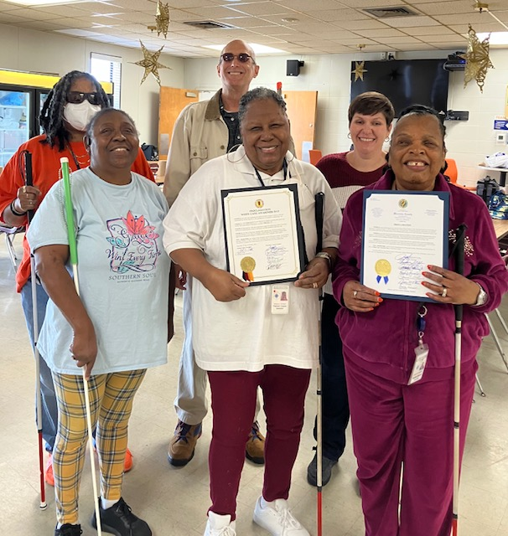
Worcester, Wicomico and Dorchester Counties
White Cane Day Proclamations
Image: Eastern Shore chapter members Heather Guy, Tim Meagher, Pam Dennis, Muffin Copper, Cindy Johnson-Hall, and Carolyn Spence accept proclamations for Wicomico and Worcester Counties
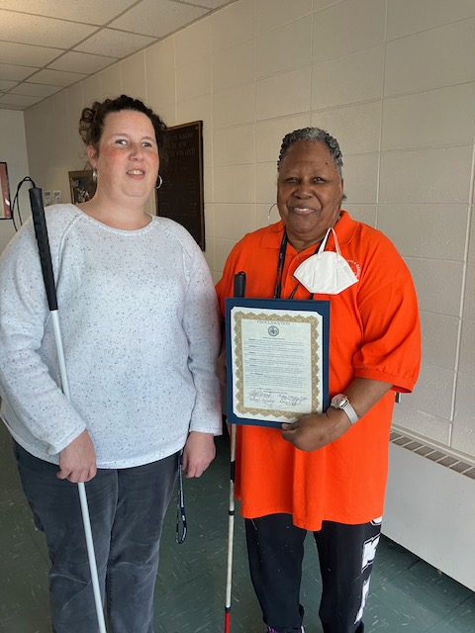
Image: Danielle Earl representing the NFBMD At-Large Chapter and Francis Muffin Copper representing the Eastern Shore chapter accept a proclamation from Dorchester County.

Committees of the
National Federation of the Blind of Maryland
If you’re interested in being appointed to a particular committee, notify the NFBMD president at president@nfbmd.org or 443-426-4110.

Advocacy Committee
Sharon Maneki, chairperson

Ambassadors Committee
Judy Rasmussen and Debbie Brown, co-chairpersons

Audit Committee
Barry Hond and Mary Ellen Jernigan, co-chairpersons

BELL Committee
Brittany Bomboy, chairperson

Braille Spectator Committee
Ronza Othman and Sharon Maneki, editors

Deaf-Blind and Hearing Loss Issues Committee
Janice Toothman and Heather Guy, co-chairpersons

Development and Fundraising Committee
Jenivieve White and Ellen Ringlein, co-chairpersons

Diversity, Equity, and Inclusion Committee
Juhi Narula and Qualik Ford, co-chairpersons

Employment Committee
Pam Goodman and Jannis Forbes, co-chairpersons

Guide Dog Issues Committee
Sherry Shirek, chairperson

Legislation Committee
Sharon Maneki, chairperson

Membership Committee
Dezman Jackson, chairperson

Nominating Committee
Marguerite Woods, chairperson

PAC Plan Committee
John Paré and Stephanie Flynt, co-chairpersons

Public Relations Committee
Chris Danielsen, chairperson

Resolutions Committee
Chris Danielsen, chairperson

Scholarship Committee
Mildred Rivera, chairperson

Sharon Maneki Youth Empowerment Grant Committee
Sharon Maneki, chairperson

Social Media Committee
Karen Anderson, chairperson

Spanish Services Committee
Teresa Graham, chairperson

Sports and Recreation Committee
Lou Ann Blake and Qualik Ford, co-chairpersons

Transportation Committee
Aloma Bouma and Sheryl Fogle-Hatch, co-chairpersons

Website and Technology Committee
John Berggren, chairperson

Youth Activity Committee
Brittany Bomboy, chairperson

Convention-Related Committees

Anna Freysz Cable Award Committee
Debbie Brown, chairperson

Convention Child Care Committee
Brittany Bomboy, chairperson

Convention Organization and Activities
Meleah Jensen and Justin Young, co-chairpersons

Convention Registration Committee
Marie Marucci, chairperson

Distinguished Educator of Blind Children Award Committee
Teresa Graham, chairperson

Door Prize Committee
Juhi Narula and Qualik Ford, co-chairpersons

Gold Cup Crab Race Committee
Juhi Narula and Jen White, co-chairpersons

Jennifer Baker Award Committee
Melissa Riccobono, chairperson

Kenneth Jernigan Award Committee
Mary Ellen Jernigan, chairperson

National Funding Support Auction Committee
Michael Bullis, chairperson

Groups of the
National Federation of the Blind of Maryland
If you’re interested in joining a particular group, contact that group’s chairperson.

Blind Crafters Group
Danielle McCann and Karen Anderson, co-chairpersons

Blind Parents Group
Denna Lambert and Melissa Riccobono, co-chairpersons

Diabetes Action Network
Eileen Ley, chairperson

Performing Arts Group
Chris Danielsen, chairperson

Significant Others and Loved Ones Group
Jenivieve White and Tony Cobb, co-chairpersons

Veterans Group
Ed Jackson, chairperson

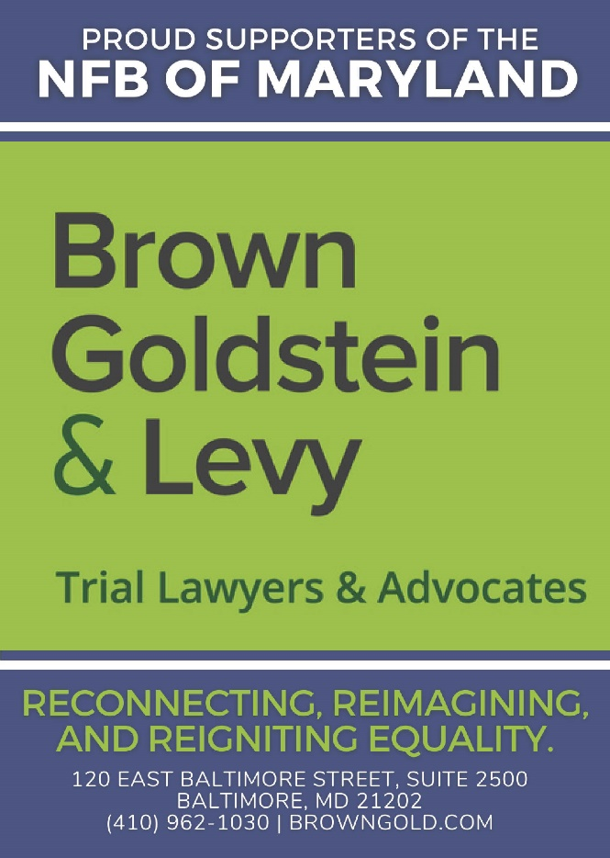
Image description: Quarter page ad from Brown Goldstein and Levy in blue and green. Proud supporters of the NFB of Maryland. Brown Goldstein & Levy trial lawyers & advocates. Reconnecting, Reimagining and Reigniting Equality. 120 East Baltimore Street, Suite 2500, Baltimore, MD 21202, 410-962-1030, browngold.com
Leaving A Legacy: Dream Makers Circle
You can help build a future of opportunity for the blind by becoming a member of our Dream Makers Circle. It is easier than you think. Just visit your bank and convert an account to a P.O.D. (payable on death) bank account which is payable after your passing to the National Federation of the Blind or the National Federation of the Blind of Maryland. Your legacy gift to the National Federation of the Blind or the National Federation of the Blind of Maryland can be made in the form of a will or living trust, an income generating gift, or by naming us as the beneficiary of a retirement plan, IRA, pension, or a life insurance policy. You can designate a specific amount, a percentage, or list NFB as one of several beneficiaries. For additional information, please contact Patti Chang at 410-659-9314, ext. 2422 or at pchang@nfb.org.

STRIVE
Lyrics by Barbara Elliott

Sometimes people tell me blind people should be quiet and sit down
But I say "No!" I say "No!" I say "No."
They contend that I should be content to let others lead me around,
But I say "No!" I say "No!" I say "No."
Everybody needs somebody to help sometimes, but I'm in charge of me,
Chorus: I've gotta strive, strive, strive a little farther,
Reach, reach, reach a little longer,
Work, work, work a little harder,
Hope, hope, hope a little stronger.
Watch me, watch me, watch me.
Nothin's gonna stop me, stop me, stop me.
I'm spreading my wings, soaring on a dream,
I can do anything!
I gotta be brave even when I'm afraid to do hard things.
I'll tell myself "Go!" I'll just go, I will go.
I'm not a fool; I need training and tools to live out my dreams.
So I'll say "Go!" I'll just go, I will go.
I'm not a passenger in my life. I'm gonna take control and drive.
Chorus

Convention Agenda

Friday, November 11
8:30 a.m. to 6 p.m. — Fun with Friends Childcare
Duncan Room

Brittany Bomboy, Convention Childcare Coordinator; Baltimore, Maryland

9 a.m. to Noon — Annual Conference for Parents and Teachers of Blind Children: Maryland Parents of Blind Children
Lindsay B and C
What are the skills and tools blind students need in school and to live the lives they want? How do we best prepare transition-age students for life beyond school? How do you make sure school and rehabilitation services are appropriately addressing their needs? What can you do to support them at home? Learn about resources, opportunities, blindness skills, and how to have and model a positive attitude on blindness. These are only some of the topics to be discussed at this seminar. Includes a networking pizza party for families.

Garret Mooney, president, Maryland Parents of Blind Children Division; Baltimore, Maryland

9 to 10 a.m. — Resolutions Committee Meeting
Fitzgerald Ballroom B
Everyone is encouraged to attend!

Chris Danielsen, chairperson; Baltimore, Maryland

10 to 11:45 a.m. — NFBMD Board of Directors Meeting (Open to All)
Fitzgerald Ballroom B

11 a.m. to 6 p.m. — Exhibits
Fitzgerald West Foyer and Fitzgerald Ballroom A
Check out the latest offerings from a variety of companies and organizations that provide technology and services for the blind.

Jenivieve White, sponsorship and exhibits coordinator and treasurer, National Federation of the Blind of Maryland; Owings Mills, Maryland

11:45 a.m. — Boxed Lunch Distribution
Fitzgerald North Foyer
*You paid for a boxed lunch at pre-registration.

Noon to 2 p.m. — Advocacy Seminar — How You Can Make the World More Accessible: Simple and Effective Advocacy Strategies
Fitzgerald Ballroom B
Explore a variety of accessibility problems and possible solutions for them.

Sharon Maneki, Board Member and Director of Legislation and Advocacy, National Federation of the Blind of Maryland; Columbia, Maryland

1 to 2 p.m. — Deaf-Blind and Hearing Loss Issues Committee Meeting
Cole Room
Share strategies and ideas to maintain independence. Anyone interested is invited to attend.

Janice Toothman, co-chairperson; Bowie, Maryland; Heather Guy, co-chairperson; Salisbury, Maryland

2 to 4 p.m. — Employment Workshop — The Employment Game: Strategizing, Scoring, and Winning
Fitzgerald Ballroom B
Don’t be a bench sitter! Join us for three fun, informative & interactive employment activities including joining the winning team of a game show, facilitated interactive conversations about what our employment needs are, and a panel discussion on strategizing about disability disclosure.

Pam Goodman, co-chairperson, NFBMD Employment Committee; Linthicum, Maryland; Janice Forbes, co-chairperson, NFBMD Employment Committee; Laurel, Maryland

2 to 4 p.m. — Senior Issues Seminar: My Eyes Don’t Work, But My Brain Still Does: Navigating Vision Loss While Aging
Warfield Ballroom
Learn how to grow your independence and manage your vision loss as an older adult. Please join us for an informative, thought provoking, and inspiring seminar. For seniors and others facing vision loss.

Marguerite Woods, president, Maryland Senior Issues Division; Board Member, National Federation of the Blind of Maryland; Baltimore, Maryland

2 to 6 p.m. — Convention Registration and Packet Pickup
Fitzgerald North foyer

3 to 4 p.m. — Protecting the Rights of Guide Dog Users
McIntosh Room
Share strategies and ideas on how to ensure that the rights of guide dog users are protected.

Sherry Shirek, Chairperson, NFBMD Guide Dog Committee; Baltimore Maryland

4 to 5 p.m. — Financial Literacy and Tax Workshop — What Blind People Need to Know
Fitzgerald Ballroom B
What are some unique challenges that blind people have when it comes to filing their taxes? What deductions and tax credits are available? What are some strategies for preparing tax filings as a blind person? This seminar will share tips and tricks in these areas and more.

Keith Price, Senior Tax Preparer, Hutt Company; Owner, KLP Tax Services; Columbia, Maryland

4 to 5 p.m. — NFBMD Cane Walk
Lindsay Foyer
The Maryland Parents of Blind Children will host a cane walk for children and adults.

Garret Mooney, president, Maryland Parents of Blind Children Division; Baltimore, Maryland

4 to 7 p.m. — Student Workshop
Grason Room
Come learn about matters of interest to students including how to self-advocate in school, with potential employers, and in the world. Learn what resources are available for students. Registration from 4 to 4:15 p.m.

Qualik Ford, president, Maryland Association of Blind Students; Baltimore, Maryland

5 to 6 p.m. — Blind Parents Meeting
McIntosh Room
Share tips and tricks on how to parent using non-visual techniques. Network with other blind parents and caregivers.

Melissa Riccobono, co-chairperson; Baltimore Maryland; Denna Lambert, co-chairperson; Greenbelt, Maryland

5 to 6 p.m. — Narrowing the Gap Reunion
Lindsay A
NFB Narrowing the Gap Teachers will get together for in-person networking and fun.

Karen Anderson, Coordinator of Education Programs, National Federation of the Blind; Baltimore Maryland

6 to 8 p.m. — Annual Pizza Party for Families of Blind Children
Lindsay B and C
Participants of the Parents and Educators Seminar are invited to come meet and network and enjoy pizza.

Garret Mooney, president, Maryland Parents of Blind Children Division; Baltimore, Maryland

6:30 to 9 p.m. — Maryland Association of Blind Merchants Annual Meeting and Networking Mixer
Warfield Ballroom
Come learn about matters of interest to blind merchants and those in the Business Enterprise Program.

Melba Taylor, president, Maryland Association of Blind Merchants; Bowie, Maryland

7 p.m.—NFB BELL ACADEMY REUNION
Lindsay A

7 to 8:30 p.m. — Dinner and a Play
Fitzgerald Ballroom B and C
The Braille is Beautiful Players will entertain and delight.

Debbie Brown, play director; first vice president, National Federation of the Blind of Maryland; Rockville, Maryland

8:30 to 11:30 p.m. — Crab Idol
Fitzgerald Ballroom B and C
This American Idol-style evening promises to be fun for all ages. Those wishing to perform songs can do so for $5 per person per performance. Chapters and Divisions will battle it out to determine which has the most talent. Enjoy snacks and fellowship thanks to the Maryland Association of Blind Students and Maryland Parents of Blind Children. Proceeds support NFBMD, MDABS, and MDPBC. To sign up to perform, contact Qualik Ford or Garret Mooney.

Saturday, November 12
7 to 8:15 a.m. — At-Large Chapter Meeting
McIntosh Room
The At-Large Chapter will meet face-to-face. Continental breakfast will be available.

Marguerite Woods, president; Baltimore, Maryland

7 to 8:15 a.m. — Western Maryland Chapter Meeting
Burke Room
The Western Maryland Chapter will meet in person. Continental breakfast will be available.

Wendy Ruth, president; Hagerstown, Maryland

7 to 8:15 a.m. — Reorganizing Meeting for the Baltimore County Chapter
Lindsay B and C
Come meet to discuss reorganizing the Baltimore County Chapter. Continental breakfast will be available.

Dezman Jackson, chairperson, NFBMD Membership Committee; Baltimore, Maryland

8 to 8:25 a.m. — Convention Registration and Packet Pickup
Fitzgerald North foyer

8:15 a.m. to 5:15 p.m. — Fun with Friends Childcare
Duncan Room

Brittany Bomboy, coordinator; Baltimore, Maryland

8:30 a.m. to noon — Saturday Morning General Session

Fitzgerald Ballroom
8:30 a.m. — Call to Order and Opening Ceremonies

8:50 a.m. — Reimagining Our Internal Programs
Get on the Pac Plan
John Pare and Stephanie Flynt, Maryland PAC Plan co-chairpersons; Baltimore, Maryland

Gold Cup Crab Race
Juhi Narula, ticket agent; Baltimore, Maryland

9 a.m. — Welcome from Congress
The Honorable Steny Hoyer, Majority Leader and Maryland Fifth District Representative, U.S. House of Representatives; Mechanicsville, Maryland

9:10 a.m. — Happy Anniversary to Us
Sharon Maneki, board member and director of Legislation and Advocacy, National Federation of the Blind of Maryland; Columbia, Maryland

9:25 a.m. — Reconnecting in A Time of Pandemic, Reimagining the Federation’s Future: A Report from Our National Office
Donald Porterfield, president, National Federation of the Blind of Arizona; Board Member, National Federation of the Blind; Tuscan, Arizona

10:05 a.m. — Reigniting Our Love of the Arts, History, and Culture
Ralph Welsh, president, Maryland Arts Access; Lutherville, Maryland
Bob Watson, Braille Enterprises, LLC; Abington, Maryland
Cheryl Fogle-Hatch, president and Founder, MuseumSenses; Baltimore, Maryland

10:35 a.m. — Reimagining Rehabilitation Services for the Future
Toni March, director, Office of Blindness and Vision Services, Maryland Division of Rehabilitation Services (DORS); Baltimore, Maryland

10:45 a.m. — Reigniting Our Partnership: A Report from Blind Industries and Services of Maryland
Michael Gosse, president, Blind Industries and Services of Maryland; Baltimore, Maryland

10:55 a.m. — ABLE Accounts: Promoting Health, Independence, and Financial Stability for People with Disabilities
Bette Anne Mobley, Director, Maryland ABLE; Baltimore, Maryland

11:05 a.m. — Reimagining the Education of Blind Students: Narrowing the Gap
Sadiqa Al-Salam, Maryland Narrowing the Gap Program Participant; Upper Marlboro, Maryland
William Klotz, Maryland Narrowing the Gap Program Participant; Baltimore, Maryland
Katelyn Paylor, Maryland Narrowing the Gap Program Participant; Williamsport, Maryland
Erin Zobell, Maryland Narrowing the Gap Program Participant; California, Maryland

Panel Moderator: Karen Anderson, Coordinator of Education Programs, National Federation of the Blind; Baltimore, Maryland

11:40 a.m. — Reports and Resolutions

Noon — Adjourn

12 to 12:15 p.m. — Convention Registration and Packet Pick-Up
Fitzgerald North Foyer

12 to 1:45 p.m. — Luncheon: The Education of Blind and Low-Vision Students
Lindsay A, B, and C
For parents, teachers of the blind, and those interested in matters concerning blind students.

Garret Mooney, president, Maryland Parents of Blind Children’s Division, National Federation of the Blind of Maryland; Baltimore, Maryland

12 to 1:45 p.m. — Luncheon: Reclaiming Independence After Vision Loss
Warfield Ballroom
For seniors and others facing vision loss.

Marguerite Woods, president, Maryland Senior Issues Division; Board Member, National Federation of the Blind of Maryland; Baltimore, Maryland

12 to 1:45 p.m. — Maryland Association of Blind Students Annual Business Meeting and Luncheon
Grason Room
The Maryland Association of Blind Students will hold its annual business meeting, including planning future workshops and events and holding elections.

Qualik Ford, president; Baltimore, Maryland

1:20 to 2 p.m. — Banquet Ticket Exchange
Fitzgerald North Foyer

2 to 5 p.m. — Saturday Afternoon General Session

Fitzgerald Ballroom
2 p.m. — Call to Order

2:05 p.m. — Reconnect, Reimagine, Reignite
Ronza Othman, president, National Federation of the Blind of Maryland; Baltimore, Maryland

2:40 p.m. — Rebuilding Community: MSB’s Refocus on LRE
Diane Colburn, director of statewide services, Maryland School for the Blind; Baltimore, Maryland

W. Robert Hair, superintendent, Maryland School for the Blind; Baltimore, Maryland

3 p.m. — Reimagining Employment: Working and Winning
Donald Porterfield, criminal prosecutor; Tucson, Arizona
Laura Havard, medical social worker; Silver Spring, Maryland
Tony Stevens, executive director, Downtown Sailing Center; Baltimore, Maryland

Panel Moderators: Pam Goodman, co-chairperson, NFBMD Employment Committee; Linthicum, Maryland; Janice Forbes, co-chairperson, NFBMD Employment Committee; Laurel, Maryland

3:30 p.m. — Reimagining State Programs
Carol Beatty, secretary, Maryland Department of Disability; Baltimore, Maryland
Denise Schuler, director, AT Reuse, Maryland Technology Assistance Program; Baltimore, Maryland
John Owen, director, Maryland State Library for the Blind and Print Disabled; Baltimore, Maryland

4:05 p.m. — Reconnecting with Our Title Sponsor
Maggie Felton, Nurse Educator, Vanda Pharmaceutical, Inc.; Washington, DC

4:15 p.m. — Reimagining A Bright Future After Going Blind as an Adult
Marguerite Woods, board member, National Federation of the Blind of Maryland; president, Maryland At-Large Chapter; president, Maryland Senior Issues Division; Baltimore, Maryland
Sherry Shirek, chairperson, Maryland Guide Dogs Committee, National Federation of the Blind of Maryland; Baltimore, Maryland
Lou Ann Blake, treasurer, Greater Baltimore Chapter; Baltimore, Maryland

4:45 p.m. — Reports and Resolutions

5 p.m. — Adjourn

6 p.m. — Reception and Cash Bar
Fitzgerald West Foyer

6:30 to 10 p.m. — Fun with Friends Childcare
Duncan Room
Brittany Bomboy, coordinator
*Childcare ends at 10 p.m., or 15 minutes after the banquet ends, whichever is earlier

7 p.m. — 56th Annual Convention Banquet
Fitzgerald Ballroom
Master of Ceremonies: Melissa Riccobono, Board Member, National Federation of the Blind of Maryland; Baltimore, Maryland
Keynote Banquet Address: Donald Porterfield, president, National Federation of the Blind of Arizona; Board Member, National Federation of the Blind; Tucson, Arizona
Scholarships and Awards

Immediately after the Banquet — Maryland Gold Cup Crab Race
Race Callers: Ronza Othman and Juhi Narula

Sunday, November 13
7:30 to 9 a.m. — Luggage Collection
Warfield Ballroom
For bus passengers only

7:30 to 8:45 a.m. — Training Center Information and Graduate Networking Breakfast
Lindsay B and C
Those interested in learning about adjustment to blindness training can talk with training center ambassadors and graduates. Alumni from the Louisiana Center for the Blind, Colorado Center for the Blind, BLIND, Inc. and Blind Industries and Services of Maryland can reconnect. Continental breakfast will be available.

Coordinators: Chris Danielsen (LCB), president, Greater Baltimore Chapter; Garret Mooney (CCB), president, Maryland Parents of Blind Children; and Matt Yannuzzi (BISM), president, Central Maryland Chapter

8 to 8:30 a.m. — Nonsectarian Devotions
Fitzgerald Ballroom

Judy Rasmussen, secretary, National Federation of the Blind of Maryland; Kensington, Maryland

8:30 to 8:50 a.m. — Convention Registration and Packet Pick-Up
Fitzgerald North Foyer

9 a.m. to noon — Sunday Morning Session
Fitzgerald Ballroom
9 a.m. — Call to Order

9:05 a.m. — Baltimore County Welcome
John Olszewski, Jr., County Executive, Baltimore County; Towson, Maryland

9:20 a.m. — Recognizing Our Veterans
Ed Jackson, board member, Greater Baltimore Chapter; Chairperson, Veterans Group, National Federation of the Blind of Maryland; Reisterstown, Maryland

9:30 a.m. — Reimagining Our Children’s Future: NFB BELL Academy
Brittany Bomboy, NFB BELL Academy coordinator for Maryland; Baltimore, Maryland
Maryland NFB BELL Academy Students

10 a.m. — Reimagining Voting: Partnership and Progress
Linda Lamone, administrator, Maryland State Board of Elections; Annapolis, Maryland

10:15 a.m. — Reimagining Innovation, Reigniting the Flame of Independence: Excellence in Nonvisual Access and Blindness Programs
Karen Anderson, education programs coordinator, Blindness Initiatives, National Federation of the Blind; Baltimore, Maryland

10:25 a.m. — Reimagining Joy: Horseback Riding to Happiness
Faith Waybright, participant, Freedom Hills Therapeutic Riding Program; Elkton, Maryland

10:35 a.m. — Financial Report
Jenivieve White, treasurer, National Federation of the Blind of Maryland; Owings Mills, Maryland

10:55 a.m. — Affiliate Elections

11:20 a.m. — Resolutions, Audit Committee Report, and Other Business

Noon — Adjourn

A Closing Message
On behalf of the officers and Board of Directors, I’d like to take this opportunity to thank all federationists and friends for your generous monetary donations and gifts of goods and services. We had a very successful year and an outstanding convention because of your help!
Ronza Othman, President

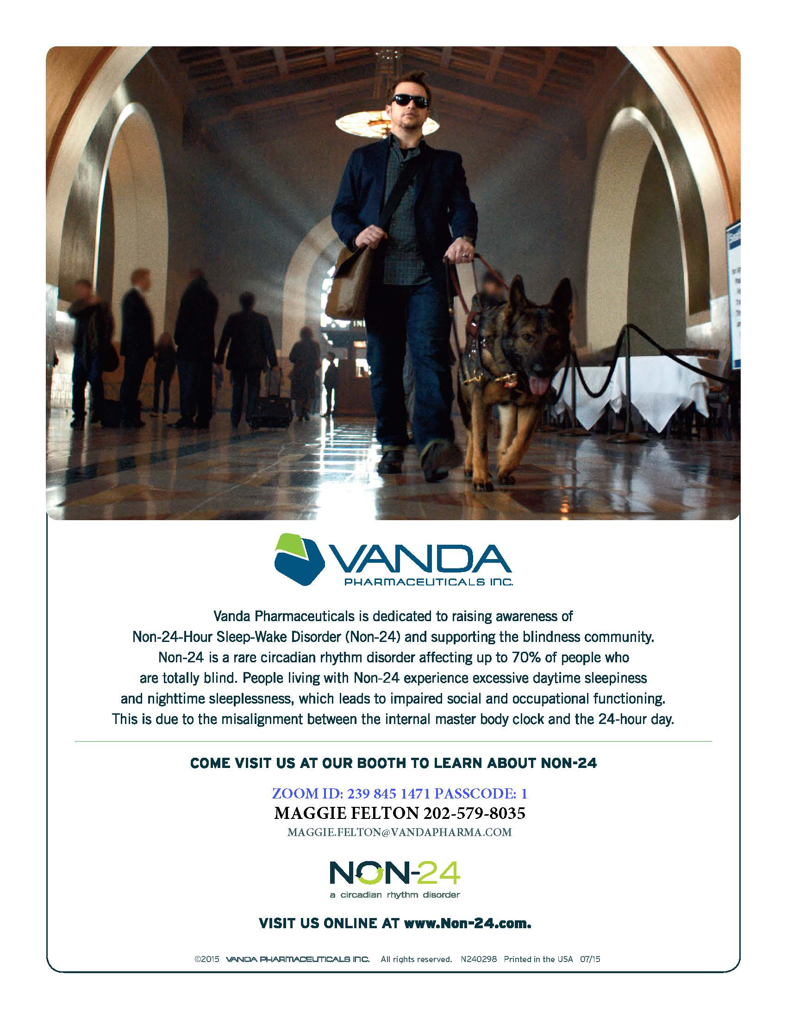

Image description: Full page ad from Vanda Pharmaceuticals, Inc. At the top of the ad is a photo of a man wearing dark glasses walking through a lobby led by a guide dog. Vanda Pharmaceuticals is dedicated to raising awareness of Non-24-Hour Sleep-Wake Disorder (Non-24) and supporting the blindness community. Non-24 is a rare circadian rhythm disorder affecting up to 70% of people who are totally blind. People living with Non-24 experience excessive daytime sleepiness and nighttime sleeplessness, which leads to impaired social and occupational functioning. This is due to the misalignment between the internal master body clock and the 24-hour day. Come visit us at our booth to learn more about Non-24.
Maggie Felton 202-579-8035, Maggie.felton@vandapharma.com, www.non-24.com

BRAILLE IS BEAUTIFUL

Na na na-na na na, na na na-na nah.
Na na na na nah, na na na-na nah.

Chorus:
Go on and live your life,
Don't need a bit of sight.
In the end you'll find
Braille is beautiful.
Put your fingers on the page.
Tell your friends it's all the rage.
It's all gonna be OK, yeah
Braille is beautiful!

Na na na na na na, Na na na-na nah Braille is beautiful!
Na na na-na nah, Na na na-na nah.

Verse
Louis Braille was his name. Slate 'n' stylus was his game.
They tried to stop him, but we adopted the code that paved the way.

Chorus

Na na na na na na, Na na na-na nah Braille is beautiful!
Na na na-na nah, Na na na-na nah.
Na na na-na nah, Na na na-na nah.

BRAILLE IS BEAUTIFUL!

2022 NFBMD Exhibitors
The following is a list of organizations that are participating in the 2022 NFBMD Exhibit Hall. Check NFBMD.org for updates and additions to this list.

- Vanda Pharmaceuticals
- Maryland State Library for the Blind and Print Disabled
- Maryland Technology Assistance Program
- Maryland Relay/Telecommunications Access of Maryland
- Maryland Department of Disabilities
- BlindShell USA
- Freedom Hills Therapeutic Riding Program
- Infinite Reality, LLC
- Inspirational 3 Support Foundation
- Integration Technologies Group
- Johns Hopkins University
- JW.org
- Maryland Able
- Maryland Division of Rehabilitation Services (DORS)
- NFB Newsline
- NFBMD National Harbor Chapter
- PS You Are Fabulous
- Vispero
- Young and Supremely Blessed, Inc.

