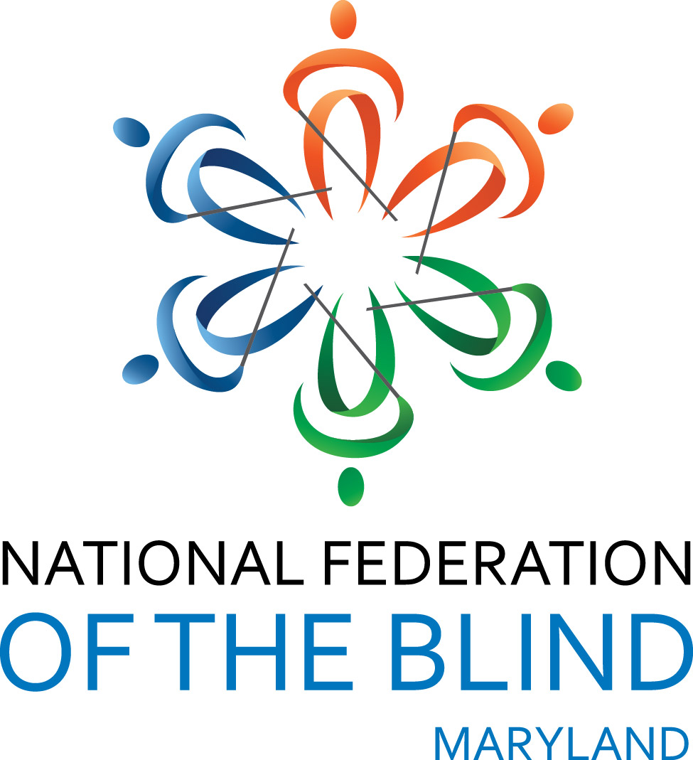 JOHN T. McCRAW SCHOLARSHIP PROGRAM: 2023-2024

NATIONAL FEDERATION OF THE BLIND OF MARYLAND

The National Federation of the Blind of Maryland (NFBMD) is thrilled to administer the John T. McCraw Scholarship Program for academic year 2023-2024. The program will award up to four individual scholarships of $4,000 each. These scholarships will be given to qualified blind students who exhibit academic achievement, community involvement, and leadership.

The John T. McCraw Scholarship Program has been established to promote post-secondary educational opportunities for Maryland's blind students. The recipients may use these scholarships to defray the cost of educational expenses incurred at any post-secondary institution during the 2023-2024 academic year. All John T. McCraw scholarships are merit-based and are awarded based on academic excellence, community service, and leadership.

NOTE: A special scholarship may be awarded to former McCraw Scholarship recipients. To apply for this special scholarship, former recipients must still meet all of the requirements for the McCraw Scholarship Program and submit a new application.

WHO IS ELIGIBLE
A) Any legally blind student is eligible to receive a scholarship who:
1. Resides in the State of Maryland, or is pursuing post-secondary studies in the State of Maryland;
2. Will turn age 18 prior to July 1, 2023;
3. Will be enrolled as a full-time or part-time student at any post-secondary institution in the Fall of 2023 and the Spring of 2024. Priority will be given to full-time students.
B) Recipients are expected to attend the annual Convention of the National Federation of the Blind in its entirety, July 1-6, 2023, in Houston, Texas, as well as the annual Convention of the National Federation of the Blind of Maryland, November 10-12, 2023, in Hunt Valley, Maryland. Financial assistance to attend the Conventions will be provided.
C) Applications must be submitted by April 15, 2023. Shortly thereafter, the scholarship committee will select the recipients, but will not award the scholarships until personally interacting with the recipients at both conventions. Scholarships will be awarded at the state convention banquet on November 11, 2023. Recipients' participation in both conventions in their entirety is mandatory in order to qualify for these scholarships.
D) The scholarship committee may request additional information from an applicant. The scholarship committee's decision concerning the recipients of the John T. McCraw Scholarship Program is final.
(Blind students are also invited to apply for the nationwide scholarships offered by the National Federation of the Blind. The application deadline for the national NFB scholarships is March 31, 2023. Visit www.nfb.org/scholarships to apply for the national scholarships.)

Note: Applicants who are not selected to receive a John T. McCraw Scholarship may be considered for a grant to participate in the NFB National Convention, NFB of Maryland State Convention, or both. Those interested in this grant should notify the scholarship committee.

SEE REVERSE SIDE FOR APPLICATION
JOHN T. McCRAW SCHOLARSHIP PROGRAM 2023-2024
APPLICATION

Name: Date of Birth:

Home address:

Home phone number:

Cell phone number: _

Email Address:___________________________________________________________________________

Institution being attended in spring semester, 2023, with class standing (freshman, sophomore, etc.) and number of credit hours:

Cumulative grade point average at this institution:

Institution to be attended in fall 2023, with class standing and number of credit hours. Send by separate letter if admitted to school after submitting completed application:

List all post-secondary institutions attended with highest class standing attained and cumulative grade point average:

High school attended and cumulative grade point average (if applying as an incoming freshman or sophomore):

SUPPORTING DOCUMENTS (These items may be mailed separately):
1. An essay from the applicant of 500 – 700 words: The topic is you. What sets you apart from other applicants? Who are you? What are your outstanding qualities? How do you handle your blindness? What makes you unique and qualifies you for an NFB of Maryland scholarship?
2. Two letters of recommendation including contact information for the author of each.
3. A current transcript from the institution you are now attending and transcripts from all other post-secondary institutions attended. If you have not yet attended such an institution or have not completed one year of study, send a high school transcript.
4. A resume including education, work experience, volunteer experience, and list of organizations and entities of which the applicant is a member and/or holds office.

EMAIL APPLICATION AND SUPPORTING DOCUMENTS TO (Preferred):
President@nfbmd.org, with Subject heading: scholarship application
OR SEND COMPLETED APPLICATION AND SUPPORTING DOCUMENTS TO:
Scholarship Committee Chairman, NFBMD, 1800 Johnson Street, Suite N1, Baltimore, Maryland 21230

