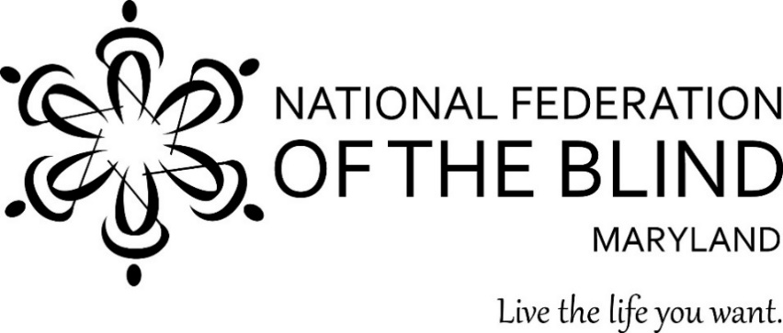

Subject: Appropriation for the Center of Excellence in Nonvisual Access (CENA)
to Education, Public Information, and Commerce

From: Members of the National Federation of the Blind of Maryland

To: Members of the Maryland General Assembly

Contact: Ronza Othman, President
National Federation of the Blind of Maryland
15 Charles Plaza, #3002
Baltimore, MD 21201
Phone: 443-426-4110
Email: President@nfbmd.org

Date: January 2023

Proposed Action: The Maryland General Assembly should maintain the $250,000 appropriation for the Nonvisual Accessibility Initiative (NVAI) in the Governor’s Budget to support the Center of Excellence in Nonvisual Access (CENA) to Education, Public Information, and Commerce.

Background: In 2014, the National Federation of the Blind (NFB) founded the NFB Center of Excellence in Nonvisual Access. The CENA is a center of expertise, best practices, and resources which enables business, government, and educational institutions to provide accessible information and services more effectively to blind citizens. The State of Maryland, through the Maryland Department of Disabilities (MDOD), partners with the CENA to support a series of projects under the Nonvisual Accessibility Initiative maintaining the State of Maryland as an ongoing leader in nonvisual accessibility.

The public-private partnership between the NFB CENA and MDOD (CENA/MDOD) has improved the standard of accessibility throughout the state. Through the development and implementation of a variety of projects within the following six focus areas outlined below, we will continue to build a more accessible Maryland.

Enhancing Access to Education Technology and Strategies
Inaccessible instructional materials prevent blind and low-vision students from accessing the fundamental tools of education, leaving them woefully unprepared for their futures. Problems with inaccessible education technology created significant challenges in the provision of effective virtual instruction to Maryland’s blind and low-vision students throughout the COVID crisis. Under the NVAI the CENA/MDOD worked diligently to identify accessible education technology, while also working with developers to make other education technologies nonvisually accessible. Moreover, CENA/MDOD made significant progress in developing collaborative relationships with Maryland universities to enhance the accessibility of post-secondary learning materials and environments. In the coming year, through the NVAI, the NFB will continue to address the lack of accessible education technology, digital publications, and instructional materials by conducting trainings on resources, strategies, and best practices in the creation and dissemination of tools that are “born accessible.”

Enhance Access to Employment-Related Tools and Services
The unemployment/underemployment rate for blind people in this country continues to exceed 70 percent, and the need to utilize more online, digital, and virtual means of providing employment services and supports has created both problems and opportunities. Under the NVAI, the CENA/MDOD will continue to work in coordination with the Maryland State Department of Labor and Department of Rehabilitation Services to develop and implement the training and tools which will enhance access to public employment programs and services, and create greater employment opportunities for blind and low-vision Maryland job seekers. In addition, the NFB will conduct outreach to employers in an effort to provide them with training and support to eliminate the employment barriers faced by blind and low-vision Maryland citizens.

Offering Accessibility Boutiques and Other Training Seminars
Accessibility Boutiques are one to two-hour basic overviews/trainings designed to create public awareness about accessible software, products, services, and strategies. Quarterly Trainings are half-day trainings which offer a more substantive training experience to the participants and address major issues related to nonvisual accessibility. The CENA/MDOD will continue to offer Accessibility Boutiques and Quarterly Trainings, at no cost to Maryland citizens, on topics that assist both laypeople and professionals to remain knowledgeable of the evolving tools, strategies, and best practices to build a more accessible Maryland.

Maintaining the Accessibility Switchboard
The NFB will continue to develop and market the Accessibility Switchboard, a dynamic online portal consisting of an accessibility information resource for consumers and a compliance information portal for organizations. This work will be informed by the Accessibility Community of Practice, a volunteer group of accessibility experts from educational institutions, corporations, and the public sector.

Assisting with the Integration of Smart Technologies for Accessible Cities
The development and implementation of accessible, safe, affordable, and efficient transportation allows blind and low-vision Maryland citizens to independently travel throughout their communities. In addition, emerging nonvisual access navigation or wayfinding technologies facilitate independent access to a variety of public and commercial venues, including college campuses, public and commercial buildings, and other environments. In order to promote the integration of innovative technologies and strategies toward the creation of accessible cities, the CENA/MDOD will continue to participate in meetings and establish partnerships with technology developers and city planners in the evaluation and implementation of various transportation and wayfinding strategies. Our active involvement will assist in the integration of accessibility features throughout public spaces that are seamless and esthetically pleasing.

Coordinating the Accessibility Inclusion Fellowship Program
The “Final Report of the Study on Accessibility Concepts in Computer Science, Information Systems and Information Technology Programs in Higher Education” recommended that three annual fellowships be awarded to help instructors begin to include accessibility concepts contained within the minimum areas of instruction in at least one course offering in their institution. The CENA/MDOD has offered these fellowships, and will continue to recruit and support an additional cohort in the coming year.

Conclusion
Access to information remains one of the greatest barriers faced by blind people. The public-private partnership between the NFB CENA and MDOD continues to be an effective method of removing these barriers by providing information about best practices and developing innovative techniques for achieving nonvisual access. The Maryland General Assembly should allow this state-of-the-art program to continue by maintaining and approving the $250,000 appropriation in the Governor’s Budget under the Maryland Department of Disabilities.

