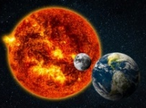
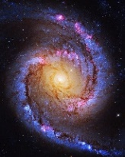
STEM Career Exploration Lab 2023
3D Printing and Astronomy Camp

Calling all High School Students and Graduating Seniors!
Thinking about planning your education and career journey?
Interested in Science, Technology, Engineering, and Mathematics (STEM)?

Join a research study to help improve STEM for students with visual impairments
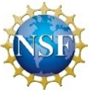
Funded by the National Science Foundation
Principal Investigator Dr. Thomas Madura of San José State University

As part of this study, use tactile models, sound, and hands-on activities designed for the visually impaired to:

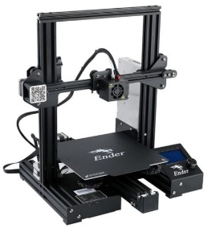
- Build a 3D printer and make objects using 3D printers
- Learn about the universe from actual scientists
- Learn about Moon phases and the inside of the Sun
- Hear the Sun and use sound to understand light and waves
- Build a constellation in 3D and trace the life cycles of stars
- Discover the shape and structure of star clusters and galaxies
- Learn about the Big Bang and the structure of the universe

Complete surveys and interviews about your experience to help us improve the activities

Meet and talk to STEM professionals with blindness/visual impairments like:
- Kenneth Silberman of NASA, an Engineer, Programmer, and Patent Attorney
- Nicolas Bonne, an Astronomer and Project Lead for the Tactile Universe

Go on free field trips to local museums and STEM businesses!

Room and Board for participating students with visual impairments*
Twenty-four hour safety and supervision: camp assistants, social activities, and new friendships
*Only for students with visual impairments

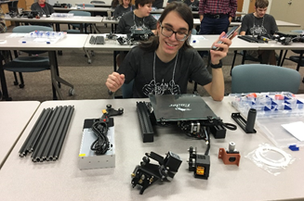
Limited to the first twenty applicants!
Sighted students also welcome!

When: July 31st through August 4th 2023
Where: Maryland School for the Blind

For Parental Consent Forms, Details, and to Register Visit:
https://sjsu.qualtrics.com/jfe/form/SV_e9idPooLE587702

