# USBTA TRAINING FOR PROVIDERS, COACHES, VOLUNTEERS & BLIND TENNIS CLASS

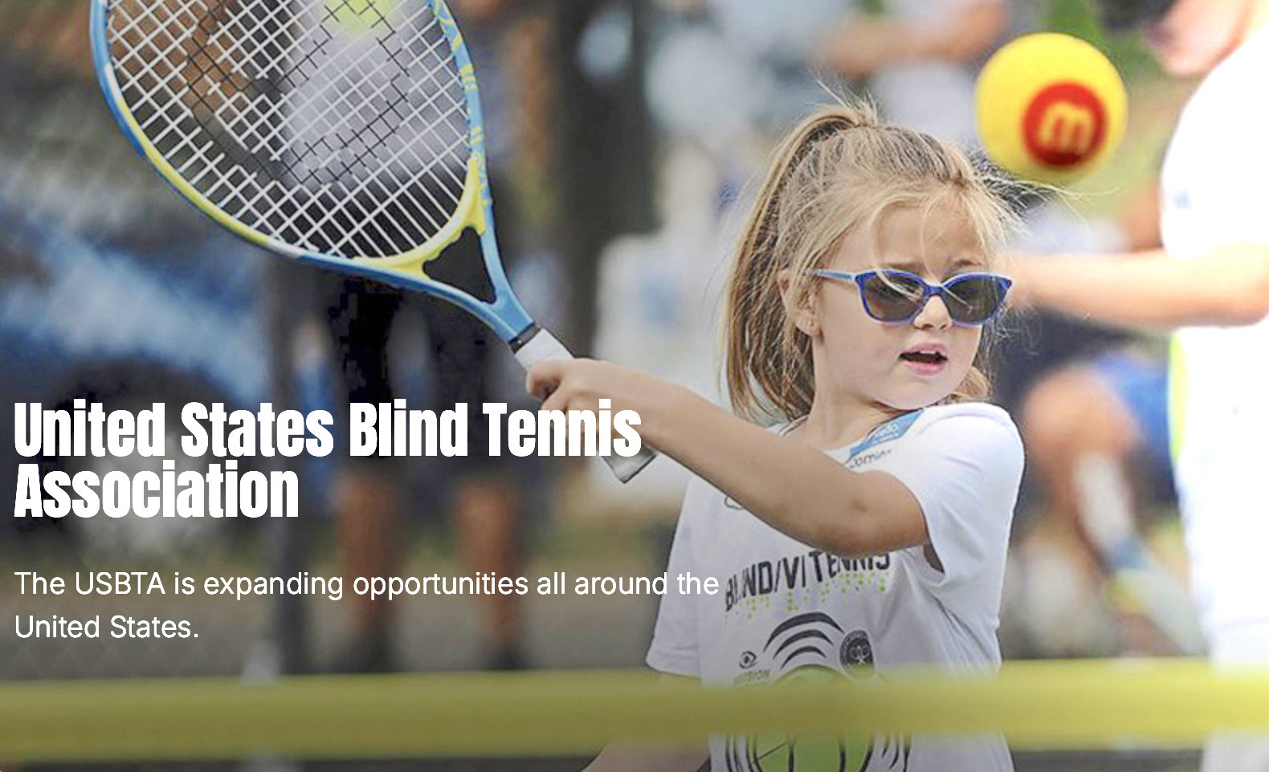

Who:

USBTA United States Blind Tennis Association in Partnership with the Maryland School for the Blind; Tennis professionals and players at large.

What:

A Blind Low Vision (BLV) Train the Trainer (day 1 and 2)

A learn-to-play BLV tennis (day 2) event.

Training for Providers, Coaches, Volunteers & Blind Tennis Class

Rackets and snacks provided. One hour lunch break on day 1.

When:

Saturday Sept. 21, 10am to 3pm Training (day 1)

Sunday Sept. 22, 10am to 12pm Training and Class (day 2)

Where:

The Maryland School for the Blind, 3501 Taylor Avenue, Nottingham, MD

To Register (FREE) and Information: Please email [JAIMEFRANKB@GMAIL.COM](mailto:JAIMEFRANKB@GMAIL.COM) or Text 443-926-4731

In partnership with the Tennis Alliance of Anne Arundel County

